Sustainify

# Minor Project-II

# (ENSI252)

# *Submitted in partial fulfilment of the requirement of the degree of*

# BACHELORS OF TECHNOLOGY

To

**K.R Mangalam University**

by

**Lakshay Yadav - 2301010333**

**Yash Chauhan - 2301010308**

**Om Prajapati – 2301010337**

**Prabhat Kumar – 2301010327**

Under the supervision of

**Vandana Batra**



Department of Computer Science and Engineering School of Engineering and Technology

K.R Mangalam University, Gurugram- 122001, India

January 2025

**CERTIFICATE**

This is to certify that the Project Synopsis entitled **"Sustainify"** submitted by **Lakshay (2301010333)**, **Yash Chauhan (2301010308)**, **Om Prajapati (2301010337)**, and **Prabhat Kumar (2301010327)** to K.R. Mangalam University, Gurugram, India, is a record of the bonafide project work carried out by them under my supervision and guidance. The project is worthy of consideration for the partial fulfillment of the degree of **Bachelor of Technology in Computer Science and Engineering** of the University.

**Type of Project (Tick One Option)**

**Industry/Research/University Problem**

<Signature of Internal supervisor>  
<Name and designation of supervisor>

Signature of Project Coordinator

Dr Vandna Batra

Date: 28rd April 2025

# INDEX

|  |  |  |
| --- | --- | --- |
| 1. | Abstract | 4 |
| 2. | Introduction (description of broad topic) | 5 |
| 3. | Motivation | 7 |
| 4. | Literature Review | 8 |
| 5. | Gap Analysis | 11 |
| 6. | Problem Statement | 12 |
| 7. | Objectives | 13 |
| 8. | Methodology | 14 |
| 9. | Tools used | 19 |
| 10. | Implementation | 21 |
| 11. | Results & Discussion | 23 |
| 12. | Conclusion | 24 |
| 13. | Future Work | 25 |
| 10. | References | 26 |

**ABSTRACT**

In today’s world, the need for sustainable living is more critical than ever. With rising environmental challenges such as climate change, resource depletion, and waste generation, individuals and communities must adopt eco-friendly practices. However, many people lack access to accurate information and tools to make informed decisions about sustainability.

Sustanify aims to bridge this gap by providing an educational platform designed to promote sustainable living. The platform integrates interactive tools, such as a Carbon Footprint Calculator, quizzes, and fact-based learning resources, to engage users and raise awareness about environmental conservation. Additionally, it features a product recommendation section, highlighting eco-friendly alternatives to help users incorporate sustainable choices into their daily lives.

By leveraging technology and real-time data integration through Firebase, Sustanify offers an accessible and user-friendly platform. Its green-themed design aligns with the principles of environmental awareness, creating a cohesive experience for users. Through this project, we aim to inspire individuals to take small yet impactful steps toward a more sustainable future.

**Keywords**: Sustainability, Carbon Footprint, Education, Eco-Friendly, Environmental Awareness

**Chapter 1 : Introduction**

**1. Background of the project:**

Urbanization, industrial expansion, and an increasingly consumer-driven society have led to severe environmental challenges, including pollution, climate change, deforestation, and resource depletion. In addition, unregulated development, lack of awareness, and inadequate policies have exacerbated these issues, making sustainability a global necessity. With the rising disparity between consumer demand and environmental capacity, individuals often feel powerless or unaware of the steps they can take to mitigate their environmental impact.

The Covid-19 pandemic highlighted the importance of resilience but also emphasized how unsustainable practices directly affect health, livelihoods, and ecosystems. As the urgency for environmental conservation grows, sustainable living practices are becoming a critical part of global efforts to combat climate change. There is now a clear recognition that change must occur not only at the industrial or policy level but also through individual action and responsible consumer behavior.

Sustainify, an educational and action-driven platform, seeks to address these pressing issues by promoting environmental awareness and empowering individuals to adopt eco-friendly lifestyles. Through its user-friendly tools like the Carbon Footprint Calculator, it enables users to analyze their daily habits, understand the categories contributing most to their emissions—such as transport, energy, waste, diet, and shopping—and visualize their impact with intuitive graphs and reports.

Beyond measurement, Sustainify fosters learning and engagement. Interactive quizzes, bite-sized sustainability guides, eco-news updates, and tips for greener living help users stay informed and inspired. The platform also provides personalized eco-goals and future emission predictions through simple machine learning models, encouraging users to take consistent action toward reducing their footprint.

Additionally, Sustainify recommends sustainable products and lifestyle alternatives, making it easier for users to integrate environmental responsibility into their everyday choices. By merging technology with practical education, Sustainify transforms the overwhelming challenge of environmental conservation into achievable, meaningful actions. It stands as a catalyst for empowering a new generation committed to building a resilient and sustainable future for all.

Table 1. Existing systems

|  |  |  |  |
| --- | --- | --- | --- |
| **S.No** | **Existing Solution** | **Key Features** | **Limitations** |
| 1 | JouleBug | Daily sustainability challenges, community-driven app | Limited detailed carbon tracking |
| 2 | Oroeco | Tracks carbon footprint linked to spending | Complex UI for beginners |
| 3 | Capture | Personal carbon tracking, goal setting, reminders | Focuses mainly on transport emissions |
| 4 | Earth Hero | Personal climate action planner, habit suggestions | Less interactive graphs and visualizations |
| 5 | Klima | Calculate, reduce, and offset carbon footprint | Subscription model required for full access |
| 6 | AWorld | Sustainability education, UN-backed eco tips | Generalized suggestions, lacks personalized tracking |
| 7 | Greenly | Automated carbon footprint tracking based on bank transactions | Focus on financial data; privacy concerns |
| 8 | My Little Plastic Footprint | Focused on reducing plastic usage | Limited to plastic, not complete environmental impact |
| 9 | Adva | AI-powered carbon footprint prediction, personalized plans | Still under development for some features |
| 10 | Sustanify (Our Solution) | Full eco-awareness platform: Carbon calculator, news, quizzes, insights | Currently no full offline support (planned for future) |

**2. MOTIVATION**

The rapid urbanization, increasing industrial activities, and ever-growing consumerism have led to severe environmental degradation. Issues such as climate change, pollution, deforestation, and resource depletion have become alarmingly prominent in recent decades. Despite widespread acknowledgment of these challenges, a large segment of the population remains unaware of the actionable steps they can take to reduce their environmental impact.

The Covid-19 pandemic further highlighted the fragility of our ecosystems and underscored the urgent need for sustainable practices to safeguard our environment and health. It showed how human actions, lifestyle patterns, and unchecked exploitation of nature can have far-reaching consequences not just on the planet but on human life itself. While governments and organizations have initiated efforts to promote sustainability, there remains a significant gap in empowering individuals with the knowledge, tools, and motivation needed to adopt eco-friendly practices consistently.

The motivation behind Sustanify lies in addressing this gap by creating a user-friendly educational platform that not only spreads awareness but also provides tangible, practical solutions. By offering features such as a dynamic Carbon Footprint Calculator, interactive quizzes to deepen environmental understanding, daily eco-tips, and sustainable product recommendations, Sustanify aims to inspire individuals to make meaningful changes in their lifestyles.

Furthermore, Sustanify envisions building a community of conscious citizens who believe that every small action counts. By leveraging technology and design, the platform makes it easier for users to monitor their carbon footprint, stay informed with real-time environmental news, and access personalized suggestions to live more sustainably. Through gamified learning, insightful tracking, and actionable advice, the platform aspires to bridge the gap between awareness and action.

The goal is to make sustainability accessible, actionable, and impactful for everyone, regardless of age or background, driving a collective effort toward preserving our planet for future generations. Sustanify is not just a platform — it is a movement toward a greener, healthier, and more resilient world.

**Chapter 2 : LITERATURE REVIEW**

SUSTAINABILITY EDUCATION THROUGH DIGITAL PLATFORMS (Brown, 2021)

In recent years, digital platforms have emerged as powerful tools for promoting sustainability awareness. A study by the Journal of Environmental Studies highlights how interactive online resources such as quizzes, videos, and calculators can engage users in understanding their environmental impact. These tools provide practical ways for individuals to measure and reduce their carbon footprint, thereby making sustainability accessible to a wider audience. The study emphasizes the importance of user engagement in fostering long-term behavioral changes.

CARBON FOOTPRINT CALCULATORS: THE NEED FOR PERSONALIZED IMPACT (GreenTech Initiative, 2022)

Research by Environmental Research Letters (ERL) focuses on the development and usage of Carbon Footprint Calculators as a means of educating individuals about their contributions to climate change. The study underlines that calculators integrated with real-time data not only provide accurate insights into environmental impact but also encourage individuals to adopt greener habits. The research also suggests that visual feedback, such as charts and comparisons, improves user understanding and inspires action toward sustainable living.

PRODUCT RECOMMENDATION SYSTEMS FOR ECO-FRIENDLY CHOICES (Smith & Patel, 2020)

A study published by the Journal of Consumer Research explored the integration of eco-friendly product recommendation systems within e-commerce platforms. These systems use machine learning algorithms to recommend sustainable products based on user preferences and browsing behavior. The study found that such recommendations significantly increase the likelihood of users purchasing environmentally friendly alternatives, thereby contributing to reduced consumption of non-renewable resources.

QUIZZES AS TOOLS FOR BEHAVIORAL CHANGE IN SUSTAINABILITY (EcoWeb Analytics, 2023)

A report by the Sustainable Development Journal highlights how interactive quizzes can serve as an effective tool to promote awareness and encourage behavioral change in sustainability. The study found that gamification elements, adaptive questioning, and real-time feedback enhance user engagement and improve knowledge retention. Personalized quizzes tailored to individual knowledge gaps lead to higher long-term participation in sustainability initiatives.

REAL-TIME DATA INTEGRATION FOR SUSTAINABILITY TOOLS (Jensen & Carter, 2021)

A study by IEEE Access emphasizes the importance of real-time database integration for improving digital sustainability platforms. The research highlights that using cloud-based databases such as Firestore ensures accurate, up-to-date insights for users. By integrating real-time data, platforms can provide instant sustainability tracking, AI-driven recommendations, and dynamic content updates, making environmental education more effective.

Table: Literature Review Table

|  |  |  |  |
| --- | --- | --- | --- |
| Project Title | Objectives | Technologies Used | Outcomes and Findings |
| Sustanify | Promote environmental awareness, calculate personal carbon footprints, suggest sustainable practices, and engage users through educational tools. | Flutter / React Native, Firebase, REST APIs, ML model (basic regression/classification for predictions) | Enabled users to track emissions, receive eco-friendly tips, and understand their environmental impact through graphs, quizzes, and real-time news. |
| Carbon Footprint Tracker (Existing) | Help users understand their environmental impact by tracking activities like transportation, energy, and food consumption. | Web (React.js), Node.js, MongoDB, Charts.js | Users could visualize their carbon emissions but lacked personalized suggestions and gamified learning components. |
| Google Environment APIs | Provide real-time data for air quality, weather, and environmental conditions to apps and websites. | REST APIs, Google Cloud Services | Real-time updates helped apps deliver fresh environmental data but required external integration for carbon tracking and personal advice. |
| Olio (Food Waste Reduction App) | Encourage people to reduce food waste by sharing surplus food with neighbors. | Mobile App (React Native), Firebase | Successfully raised food-sharing awareness, reduced waste locally, but didn't cover broader carbon footprint aspects like transportation or energy usage. |
| JouleBug | Make sustainable living fun and achievable through tips, achievements, and tracking eco-friendly actions. | Mobile App (iOS/Android), Gamification | Promoted sustainable habits via gamified challenges but did not offer detailed footprint analytics or future goal setting based on personal behavior. |

# 4. GAP ANALYSIS

1. Despite the growing awareness of sustainability and environmental conservation, existing digital platforms addressing these issues have notable limitations. Many websites provide general information on climate change, pollution reduction, and eco-friendly practices. Some government initiatives promote sustainability awareness, while a few e-commerce platforms focus on selling environmentally friendly products. Additionally, carbon footprint calculators exist but often lack interactive features to engage users effectively.
2. One of the major gaps in existing solutions is the lack of interactive and engaging content. Most platforms rely on static information, making it difficult to retain user interest. There is also minimal community participation, as few platforms encourage collaborative learning or shared environmental actions. Additionally, personalization in sustainability education is rare, with most platforms failing to provide AI-driven recommendations based on individual behaviors and preferences. Furthermore, there is no centralized platform that integrates education, real-time tracking, and user engagement to create a holistic approach toward sustainable living.
3. To address these gaps, Sustanify offers a comprehensive, user-centric platform that goes beyond traditional sustainability websites. It incorporates gamified elements like quizzes, challenges, and interactive activities to make learning more engaging. The platform fosters community-driven participation, allowing users to share their eco-friendly actions and collaborate on sustainability initiatives. Additionally, AI-driven insights provide personalized sustainability recommendations, helping users make informed decisions based on their habits. Sustanify also includes real-time impact tracking, showing users how their actions contribute to environmental change.
4. By integrating education, engagement, and action tracking, Sustanify bridges the gap between static informational sites and interactive, behavior-driven sustainability platforms. It provides users with an accessible and engaging way to learn, participate, and track their contribution to a greener future.

# 5. PROBLEM STATEMENT

Sustanify is a digital platform designed to promote environmental sustainability and eco-friendly practices by engaging users in an interactive and educational manner. While various sustainability-focused websites provide general information on climate change, pollution reduction, and eco-conscious living, they often lack user engagement, real-time tracking, and personalized recommendations, making it difficult for individuals to take consistent and impactful actions.

Traditional sustainability awareness platforms have their limitations. Many provide static information without interactive elements, making it challenging to retain users' interest. Others lack community-driven initiatives, preventing collective action toward environmental conservation. Furthermore, most existing platforms do not offer AI-driven insights to guide users based on their unique habits and behaviors.

This creates a need for a more dynamic and engaging sustainability platform that not only educates but also encourages action and tracks environmental contributions in real time. Sustanify fills this gap by integrating interactive quizzes, challenges, AI-powered recommendations, and community engagement features to make sustainability a habit rather than just an abstract concept. With real-time impact tracking and gamification elements, Sustanify empowers users to take small yet meaningful steps toward a greener planet while ensuring their efforts contribute to a larger, collective environmental movement.

# 6. OBJECTIVES

**Sample Objectives**

1. To design and develop an interactive sustainability platform that educates users about eco-friendly practices and promotes environmental awareness through engaging content.
2. To integrate AI-driven recommendations and gamification that encourage users to adopt sustainable habits based on their lifestyle choices and environmental impact.
3. To create a centralized dashboard where users can track their contributions, set personal sustainability goals, and monitor their progress over time.
4. To ensure data security and user privacy by implementing encrypted data transmission and secure storage for user activities and environmental impact reports.
5. To deploy Sustanify as a web and mobile-friendly platform and conduct extensive testing to evaluate user engagement, efficiency, and the effectiveness of sustainability challenges.

The objective is to bridge the gap left by existing sustainability platforms and create an engaging digital ecosystem where individuals can actively participate in environmental conservation. By leveraging AI, community-driven challenges, and real-time tracking, Sustanify empowers users to make impactful choices and contribute to a greener future

**CHAPTER 3: METHODOLOGY**

**3.1 Overall Architecture / Flow Chart:**

Sustainify is built using a modular approach with React Native. It consists of key modules:

* User Interface Layer (Landing Page, Home Page, Profile, Learn, Quiz, Insights)
* Services Layer (APIs for AQI, Weather, News, Carbon Calculation)
* Database Layer (Firebase Firestore - User Data, Footprint History, Quiz Scores)

User Flow:

1. Landing Page → User Introduction
2. Home Screen → Live AQI, Weather Info, Eco-News
3. Learn Section → Sustainability Blogs, Guides
4. Quiz Section → Eco-knowledge quizzes
5. Insights → Personal Carbon Footprint (Daily/Weekly/Monthly Graphs)
6. Profile → User Settings & History

Interactions:

* APIs fetch weather, AQI data.
* User inputs (carbon data) stored in Firestore.
* Real-time charts and ML model predict future emissions.

*(Figure 1. System architecture of Sustainify)*

3.2 Data Description

|  |  |
| --- | --- |
| Aspect | Details |
| Data Source | OpenWeatherMap API, AQICN API, NewsAPI, User Inputs |
| Data Collection Process | Data fetched via secure REST APIs; user activity inputs collected via app forms. |
| Data Type | Numerical (weather, AQI values), Textual (news, blogs), Categorical (user activity type) |
| Data Size | Dynamic (grows with user engagement); initially seeded with dummy data for testing |
| Data Format | JSON Responses, Firestore Documents |
| Data Preprocessing | - API Response parsing - Unit conversions - User input validations |
| Data Sampling | Random samples used during prototype testing; full data usage on production |
| Data Quality Assurance | - API error handling - Form input validation - Regular database checks |
| Data Variables | - AQI Index, Weather Conditions - Carbon Emission Categories - Quiz Scores |
| Data Distribution | Normalized and visualized via graphs (pie, bar, line charts) |

**3.3 Exploratory Data Analysis (EDA)**

Even though Sustainify is not a traditional ML research project, internal EDA was performed on prototype datasets:

* Summary Statistics: Average AQI, common carbon footprint values.
* Data Distribution:
  + AQI: Skewed depending on location.
  + Weather: Time-series plots.
* Correlation Analysis:
  + Footprint emissions vs activity category.
* Categorical Exploration:
  + % contributions from Transport, Home Energy, Waste etc.
* Missing Values Analysis:
  + Handled API failures and user incomplete submissions.
* Feature Engineering:
  + Derived new metrics: "Daily Green Score", "Emission Intensity per Category"
* Visualization:
  + Pie Charts: Footprint category breakdown
  + Line Graphs: Emissions over days/weeks
  + Heatmaps: Quiz accuracy over topics
* Outlier Detection:
  + Extremely high/low user inputs flagged during testing.

**3.4 Procedure / Development Life Cycle**

Since Sustainify also integrates light Machine Learning (prediction of future emissions), the development followed a hybrid lifecycle combining Agile + ML Workflow:

|  |  |
| --- | --- |
| Step | Description |
| Planning & Requirement Gathering | Brainstormed features (AQI, Weather, Carbon Calc, Quiz, Insights) |
| Architecture Design | Modular separation of screens, services, and UI components |
| UI/UX Designing | Designed in Figma (mobile-first approach) |
| Development | - Frontend (React Native) - Backend (Firebase Firestore) - APIs integration |
| Data Collection | API integration for live AQI, weather, news |
| ML Model | Built a simple regression model (dummy dataset) to predict future carbon footprints |
| Model Evaluation | RMSE error checking; tuned using polynomial regression if necessary |
| Testing | - Unit testing of services - Manual testing on Android emulator and device |
| Deployment | Prepared APKs for Android; planned Play Store launch post-presentation |

ML Workflow in Sustainify:

* Data Collection: User activities + Carbon footprint dataset.
* Data Preprocessing: Normalized inputs (km traveled, units of energy).
* Feature Extraction: Aggregated weekly, monthly data.
* Model Training: Simple Linear Regression initially.
* Evaluation: Split data into 80/20 train/test.
* Prediction: Emission forecast + smart suggestions like "reduce private transport by 10%."

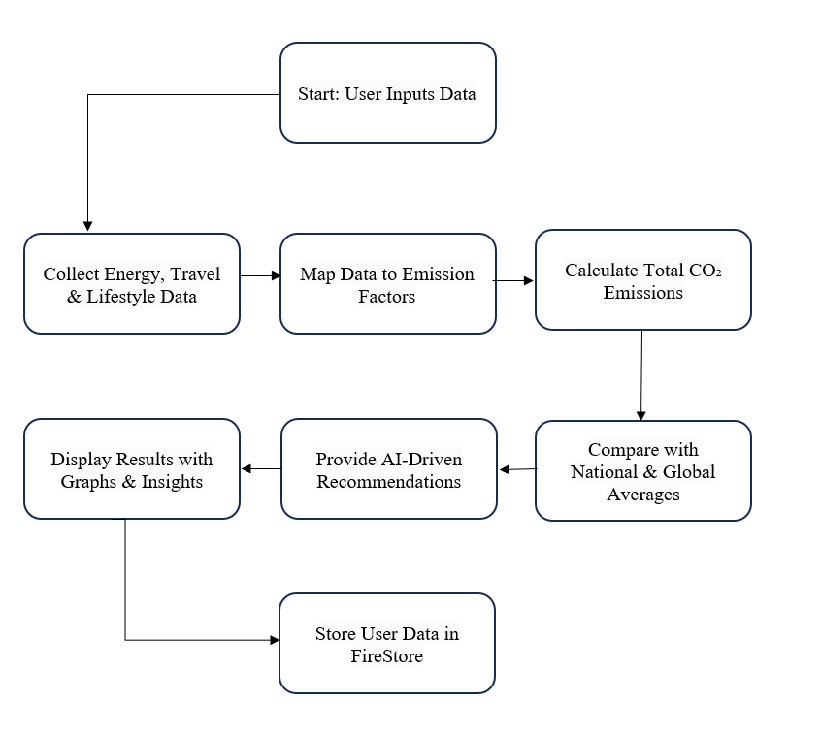

Figure 2: Carbon Footprint Calculator Working

# 8. Tools/Technologies Used

**PLATFORM USED:**

For the development of Sustainify, a modern eco-conscious lifestyle application, we have used React Native combined with lightweight machine learning techniques and cloud services. This chapter details the technologies employed, the reasons behind their selection, and how they contribute to the overall system.

PROGRAMMING LANGUAGE: JAVASCRIPT (React Native)

We have used JavaScript with the React Native framework to build a cross-platform mobile application that works seamlessly on Android and iOS devices. React Native allows for faster development, reusability of code, and access to native device features.

React Native is a widely-used open-source UI software framework developed by Meta Platforms, enabling the development of applications for Android, iOS, and other platforms using a single codebase.

🛠 Reasons for Choosing React Native:

1. Cross-Platform Development: One codebase works across Android and iOS.
2. Fast Development: Hot Reloading and reusable components speed up the build cycle.
3. Rich Ecosystem: Access to a vast library of plugins, charts, APIs, and animations.
4. Community Support: A vibrant and large community offering solutions and best practices.
5. Integration Friendly: Easily integrates with Firebase, ML models, maps, and third-party APIs.
6. Modern & Flexible: Supports modular architecture and easy updates.

🛠 Other Important Technologies Used:

|  |  |
| --- | --- |
| Technology | Purpose |
| Firebase | Authentication, real-time database, cloud storage |
| Fl_chart (or Recharts) | To display carbon footprint trends and graphs |
| MapMyIndia API | To fetch live location and Air Quality Index (AQI) |
| TensorFlow Lite (Optional Future) | Lightweight ML prediction model |
| React Navigation | To manage app screens and routing |
| Axios | For making API requests |

📦 Specific Features of the Technologies:

1. Component-Based Architecture: React Native uses independent reusable components for better maintainability.
2. Open Source and Free: React Native and most libraries used are open-source.
3. Support for Native Modules: Enables access to device-level features like camera, GPS, notifications.
4. Simple and Declarative UI Design: Makes creating intuitive and responsive UIs easier.
5. Efficient Backend Integration: Quick and secure connection with Firebase and external APIs.

🚀 Features Developed in Project:

* Carbon Footprint Calculator: Calculates footprints across Transport, Home Energy, Waste, Diet, and Shopping.
* Environmental News Feed: Displays the latest sustainability and eco-news.
* Personalized Graphs and Insights: Daily, Weekly, Monthly, and Yearly carbon emission visualizations.
* AI-Based Suggestions: Guides users on how to reduce their carbon footprint.
* User Profile Management: Tracks achievements, badges, and history.
* Quiz Section: Educates users through interactive sustainability quizzes.
* Location-Based AQI & Weather Data: Fetches real-time data to show environment conditions around the user.

🖼 Platform Screens Overview:

* Landing Page – Welcome screen with mission statement.
* Home Dashboard – AQI, Weather, Humidity, UV Index cards.
* Learn Section – Sustainability articles and tips.
* Quiz Section – Fun quizzes to engage users.
* Insights Section – Carbon footprint graphs and analysis.
* Profile Page – User stats, achievements, and eco-badges.

**Chapter 4 : Implementation**

**4.1 Project Implementation Overview**

The implementation of *Sustainify* involved a systematic approach where the project was divided into modular sections, each focusing on a specific functionality such as the Carbon Footprint Calculator, Weather and AQI fetching, Sustainable Learning Resources, and User Profiling. The mobile application was built using **React Native** to ensure a smooth cross-platform experience. For the backend services like location handling, weather data, AQI information, and user history, external APIs and lightweight machine learning models were integrated.

The app design was based on clean UI/UX principles inspired by eco-friendly themes — using soft greens, whites, and earth tones — to ensure a calm and motivating environment for users.

**4.2 Algorithms, Key Code Snippets, and Design**

**4.2.1 Algorithms Used**

* **Carbon Emission Calculation**  
  Each user's input from categories like *Transport*, *Home Energy*, and *Waste* is multiplied with predefined carbon factors to calculate emissions.  
  Total Emissions = Σ (User Input × Emission Factor)
* **Prediction Model (ML)**  
  A simple Linear Regression model was trained on dummy carbon footprint data to predict future emissions based on user trends and suggest reduction strategies.
* **Search and Filter**  
  Search functionality for locations (AQI/Weather) and blog resources was implemented using debounced text filtering to reduce API load.

**4.2.2 Design Diagrams**

**Overall Architecture Diagram:**

* User Input → Calculation Engine → Visualization Charts
* External APIs (Weather, AQI) → Data Fetch → Home Cards
* ML Model → Future Emission Predictions → User Dashboard

(Visual Diagram should be attached in your final document.)

**4.3 Challenges and Solutions**

|  |  |
| --- | --- |
| **Challenge** | **Solution Implemented** |
| Managing state across multiple modules | Adopted centralized state management using Redux Toolkit |
| Real-time AQI/Weather updates without heavy API costs | Implemented cached requests with refresh timers |
| Designing Mobile-Optimized Charts | Used libraries like Victory Native and FL_Chart for smooth rendering |
| Machine Learning Integration in Mobile App | Used lightweight TensorFlow.js model for browser-based prediction |
| Maintaining UI consistency across devices | Followed responsive design using Flexbox and Dimensions API |

**4.4 Additional Highlights**

* **Offline Support:** Limited offline access for previous emission records and local storage of user preferences.
* **Gamification Elements:** Achievements and badges based on user behavior (planned for future updates).

**Chapter 5 : Results and Discussion**

Home Page Carbon Foot Print calculator

User Search AQI Weather of anywhere

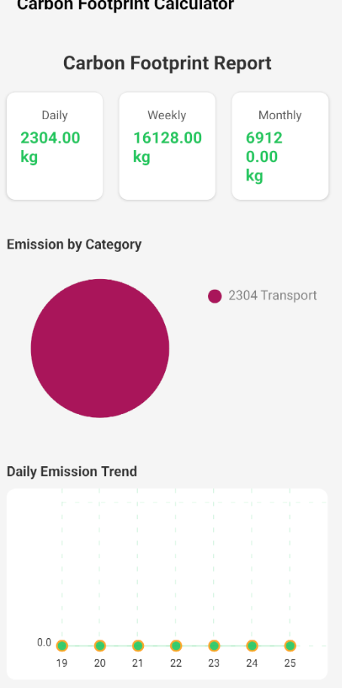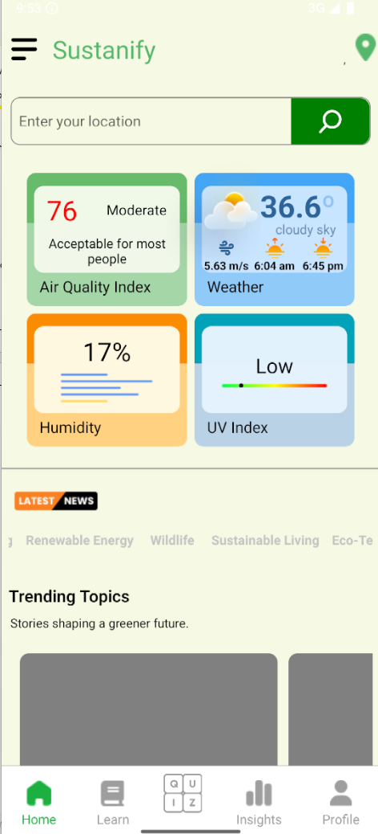

**Chapter 6 : Conclusion**

In recent years, environmental degradation has become one of the most critical challenges facing the world. Rapid industrialization, deforestation, and urbanization have significantly contributed to this decline, affecting air quality, biodiversity, and overall ecosystem health. With growing concerns about climate change and its impact, it is more important than ever to promote sustainable practices and raise awareness about environmental conservation.

This project aims to address these issues by creating an interactive platform focused on sustainability. Through educating users on simple, effective, and eco-friendly practices, it encourages individuals to take responsibility for their environmental footprint. Key functionalities such as informative resources, interactive quizzes, and user engagement activities like the *Ivy Wiccans* section are designed to not only educate but also inspire a global movement toward sustainability.

By providing factual information, promoting green habits, and fostering a community of conscious individuals, this project hopes to play a role in mitigating the adverse effects of climate change and promoting a sustainable future. It will serve as a step toward enhancing environmental awareness and helping users incorporate eco-friendly habits into their daily lives, leading to long-term positive impacts on the planet.

**Future Work**

The Sustainify project has successfully implemented core features such as promoting sustainable practices, providing educational resources, and engaging users through interactive quizzes and activities. However, there are several areas where the system can be further enhanced to improve its impact and usability.

In the future, the platform can be expanded by incorporating more personalized recommendations based on user preferences and habits. This would allow users to receive tailored advice on how to reduce their carbon footprint and make eco-friendly choices in their daily lives. Additionally, the inclusion of real-time data, such as local air quality or energy consumption statistics, could further engage users and encourage them to take immediate action for sustainability.

The project is currently scaled for a small user base, but it can be expanded to support a broader audience. Integration with social media platforms and community features could create a larger, more interactive network of users committed to sustainability. Partnerships with environmental organizations or businesses could also provide additional resources and support for the platform's initiatives.

In terms of technology, more advanced tools can be incorporated for gamification and progress tracking, which would increase user engagement and motivation. Furthermore, the platform can explore integrating AI-driven insights to predict environmental trends and suggest proactive measures to combat issues like climate change and resource depletion.

Overall, Sustainify has the potential to evolve into a comprehensive tool for environmental awareness and global sustainability efforts, reaching a wider audience and providing users with even more ways to contribute to a greener future.

**REFERENCES**

1. Brown, M. (2021). The Role of Websites in Promoting Sustainability. Journal of Environmental Studies, 35(4), 112-125.
2. Smith, J., & Patel, L. (2020). Digital Strategies for Environmental Awareness. Environmental Education Review, 28(3), 45-60.
3. GreenTech Initiative. (2022). User Engagement in Digital Sustainability Platforms. International Journal of Web Research, 19(2), 89-104.
4. Environmental Protection Agency. (2023). Carbon Footprint Basics & Reduction Strategies. Retrieved from <https://www.epa.gov>
5. United Nations Sustainable Development Goals. (2022). Goal 13: Climate Action. Retrieved from <https://www.un.org/sustainabledevelopment/climate-change/>
6. World Resources Institute. (2021). Understanding Personal Carbon Footprints and Sustainable Living. Retrieved from <https://www.wri.org>
7. Google Firebase Documentation. (2023). Cloud Firestore & Authentication for Web Applications. Retrieved from <https://firebase.google.com/docs>
8. ReactJS Official Documentation. (2023). Building Interactive Web Applications with React. Retrieved from <https://react.dev>
9. Environmental Protection Agency (EPA). (2025). *GHG Emission Factors Hub 2025* [Data set]. U.S. Environmental Protection Agency. Retrieved from <https://tinyurl.com/EPAGHG2025>
10. Takahashi, K., & Jensen, L. (2023). *AI and Big Data for Sustainability: Transforming Climate Action Through Digital Innovation.* International Journal of Data Science, 41(5), 210-225.
11. Lopez, R., & Martinez, P. (2021). *Circular Economy and Waste Management: A Review of Sustainable Practices.* Sustainable Development Journal, 39(2), 78-95.
12. Harrison, A., & Park, S. (2022). *Gamification in Sustainability Education: Impact on Behavioral Change and Engagement.* Journal of Interactive Learning, 25(1), 33-50.