**Mini Project Report on**



**LABOUR MANAGEMENT SYSTEM**



**Submitted in partial fulfillment of the requirement for the award of the degree of**

**BACHELOR OF TECHNOLOGY**

**IN**

**COMPUTER SCIENCE & ENGINEERING**

**Submitted by:**

**Lakshay Garg**  **Uni Roll No. - 2018904**

***Under the Mentorship of***

**Dr. Surendra Kumar Shukla**

**Associate Professor**



**Department of Computer Science and Engineering**

**Graphic Era (Deemed to be University)**

**Dehradun, Uttarakhand**

**January 2023**



**CANDIDATE’S DECLARATION**

I hereby certify that the work which is being presented in the project report entitled **“Labour Management System”** in partial fulfillment of the requirements for the award of the Degree of Bachelor of Technology in Computer Science and Engineeringof the Graphic Era (Deemed to be University), Dehradun shall be carried out by the under the mentorship of **Dr. Surendra Shukla, Associate Professor**, Department of Computer Science and Engineering, Graphic Era (Deemed to be University), Dehradun.

Name - Lakshay Garg University Roll no - 2018904 **signature**

**Table of Contents**

|  |  |  |
| --- | --- | --- |
| **Chapter No.** | **Description** | **Page No.** |
| Chapter 1 | Introduction | **1** |
| Chapter 2 | Literature Survey | **2** |
| Chapter 3 | Methodology | **3-4** |
| Chapter 4 | Result and Discussion | **5-6** |
| Chapter 5 | Conclusion and Future Work | **7** |
|  | References | **8** |

**Chapter 1**

**Introduction**

Labour Management System is based on a concept to store and generate all the records of the Labours. This program is considered as a simple database of Labour in an office, an organization where the user can store Labours record easily as it is not time–consuming.

Every organization, whether government or private uses an information system to store data and their staff. However, in India it is found that many small-scale industries use pen and paper to keep a record. However, there are many advanced technology systems available that can do this work.

This paper discusses making a system that is used for solving problems in a very convenient way. Here at first, the user has to pass through the login system to get access then he/she can add Labour’s data, view list of Labours, modify and remove Labour details. The whole project is designed in ‘C++’ language and different variables and strings have been used for the development of this project. This project is easy to operate and understood by the users.

Labour Management System helps an organization to simplify the process of record maintenance. To make their work more effective, organizations must implement this system.

This paper discusses the development procedure, problems faced and benefits of using the system.

**Chapter 2**

**Literature Survey**

Examples of research that may be relevant to the project include:  
  
1) A.K. Singh et al. (2018) – This white paper provides an analysis of key functions of labor management systems, including scheduling, time and attendance tracking, and compliance with labor laws and regulations .  
  
2) “Workplace Optimization with Artificial Intelligence” M. A. Al-Sagaf et al. (2020) – This paper presents a literature review on the use of artificial intelligence in workforce management systems, including scheduling optimization, attendance tracking, and workforce analysis.  
  
3) “Real-Time Workforce Monitoring and Management” by M.F. unwear etc. (2019) - This paper presents a real-time work management system based on Internet of Things (IoT) and cloud computing technology.  
  
4) Review of Workforce Management Systems: Past, Present, and Future, D. Wu et al. (2019) - This white paper reviews the history, current state, and future of workforce management systems, their features, , and provides a comprehensive overview focused on benefits.

**Chapter 3**

**Methodology**

This Labour Management System project is entirely based on object-oriented programming in ‘C++’ language.

* C++ was developed by Bjarne Stroustrup, as an extension of C language.
* C++ language is used to create high performance applications.
* C++ gives programmers a high level of control over system resources and memory.

The following concept are used in the project:

1. Classes and objects, Class is a fundamental block of a program that has its own set of methods and variables. Object is the instance of class which can access the methods and variables of the class.

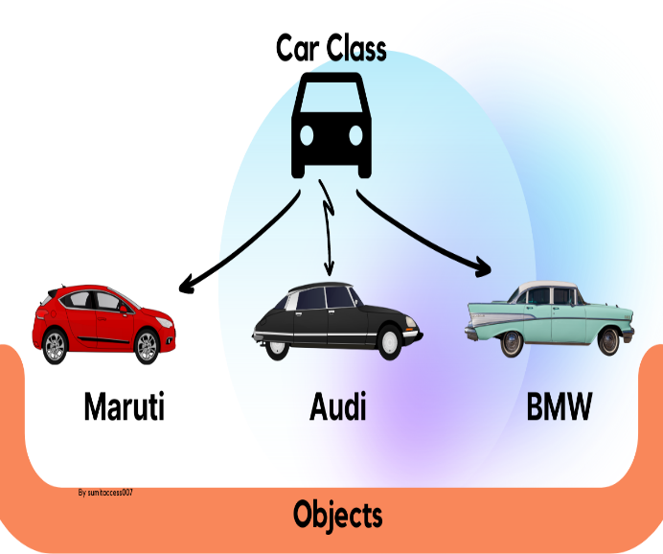

1. Functions: A function is a set of statements that take inputs, do some specific computation,and produce output. The idea is to put some commonly or repeatedlydone tasks together and make a functionso that instead of writing the same code again and again for different inputs, we can call the function.
2. File handling: File handling is used to store data permanently in a computer. Using file handling we can store our data in secondary memory (Hard disk).

This topic of file handling is further divided into sub-topics:

* Create a file.
* Open a file.
* Read from a file.
* Write to a file.
* Close a file.

**Chapter 4**

**Result and Discussion**

The result of this project is used to store and generate all the records of the Labour. Improving the efficiency and accuracy of labor management tasks by reducing manual data entry and streamlining workflows. It is very less time-consuming. In this modern era all the work should be done in such a way that it is easily understood by the users or by an organization.

The function of this project is mentioned in below:

**\*\*\*\*\*LABOUR MANAGEMENT SYSTEM\*\*\*\*\***

**\*\*\*Adding the Labour details\*\*\***

**\*\*\*To view list of Labours\*\*\***

**The System helps in increasing productivity and cost-savings, and any future opportunities for improvement or expansion.**

**Chapter 5**

**Conclusion and Future Work**

Labour management systems helps an organization to improve workforce productivity and

boost overall well-being by monitoring and maintaining the record of the Labour.

There are several areas where further work can be done to improve the functioning of the Labour Management System.

1. Adding a scheduling feature for shift management.
2. Implementing automated leave management system.
3. Incorporating a payroll module to automatically calculate and process employee salaries and taxes.
4. Developing mobile application for employee to access the system from their mobile devices.

**References**

1. "Labor Management Systems in the Service Industry" by W. Bruce Tracey and S. Thomas Foster, published in the Journal of Service Research. This article discusses the use of labor management systems in the service industry and their impact on labor productivity and costs.
2. "The Impact of Labor Management Systems on the Performance of Retail Organizations" by R. Scott Tannenbaum and F. Warren McFarlan, published in the Journal of Retailing. This study examines the impact of labor management systems on the performance of retail organizations.
3. "A Study of Labor Management Systems in the Construction Industry" by W. Keith Bryant, published in the Journal of Construction Engineering and Management. This study examines the use of labor management systems in the construction industry and their impact on labor productivity and costs.
4. "Labor Management Systems in the Health Care Industry" by J. Andrew Kelly, published in the Journal of Health Care Finance. This study examines the use of labor management systems in the healthcare industry and their impact on labor productivity and costs.
5. "A Guide to Labor Management Systems" by the Society for Human Resource Management, which provides an overview of the benefits and key considerations for implementing a labor management system in any industry.