## **First LED Blink**

|  |
| --- |
|  |

Open the Reference manual of your controller(mine is stm32f070rb). There is an onboard LED on the board which we will blink using the above code. It is at Port A and Pin 5.

* We have to first turn on the clock of the particular port which we want to use. In the Datasheet, look block diagram in description section. You need to find the peripheral which you have to use and look at the clock connected to that peripheral.

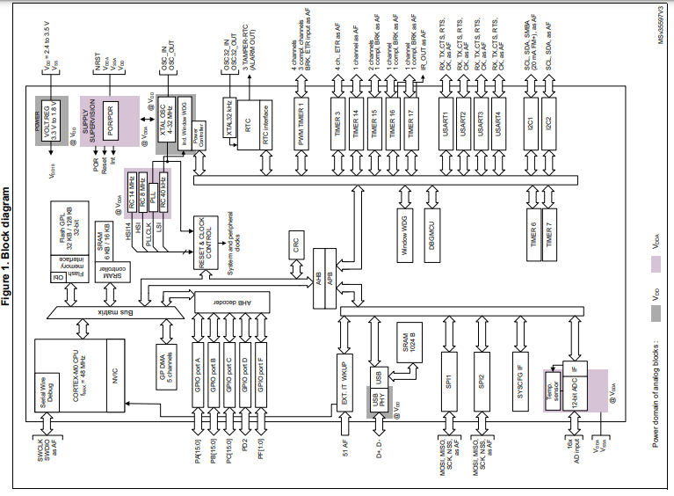

**ENABLING CLOCK**

* GPIOA is connected to AHB bus. In the reference manual, in the RCC register open the RCC_AHBENR register and in the we can find the IOPAEN bit i.e. Input-ouptut port A clock enable bit.

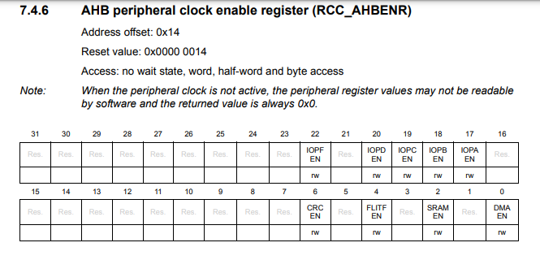

* We are selecting the RCC register, dereferencing it to select the AHBENR and bit-banging ‘1’ to the position of IOPAEN.
* We can either do RCC->AHBENR |= 1 << 17 to shift 1 left side 17 times to the IOPAEN bit or there is a pre-defined definition of it in header file provided by stmicroelectronics.
* Using the definition makes it easy for us to understand it later when we will forget the code and shifting 1, 17times would be confusing.

**GPIO OUTPUT CONFIG**

* We will now configure the GPIO bit. We need it to be General purpose output mode. Open the GPIO register in reference manual.
* First register is GPIO port mode register. In that function it is written we can configure it to be either- Input mode, output mode, alternate mode, analog mode.
* It takes two bit to configure a GPIO and as we have 15 GPIO max, there are 15 moder register to configure. Means MODER0[1] and MODER0[0] is to configure Pin 0 of the port we choose.
* Dereference the GPIOA to moder. To configure pin 5 to output, we need to shift ‘1’ at MODER5[0] and shift ‘0’ at MODER5[1] because output is ‘01’.
* Only to output the port, go to the ODR register by dereferencing GPIOA->ODR and shift ‘1’ in bit 5 or use ‘GPIO_ODR_5’ definition. Shifting one will make the pin high and LED will be turned on. Shifting zero will turn the LED off.
* For now, use the HAL_delay function to wait for 1 second and blink the LED.