Ans 1: grep command is used to search a pattern in a file line by line.It can have the following attributes:
-v list the lines that do not contain the pattern
-c Shows the line where the pattern is together with the line number
-n Displays the number of lines that contains the pattern in the file
-i Search is no more case sensitive

Example:
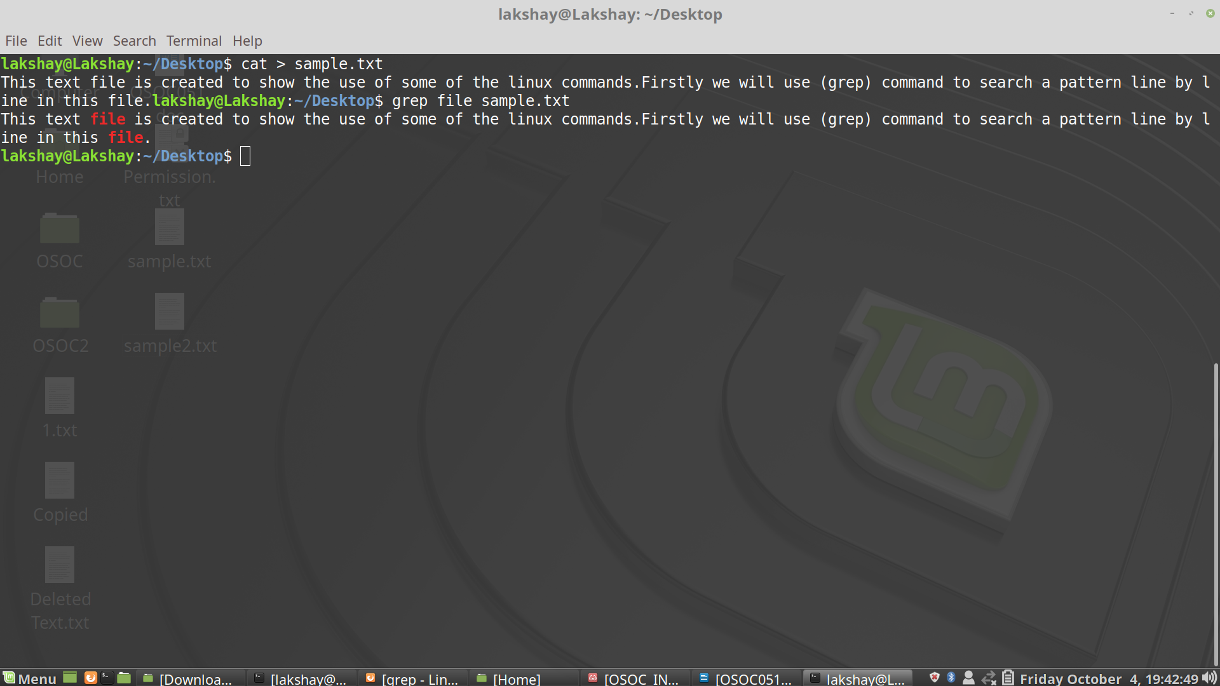

Ans 2: There are in total three permissions:
1) r - Read permission
2) w - Write permission
3) x - Execution permission

For any file there are 10 characters which represent permissions given to a file.We can display that by using ls -l command.It will be shown like:
-rw-r--r--
First character describes whether it is a file or a directory. For a directory first character will be d.
Characters at position 2,3,4: (Read Write Execute) For user
Characters at position 5,6,7: (Read Write Execute) For Group
Characters at position 8,9,10: (Read Write Execute) For All

Example:We have a file on desktop named permission.txt For changing the permissions chmod command is used along with octal code to each section.

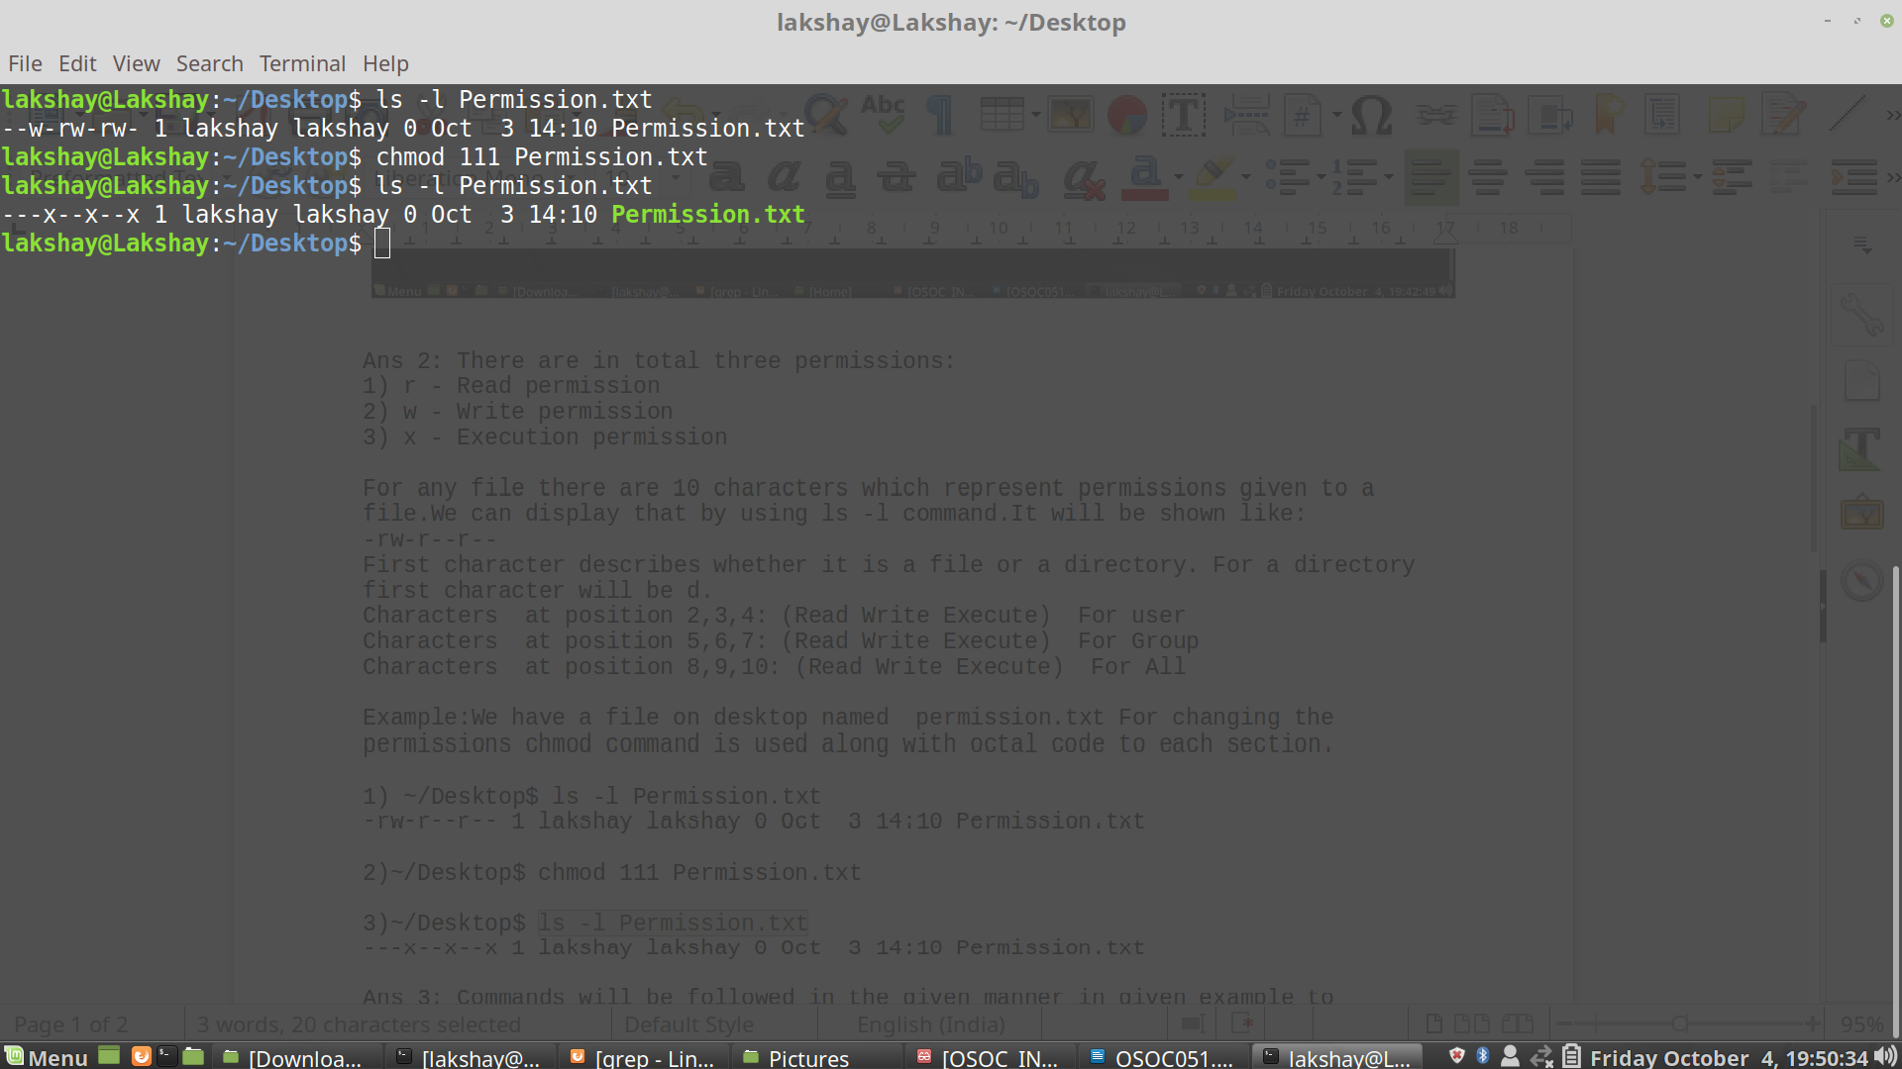
Ans 3: Commands will be followed in the given manner in given example to accomplish the task:

mkdir command is used to make directory.cp is used to copy files.

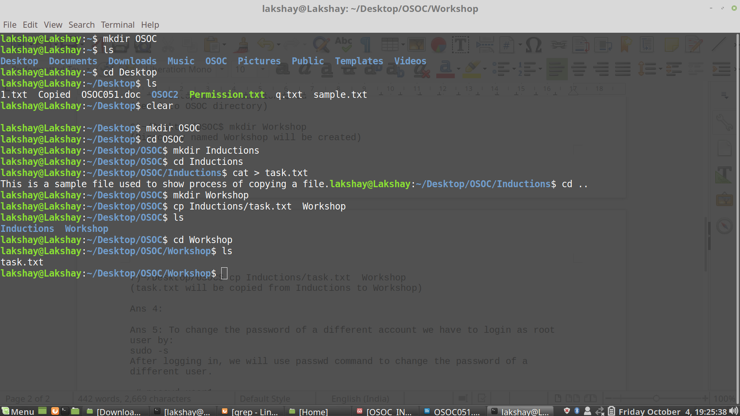

Ans 4: We can check our system’s connectivity by using ping command(Packet Internet Groper)

Ans 5: To change the password of a different account we have to login as root user by:
sudo -s
After logging in, we will use passwd command to change the password of a different user.

~# passwd user1
Enter new UNIX password:
Retype new UNIX password:
passwd: password updated successfully

Password will not be visible during typing.

Ans 6:

Ans 8: Branching refers to

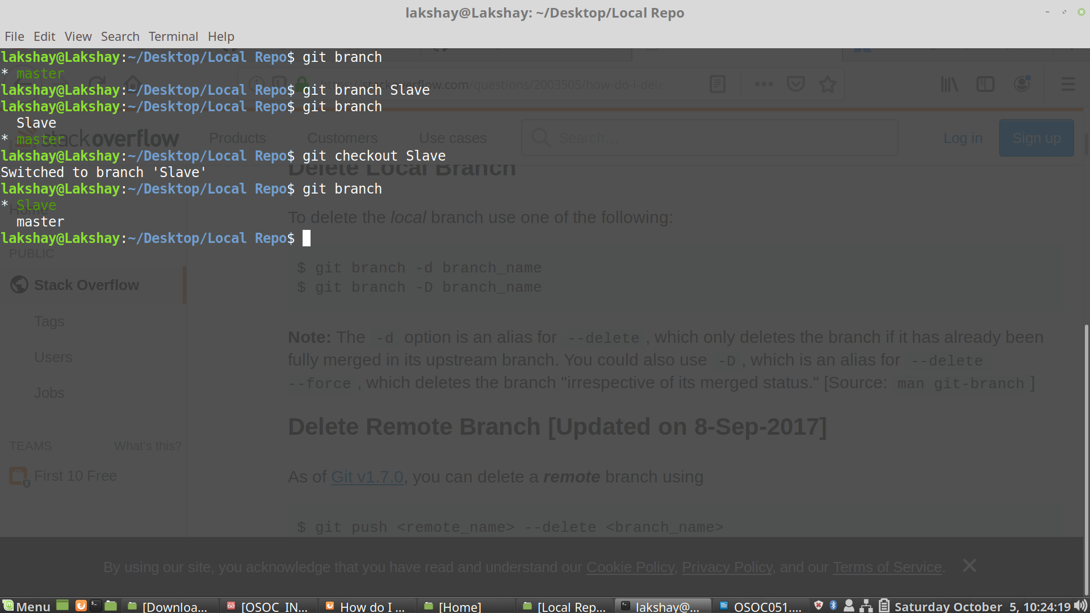

Ans 9:

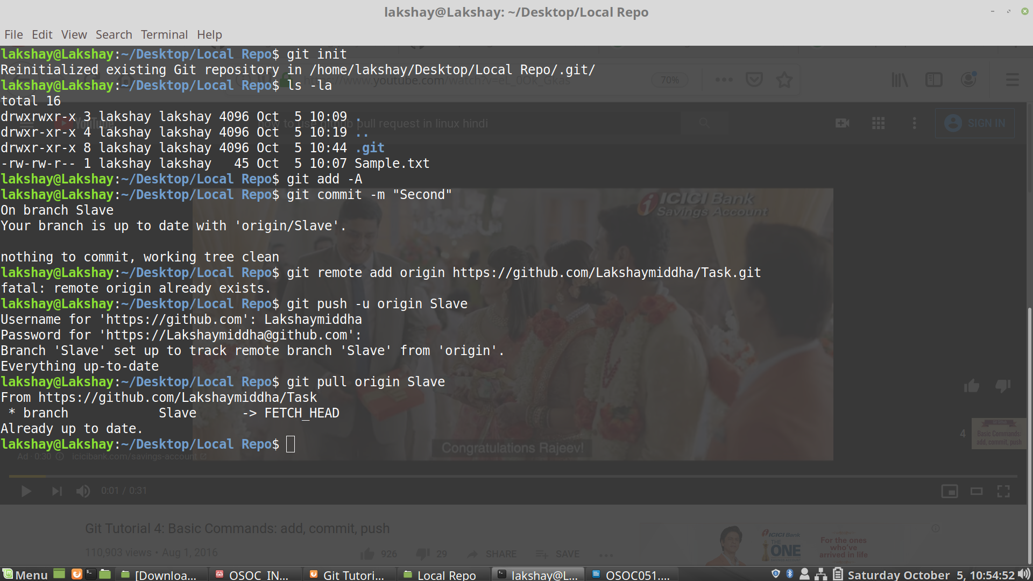

Ans 10:

