
Podcast Journalism: A News Value-Based Study of News Podcasts of Times of India and The Hindu Publications (A Mixed Method Analysis)

Submitted by:
Medha Sahu
Roll No: 2023BAJMC016

Submitted to:
Dr. Swati Jaywant Rao Bute
Undergraduate Program: BA in Journalism and Mass Communication
Jagran School of Journalism
Faculty of Media and Social Sciences
Jagran Lakecity University, Bhopal
YEAR 2025-26

Declaration
I hereby declare that the dissertation entitled Podcast Journalism: A News Value-Based Study of News Podcasts of Times of India and The Hindu Publications (A Mixed Method Analysis) is my original work carried out under the supervision of Dr. Swati Rao Bute, Faculty of Media and Social Science, Jagran Lakecity University, Bhopal. This work has not been submitted for any other degree or diploma in any other institution.
Signature of Student: ___________________
Date: ___________________

Certificate
This is to certify that the dissertation entitled Podcast Journalism: A News Value-Based Study of News Podcasts of Times of India and The Hindu Publications (A Mixed Method Analysis) submitted by Medha Sahu has been completed under my supervision. It is an original and independent work carried out by the student towards partial fulfillment of the requirements for the degree of Journalism and Mass communication at Jagran Lakecity University, Bhopal.
Supervisor’s Name: ___________________
Signature: ___________________
Date: __________________

Acknowledgment
I would like to express my sincere gratitude to my supervisor, Dr. Swati Jaywant Rao Bute, for their continuous support, valuable guidance, and feedback during the preparation of this dissertation. I am thankful to all my professors at Jagran Lakecity University for their encouragement and for providing a stimulating learning environment. I also wish to thank all the participants who took part in the survey and contributed to the success of this research. Finally, I thank my friends and family for their patience and motivation throughout this study.

Table of Content
Chapter1: Introduction
1.1 Background……………………………………………………………………………………07
1.2 Benefits and Challenges of Podcast Journalism………………………………………………08
1.3 Pervasive Role of Podcasts in News Consumption…………………………………………...08
1.4 Statement of the Problem……………………………………………………………………...08
1.5 Significance of the Study……………………………………………………………………...09 1.6 Research Question…………………………………………………………………………….09 1.7 Research Objective……………………………………………………………………………09
Chapter 2: Literature Review
2.1 The Role of Podcasts in Connectivity and Community Building…………………………….10
2.2 Podcasts and Self-Identity Formation………………………………………………………...10
2.3 Positive Effects on Learning and Awareness………………………………………………….10
2.4 Negative Impacts and Challenges……………………………………………………………..11
2.5 Research Gap………………………………………………………………………………….11 2.6 Theoretical Framework……………………………………………………………………….11
Chapter 3: Research Methodology and Analysis
3.1 Research Design……………………………………………………………………………....14
3.2 Sampling Technique…………………………………………………………………………..14
3.3 Data Collection Tools…………………………………………………………………………16
Chapter 4: Data Analysis 4.1 Data Analysis…………………………………………………………………………………18
Chapter 5 Result Conclusion and Discussion
5.1 Results and Findings………………………………………………………………………….31
5.2 Discussion…………………………………………………………………………………….32
5.3 Conclusion ……………………………………………………………………………………32
Chapter 6: References / Bibliography
Appendices
- Appendix A: Podcast Log Sheet
- Appendix B: Survey Questionnaire
- Appendix C: Data Tables and Charts

Abstract:
Podcast journalism is a new form of digital storytelling that blends the closeness of audio with the depth of traditional reporting. This dissertation looks at how news podcasts from The Times of India and The Hindu influence audience engagement, trust and news perception. It compares the tone, narrative style and emotional appeal of both outlets, focusing on how people of different ages experience and interpret podcast news. The research uses a mixed-method approach involving content analysis of 06 news episodes from both podcasts and survey data from 100 respondents across various genders, age groups and professions. The results show that podcasts allow for multitasking, create an emotional connection and make complicated issues easier to understand. However, challenges like accuracy, bias and lack of regulation still affect their credibility. The findings help us understand how podcast journalism is changing the Indian news experience.
Keywords: Podcast Journalism, Digital News, Audience Engagement, tone, news perception, emotional appeal, Storytelling

Chapter 1 : Introduction
1.1 Background
In the last decade, podcasting has transformed from a simple audio format into a rich multimedia experience that combines sound and visuals. What began as an extension of radio has evolved into a powerful form of digital storytelling that reaches global audiences. The rise of video podcasts also known as "vodcasts," has changed how people consume news and information by adding visual context, facial expressions and on-screen graphics to support the spoken narrative.
Unlike traditional print or television formats video podcasts offer flexibility, portability and intimacy. Audiences can watch or listen anytime whether while traveling, working or relaxing. This on-demand nature allows people to stay informed without being tied to fixed broadcast schedules.
The global video podcast industry began expanding rapidly after 2015, driven by affordable smartphones, faster internet and platforms like YouTube, Spotify Video and Apple Podcasts. According to the Reuters Institute Digital News Report (2024) over 45% of internet users worldwide now watch or listen to podcasts at least once a month. These podcasts now serve as major sources for news, education and public discussions, not just entertainment.
In India, the popularity of podcasts, especially audio-video podcasts, surged after the COVID-19 pandemic. With physical interaction limited, people turned to digital media for connection and reliable information. Platforms like YouTube, Spotify and news organizations' official websites saw significant growth in podcast viewership from 2020 to 2024. India now ranks among the top five podcast markets globally, with millions engaging with news, politics, lifestyle and educational video podcasts.
Recognizing this trend major Indian media organizations like The Times of India and The Hindu began investing in news-based video podcasts. These podcasts combine professional journalism with visuals such as news clips, studio discussions and infographics to create a more immersive experience. This shift to video based storytelling marks a significant change in Indian journalism blending factual reporting with emotional and visual appeal.
Video podcast journalism offers unique advantages. It helps visual learners understand information better, allows journalists to present evidence or interviews and builds trust by showing the faces and expressions of presenters. For viewers, video podcasts feel more transparent and genuine than textbased articles. However, this shift also brings challenges such as maintaining journalistic accuracy, avoiding visual manipulation, and ensuring accessibility for audiences with slow internet.
The growing acceptance of video podcasts in India reflects a broader shift towards interactive, visual and personalized news experiences. This raises important questions: Are video podcasts merely another form of digital entertainment or are they changing how people understand and trust the news? This study aims to explore this by comparing the news video podcasts from The Times of India and The Hindu.
Through this research the study seeks to understand how storytelling, tone, visuals, and delivery styles in these podcasts help build trust, engagement and comprehension among audiences. It also aims to uncover whether video podcasts are creating a new culture of news consumption in India.
1.2 Benefits and Challenges of Video Podcast
Video podcast journalism combines audio storytelling with visual presentation, making news more engaging and relatable. The mix of voice, tone, facial expression and on-screen visuals helps audiences connect emotionally with the story. This format allows for flexibility, letting people watch or listen whenever they like and reaching those who prefer visual learning or multitasking while consuming news.
One key benefit is transparency. Seeing the speaker's face and expressions fosters a sense of honesty and reliability. The visual context, such as charts, photos and short clips, makes complex topics easier to grasp. Additionally video podcasts encourage interaction and engagement through comments and social media.
However, challenges exist. Producing video podcasts requires technical know-how, including editing, camera work and lighting. Poor production quality can harm credibility and engagement. Another concern is the risk of misinformation, as India still lacks strong guidelines and regulations for video podcast journalism. Balancing creativity in storytelling with factual reporting is a significant challenge for modern newsrooms.
1.3 Pervasive Role of Video Podcast in News Consumption
Video podcasts have become a key part of people's digital habits. For many, watching a podcast episode on YouTube has replaced reading the morning newspaper or watching television bulletins. They offer in-depth discussions, visual explanations and human stories in a conversational style that feels more personal than traditional reporting.
Younger audiences, aged 18-35, often prefer video podcasts for their informal style and interactive presentation. Meanwhile older viewers appreciate the clarity and visual storytelling that help them grasp complex topics like the economy or politics. Thus, video podcasts bridge the generational gap in how Indians consume and interpret news.
They also allow people to multitask listeners can engage while driving, cooking or exercising. This combination of flexibility, accessibility and emotional storytelling has made video podcasts one of the most inclusive and participatory forms of journalism today.
1.4 Statement of the Problem
Although video podcast journalism is growing rapidly in India, there is limited understanding of how it impacts audience trust, engagement and perception of credibility. It is unclear if audiences view these podcasts as reliable news sources or simply another form of entertainment.
This study aims to address this gap by comparing the video podcasts of The Times of India and The Hindu, focusing on how they present stories, the tone of narration and how visual elements shape the viewer's sense of trust and understanding.
1.5 Significance of the Study
This research is important because it will provide deeper insights into how storytelling, visuals and journalistic values work together in video podcast journalism. It will explore how different narrative techniques influence engagement, credibility and audience connection. The findings will be valuable for:
- Journalists: to understand how to tailor storytelling for visual podcasts.
- Media organizations: to create more credible and appealing digital content.
- Educators and students: to learn how podcast journalism can fit into modern journalism curricula.
- Future researchers: to build on these findings for further studies on visual communication and digital media trust.
By comparing The Times of India and The Hindu, this study will reveal how traditional print media houses are turning into multimedia storytellers and how this change is shaping the future of journalism in India.
1.6 Research Questions
- How do the podcasts produced by The Times of India and The Hindu differ in content style, presentation, and storytelling techniques?
- How do The Times of India and The Hindu combine audio and video elements to deliver trustworthy and engaging news?
- To identify the audience needs and expectations to podcast.
1.7 Research Obejective
  - To compare the content structure, storytelling techniques and presentation styles used by The Times of India and The Hindu in their podcast programs.
  - To analyse how the mix of audio narration and visuals affects audience engagement, understanding and trust.

Chapter 2: Literature Review
2.1 The Role of Audio-Video Podcast in Connectivity and Community Building
Podcasting has changed from being just audio to a platform for audio-visual storytelling. Listeners now not only hear but also see the expressions, gestures and visual cues of the speakers. According to Llinares, Fox, and Berry (2018), the immersive nature of podcasting helps audiences feel a personal connection with hosts. As video-integrated podcasts grow on platforms like YouTube and Spotify Video, this sense of closeness has increased.
Markman (2012) explains that podcasts help create communities around shared interests. Viewers often engage through comments, live chats and social media discussions, which traditional radio or print journalism did not allow. Bonini (2015) argues that this participatory environment has turned podcast listeners into active participants, influencing public conversations and trust.
In India, Sharma (2022) found that video podcasts connect better with younger audiences who prefer visual interaction. Including facial expressions, graphics and on-screen data improves credibility and keeps attention. This shows how The Times of India and The Hindu use podcasts not just to report news, but also to create interactive communities of informed citizens.
2.2 Audio-Video Podcast and Self-Identity Formation
Perks and Turner (2019) suggest that individuals often connect with hosts or topics of podcasts as part of their identity development. For instance, a viewer who follows podcasts about political analysis or environmental issues may start to align their values with those of the hosts. In audio-video formats, this connection deepens due to the visual intimacy—viewers can see real reactions, empathy and authenticity.
McHugh (2016) argues that visual storytelling adds emotional weight to journalism. Through body language, tone and settings, video podcasts make complex issues more relatable. For example, The Hindu’s explainer podcasts use visuals like maps or data charts to simplify complex news topics, while The Times of India’s conversational podcasts use informal visuals to make stories more relatable.
Berry (2016) notes that this mixed storytelling helps audiences develop emotional ties, turning them into visual participants in news narratives.
2.3 Positive Effects on Learning, Awareness and News Literacy
Podcasts are strong educational tools, and adding visuals boosts understanding. The Pew Research Center (2023) reports that over 50% of global podcast audiences listen for educational or informative content. In India, Kumar and Patel (2023) found that both students and working professionals use podcasts to stay updated on current events while multitasking.
Dual Coding Theory (Paivio, 1971) supports this idea, suggesting that information presented in audio and visual formats is easier to process and remember. Audio-video podcasts, therefore, enhance news literacy and retention of complex issues like politics, economics or climate change.
The Reuters Institute Digital News Report (2024) noted that audiences find video podcasts more trustworthy and engaging because visuals confirm authenticity, such as showing live sources, interviews, or locations. In India, both The Times of India and The Hindu use video cues to strengthen fact-based storytelling and avoid misinterpretation.
2.4 Negative Impacts and Challenges of Audio-Video Podcast
Although audio-video podcasts offer many benefits, they also present challenges. Spinelli and Dann (2019) warn that as podcasting becomes more visual and commercial; there is a growing risk of prioritizing entertainment over reliability. Berry (2016) stresses the importance of maintaining journalistic ethics, especially since visuals can be manipulated to attract viewers.
In India, Sharma (2022) notes that regulations for podcasts are still unclear. As YouTube-based podcasts become more popular, issues like copyright, misinformation and biased visual editing arise. Additionally, producing high-quality video podcasts requires better equipment, editing skills, and financial investment, making it tough for smaller or independent news outlets to compete.
McClung and Johnson (2010) also observed that the constant stream of multimedia content can lead to audience fatigue, resulting in shorter attention spans over time.
2.5 Research Gap
1. Most previous studies focus on educational or entertainment podcasts. Very few studies examine how podcasts affect news understanding, trust, and engagement among Indian listeners.
2. There is limited research on Indian news podcasts, especially those produced by established newspapers. This study aims to fill that gap, highlighting how podcast journalism is reshaping digital news habits in India.
2.6 Theoretical Framework
This research is guided by three main communication theories, the Uses and Gratifications Theory, Marshall McLuhan’s Media Theory and the Dual Coding Theory. These theories help explain why people choose to watch or listen to video podcasts, how they interpret the messages and how this form of media affects their understanding and engagement with news.
a. Uses and Gratifications Theory (Blumler & Katz, 1974)
The Uses and Gratifications Theory focuses on what people do with media rather than what media does to them. It suggests that audiences are active users who select specific media formats to meet their personal needs such as information, entertainment, social interaction or emotional satisfaction. In the context of video podcasts, this theory explains why people prefer this medium over others. For example: Some people watch news podcasts to stay updated on current issues in a simple and conversational format. Others might be drawn to the host’s personality or storytelling style, which provides comfort, entertainment or a sense of belonging.
The visual aspect of video podcasts improves satisfaction because it builds authenticity and trust. Viewers can see the host’s expressions, gestures and tone, making the content feel more personal and reliable.
Relation with the study:
This theory is directly connected to the study because it explores how and why audiences in India consume video podcasts like those from The Times of India and The Hindu. It helps understand what motivates people, whether it is trust, accessibility or entertainment and what kind of satisfaction they gain from consuming news in this format.
b. Marshall McLuhan’s Media Theory (“The Medium is the Message”) (1964)
McLuhan’s famous idea, “The medium is the message” means that the form of communication is as important as the content itself. The medium shapes how the message is understood and experienced. In this research, video podcasts represent a new kind of medium that changes how audiences receive news. Unlike print or audio-only formats, video podcasts combine visual, auditory, and emotional elements. For example: A host’s facial expressions, tone or on-screen data visuals can make a story more impactful. The platform, like YouTube or Spotify Video, influences how people engage with the news through comments, likes, or recommendations. The format itself, including casual talk shows, expert interviews, or visual storytelling, transforms traditional journalism into a more interactive and immersive experience.
Relation with the study:
This theory supports the idea that video podcasts are reshaping modern journalism. It explains how the medium, video-based podcasts, changes the audience’s experience of news, making it more emotional, participatory, and visually engaging. The dissertation uses this theory to analyze how form and platform affect credibility and connection in digital news consumption.
c. Dual Coding Theory (Paivio, 1971)
The Dual Coding Theory explains how people process information through two systems: verbal (language, speech) and non-verbal (images, visuals). When both systems are used together, information becomes easier to understand, remember and relate to. Video podcasts use this theory effectively because they combine: Verbal communication (the podcast host’s spoken explanations or interviews) and Visual elements (facial expressions, on-screen text, images or infographics). This combination helps audiences grasp complex topics easily, such as policy discussions, economic updates, or investigative reports, because visuals reinforce what they hear.
Relation with the study:
This theory connects to the research by explaining why video podcasts are more effective than text or audio-only formats in delivering news. It helps understand how viewers process and retain information when they can both see and hear it. This supports the dissertation’s focus on how video podcasts improve understanding, engagement, and memory among audiences.
Together, these three theories provide a strong foundation for analyzing why people prefer video podcasts and how they experience them as a form of news consumption:
  - Uses and Gratifications Theory explains why audiences choose video podcasts and what needs they fulfill.
  - McLuhan’s Media Theory explains how the medium itself shapes audience perception.
  - Dual Coding Theory explains why combining visual and auditory content improves learning and trust.
By applying these theories, this dissertation aims to understand the growing influence of video podcast journalism in shaping people’s habits, trust, and engagement with news in India.

Chapter 3: Research Methodology
3.1 Research Design
This research uses a mixed-method approach that combines qualitative content analysis and quantitative surveys.
• Qualitative Analysis: The content analysis of The Times of India and The Hindu explores the stories, tone and emotion in their podcasts.
• Quantitative Analysis: This part uses survey data to understand how people from different backgrounds engage with and perceive news podcasts.
The main goal is to understand how video podcasts influence people’s engagement with news, their learning habits and their trust in journalism. The quantitative part collects data from a large group through a structured questionnaire while the qualitative part gathers personal opinions and experiences to provide depth to the findings. The study aims to describe how and why people use audio-video podcasts, what motivates them and how this medium affects their understanding of information.
3.2 Sampling Technique
Sampling technique refers to how a group of participants or materials is selected from a larger population for research. In this study, a mixed method approach was used with both quantitative and qualitative data. The quantitative part involved a public survey while the qualitative part involved content analysis of newspaper podcasts. The sampling technique was divided into four parts: sample universe, sample area, sampling method and sampling design.
a) Sample Universe
The sample universe includes the entire population or group from which the research sample is drawn.
1. Universe for Quantitative Method:
The quantitative part of this study included the general population from Chhattisgarh and Madhya Pradesh. These states were chosen for their increasing use of digital media and awareness of online journalism and podcasts. People from various age groups (18–50 years), professions, and educational backgrounds were included to ensure a balanced representation of listeners. The survey included 100 participants who were either active or occasional podcast listeners.
2. Universe for Qualitative Method:
The qualitative part of the research focused on newspaper-based podcasts, specifically those produced by The Times of India and The Hindu. These two are among India’s leading national newspapers and have strong digital media presences. Their podcasts were chosen to analyze how traditional print journalism is evolving into audio-video formats.

b) Sample Area
The sample area is the specific geographical or institutional location from which data is collected.
1. Sample Area for Quantitative:
Quantitative data was collected from two major cities: Bhopal (Madhya Pradesh) and Bilaspur (Chhattisgarh). These cities represent a mix of urban and semi-urban populations, where the use of digital media and smartphones is rapidly increasing. Collecting data from these areas provided insights into how people from different regions and backgrounds use and experience podcasts.
2. Sample Area for Qualitative:
Qualitative data was collected from the official podcasts of The Times of India and The Hindu. A total of 03 podcast episodes from each publication (06 in total) were selected for detailed analysis. These episodes came from platforms like Spotify, YouTube and the newspapers’ official websites, covering themes such as current affairs, politics, health and social issues. This analysis helped compare the storytelling style, tone, news values and audience engagement techniques of each publication.
c) Sampling Method
The sampling method defines how the participants or materials were chosen for the study.
1. Sampling Method for Quantitative:
For the quantitative survey, purposive random sampling was used. Participants were intentionally chosen from people familiar with podcasts or who had access to digital media platforms, but selection within that group was random. A total of 100 respondents took part in the survey, representing a mix of students, working professionals, homemakers and business owners. This method ensured diversity in responses while focusing on individuals experienced with digital audio or video content.
2. Sampling Method for Qualitative:
For the qualitative part, purposive sampling was used. The podcasts of The Times of India and The Hindu were specifically selected for their consistent news production and popularity among Indian audiences. The focus was on understanding their journalistic style, narrative techniques and how they use voice, tone and visuals (in video podcasts) to build audience trust and engagement.

d) Sampling Design
1. Sampling Design for Quantitative:
S.no | Sample Type | Sample Number
1 | 18-26 Age Group (College Students) | 33
2 | 30-45 Age Group (professionals) | 33
3 | Above 55 Age Group (senior Citizens) | 34

2. Sampling Design for Qualitative:
S.no | Sample Type (Newspaper Podcast) | Sample Number | Sample Result
1 | Times of India | 03 | Crime – 01  Entertainment – 02
2 | The Hindu | 03 | Crime – 01  Entertainment - 02

3.3 Data Collection
Design of Data Collection Tools for collecting Qualitative and Quantitative data
a) Data Collection Tool for Quantitative Method – Survey
The survey questionnaire was the main tool for gathering quantitative data. It aimed to collect opinions and experiences regarding podcast journalism.
1. Purpose of the Survey
The survey sought measurable data about:
  - How often people listen to podcasts
  - Which type of podcasts (audio/video/news/entertainment) they prefer
  - Their level of trust and engagement with podcast content
  - Whether they see podcasts as reliable news sources
  - Their reasons for choosing podcasts (convenience, entertainment, knowledge, etc.)
The data offered insights into public perception and how podcast journalism compares to traditional media formats like television or newspapers.
2. Sample Size and Area
The survey included 100 participants from Bhopal (Madhya Pradesh) and Bilaspur (Chhattisgarh). Participants were chosen using purposive random sampling, including both regular podcast listeners and occasional users. The group represented various age groups (18–50 years) and occupations (students, professionals, homemakers and self-employed individuals).
3. Structure of the Questionnaire
The questionnaire had three sections:
  - Section A: Demographic Information (age, gender, occupation, education, and location)
  - Section B: Podcast Usage and Preferences (listening frequency, preferred platforms, and podcast types)
  - Section C: Perception and Impact (trust, engagement, learning, and experience with news podcasts)
Each question used clear and straightforward language, mixing multiple-choice, Likert scale, and open-ended questions to collect both numerical and descriptive responses.
b) Data Collection Tool for Qualitative Method – Log Sheet
For the qualitative part of the study, a log sheet was used to analyze and record observations of content structure, storytelling style, and tone in news podcasts.
1. Purpose of the Log Sheet
The log sheet documented and compared how The Times of India and The Hindu present their news stories in podcasts. It focused on narrative quality, tone, pace, emotional depth, and engagement strategies used in each episode. This approach helped evaluate:
  - How storytelling and sound design affect audience understanding
  - Whether the podcasts maintain journalistic ethics and factual accuracy
  - How each publication keeps its brand voice in the podcast format
2. Sample and Duration
A total of 06 podcast episodes were analyzed, with 03 from The Times of India and 03 from The Hindu. The selection came from each newspaper’s official podcast series, found on platforms like Spotify, YouTube, and Apple Podcasts. Topics included:
  - National and international current affairs
  - Health and environment
  - Politics and public policy
  - Lifestyle and social issues
Each episode was carefully listened to and documented using a structured log sheet.

Chapter 4: Data Analysis & Interpretation
Data analysis and interpretation are key steps in research. They help transform raw information into valuable insights. This study collected and analysed both quantitative and qualitative data to understand the role, reach, and impact of audio-video podcast journalism in India. It specifically compared The Times of India and The Hindu publications. Two main tools were used for data collection and analysis:
1. Survey Questionnaire (Quantitative Method)
2. Log Sheet (Qualitative Method)
Both tools explored how people consume podcasts, their level of trust and engagement, and how newspapers use podcast storytelling to reach their audiences.
4.1 Data Analysis Process
After filling out the log sheets for all 10 episodes, the data was analyzed thematically. Common patterns, tones, and styles were identified. For instance:
  - The Times of India podcasts were fast-paced, conversational, and focused on quick daily updates
  - The Hindu podcasts were slower, more analytical, and concentrated on depth and interpretation
This comparison highlighted the differences in news values and storytelling approaches between the two organizations.
After collecting data, responses were summarized and analyzed using:
  - Frequency distribution to find common trends (e.g., percentage of people who listen daily)
  - Bar and pie charts for visual representation of audience preferences
  - Comparative analysis to observe differences between listeners of The Times of India and The Hindu podcasts
The results highlighted how different age groups and regions perceive podcast journalism and its impact on their understanding of news.

Data Analysis of Quantitative Data
Section A – Demographic Information

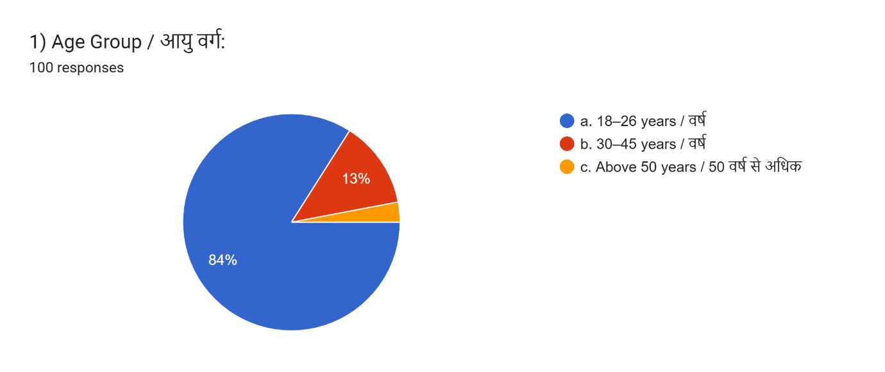Graph 1: Age Group of the Participants
Data gathered from the survey that 84% respondests were of age group of 18 -26, consume the news through the podcast. Which is higher in all the age groups.
- 18 to 26 years: 84%
- 30 to 45 years: 13%
- Above 50 years: 3%
The data shows that young adults are the primary consumers of video podcasts. The high percentage (84%) of participants aged 18 to 26 indicates that this group is most comfortable with digital media platforms like YouTube and Instagram. Older age groups (30 to 45 and 50+) engage significantly less, highlighting a digital generation gap. This suggests that video podcast journalism largely appeals to younger audiences who prefer mobile-friendly, on-demand content.

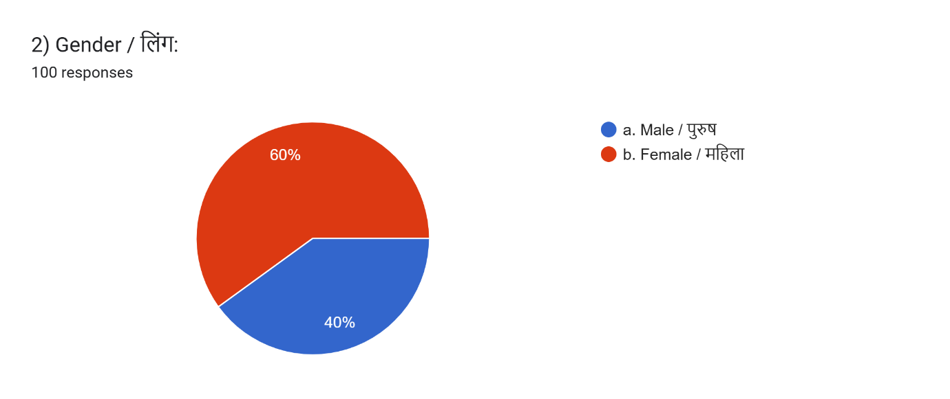
Graph 2: Gender of the Participants
Data gathered from the survey that 60% respondents’ were of gender Female, consume the news through the podcast. Which is higher in both the gender.
- Male: 40%
- Female: 60%
More women than men participated. This indicates that women are more actively consuming and engaging with video podcast content or are more willing to take part in media research. This also suggests a change in consumption patterns, as earlier studies often showed male dominance in digital news engagement.

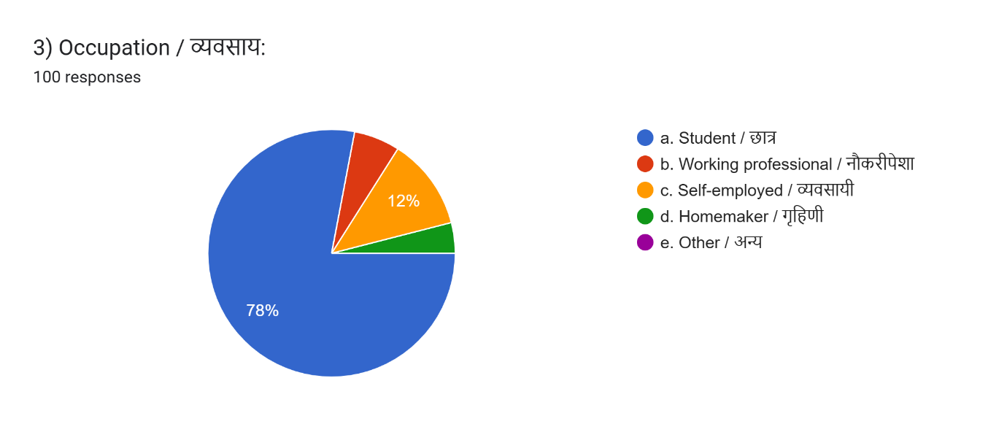
Graph 3: Occupation of the Participants
Data gathered from the survey that 78% respondents were Occupation is students, consume news through the podcast. Which is higher in all the occupations.
  - Students: 78%
  - Working professionals: 6%
  - Self-employed: 12%
  - Homemakers: 4%
  - Others: 0%
A large majority of respondents were students, consistent with the age data. This suggests that video podcasts are becoming a primary news source for young learners and college communities. The small percentage of working professionals (6%) implies that adults might prefer traditional news or quicker formats like short articles or TV updates.
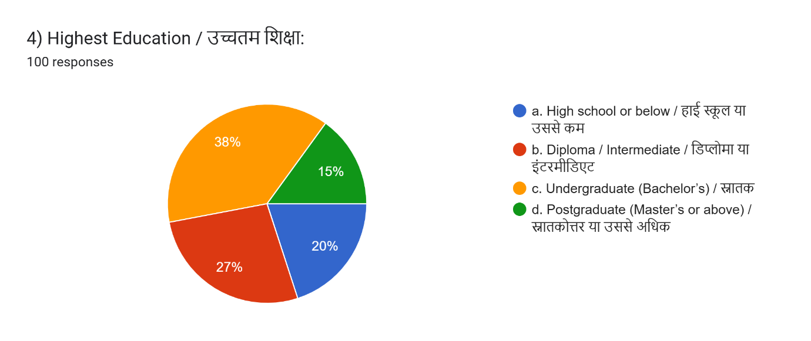
Graph 4: Highest Education of the Participants
Data gathered from the survey that 38% respondents were of Highest Education of Undergraduate (Bachelor’s), consume news through the podcast. Which is higher in all the occupations.
- High school or below: 20%
- Diploma/Intermediate: 27%
- Undergraduate: 38%
- Postgraduate: 15%
Most respondents (38%) were undergraduate students, indicating that somewhat educated individuals make up the main audience for video podcasts. Only 15% of postgraduates shows that video podcast consumption is not limited to highly educated individuals, making podcasts accessible to a broader audience.
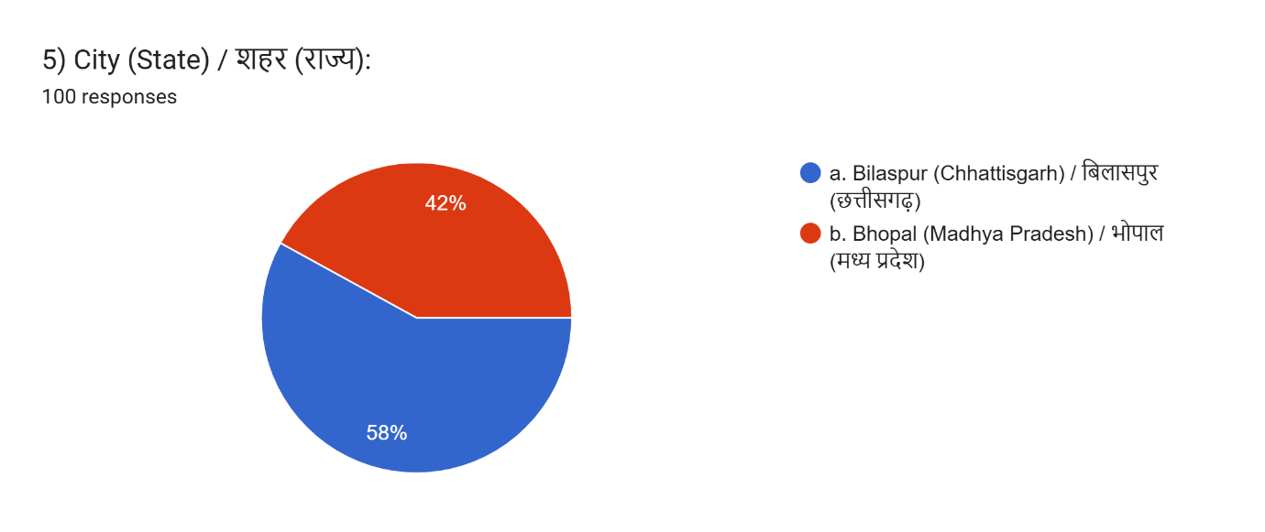Graph 5: City(state) of the Participants
Data gathered from the survey that 58% respondents were of City(State) of Bilaspur (Chhattisgarh), consume news through the podcast. Which is higher in both the cities.
- Bilaspur (CG): 58%
- Bhopal (MP): 42%
The responses reflect a good mix of Tier-II and Tier-III urban populations. This indicates that interest in video podcasts is not limited to major cities, but is growing in smaller ones as well.

Section B – Viewing habits
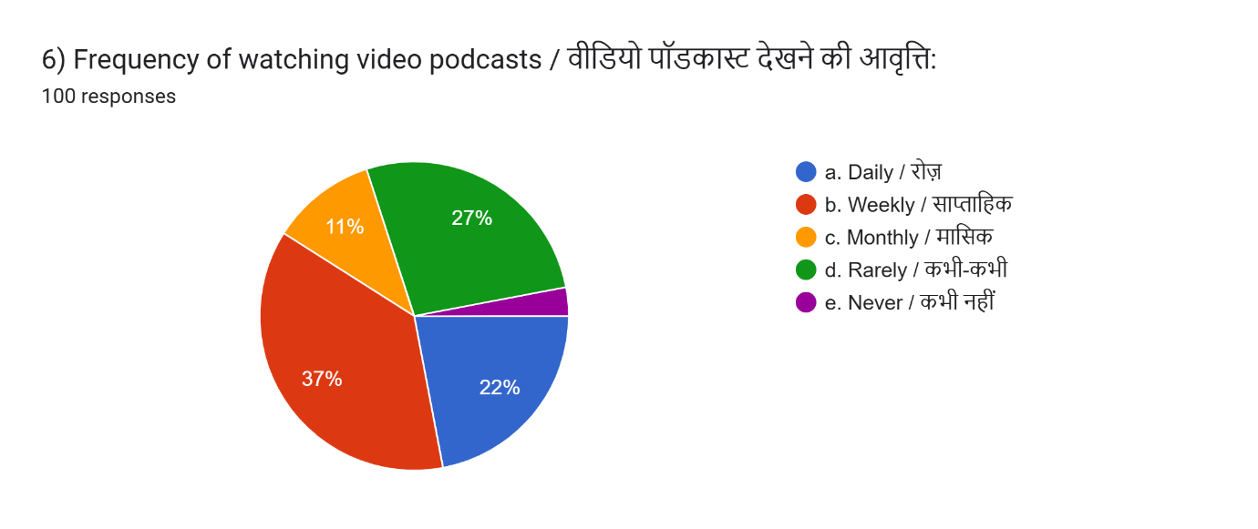
Graph 6: Frequency of watching video podcast of the Participants
Data gathered from the survey that 37% respondents were of Frequency of watching video podcasts is weekly, consume news through the podcast. Which is higher in all the frequencies.
- Daily: 22%
- Weekly: 37%
- Monthly: 11%
- Rarely: 27%
- Never: 3%
Weekly viewers form the largest group (37%), showing that video podcasts are steadily becoming a regular news source. Daily viewers (22%) are highly engaged. Rare viewers (27%) suggest that a significant number still use podcasts occasionally. Only 3% never consume podcasts, confirming that awareness of video podcasts is widespread.
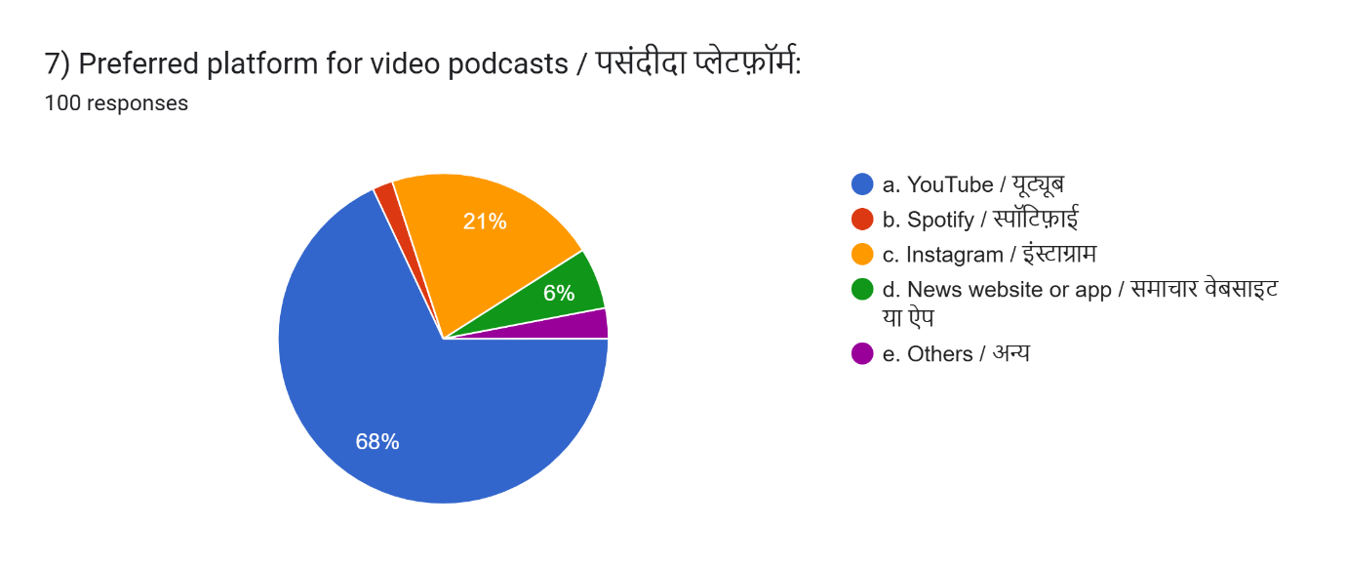
Graph 7: Preferred platforms for video podcasts
Data gathered from the survey that 68% respondents were of preferred platform for video podcast is Youtube, consume news through the podcast. Which is higher in all the platforms.
- YouTube: 68%
- Spotify: 2%
- Instagram: 21%
- News website/app: 6%
- Others: 3%
YouTube is the leading platform for video podcasts, mainly due to its accessibility, visual format, and wide usage in India. The 21% choosing Instagram indicates that short-form video podcasts or clips (Reels, IGTV) are gaining popularity. Very few people use Spotify for video podcasts.
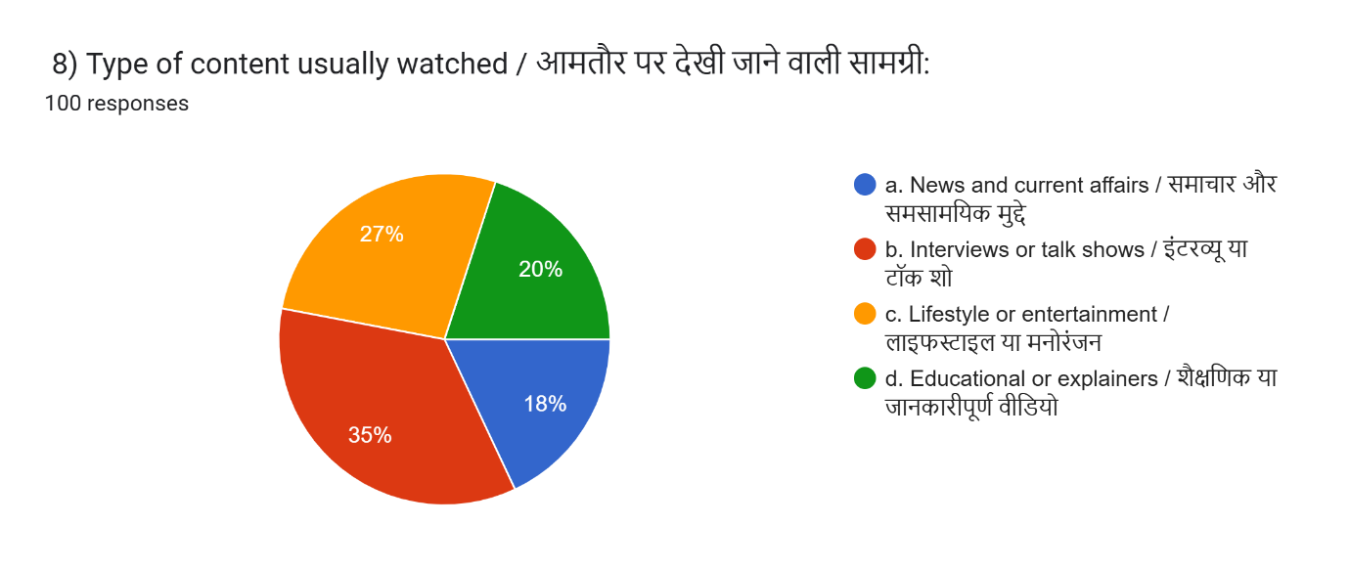
Graph 8: Types of content usually watched
Data gathered from the survey that 35% respondents were of what type of content usually watched is Interview or talk shows, consume news through the podcast. Which is higher in all the content watched.
- Interviews/Talk Shows: 35%
- Lifestyle/Entertainment: 27%
- Educational/Explainers: 20%
- News & Current Affairs: 18%
The most preferred content is interviews and talk shows, showing that audiences favor conversational formats. Surprisingly, news/current affairs ranks lowest (18%), suggesting that audiences prefer discussion-based or narrative styles instead of traditional news reading.
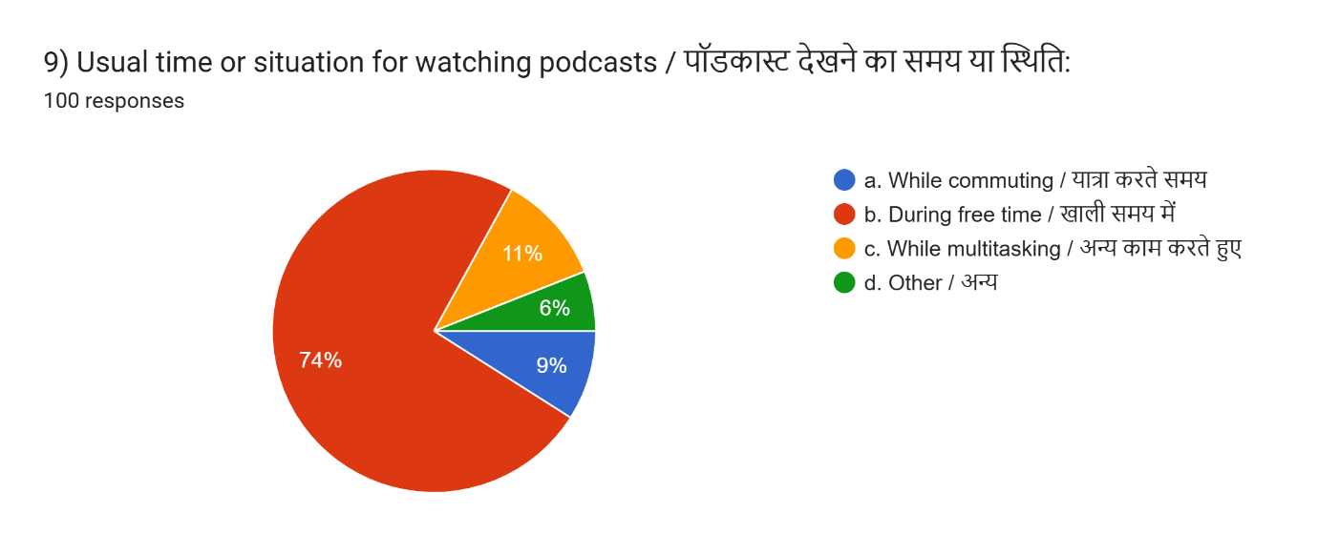
Graph 9: Time or situations for watching podcasts
Data gathered from the survey that 74% respondents were of what time or situation for watching podcasts, consume news through the podcast. Which is higher in all the time or situation.
- During free time: 74%
- While travelling: 9%
- While multitasking: 11%
- Other times: 6%
This shows that watching video podcasts is mainly a leisure activity, not a hurried or stressful media experience. People like to view podcasts during relaxed moments to absorb information at their own pace.
Section C - Perception and Engagement
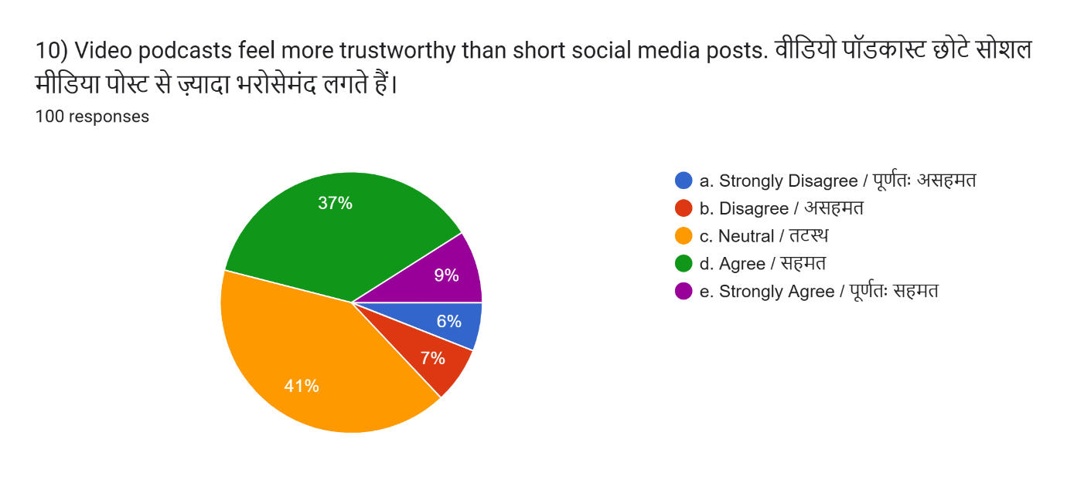
Graph 10: Video podcast is more trustworthy than short social media posts.
Data gathered from the survey that 41% respondents were of Video podcast is more trustworthy than short social media posts is neutral, consume news through the podcast. Which is higher in trusted.
- Agree: 37%
- Strongly Agree: 9%
- Neutral: 41%
- Disagree: 7%
- Strongly Disagree: 6%
Almost half (46%) see video podcasts as more trustworthy than social media posts. A large neutral group (41%) indicates that many viewers are still forming opinions on podcast credibility. This suggests that video podcasts have moderate but increasing trust levels.
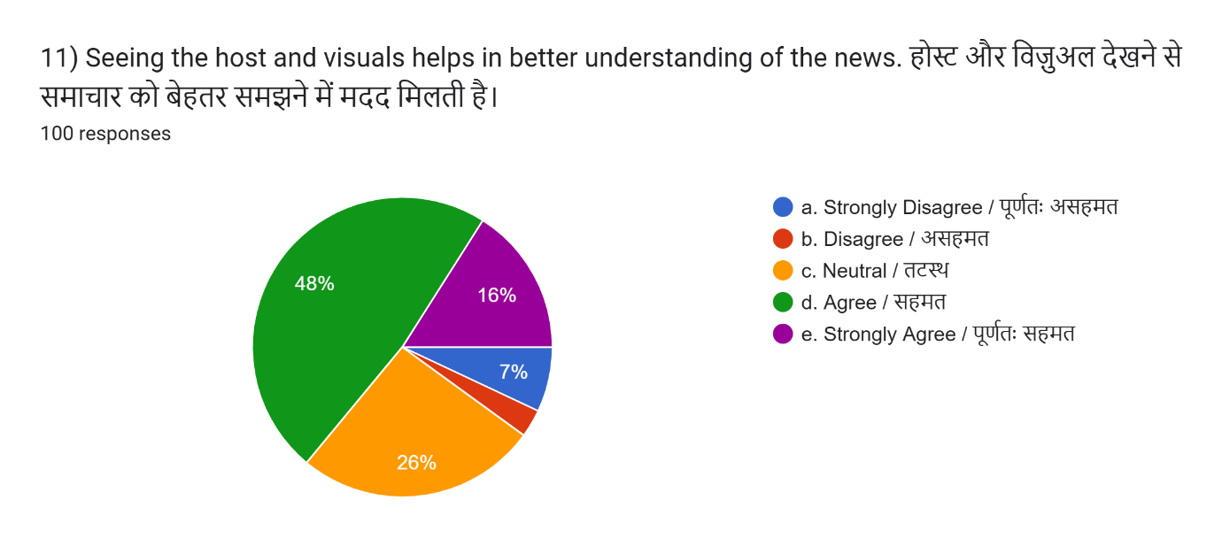
Graph 11: Visuals make news easier to understand
Data gathered from the survey that 48% respondents were of visuals that makes news easier to understand is agree, consume news through the podcast. Which is higher in trusted.
- Agree: 48%
- Strongly Agree: 16%
- Neutral: 26%
- Disagree: 3%
- Strongly Disagree: 7%
A strong majority (64%) believe that visuals help them understand news better. This supports the idea that combining visuals with audio improves comprehension.
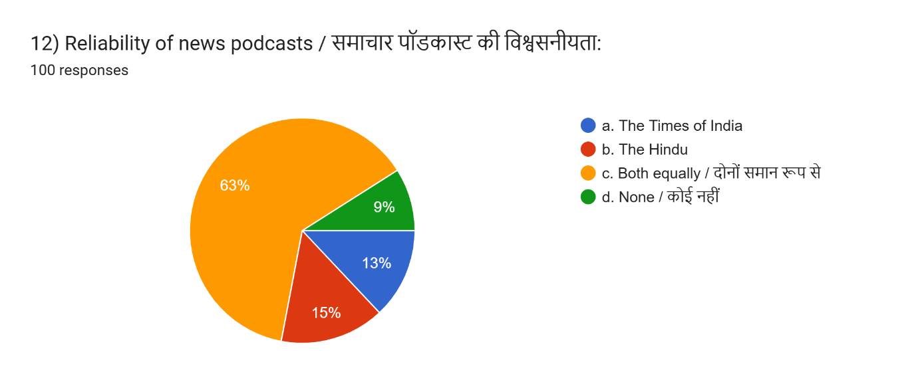
Graph 12: Reliability of news podcasts
Data gathered from the survey that 63% respondents were reliable in both (The Times of India and The Hindu), consume news through the podcast. Which is higher in reliability.
- Both equally reliable: 63%
- The Hindu: 15%
- TOI: 13%
- None: 9%
Most respondents feel both newspapers are equally reliable in video podcast journalism. The Hindu slightly leads over TOI in preference, but the difference is minimal.
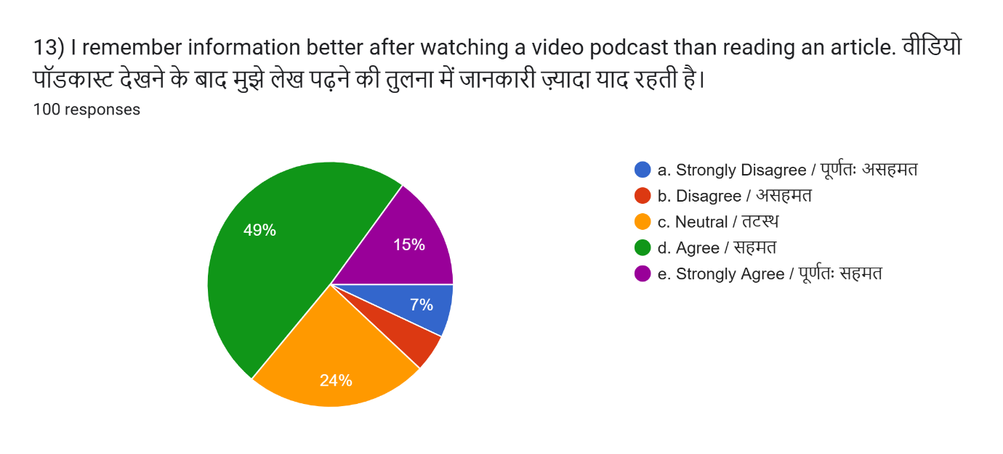
Graph 13: Video podcasts help people remember news better than articles.
Data gathered from the survey that 49% respondents were is video podcast help people remember news better than articles is agree , consume news through the podcast. Which is higher in remembering.
- Agree: 49%
- Strongly Agree: 15%
- Neutral: 24%
- Disagree: 5%
- Strongly Disagree: 7%
A total of 64% say they remember information better through video podcasts. This shows that video podcasts are more memorable than written articles.
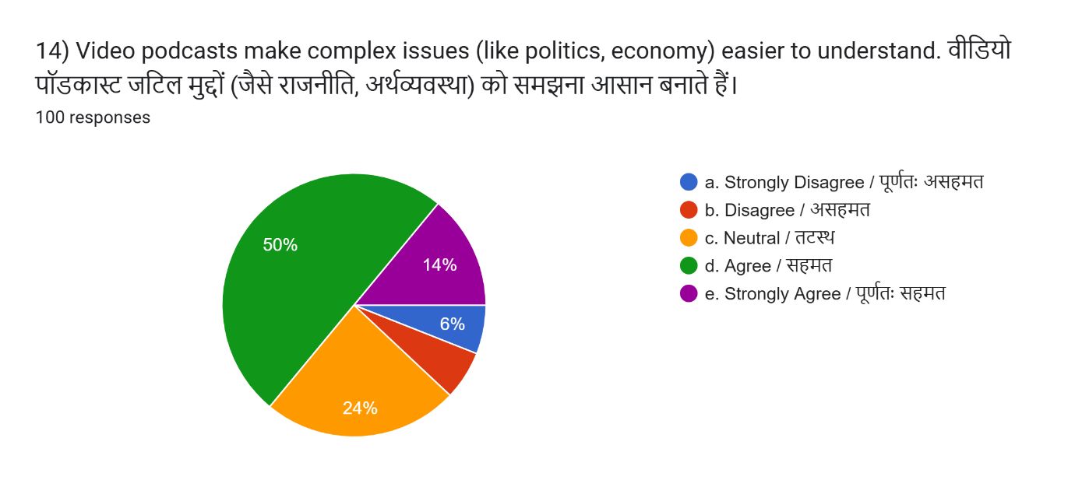
Graph 14: Is video podcast simplify complex issues
Data gathered from the survey that 50% respondents is video podcast simplify complex issues is agree , consume news through the podcast. Which is higher in simplify complex issues.
Agree: 50%
b. Strongly Agree: 24%
c. Neutral: 24%
d. Disagree: 6%
e. Strongly Disagree: 6%
A significant 74% feel that video podcasts make complex topics easier to understand. This proves that video podcasts serve as effective educational tools.

Section D – Impact and Feedback
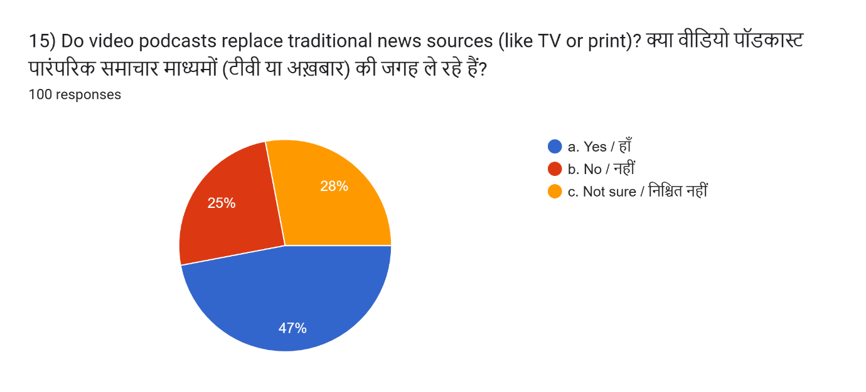
Graph 15: Do video podcasts replace traditional news, like TV or print?
Data gathered from the survey that 47% respondents is video podcast replace traditional news like TV or print is Yes , consume news through the podcast. Which is higher in replacement of traditional media.
- Yes: 47%
- No: 25%
- Not sure: 28%
Almost half the respondents think video podcasts are replacing TV and print news. This shows a strong ongoing shift toward digital video journalism, especially among youth.
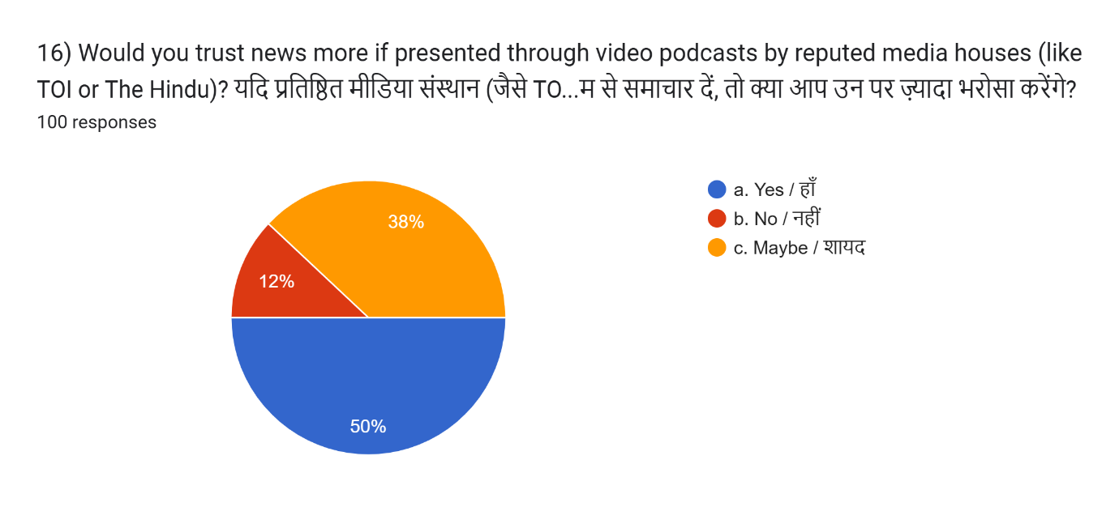
Graph 16: Is news more trusted in video podcasts from TOI or The Hindu
Data gathered from the survey that 50% respondents is news more trusted from TOI or The Hindu is Yes , consume news through the podcast. Which is higher in news more trusted in video podcast.
- Yes: 50%
- Maybe: 38%
- No: 12%
Half of the respondents trust news more when delivered through podcasts by established brands like TOI or The Hindu. This highlights the importance of institutional credibility in digital news.

Data Analysis of Qualitative Data
Sno. | Headline of the Story | Date | Duration | Source | Beat
1 | Is there a right to take offence | 20-02-2025 | 37:55 | The Hindu | Crime
2 | Red Fort Blast Reality: Who Pressed The Button For Op Sindoor ‘Retaliation’ | 21-11-2025 | 01:06:40 | The Times of India | Crime
3 | Cannes Film Festival 2025: Rewind | 28-05-2025 | 41:26 | The Hindu | Entertainment
4 | Why does everything looks same ? | 11-06-2025 | 23:46 | The Hindu | Entertainment
5 | Lifting India's Hopes: The Unfiltered Story of Mirabai Chanu | 24-06-2025 | 43:38 | The Times of India | Entertainment
6 | From Assam to the Olympics: Lovlina Borgohain’s Inspiring Journey | 27-08-2025 | 44:06 | The Times of India | Entertainment

Chapter 5: Results, Conclusion, and Discussion
5.1 Results and Findings
The data collected from surveys and log sheets were analyzed to understand how audiences view podcast journalism and how newspapers create news content using podcasts. The findings are split into two parts: Quantitative (Audience Survey) and Qualitative (Podcast Log Sheet Analysis).
- Quantitative Findings
This chapter presents the detailed results of a survey conducted with 100 respondents from Bilaspur (Chhattisgarh) and Bhopal (Madhya Pradesh). The aim was to understand how people consume, trust, and engage with video podcast journalism, specifically podcasts produced by The Times of India and The Hindu. The results analyze demographic characteristics, viewing habits, perception, engagement, and trust patterns.
B. Qualitative Findings (Log Sheet – 06 Podcast Episodes)
06video podcasts were reviewed (2 crime and 4 entertainment):
Crime Podcasts
The Hindu
- Adopts a calm, analytical, discussion-based format.
- Emphasizes context, legal reasoning, and impartial reporting.
- Uses minimal visuals; maintains a factual and neutral tone.

The Times of India
- Employs dramatic, investigative storytelling for high engagement.
- Includes B-roll, timelines, strong narration, and emotional pacing.
- Focuses on action, suspense, and connecting with viewers.
- Entertainment Podcasts

Entertainment Podcast
The Hindu
- Addresses entertainment as culture and artistic analysis.
- The tone is intellectual and reflective.
- Visuals are subtle and informative.

The Times of India
- Uses human-interest storytelling, emotional journeys, and motivational themes.
- Features strong visuals, cinematic editing, and background music.
- Aims at broad and youth-friendly audiences..

5.2 Discussion
The results show that podcast journalism is becoming a popular form of digital storytelling, especially among younger urban audiences. It successfully combines the strengths of traditional journalism, such as credibility and accuracy, with modern digital appeal, including flexibility, emotion and engagement.
1. Changing News Consumption Habits:
The study highlights that people, especially younger audiences, prefer short, engaging, and visual news formats. Podcasts fit this lifestyle well, as they can be consumed anytime and anywhere.
2. Rise of Video Podcasts:
The growing interest in video podcasts shows that audiences want a mix of visual cues and vocal expressions. This helps build trust and a connection between the host and the listener.
3. Trust and Authenticity:
Unlike social media, podcasts are often hosted by journalists or credible speakers, which creates authenticity. Listeners value hearing the human voice behind the news rather than just reading headlines.
4. News Role of Newspapers:
Traditional newspapers like The Times of India and The Hindu are effectively using podcasts to expand their reach and connect with digital audiences. They maintain their journalistic values while adapting to new technology.
5. Challenges and Future Needs:
Although popular, podcasts still face challenges like regional language diversity, promotion, and limited awareness in rural areas. To grow further, news organizations should create more localized content and promote podcasts across multiple platforms.
5.3 Conclusion
This research concludes that audio-video podcasts have become an influential and rapidly growing form of digital journalism in India. They offer a mix of information and entertainment, helping audiences stay informed conveniently. From the quantitative analysis, it is evident that most listeners are young, tech-savvy, and open to new ways of consuming news. The qualitative analysis shows that newspapers like The Hindu and The Times of India are innovating by using podcasts as a storytelling tool, each in their own unique way. Overall, the study found that:
• Podcasts are trusted, accessible, and effective in spreading awareness.
• They boost audience engagement through conversational delivery.
• They create opportunities for modern journalism, combining creativity with credibility.
In the future, podcast journalism is likely to grow quickly as internet access and mobile use increase. With better promotion, local language versions, and visual appeal, audio-video podcasts can become one of the most powerful tools for communication in modern media.

Biblography / References
- R. (2016). Podcasting: Considering the evolution of the medium and its association with the word ‘radio’. The Radio Journal – International Studies in Broadcast & Audio Media, 14(1), 7–22. https://doi.org/10.1386/rjao.14.1.7_1
- Bonini, T. (2015). The ‘Second Age’ of podcasting: Reframing podcasting as a new digital mass medium. Quaderns del CAC, 41(18), 21–30.
- Kumar, S., & Patel, R. (2023). Digital storytelling and the rise of podcasts in Indian journalism. Media Studies Journal of India, 5(2), 45–58.
- Llinares, D., Fox, N., & Berry, R. (Eds.). (2018). Podcasting: New aural cultures and digital media. Palgrave Macmillan.
- Markman, K. M. (2012). Doing radio, making friends, and having fun: Exploring the motivations of independent audio podcasters. New Media & Society, 14(4), 547–565. https://doi.org/10.1177/1461444811420848
- McHugh, S. (2016). How podcasting is changing journalism. The Conversation. Retrieved from https://theconversation.com
- Perks, L. G., & Turner, J. S. (2019). Podcasts and personal identity: Listening as an act of self-creation. Radio Journal: International Studies in Broadcast & Audio Media, 17(1), 23–40.
- Pew Research Center. (2023). Podcast listening continues to grow in the U.S. and globally. Retrieved from https://www.pewresearch.org
- Sharma, N. (2022). Podcast journalism in India: Issues of regulation and accountability. Indian Journal of Communication Studies, 12(3), 65–78.
- Spinelli, M., & Dann, L. (2019). Podcasting: The audio media revolution. Bloomsbury Academic.
- The Hindu. (2024). The Hindu podcasts – News analysis and insights. Retrieved from https://www.thehindu.com/podcasts
- The Times of India. (2024). TOI podcasts – Latest news, daily briefings, and interviews. Retrieved from https://timesofindia.indiatimes.com/podcasts

