1.Created A Table  
**Employees Table** Requirements:

● Employee ID: Unique identifier for each employee.

Data Type: NUMBER

Constraints: PRIMARY KEY, Auto-generated (using IDENTITY)

● First Name: First name of the employee.

Data Type: VARCHAR2(50)

Constraints: NOT NULL

● Last Name: Last name of the employee.

Data Type: VARCHAR2(50)

Constraints: NOT NULL

● Email: Email address of the employee.

Data Type: VARCHAR2(100)

Constraints: NOT NULL, UNIQUE

● Phone Number: Phone number of the employee.

Data Type: VARCHAR2(15)

● Hire Date: Date the employee was hired.

Data Type: DATE

Constraints: must be after 2000-01-01.

● Depart ID: Identifier for the department the employee belongs to.

Data Type: NUMBER

Constraints: FOREIGN KEY (references Departs table)

● Created Timestamp: Date the row was created.

Data Type: DATE

● Updated Timestamp: Date the row was updated.

Data Type: DATE

**Departs** Table Requirements:

● Depart ID: Unique identifier for each department.

Data Type: NUMBER

Constraints: PRIMARY KEY, Auto-generated (using IDENTITY)

● Depart Name: Name of the department.

Data Type: VARCHAR2(50)

Constraints: NOT NULL

● Location: Location of the department.

Data Type: VARCHAR2(50)

● Province: Location of the department.

Data Type: VARCHAR2(50)

Default value: ON

Constraints: must be in ‘ON’, ‘BC’, ‘QC, ‘AB’, ‘MB’, ‘NB’.

● Created Timestamp: Date the row was created.

Data Type: DATE

● Updated Timestamp: Date the row was updated.

Data Type: DATE

**Compensation History** Table Requirements:

● Comp ID: Unique identifier for each compensation record.

Data Type: NUMBER

Constraints: PRIMARY KEY, Auto-generated (using IDENTITY)

● Employee ID: Identifier for the employee.

Data Type: NUMBER

Constraints: FOREIGN KEY (references Employees table)

● Compensation Date: Date of the compensation record.

Data Type: DATE

Constraints: NOT NULL

● Salary: Salary amount.

Data Type: NUMBER(10, 2)

Constraints: NOT NULL, must be a positive number.

● Bonus: Bonus amount.

Data Type: NUMBER(10, 2)

Constraints: must be smaller than salary.

● Created Timestamp: Date the row was created.

Data Type: DATE

● Updated Timestamp: Date the row was updated.

Data Type: DATE

**Cash Rewards** Table Requirements:

● Reward ID: Unique identifier for each cash reward.

Data Type: NUMBER

Constraints: PRIMARY KEY, Auto-generated (using IDENTITY)

● Employee ID: Identifier for the employee.

Data Type: NUMBER

Constraints: FOREIGN KEY (references Employees table)

● Reward Date: Date the reward was given.

Data Type: DATE

Constraints: NOT NULL

● Reward Amount: Amount of the reward.

Data Type: NUMBER(10, 2)

Constraints: NOT NULL

● Created Timestamp: Date the row was created.

Data Type: DATE

● Updated Timestamp: Date the row was updated.

Data Type: DATE

**Additional Requirements:**● **Relationships**:

○ Foreign key relationship between Employees table and Departs table on the Depart ID field.

○ Foreign key relationship between Compensation History table and Employees table on the Employee ID field.

○ Foreign key relationship between Cash Rewards table and Employees table on the Employee ID field.

● **Indexes**:

○ Indexes on Employee ID in the Compensation History and Cash Rewards tables to improve query performance.

● Constraints:

○ Ensure referential integrity between Employees, Departs, Compensation History, and Cash Rewards tables.

2.Insert a data into the Table

3. Rename the Hire Date column from HireDate to Hire_Date on the Employees table.

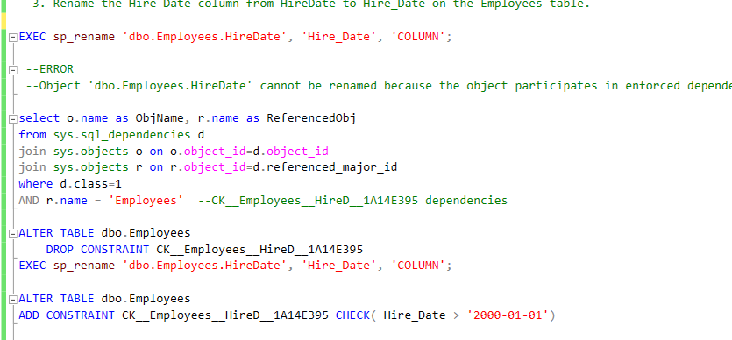

4. Write a SQL statement to add a new attribute (home_phone_number) to the Employees

Column has a fixed size of 10 digits

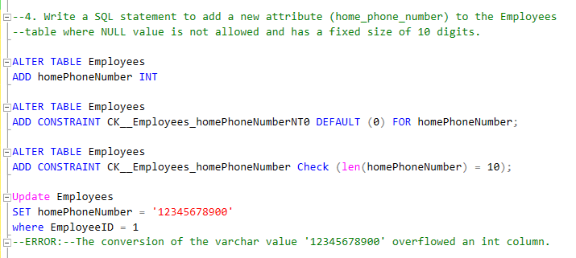

5. Write a SQL statement to update at least one employee's department to IT(feel free to

decide which employee or all employees). Don't forget to update the updated timestamp.

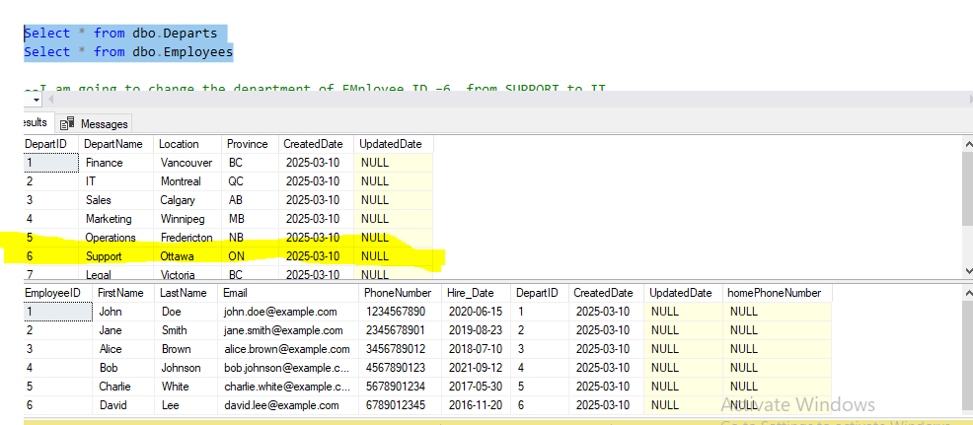

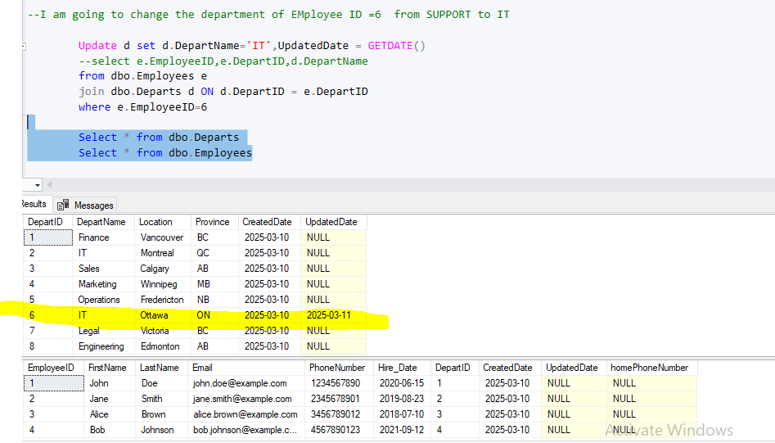

6. Write a SQL statement to double the salary of all employees in the 'IT' department and

add extra 8000 to the bonus. Don't forget to update the updated timestamp.

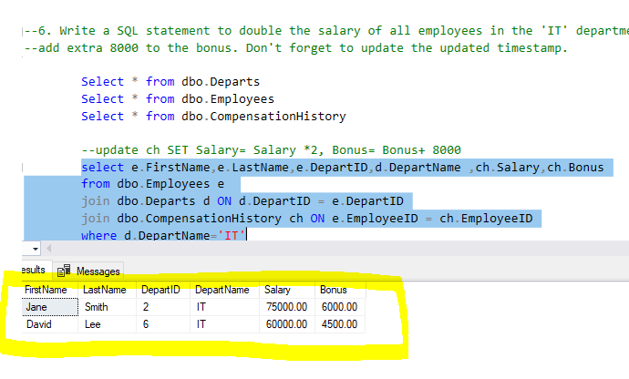

7. Write a SQL statement to find all employee id(without duplicated employee ids) who

have received one time cash rewards greater than 1000. 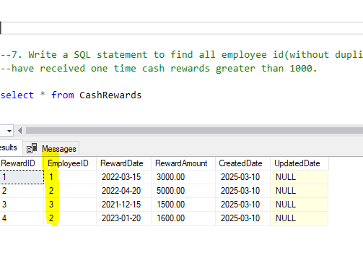

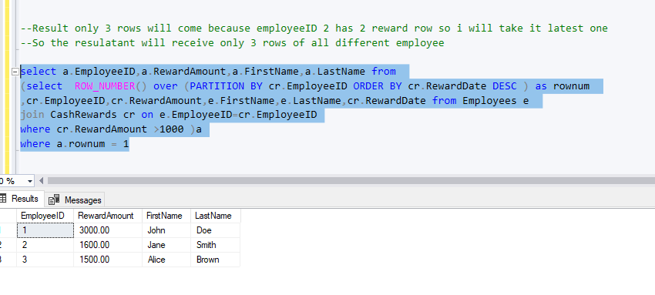

8. Write a SQL statement to find all employees who have a phone number and belong to

the 'IT' department.

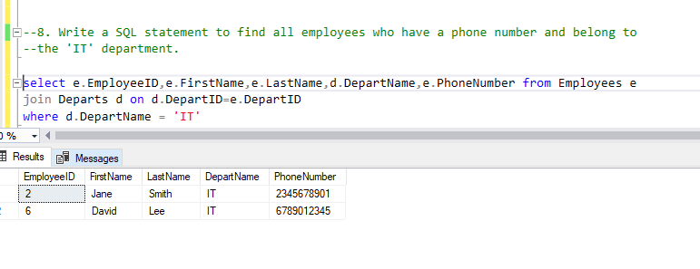

9. Write an SQL query to delete the compensation records with a bonus less than 8000.

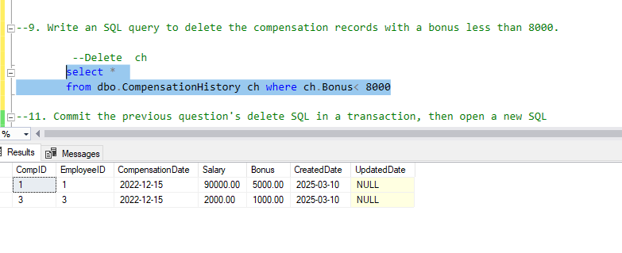

10. Write a SQL query to find the highest compensation

(salary + bonus) for each department and order the results by the total compensation in

descending order.

