**HR Analytics Dashboard  
Report view**

* Slicer (Job Role wise)
* Single card
  + - Total Employee
    - Attrition Count
    - Attrition Rate percentage wise
    - Average Age
    - Average Income
    - Average year Count
* Donut Chart (Attrition by Education)
* Stacked Column Chart (Attrition and Ager group)
* Matrix Chart Job Role VS Job Satisfaction
* Clustered Bar Chart (Attrition Vs Salary Slab)
* Area Chart for the Attrition Vs Age
* Clustered Bar Chart(Job Role Vs Attrition)

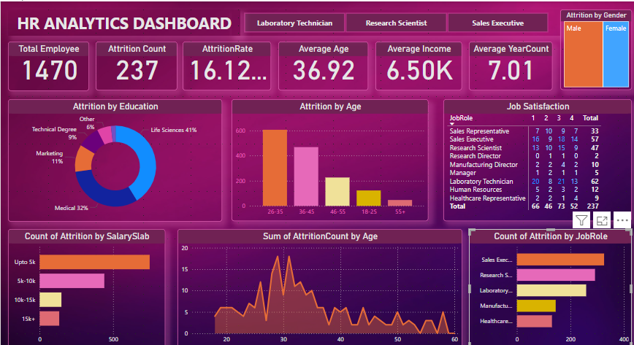  
**Model View**  
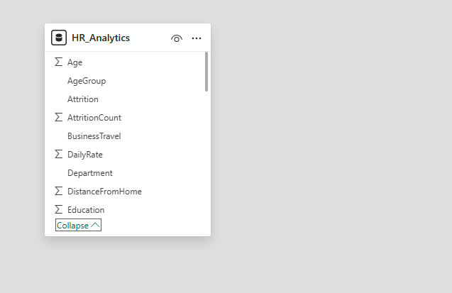  
**Table View**  
  
