**LAKSHIT MANISH SANGHRAJKA**

**Employee No. – 200764**

**Unix Assignment**

Task – 1

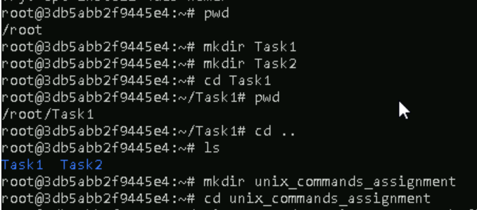

Task – 2

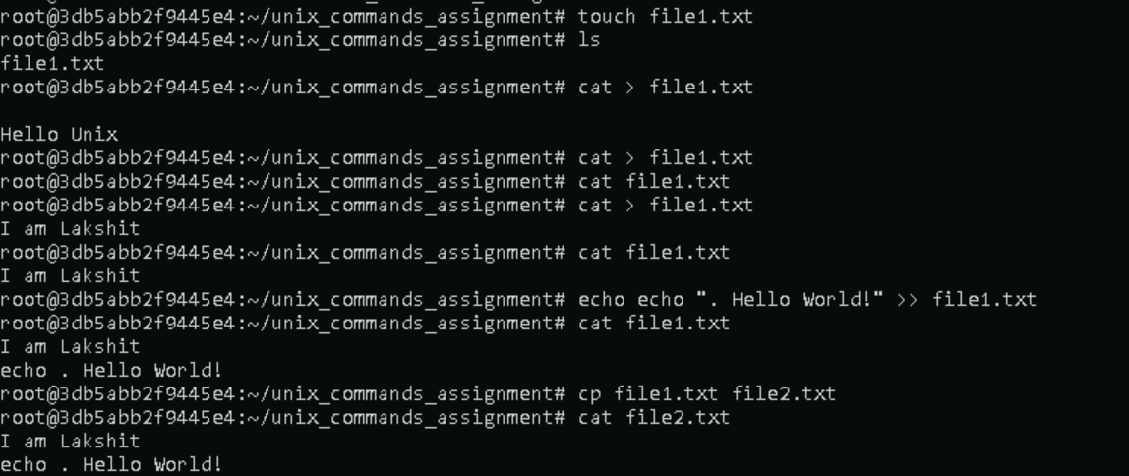

Task – 3

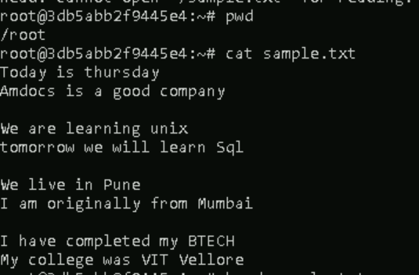

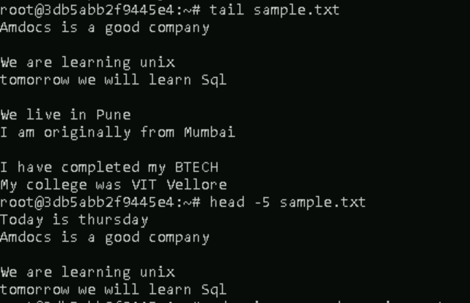

Task – 4

I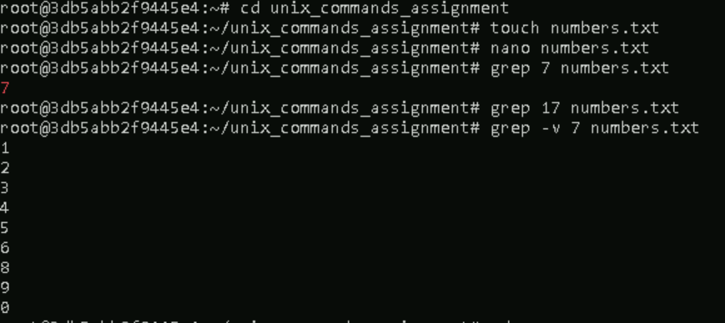

Task – 5



Important commands used in these tasks

touch filename/dir using touch command we can create new dir/folder

cat > filename (Allows u to write content inside the file after u r done typing data go to next line and press ctrl+d to save)

cat filename to show the content of the file

cp file1 file2 (copies the content of file1 to file2 if file not present creates a new file)

cp file1 file2 file3 new (copies the file 1 2 and 3 to the directory mentioned if directory not presents creates a new one)

Using nano text editor

nano filename

enter whatever text u want

click on ctrl+O and press enter to save

Click ctrl+X to exit

Working with text files

grep datatobesearched filename

grep -v data filename(here all things except the line with the data mentioned is displayed)

wc is used to count the words

head -5 filename(To show the first 5 lines of the file if the file is not present in pwd then give the filepath with filename)

tail -5 filename(To show the last 5 lines of the file if the file is not present in pwd then give the filepath with filename)

sudo nano filename to make the file with admin permissions

if we dont want to use sudo then after creating a file we can do chmod +x filename to give it various permissions

redirection examples

ls > filename (Appends the output of ls to the file)

echo "New Content" >> filename (Appends New Content to the file)