OBJECT ORIENTED PROGRAMMING
MINI PROJECT

Name: Lakshita Jain Roll No.:16014224038 Batch: A2
Name: Samruddhi Jain Roll No.:16014224039 Batch: A2
Name: Kshitij Gupta Roll No.:16014224031 Batch: A2

TOPIC: Local Train Tracker System

PROBLEM STATEMENT: In metropolitan cities like Mumbai, local trains are the primary mode of transportation for millions of commuters. However, passengers often face uncertainty regarding the real-time location, arrival time, delays, or cancellations of Local trains. This project aims to develop a Live Local Train Tracking Interface that provides real-time updates about train movements between stations.

CODE:
import pandas as pd
import tkinter as tk
from tkinter import ttk, messagebox

class TrainDataset:
def __init__(self, csv_file):
self.df = pd.read_csv(r"C:/Users/LAKSHITA/Downloads/local_train_live_status_extended.csv")

def get_train_data(self, train_number):
train_df = self.df[self.df["Train_Number"].astype(str) == str(train_number)]
if train_df.empty:
raise ValueError(f"Train number {train_number} not found in dataset!")
return train_df

class Train:
def __init__(self, train_number, dataset):
self.df = dataset.get_train_data(train_number)
self.number = self.df["Train_Number"].iloc[0]
self.name = self.df["Train_Name"].iloc[0]
self.current_station = self.df["Current_Station"].iloc[0]
self.next_station = self.df["Next_Station"].iloc[0]
self.distance = self.df["Distance_Between_Stations_km"].iloc[0]
self.time_to_next = self.df["Time_To_Reach_Next_min"].iloc[0]
self.delay = self.df["Delay_Minutes"].iloc[0]
self.expected_arrival = self.df["Expected_Arrival_CSMT"].iloc[0]
self.status = self.df["Status"].iloc[0]
self.last_updated = self.df["Last_Updated"].iloc[0]

def get_summary(self):
return (
f" Train Number: {self.number}\n"
f"Train Name: {self.name}\n"
f" Current Station: {self.current_station}\n"
f" Next Station: {self.next_station}\n"
f" Distance to Next: {self.distance} km\n"
f" Time to Reach Next: {self.time_to_next} min\n"
f" Delay: {self.delay} min\n"
f" Expected Arrival (CSMT): {self.expected_arrival}\n"
f" Status: {self.status}\n"
f" Last Updated: {self.last_updated}"
)

class TrainTrackerUI:
def __init__(self, root, dataset):
self.root = root
self.dataset = dataset
self.root.title("🚄 Train Tracking System")
self.root.geometry("700x500")
self.root.configure(bg="#0a192f")

title = tk.Label(
root,
text="Live Train Tracker",
font=("Segoe UI Semibold", 24, "bold"),
fg="#64ffda",
bg="#0a192f"
)
title.pack(pady=20)

frame = tk.Frame(root, bg="#112240", bd=2, relief="groove")
frame.pack(pady=10, ipadx=10, ipady=10)

tk.Label(
frame,
text="Enter Train Number:",
font=("Segoe UI", 12),
bg="#112240",
fg="#ffffff"
).grid(row=0, column=0, padx=10, pady=5)

self.train_entry = ttk.Entry(frame, width=25, font=("Segoe UI", 11))
self.train_entry.grid(row=0, column=1, padx=10, pady=5)

style = ttk.Style()
style.configure("TButton", font=("Segoe UI", 11, "bold"), padding=6)
style.map("TButton", background=[("active", "#64ffda")])

ttk.Button(
frame,
text="🔍 Track Train",
command=self.start_tracking
).grid(row=0, column=2, padx=10, pady=5)

self.output_box = tk.Text(
root,
height=13,
width=70,
bg="#0a192f",
fg="#d1d5db",
font=("Consolas", 11),
relief="solid",
borderwidth=1,
wrap="word"
)
self.output_box.pack(pady=20)

tk.Label(
root,
text="Developed in Python + Tkinter",
font=("Segoe UI", 9),
bg="#0a192f",
fg="#8892b0"
).pack(side="bottom", pady=10)

def start_tracking(self):
train_number = self.train_entry.get().strip()
if not train_number:
messagebox.showwarning("Input Error", "Please enter a Train Number!")
return

try:
train = Train(train_number, self.dataset)
self.output_box.delete(1.0, tk.END)
self.output_box.insert(tk.END, train.get_summary())
except ValueError as e:
messagebox.showerror("Train Not Found", str(e))

if __name__ == "__main__":
csv_path = "train_data.csv"
dataset = TrainDataset(csv_path)

root = tk.Tk()
app = TrainTrackerUI(root, dataset)
root.mainloop()

OUTPUT:
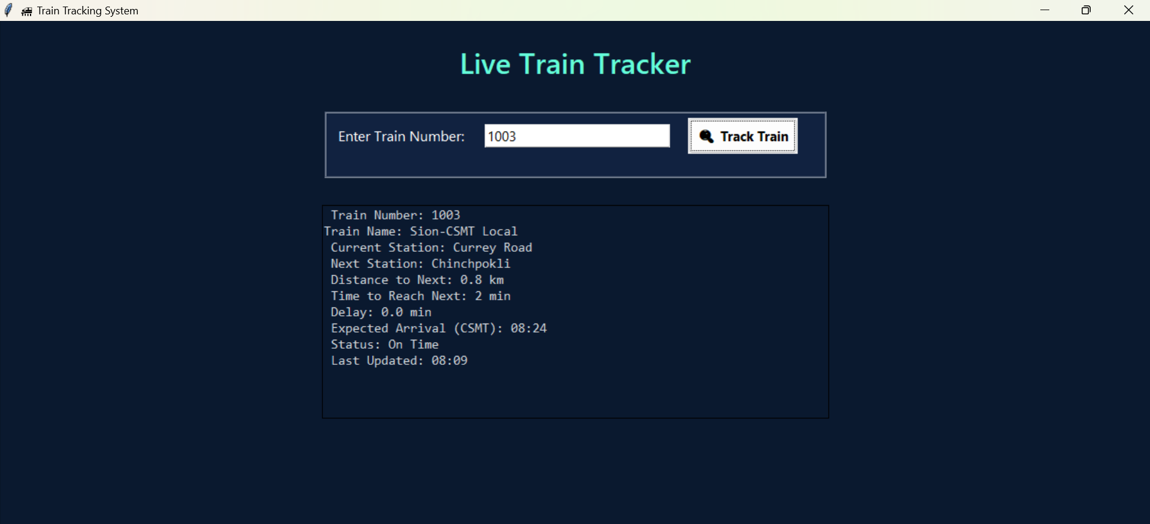

FUTURE ENHANCEMENTS:
Integrate real-time API data from railway servers.

Add voice announcements (e.g., “Train number 12345 is arriving at Dadar in 3 minutes”).

Include maps or visual route indicators using folium or Tkinter Canvas.

Enable push notifications for delays or cancellations.

OUTCOME:
The project successfully provides a real-time simulation of train tracking using a local dataset.
It demonstrates how Python, Pandas, and Tkinter can be combined to build an interactive, data-driven desktop application with a clean and responsive user interface.

