SIMATS ENGINEERING
C Programming - CO1 (Unit 1)
ASSIGNMENT
Design, Implement and Validate a Reliable Billing Program for a Rural Electricity Co-operative
Grama Jyothi Rural Electricity Co-operative
Item | Details
Student name | Lakshitha Kirubakaran
Register number | 1912260564
Course / Slot | C Programming (CSA02) - CO1
Submission date | 26/10/2026
Compiler | GCC 13.3.0 (Ubuntu 13.3.0-6ubuntu2~24.04.1), x86-64 Linux

Environment and build commands
Item | Value
Operating system | Ubuntu 24.04 (x86-64), bash
Compiler | gcc (Ubuntu 13.3.0-6ubuntu2~24.04.1) 13.3.0
Standard compile command | gcc -Wall -Wextra -o <name> <name>.c (add -lm only where math.h is used, -O2 only for timing programs)
Data model on this system | char 8, short 16, int 32, long 64, long long 64 bits (LP64)
Test harness | python3 run_tests.py runs Task 9 and Task 12 cases and compares actual output with the expected value
Screenshots | python3 make_screenshots.py re-runs every program and renders the real terminal output as the PNG files in each TaskNN/screenshots folder

Every program in this report was compiled with -Wall -Wextra and produced no warnings unless the warning was the point of the experiment (Tasks 6, 7 and 8 show those on purpose). All numbers, timings and screenshots were produced by running the programs on the machine described above; timings vary a little between runs, so the ranges of several runs are quoted where relevant.

Scenario summary used throughout
- About 4,000 households per village are billed monthly; a taluk has 60,000 and a district 800,000.
- Tariff: Rs 50 fixed charge; first 100 units free; units 101-200 at Rs 2.25; units above 200 at Rs 4.50.
- Meter register is 16-bit: it rolls over from 65535 to 0.
- Defects to remove: bills wrong by a few paise (floating point), negative bills at roll-over, tariff typed in many places.

Repository layout
Folder structure
CSA02-<RegNo>-Assignment1/
README.md student details, compiler, commands, result notes
run_tests.py make_screenshots.py oracle (Task12)
Task01/ ... Task12/ C source, input files, screenshots/ (PNG + raw .txt output)
diagrams/ UML diagrams used in the report

Task 1 - Understand the Problem and Identify the Data (K4, 4 marks)

1.1 Problem analysis
The program converts two meter readings per household into a bill. Everything the program needs falls into four groups: values that come in (inputs), values the program computes (outputs), values that never change during a run (constants) and rules that every correct bill must obey. The three defects described in the scenario each map to a weakness in this data model: paise errors come from storing money as a fractional number, negative bills from ignoring the 16-bit roll-over, and the half-applied tariff revision from typing the tariff in many places instead of defining it once.
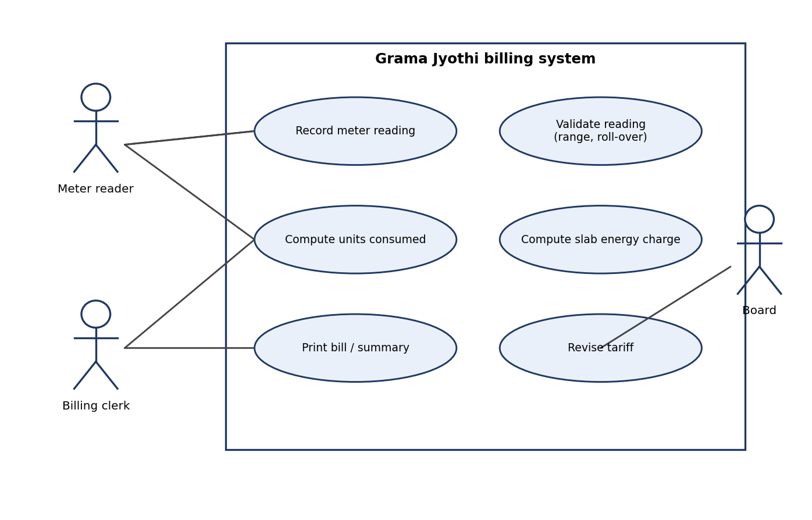
Figure 1.1: UML use-case diagram of the billing system

1.2 Data items and justification
Data item | Role | Properties (sign / fraction / size) | Justification
Household number | input | positive integer, up to 800,000 in a district | An identifier, never used in arithmetic; whole number, never negative.
Category | input | single letter, e.g. D = domestic | One character is enough. Assumption A1: all households use the same slab tariff.
Previous reading | input | 0 .. 65535, whole | Value shown on a 5-digit, 16-bit register. Negative or larger values are invalid.
Current reading | input | 0 .. 65535, whole | Can be smaller than previous after a roll-over (65535 to 0).
Units consumed | output | 0 .. 65535 by the register; realistic maximum about 10,000 a month | Computed as (current - previous) modulo 65536. The raw difference can be negative; the corrected value never is.
Energy charge | output | fractional in rupees (Rs 2.25 per unit); whole in paise | Store as paise so that no fraction exists. One bill can reach about Rs 45,000 = 4,500,000 paise.
Fixed charge | output / constant | Rs 50 = 5000 paise | Charged even for zero units (Assumption A6).
Total bill | output | never negative | total = energy + fixed. District total is about 3.3 x 10^10 paise - larger than a 32-bit int.
Running total (taluk / district) | output | large | Needs a 64-bit integer (measured in Task 10).

1.3 Constants (never change during a run)
- Slab limits: 100 and 200 units.
- Rates: 0, 225 and 450 paise per unit.
- Fixed charge: 5000 paise.
- Register limits: maximum reading 65535 and modulus 65536.
- Largest plausible monthly consumption (10,000 units) used to tell a genuine roll-over from a wrong reading.
- Paise per rupee: 100 (used for printing).

1.4 Rules every correct bill must satisfy
Rule | Statement | How it is checked
R1 | A bill is never negative. | Units are computed modulo 65536 (unsigned); all rates are non-negative.
R2 | total = energy charge + fixed charge. | Test table in Task 9 shows all three columns for every bill.
R3 | units = (current - previous) mod 65536, and 0 <= reading <= 65535. | Range test and roll-over tests in Task 9.
R4 | The bill never decreases when units increase (monotonic) and has no jump at 100 and 200 units. | Boundary tests 100/101 and 200/201 in Task 9.
R5 | Money is exact to the paise: no rounding in the sum of the bills. | Integer paise arithmetic; compared with float in Tasks 2, 7 and 10.
R6 | A tariff revision is made in one place only. | Single set of constants (Task 3); configuration file (Tasks 11-12).

1.5 Assumptions
- A1 One category with one tariff; the category letter is stored but not used for pricing.
- A2 The meter register has 5 decimal digits and is 16-bit: it rolls over at most once per billing period.
- A3 A monthly consumption above 10,000 units is not credible, so a current reading below the previous one is accepted as a roll-over only when the wrapped difference is at most 10,000 units; otherwise the line is rejected.
- A4 Rates are whole numbers of paise per unit.
- A5 One bill per household per month, from one line of input.
- A6 The fixed charge applies to every connection, including zero consumption.

1.6 Alternative concept: readings stored as text
If a reading were kept as the string "01530" instead of an integer, the program would store char reading[6] (5 digits plus the terminating \0). Two operations are then needed: comparison (equal-length digit strings can be compared with strcmp, which is correct for numeric order only because of the leading zeros) and subtraction, which needs a conversion first. Converting costs one multiply-and-add per digit, so it is O(d); the integer subtraction is O(1). Space per reading is d + 1 bytes for text and 2 bytes for unsigned short (8 bytes for the 64-bit integer used in the experiment).
Task01/alt_text_readings.c (2,000,000 readings per test)
/* Task 1 - Alternative concept: meter readings stored as text vs integers.
Measures conversion/compare time for d-digit readings and space per reading. */
#include <stdio.h>
#include <stdlib.h>
#include <string.h>
#include <time.h>

#define N 2000000

static double now(void)
{
struct timespec t;
clock_gettime(CLOCK_MONOTONIC, &t);
return (double)t.tv_sec + (double)t.tv_nsec * 1e-9;
}

/* O(d): one multiply-add per digit */
static unsigned long long parse(const char *s)
{
unsigned long long v = 0;
while (*s) v = v * 10 + (unsigned)(*s++ - '0');
return v;
}

int main(void)
{
int digits[] = {5, 10, 18};
printf("%-3s %-14s %-14s %-16s %-16s %-16s\n", "d", "int bytes", "text bytes",
"int diff ns", "text parse+diff ns", "text strcmp ns");
for (int k = 0; k < 3; k++) {
int d = digits[k];
unsigned long long mod = 1;
for (int i = 0; i < d; i++) mod *= 10;
unsigned long long *iv = malloc(sizeof *iv * N);
char *tv = malloc((size_t)N * (size_t)(d + 1));
for (int i = 0; i < N; i++) {
iv[i] = ((unsigned long long)i * 7919ULL + 13ULL) % mod;
snprintf(tv + (size_t)i * (size_t)(d + 1), (size_t)d + 1, "%0*llu", d, iv[i]);
}
volatile unsigned long long sink = 0;
unsigned long long acc = 0;

double t0 = now();
for (int i = 1; i < N; i++) acc += (iv[i] - iv[i - 1]) % mod;
double t1 = now();
sink = acc; acc = 0;

double t2 = now();
for (int i = 1; i < N; i++) {
unsigned long long a = parse(tv + (size_t)(i - 1) * (size_t)(d + 1));
unsigned long long b = parse(tv + (size_t)i * (size_t)(d + 1));
acc += (b - a) % mod;
}
double t3 = now();
sink = acc; acc = 0;

double t4 = now();
for (int i = 1; i < N; i++)
acc += (unsigned)(strcmp(tv + (size_t)(i - 1) * (size_t)(d + 1),
tv + (size_t)i * (size_t)(d + 1)) > 0);
double t5 = now();
sink = acc; (void)sink;

printf("%-3d %-14zu %-14d %-16.2f %-16.2f %-16.2f\n", d, sizeof(unsigned long long), d + 1,
(t1 - t0) / N * 1e9, (t3 - t2) / N * 1e9, (t5 - t4) / N * 1e9);
free(iv); free(tv);
}
printf("meter_t (unsigned short) needs only %zu bytes for a 5-digit reading.\n", sizeof(unsigned short));
return 0;
}

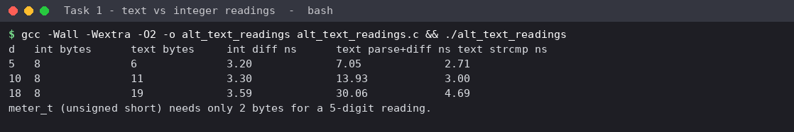
Figure 1.2: measured time and space - integer vs text readings
Digits d | Integer: subtract | Text: parse both + subtract | Text: strcmp only | Bytes: int / text
5 | 3.05 ns | 6.62 ns | 2.37 ns | 8 (2 as meter_t) / 6
10 | 3.11 ns | 13.44 ns | 2.98 ns | 8 / 11
18 | 3.05 ns | 19.62 ns | 3.49 ns | 8 / 19

Analysis. Integer subtraction stays at about 3 ns whatever the number of digits (O(1)). Parsing the text before subtracting grows almost linearly with d (6.6, 13.4 and 19.6 ns for d = 5, 10, 18), confirming O(d). Comparing strings alone is cheap, but a bill needs the *difference*, not only the order. Space is O(1) for the integer and O(d) for text; at 5 digits text costs 6 bytes against 2 bytes for unsigned short. Conclusion: keep readings as integers; text is useful only for input and display.
Evidence for Task 1: data-item table with justification, constants, six rules, six assumptions, UML use-case diagram, and a measured comparison of text vs integer readings.

Task 2 - Choose the Data Types (K4, 4 marks)

2.1 Sizes and ranges on this system
types_table.c prints sizeof and the limits from <limits.h> and <float.h>. The district check at the bottom uses the largest credible total: 800,000 bills of at most Rs 5,000.
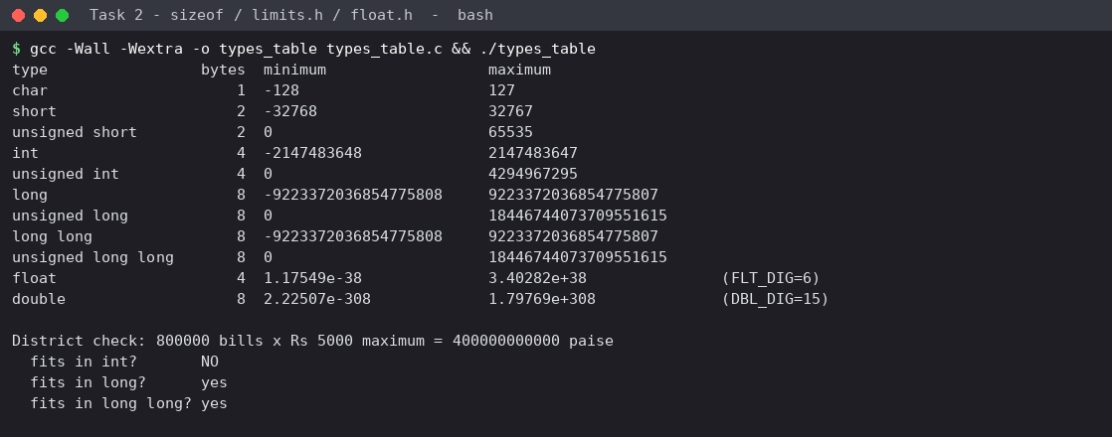
Figure 2.1: sizeof, limits.h and float.h values (gcc 13, x86-64)

2.2 Chosen data types
Data item | Type | Size | Range | Enough for a district?
Household number | int | 4 | -2,147,483,648 .. 2,147,483,647 | Yes: 800,000 << 2.1 x 10^9
Category | char | 1 | -128 .. 127 (a letter) | Yes
Meter reading | typedef unsigned short meter_t | 2 | 0 .. 65535 | Exactly the register size, so wrap-around matches the hardware
Units consumed | unsigned int | 4 | 0 .. 4,294,967,295 | Yes (units <= 65535)
Rate / charge / bill | long (paise) | 8 | +/- 9.22 x 10^18 | Yes: bill <= 4.5 x 10^6 paise
Taluk / district total | long long (paise) | 8 | +/- 9.22 x 10^18 | Yes: 4.0 x 10^11 paise needed, int (2.1 x 10^9) fails
Money as rupees | float / double - rejected | 4 / 8 | about 6 / 15 significant digits | No: most paise values are not exact in binary

long is 64 bits on this Linux system but only 32 bits on 64-bit Windows, so code that must also run there should use long long for district totals. This is discussed in Task 10.

2.3 Why money must not be float rupees
Binary floating point cannot represent most decimal fractions exactly (0.1, 0.07, 50.07 ...). Each addition adds a tiny representation error and, once the running total is large, the float cannot even represent the next paise. Storing paise in an integer removes the fraction, so every addition is exact until the type overflows - a failure that is loud and predictable rather than silent.
Task02/float_vs_paise.c
/* Task 2 - float rupees vs integer paise when 4000 bills are added */
#include <stdio.h>

int main(void)
{
const int n = 4000;
float total_f = 0.0f; /* wrong design: rupees in float */
double total_d = 0.0; /* alternative: rupees in double */
long total_p = 0; /* chosen design: paise in long */
for (int i = 0; i < n; i++) {
long bill_paise = 5000L + (i * 37L) % 9001L + 7L; /* e.g. 50.07 .. 140.07 */
total_p += bill_paise;
total_d += bill_paise / 100.0;
total_f += (float)(bill_paise / 100.0);
}
printf("Exact total (paise, long) : Rs %ld.%02ld\n", total_p / 100, total_p % 100);
printf("double rupees total : Rs %.6f error = %.6f\n", total_d, total_d - total_p / 100.0);
printf("float rupees total : Rs %.6f error = %.6f\n", (double)total_f, (double)total_f - total_p / 100.0);

float s = 0.0f;
for (int i = 0; i < 10; i++) s += 0.1f;
printf("\nSmall example: 0.1f added 10 times = %.9f (== 1.0 ? %s)\n", (double)s, s == 1.0f ? "yes" : "no");
return 0;
}

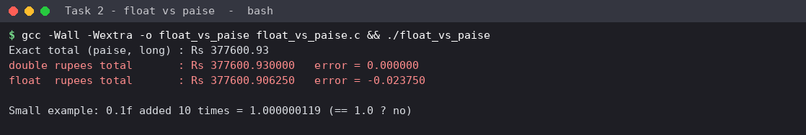
Figure 2.2: 4,000 bills added as float, double and integer paise
Result: The exact total is Rs 377,600.93. The float total is Rs 377,600.90625 - wrong by 2.4 paise (Rs 0.02375) after only 4,000 bills - while the long paise total is exact. Even 0.1f added ten times does not reach 1.0 (1.000000119).

2.4 What happens to a 16-bit register after 65535
A 16-bit unsigned counter holds 65535 = 2^16 - 1. Adding one more gives 65536, which needs 17 bits; the top bit is lost and the register shows 0. For a billing program this means the "current" reading can legitimately be smaller than the "previous" one. Ordinary subtraction then gives a negative number (the negative-bill defect in the spreadsheet).

2.5 Complete the Code - TODO 1 (without if-else)
Task02/task02_complete.c (only TODO 1 was replaced)
#include <stdio.h>
#include <limits.h>

/* The meter register is a 16-bit counter: after 65535 it rolls over to 0. */
typedef unsigned short meter_t;

unsigned int consumption(meter_t previous, meter_t current)
{
// TODO 1: Return the units consumed, correct even when the register has rolled over
// (current < previous); use unsigned 16-bit arithmetic instead of an if-else
return (meter_t)(current - previous);
}

int main(void)
{
printf("sizeof(meter_t) = %zu bytes, maximum reading = %u\n",
sizeof(meter_t), (unsigned)USHRT_MAX);
printf("Consumption: %u units\n", consumption(1200, 1530));
printf("Consumption: %u units\n", consumption(65400, 120)); /* rolled over */
return 0;
}

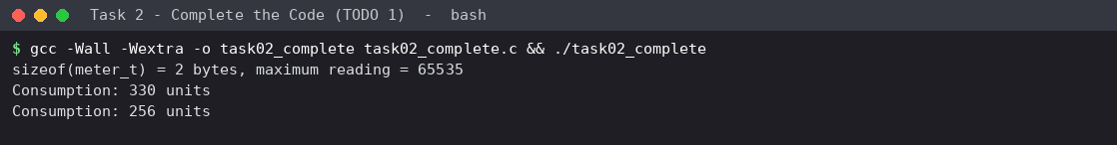
Figure 2.3: output of the completed program - identical to the expected output
Line | Expected | Actual | Result
1 | sizeof(meter_t) = 2 bytes, maximum reading = 65535 | sizeof(meter_t) = 2 bytes, maximum reading = 65535 | PASS
2 | Consumption: 330 units | Consumption: 330 units | PASS
3 | Consumption: 256 units | Consumption: 256 units | PASS

Why 256 and not a negative number. In current - previous both unsigned short operands are promoted to int, so the subtraction is 120 - 65400 = -65280. The cast (meter_t) converts this to unsigned short; C defines this conversion as reduction modulo 65536: -65280 + 65536 = 256. That is exactly the number of meter steps from 65400 up through 65535 and round to 120 (136 steps to reach 65536 = 0, plus 120). No if is needed because modular arithmetic is built into unsigned types.

2.6 Alternative concept: money as double rupees
With double rupees the bill function would compute 50.0 + (units-200)*4.50 + ... and every stored amount would be a binary approximation. To make the printed value correct the program would have to round to two decimals after each bill (round(x*100)/100) and still compare totals with a tolerance, never with ==. Time per addition is O(1) in both designs and space per value is 8 bytes for double and 8 bytes for long (4 bytes for float). The difference is in the error: integer paise has zero rounding error until overflow, while float rounding error accumulates with n. Measured in Task 7: with a revised tariff of Rs 2.27/4.53, the float total was off by Rs 0.02 (n=1,000), Rs 0.38 (4,000), Rs 14.34 (60,000) and Rs 305,381.90 (800,000), and double by less than Rs 0.00001 at every size - small but non-zero, so a bill reconciliation would still fail occasionally.
Evidence for Task 2: justified type table with sizes and ranges, an executed float-vs-paise failure, the roll-over explanation, and the completed TODO with output identical to the expected output.

Task 3 - Define the Constants (K3, 3 marks)

3.1 Kinds of constants and the choice made
Feature | `#define` | `const` variable | `enum`
Handled by | preprocessor (text replacement) | compiler | compiler
Type checking | none - the text 225 has no type | yes, e.g. const long | int only
Scope | from the definition to the end of the file (no block scope) | normal C scope rules | normal C scope rules
Storage | none (literal in the code) | may occupy memory and has an address | none
Debugger | name is not visible | name and value visible | name and value visible
Usable as array size / case label | yes | no in C (not a constant expression) | yes
Best used for | tariff values that must be one-place edits, header-shared limits | typed values such as a long rate | related whole-number sets (slab numbers, categories)

Naming convention: constants are written in UPPER_CASE with a unit suffix (RATE2_PAISE, FIXED_CHARGE_PAISE), so a reader knows the unit and cannot confuse rupees with paise. The slab limits are #defined once and all rates and limits are placed together at the top of the file, so a tariff revision is a one-place edit (rule R6).

3.2 Complete the Code - TODO 1
Pseudocode of the slab calculation:
Pseudocode
paise <- FIXED_CHARGE_PAISE
if units > SLAB2_UNITS: paise += (units - SLAB2_UNITS) * RATE3_PAISE
if units > SLAB1_UNITS: paise += (min(units, SLAB2_UNITS) - SLAB1_UNITS) * RATE2_PAISE
paise += min(units, SLAB1_UNITS) * RATE1_PAISE
return paise

Task03/task03_complete.c (only TODO 1 was replaced; macros unchanged)
#include <stdio.h>

#define SLAB1_UNITS 100 /* first 100 units */
#define SLAB2_UNITS 200 /* units 101 to 200 */
#define RATE1_PAISE 0 /* first slab is free */
#define RATE2_PAISE 225 /* Rs 2.25 per unit */
#define RATE3_PAISE 450 /* Rs 4.50 per unit above 200 */
#define FIXED_CHARGE_PAISE 5000L /* Rs 50 fixed charge */

/* Returns the bill in paise, so that no rounding error can occur. */
long compute_bill(int units)
{
long paise = FIXED_CHARGE_PAISE;
// TODO 1: Add the energy charge slab by slab using the macros: units above
// SLAB2_UNITS at RATE3_PAISE, units from SLAB1_UNITS+1 to SLAB2_UNITS at
// RATE2_PAISE, and the rest at RATE1_PAISE
if (units > SLAB2_UNITS)
paise += (long)(units - SLAB2_UNITS) * RATE3_PAISE;
if (units > SLAB1_UNITS) {
int in_slab2 = (units > SLAB2_UNITS ? SLAB2_UNITS : units) - SLAB1_UNITS;
paise += (long)in_slab2 * RATE2_PAISE;
}
paise += (long)(units > SLAB1_UNITS ? SLAB1_UNITS : units) * RATE1_PAISE;
return paise;
}

int main(void)
{
int tests[] = {0, 100, 150, 200, 350};
int n = sizeof tests / sizeof tests[0];
for (int i = 0; i < n; i++) {
long p = compute_bill(tests[i]);
printf("%3d units -> Rs %ld.%02ld\n", tests[i], p / 100, p % 100);
}
return 0;
}

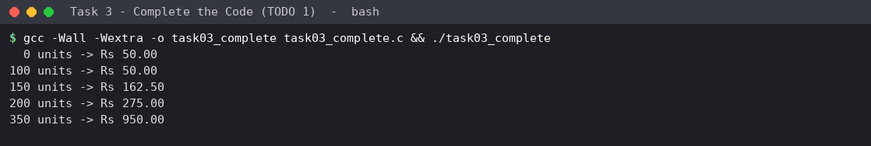
Figure 3.1: output of the completed program
Units | Hand calculation | Expected | Actual | Result
0 | 50.00 | Rs 50.00 | Rs 50.00 | PASS
100 | 50.00 + 0 | Rs 50.00 | Rs 50.00 | PASS
150 | 50 + 50 x 2.25 = 162.50 | Rs 162.50 | Rs 162.50 | PASS
200 | 50 + 100 x 2.25 = 275.00 | Rs 275.00 | Rs 275.00 | PASS
350 | 50 + 225 + 150 x 4.50 = 950.00 | Rs 950.00 | Rs 950.00 | PASS

3.3 Changing RATE2_PAISE to 230
Only the one #define line was edited (task03_rate230.c, created with sed). Every bill that includes slab 2 must rise by (units in slab 2) x 5 paise; bills at 0 and 100 units must not change.
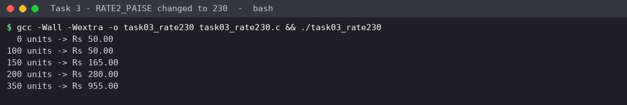
Figure 3.2: all bills after RATE2_PAISE = 230
Units | Slab-2 units | Expected change | Old bill | New bill | Consistent?
0 | 0 | 0.00 | 50.00 | 50.00 | PASS
100 | 0 | 0.00 | 50.00 | 50.00 | PASS
150 | 50 | +2.50 | 162.50 | 165.00 | PASS
200 | 100 | +5.00 | 275.00 | 280.00 | PASS
350 | 100 | +5.00 | 950.00 | 955.00 | PASS

3.4 Alternative concept: const variables and enum
task03_const_enum.c keeps the slab limits in an enum and the rates in static const long variables. The program logic does not change, but three things do: (1) the constants are typed (long), so RATE2_PAISE * units is evaluated in long without a cast; (2) they are visible in a debugger and have an address; (3) they may occupy memory.
Task03/task03_const_enum.c
/* Task 3 alternative: tariff held in const variables and an enum instead of #define */
#include <stdio.h>

enum { SLAB1_UNITS = 100, SLAB2_UNITS = 200 }; /* integer constants: enum */
static const long RATE1_PAISE = 0; /* typed constants: const long */
static const long RATE2_PAISE = 225;
static const long RATE3_PAISE = 450;
static const long FIXED_CHARGE_PAISE = 5000L;

long compute_bill(int units)
{
long paise = FIXED_CHARGE_PAISE;
if (units > SLAB2_UNITS) paise += (long)(units - SLAB2_UNITS) * RATE3_PAISE;
if (units > SLAB1_UNITS) {
int in_slab2 = (units > SLAB2_UNITS ? SLAB2_UNITS : units) - SLAB1_UNITS;
paise += (long)in_slab2 * RATE2_PAISE;

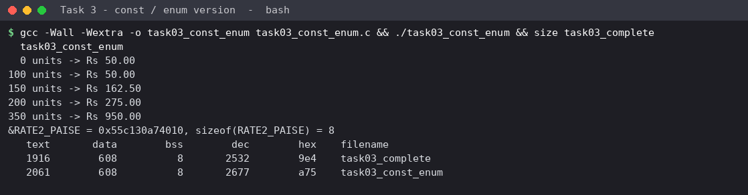
Figure 3.3: output of the const/enum version, with the size of both executables
Aspect | #define version | const + enum version | Comment
Type checking | none | yes | const gives the compiler a type to check
Debugger visibility | no names | names and values
.text size (measured) | 1,916 bytes | 2,061 bytes (+145) | at -O0 each use loads the const from memory
Symbol RATE2 in assembly (-O0) | 0 occurrences | 5 occurrences | the const exists as a variable
Time per bill | O(1) | O(1) | With optimisation gcc normally folds a static const initialised with a literal, so speed is expected to be the same (not separately measured).
Space | O(1), no storage | O(1), 8 bytes per const long (shown address 0x...010, sizeof = 8) | negligible

Evidence for Task 3: one named set of constants, completed TODO with output identical to the expected output, tariff change check, and a justified comparison of #define / const / enum with measurements.

Task 4 - Use Macros Safely (K4, 4 marks)

4.1 Macros written and the pitfalls
Task04/macros.c
/* Task 4 - writing macros safely and the classic pitfalls */
#include <stdio.h>

#define BAD_SQUARE(x) x * x /* no parentheses */
#define SQUARE(x) ((x) * (x)) /* fully parenthesised */
#define BAD_MAX(a, b) a > b ? a : b /* no parentheses */
#define MAX(a, b) ((a) > (b) ? (a) : (b)) /* safe against precedence, NOT against side effects */
#define RUPEES_TO_PAISE(r) ((long)(r) * 100L)

static inline int max_inline(int a, int b) { return a > b ? a : b; }
static inline int square_inline(int x) { return x * x; }

int main(void)
{
int a = 3;
printf("BAD_SQUARE(a+1) = %d (expected 16)\n", BAD_SQUARE(a + 1));
printf("SQUARE(a+1) = %d\n", SQUARE(a + 1));
printf("BAD_MAX(1, 0) + 10 = %d (expected 11)\n", BAD_MAX(1, 0) + 10);
printf("MAX(1, 0) + 10 = %d\n", MAX(1, 0) + 10);

int i = 5, j = 3;
int m = MAX(i++, j);
printf("MAX(i++, j): result = %d, i = %d (i++ expanded twice: i ends at 7, not 6)\n", m, i);

i = 5;
m = max_inline(i++, j);
printf("max_inline(i++, j): result = %d, i = %d (argument evaluated once)\n", m, i);

printf("RUPEES_TO_PAISE(162) = %ld paise\n", RUPEES_TO_PAISE(162));
printf("square_inline(a+1) = %d\n", square_inline(a + 1));
return 0;
}

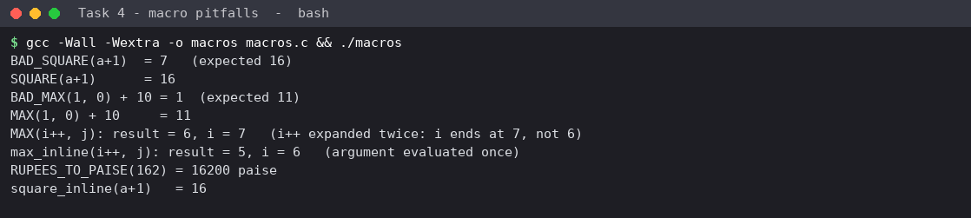
Figure 4.1: output showing each macro pitfall and its fix

4.2 How the preprocessor expands the macros (gcc -E)
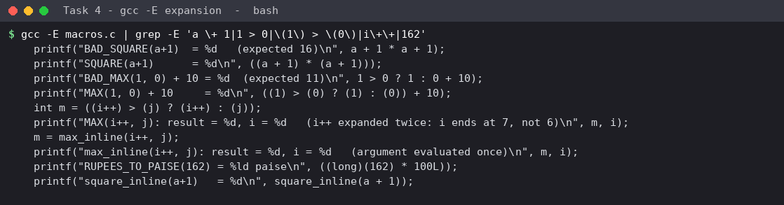
Figure 4.2: relevant lines of `gcc -E macros.c`
Pitfall | Macro as written | Expansion (from gcc -E) | Result | Fix
Missing parentheses around the argument | x * x | a + 1 * a + 1 | 7 instead of 16 | ((x) * (x))
Missing parentheses around the whole macro / operator precedence | a > b ? a : b, used as BAD_MAX(1,0) + 10 | 1 > 0 ? 1 : 0 + 10 | 1 instead of 11 (the + 10 joins the else branch) | ((a) > (b) ? (a) : (b))
Argument evaluated twice | MAX(i++, j) | ((i++) > (j) ? (i++) : (j)) | result 6, i = 7 (incremented twice) | use a function, or never pass expressions with side effects

When a function is better. Use a function when an argument may have side effects, when the operation is more than one expression, when type checking is wanted, or when the code is large. A macro is acceptable for a single, side-effect-free expression such as RUPEES_TO_PAISE(r) (((long)(r) * 100L)); the (long) cast makes the multiplication happen in 64 bits.

4.3 Alternative concept: static inline functions
static inline int max_inline(int a, int b) evaluates each argument once (max_inline(i++, j) returned 5 and left i = 6), checks types, and can be stepped in a debugger. Two further experiments measure its cost.
Task04/bench_macro_inline.c
/* Task 4 alternative: time per use of MAX/SQUARE as macro, static inline and real (non-inlined) call */
#include <stdio.h>
#include <time.h>

#define MAX(a, b) ((a) > (b) ? (a) : (b))
#define SQUARE(x) ((x) * (x))
static inline long max_inline(long a, long b) { return a > b ? a : b; }
static inline long sq_inline(long x) { return x * x; }
__attribute__((noinline)) long max_call(long a, long b) { return a > b ? a : b; }
__attribute__((noinline)) long sq_call(long x) { return x * x; }

static double now(void)
{
struct timespec t; clock_gettime(CLOCK_MONOTONIC, &t);
return (double)t.tv_sec + (double)t.tv_nsec * 1e-9;
}

#define LOOPS 300000000L

int main(void)
{
volatile long sink; long acc = 0, t;
double s;

s = now(); acc = 0;
for (t = 0; t < LOOPS; t++) acc += MAX(t & 1023, 512) + SQUARE(t & 7);
double tm = now() - s; sink = acc;

s = now(); acc = 0;
for (t = 0; t < LOOPS; t++) acc += max_inline(t & 1023, 512) + sq_inline(t & 7);
double ti = now() - s; sink = acc;

s = now(); acc = 0;
for (t = 0; t < LOOPS; t++) acc += max_call(t & 1023, 512) + sq_call(t & 7);
double tc = now() - s; sink = acc; (void)sink;

printf("%ld iterations (MAX + SQUARE per iteration), gcc -O2\n", LOOPS);
printf("macro : %.3f ns/iteration\n", tm / LOOPS * 1e9);
printf("static inline : %.3f ns/iteration\n", ti / LOOPS * 1e9);
printf("real function call: %.3f ns/iteration\n", tc / LOOPS * 1e9);
return 0;
}

Task04/code_size.sh (code size when the expression is used k times)
#!/bin/sh
# Task 4: code size (.text) when the MAX expression is used k times, at -O0
for k in 1 100 1000; do
for kind in macro func; do
f=use_${kind}_$k.c
{
echo '#define MAX(a,b) ((a) > (b) ? (a) : (b))'
echo 'static int max_f(int a, int b) { return a > b ? a : b; }'
echo 'int g(int *v) { int r = 0;'
i=0
while [ $i -lt $k ]; do
if [ $kind = macro ]; then echo " r += MAX(v[$((i%50))], v[$(((i+1)%50))]);"
else echo " r += max_f(v[$((i%50))], v[$(((i+1)%50))]);"; fi
i=$((i+1))
done
echo ' return r; }'
} > $f
gcc -O0 -c $f -o use_${kind}_$k.o
printf "k=%-5s %-6s .text = %s bytes\n" $k $kind "$(size use_${kind}_$k.o | awk 'NR==2{print $1}')"
done
done
rm -f use_*.c use_*.o

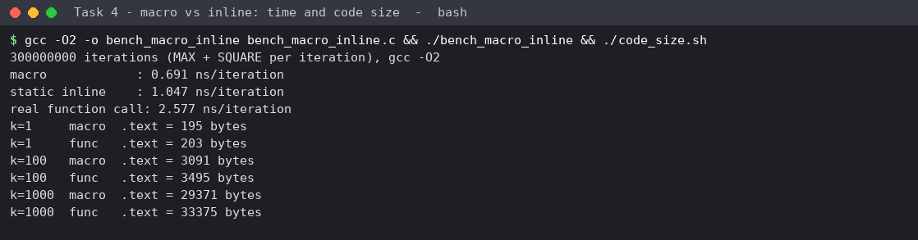
Figure 4.3: time per use (gcc -O2) and `.text` size for k uses (gcc -O0)
Metric | Macro | static inline | Real function call | Analysis
Time per iteration (MAX + SQUARE, -O2) | 0.69 - 0.83 ns | 1.05 - 1.24 ns | 2.5 ns | Both expansions are O(1). A real call costs about 1.7 ns extra. The small macro/inline gap (about 0.4 ns) is a code-generation effect of this loop; with -O2 gcc inlines the function so both are the same kind of code.
.text for k = 1 / 100 / 1000 uses (-O0) | 195 / 3,091 / 29,371 bytes | - | 203 / 3,495 / 33,375 bytes (call per use) | Space grows linearly with k, O(k), for both because each use site is copied or becomes a call; a macro or inlined function copies the body at every site.

Evidence for Task 4: three pitfalls shown with gcc -E expansions and fixed, plus a measured macro-vs-inline-vs-call comparison of time and code size.

Task 5 - Organise the Program with Header Files and Conditional Compilation (K3, 3 marks)

5.1 Structure of the program
A C program is organised, from top to bottom, as: (1) preprocessor lines - #include of header files and #define constants; (2) global declarations - type definitions, prototypes and global variables; (3) function definitions; (4) main(), where execution starts. In this task the constants, the Bill type and the prototypes were moved into tariff.h; the functions are in tariff.c; main5.c contains main().
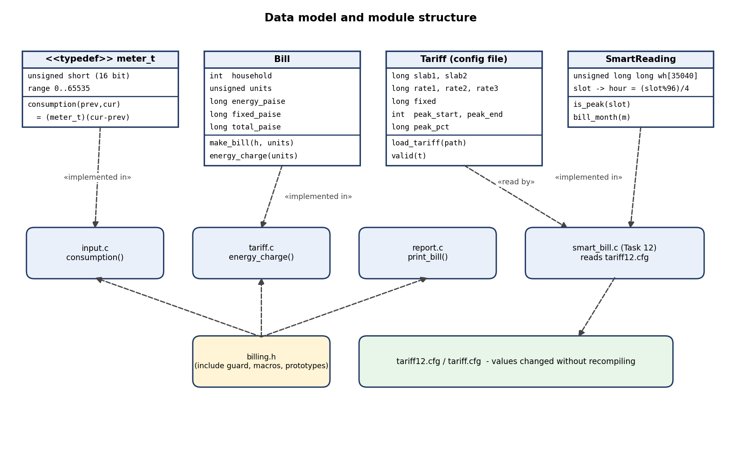
Figure 5.1: UML class and component diagram - data types and module structure (Tasks 2, 5, 8, 12)

5.2 Header file with include guard and DEBUG macro
Task05/tariff.h
#ifndef TARIFF_H /* include guard: the body is processed once per translation unit */
#define TARIFF_H

#define SLAB1_UNITS 100
#define SLAB2_UNITS 200
#define RATE1_PAISE 0
#define RATE2_PAISE 225
#define RATE3_PAISE 450
#define FIXED_CHARGE_PAISE 5000L

typedef struct { /* a type definition: a second inclusion without a guard is an error */
int household;
int units;
long energy_paise;
long fixed_paise;
long total_paise;
} Bill;

#ifdef DEBUG
#include <stdio.h>
#define DBG(...) fprintf(stderr, "[DEBUG] " __VA_ARGS__)
#else
#define DBG(...) ((void)0)
#endif

long compute_energy_charge(int units);
Bill make_bill(int household, int units);

#endif /* TARIFF_H */

Task05/tariff.c
#include "tariff.h"

long compute_energy_charge(int units)
{
long paise = 0;
int in2, in1;
in1 = units > SLAB1_UNITS ? SLAB1_UNITS : units;
in2 = (units > SLAB2_UNITS ? SLAB2_UNITS : units) - SLAB1_UNITS;
if (in2 < 0) in2 = 0;
paise += (long)in1 * RATE1_PAISE;
paise += (long)in2 * RATE2_PAISE;
if (units > SLAB2_UNITS) paise += (long)(units - SLAB2_UNITS) * RATE3_PAISE;
DBG("units=%d slab1=%d slab2=%d above=%d energy=%ld paise\n",
units, in1, in2, units > SLAB2_UNITS ? units - SLAB2_UNITS : 0, paise);
return paise;
}

Bill make_bill(int household, int units)
{
Bill b;
b.household = household;
b.units = units;
b.energy_paise = compute_energy_charge(units);
b.fixed_paise = FIXED_CHARGE_PAISE;
b.total_paise = b.energy_paise + b.fixed_paise;
DBG("household %d total=%ld paise\n", household, b.total_paise);
return b;
}

Task05/main5.c (includes tariff.h twice on purpose)
#include <stdio.h>
#include "tariff.h"
#include "tariff.h" /* second inclusion is harmless because of the include guard */

int main(void)
{
int units[] = {80, 150, 350};
for (int i = 0; i < 3; i++) {
Bill b = make_bill(1000 + i, units[i]);
printf("House %d: %3d units energy Rs %ld.%02ld fixed Rs %ld.%02ld total Rs %ld.%02ld\n",
b.household, b.units, b.energy_paise / 100, b.energy_paise % 100,
b.fixed_paise / 100, b.fixed_paise % 100, b.total_paise / 100, b.total_paise % 100);
}
return 0;
}

Why include guards are needed. A header can reach the compiler more than once (directly, and through another header). Definitions such as typedef struct {...} Bill; may appear only once in a translation unit. #ifndef TARIFF_H ... #define TARIFF_H ... #endif makes every inclusion after the first expand to nothing. The experiment below uses a copy of the header with the guard lines removed.
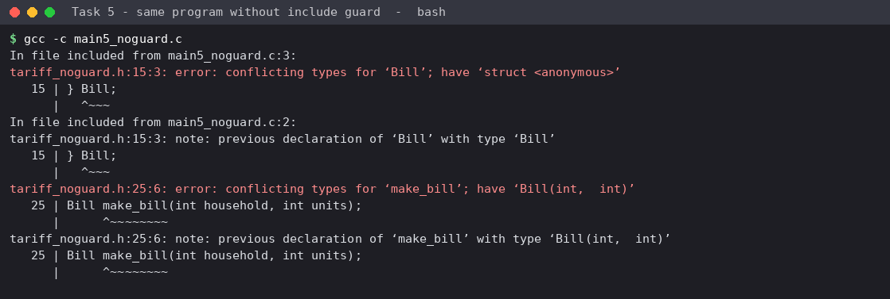
Figure 5.2: without the include guard the second #include gives "conflicting types" errors
`#include <file>` and `#include "file"`. The angle-bracket form searches only the system include directories and is used for standard headers (<stdio.h>). The quoted form searches the directory of the current source file first and then the system directories; it is used for the project's own headers such as "tariff.h".

5.3 Conditional compilation with #ifdef DEBUG
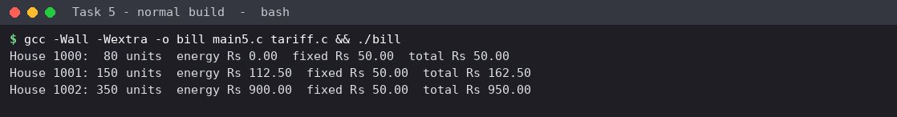
Figure 5.3: normal build, `gcc -Wall -Wextra -o bill main5.c tariff.c` - no debug output
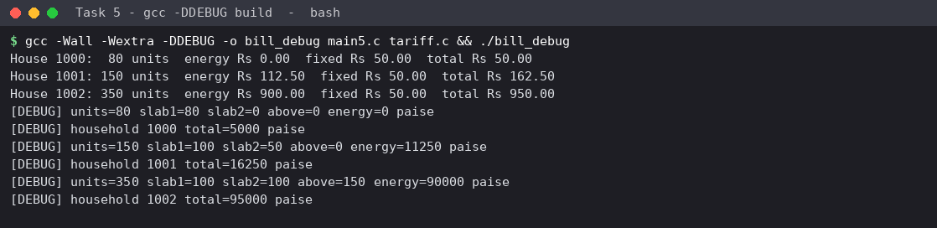
Figure 5.4: `gcc -DDEBUG` build - the intermediate slab values appear on stderr
With -DDEBUG the macro DBG(...) expands to an fprintf; without it, to ((void)0), so the debugging code does not exist in the normal executable at all. The bill lines (stdout) are identical in both builds.

5.4 Alternative concept: run-time debug flag
tariff_rt.c replaces the macro by if (g_debug) fprintf(...); debugging can then be switched on without recompiling (for example by a command-line option), but the test is executed on every call and the debug code remains in the executable.
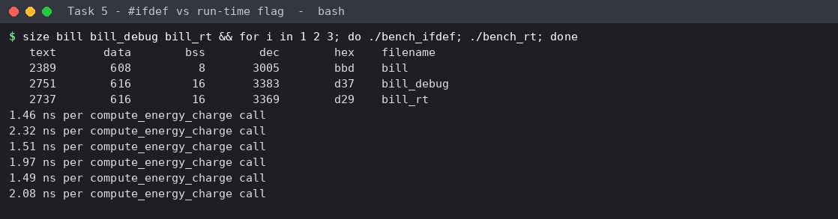
Figure 5.5: executable sizes and time per call (three runs) for the #ifdef and run-time versions
Aspect | #ifdef DEBUG (off) | Run-time flag (off) | Analysis
Time per compute_energy_charge call | 1.42 - 1.53 ns | 1.94 - 2.32 ns | The extra test costs about 0.5 - 0.8 ns per call: O(1) per call, O(n) over n calls.
.text size | 2,389 bytes | 2,737 bytes (+348) | Debug code and format strings stay in the executable: O(1) extra space, but it ships to every installation.
Switch debugging on | recompile with -DDEBUG | no recompile | Run-time flag is more flexible; #ifdef is leaner.
-DDEBUG build size | 2,751 bytes | - | Debug build is larger than the normal build by 362 bytes.

Evidence for Task 5: header file with include guard, working DEBUG mode, the guard-removal failure, and measured time and size for #ifdef versus a run-time flag.

Task 6 - Read and Print Data Correctly (K3, 4 marks)

6.1 Correct format specifiers
Data type | printf | scanf | Used for
int | %d | %d | household number
unsigned int / unsigned short (promoted) | %u | %u (%hu for unsigned short) | units, readings
long / long long | %ld / %lld | %ld / %lld | paise amounts, district totals
float | %f | %f | -
double | %f (or %lf) | %lf | not used for money
char / string | %c / %s | %c / %s | category, text
size_t | %zu | %zu | printing sizeof

6.2 Wrong specifiers - tested
Task06/wrong_specifier.c
/* Task 6 - what happens when the wrong format specifier is used (compile with -Wall to see the warnings) */
#include <stdio.h>

int main(void)
{
long big = 5000000000L; /* needs 33 bits */
unsigned short reading = 65535;
double rate = 2.25;

printf("correct %%ld : %ld\n", big);
printf("wrong %%d : %d\n", big); /* long printed with %d */
printf("correct %%u : %u\n", (unsigned)reading);
printf("wrong %%d for -1 stored in unsigned: %d\n", (int)(unsigned short)-1);
printf("correct %%f : %f\n", rate);
printf("wrong %%d : %d\n", rate); /* double printed with %d */

double d = 0;
sscanf("4.5", "%f", &d); /* %f stores a float into a double */
printf("sscanf(\"4.5\", \"%%f\", &double) gives %f instead of 4.5\n", d);
return 0;
}

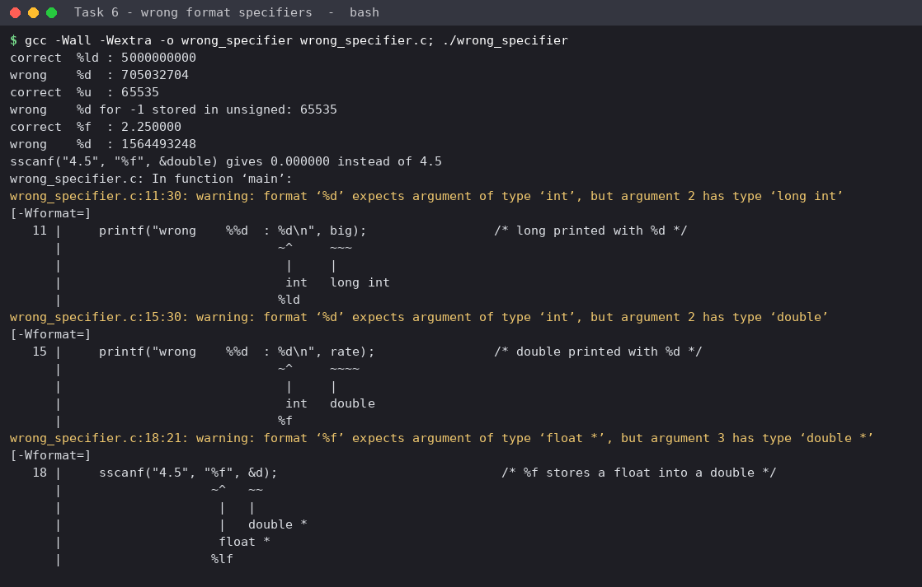
Figure 6.1: gcc warnings and the incorrect values printed
Mistake | Output | Explanation
%d for the long 5,000,000,000 | 705032704 | only the low 32 bits are used: 5,000,000,000 mod 2^32 = 705,032,704. A bill would silently change.
%d for the double 2.25 | 1627407808 (garbage) | a double is passed in a floating-point register; %d reads an unrelated integer register or stack value.
%f in sscanf into a double | 0.000000 instead of 4.5 | %f writes a 4-byte float into an 8-byte double; the result is a wrong bit pattern. %lf is required for scanf.

-Wall reports each of these as -Wformat warnings at compile time, which is why warnings must never be ignored.

6.3 Checking the return value of scanf
scanf returns the number of items successfully stored (or EOF). With input abc 10 20 it returns 0; with 15x0 1600 it returns 2 because the field 15x0 stops at x. Ignoring the return value would leave the old values in the variables and produce a bill for the wrong household.
Task06/read_bill.c
/* Task 6 - reading household, previous and current reading with scanf and checking its return value */
#include <stdio.h>

/* Prints paise as rupees.paise; handles a negative amount correctly. */
static void print_money(const char *label, long paise)
{
const char *sign = paise < 0 ? "-" : "";
long a = paise < 0 ? -paise : paise;
printf("%s Rs %s%ld.%02ld\n", label, sign, a / 100, a % 100);
}

int main(void)
{
int household;
long previous, current;
int line = 0;

printf("Enter: household previous current (EOF to stop)\n");
for (;;) {
int rc = scanf("%d %ld %ld", &household, &previous, &current);
line++;
if (rc == EOF) break;
if (rc != 3) { /* letters or missing fields */
printf("Line %d: invalid input (scanf returned %d) - skipped\n", line, rc);
int ch;
while ((ch = getchar()) != '\n' && ch != EOF) { } /* discard rest of the line */
continue;
}
printf("Line %d: house %d, previous %ld, current %ld\n", line, household, previous, current);
print_money(" sample amount:", 16250L);
}
printf("Naive print of -16250 paise: Rs %ld.%02ld\n", -16250L / 100, -16250L % 100);
print_money("Fixed print of -16250 paise:", -16250L);
return 0;
}

Task06/input_mixed.txt (input file)
101 1200 1530
102 65400 120
abc 10 20
103 15x0 1600
104 100
105 500 900

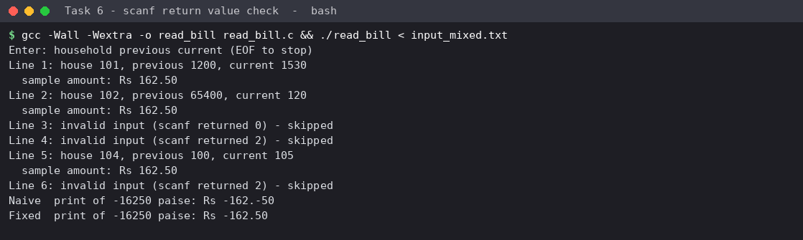
Figure 6.2: scanf return-value checks on the mixed input file
Observation. Lines 3, 4 and 6 are correctly reported as invalid. Line 5 (104 100, a missing field) shows a weakness of scanf: because a newline is just white space, scanf continued onto the next line and read 105 as the current reading, so house 104 was billed with the wrong data, and the following line was then misread. This led to the design decision in Task 9 to read one line at a time.

6.4 Printing rupees and paise from an integer
An amount in paise is split with / 100 and % 100, and %02ld pads the paise to two digits: 16250 paise prints as Rs 162.50. For a negative amount the naive method prints a sign on both parts (Rs -162.-50, shown in Figure 6.2); the fixed function prints the sign once and then works on the absolute value.

6.5 Alternative concept: fgets() with sscanf()
Task06/io_fgets.c
/* Task 6 alternative: read a whole line with fgets and convert with sscanf */
#include <stdio.h>

#define LINE_MAX_LEN 80

int main(void)
{
char line[LINE_MAX_LEN];
int n = 0;
while (fgets(line, sizeof line, stdin) != NULL) {
int household; long previous, current; char extra;
n++;
int rc = sscanf(line, "%d %ld %ld %c", &household, &previous, &current, &extra);
if (rc == 3)
printf("Line %d: house %d, previous %ld, current %ld\n", n, household, previous, current);
else
printf("Line %d: invalid input (sscanf returned %d) - line rejected, nothing left in the buffer\n", n, rc);
}
return 0;
}

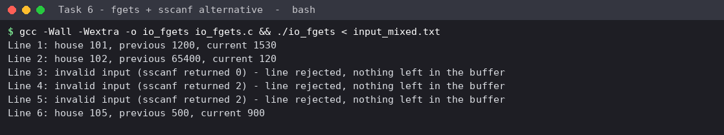
Figure 6.3: the same input read with fgets and sscanf - every line judged on its own
Aspect | scanf directly | fgets + sscanf / strtol
Time for a line of length L | O(L) | O(L) to read the line plus O(L) to convert - still O(L), about twice the constant factor
Buffer space | none visible (internal stdin buffer) | a fixed buffer, here 80 bytes: O(1) in the number of lines; lines longer than the buffer need a check
Recovery from invalid input | bad characters stay in the input; the program must drain the line itself (the getchar loop) and a missing field can swallow the next line | the bad line is already consumed; the next fgets starts at a clean line; trailing junk can be detected with an extra %c
Result on the test file | line 5 misread (see 6.3) | lines 3, 4, 5 rejected; line 6 correct

Evidence for Task 6: specifier table, a tested wrong-specifier demonstration, scanf return-value validation, a correctly formatted bill, and a comparison with the fgets approach.

Task 7 - Control Type Conversion and Precision (K4, 4 marks)

7.1 Where different types are combined in the billing program
Expression | Types involved | Conversion that happens
current - previous (both meter_t) | unsigned short, unsigned short | integer promotion: both become int, so the result can be negative; the cast back to meter_t wraps it
(long)units * RATE2_PAISE | int and long | usual arithmetic conversion: the int is converted to long (64 bit) before multiplying
paise / 100, paise % 100 | long and int | integer division: fractional part is discarded
units > SLAB1_UNITS | unsigned int and int | the int is converted to unsigned; a negative int would become huge
energy + FIXED_CHARGE_PAISE | long and long | no conversion
grand_total += total | long long and long | widening, safe

7.2 Six unexpected results
Task07/conversions.c
/* Task 7 - implicit conversions, integer division, casts and rounding */
#include <stdio.h>
#include <limits.h>

typedef unsigned short meter_t;

int main(void)
{
/* Surprise 1: integer division */
int units = 150;
double hundreds_wrong = units / 100; /* int / int = 1 before it becomes double */
double hundreds_right = units / 100.0;
printf("1) 150/100 -> %.2f (wrong) 150/100.0 -> %.2f (right)\n", hundreds_wrong, hundreds_right);

/* Surprise 2: casting a large long to int */
long total_paise = 5000000000L; /* Rs 5 crore */
int truncated = (int)total_paise;
printf("2) (int)5000000000L -> %d (low 32 bits kept; the bill silently changes)\n", truncated);

/* Surprise 3: signed/unsigned comparison */
int neg = -1;
unsigned one = 1u;
printf("3) -1 < 1u is %s (-1 is converted to %u)\n", neg < one ? "true" : "FALSE", (unsigned)neg);

/* Surprise 4: integer promotion hides the 16-bit rollover */
meter_t r = 65535;
int promoted = r + 1;
meter_t stored = (meter_t)(r + 1);
printf("4) 65535 + 1 -> %d when held in an int, but %u when stored back in meter_t\n", promoted, (unsigned)stored);

/* Surprise 5: floating point equality */
double x = 0.1 + 0.2;
printf("5) 0.1 + 0.2 == 0.3 is %s (0.1+0.2 = %.17f)\n", x == 0.3 ? "true" : "FALSE", x);

/* Surprise 6: int * int overflows before it is widened */
int units_big = 100000, rate = 450;
long wrong = units_big * rate * 100; /* all int: overflows */
long right = (long)units_big * rate * 100;
printf("6) 100000*450*100 as int arithmetic = %ld ; with a (long) cast = %ld\n", wrong, right);

/* Rounding rule: round half up when a fractional paise appears (peak surcharge 20%%) */
long rate_paise = 225;
long trunc = rate_paise * 120 / 100; /* 270 exact */
long odd_rate = 7;
long t1 = odd_rate * 120 / 100; /* 8.4 -> truncated 8 */
long t2 = (odd_rate * 120 + 50) / 100; /* round to nearest = 8 */
long odd2 = 9;
long u1 = odd2 * 120 / 100; /* 10.8 -> truncated 10 */
long u2 = (odd2 * 120 + 50) / 100; /* round half up = 11 */
printf("Rounding: 225*1.2=%ld; 7*1.2 trunc=%ld round=%ld; 9*1.2 trunc=%ld round=%ld\n", trunc, t1, t2, u1, u2);
(void)INT_MAX;
return 0;
}

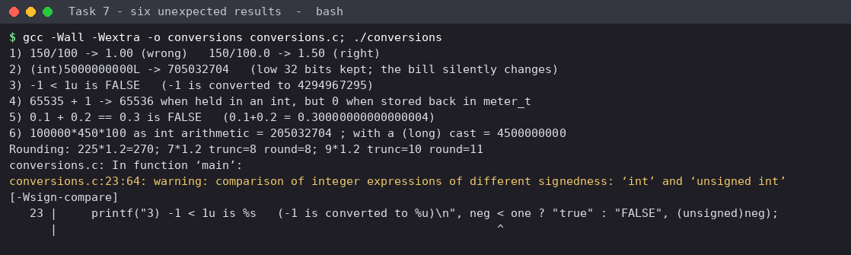
Figure 7.1: output of six expressions that behave unexpectedly (the sign-compare warning is deliberate)
# | Expression | Result | Explanation
1 | double h = 150 / 100; | 1.00 | both operands are int, so integer division gives 1 before it is converted to double. Correct: 150 / 100.0 = 1.50.
2 | (int)5000000000L | 705032704 | the cast keeps the low 32 bits. A district total cast to int silently changes.
3 | -1 < 1u | false | usual arithmetic conversions turn the int -1 into unsigned 4,294,967,295. gcc warns with -Wsign-compare.
4 | 65535 + 1 in int vs stored in meter_t | 65536 vs 0 | the sum is computed in int (promotion) but wraps when stored back in 16 bits - this is the roll-over.
5 | 0.1 + 0.2 == 0.3 | false | binary floating point cannot hold 0.1 exactly; the sum is 0.30000000000000004. Never compare money with ==.
6 | 100000 * 450 * 100 in int | 205032704 (true value 4,500,000,000) | all operands are int, so the product overflows before being assigned to a long. A (long) cast on the first operand fixes it.

7.3 Rounding rule
Rates are whole paise, so slab charges are exact. A fractional paise appears only when a percentage is applied (the Task 12 peak surcharge). The single rule used everywhere is round half up, once per bill, in integer arithmetic: (value * percent + 50) / 100. Example: 9 paise x 1.2 = 10.8, truncated 10, rounded 11; 7 x 1.2 = 8.4 gives 8 either way. Truncation would favour the co-operative by up to one paise per bill; round-half-up is unbiased on average.

7.4 Alternative concept: all calculations in float, rounded once at the end
The alternative keeps float (or double) rupees, accumulates them without rounding, and rounds only the final total. The measurement below compares both with the exact integer paise total for the current tariff (Rs 2.25 / 4.50) and for a revised tariff (Rs 2.27 / 4.53) whose rupee values are not exact in binary.
Task07/error_growth.c
/* Task 7 alternative: all arithmetic in float/double rupees (rounded once at the end) vs exact integer paise */
#include <stdio.h>
#include <math.h>
#include <time.h>

static unsigned long long state = 12345ULL;
static unsigned next_rand(void) { state = state * 6364136223846793005ULL + 1442695040888963407ULL; return (unsigned)(state >> 33); }

/* r2, r3 are the slab-2 and slab-3 rates in paise per unit */
long bill_paise(int units, long r2, long r3)
{
long p = 5000L;
if (units > 200) p += (long)(units - 200) * r3;
if (units > 100) p += (long)((units > 200 ? 200 : units) - 100) * r2;
return p;
}
float bill_float(int units, long r2, long r3)
{
float p = 50.0f;
if (units > 200) p += (units - 200) * (r3 / 100.0f);
if (units > 100) p += ((units > 200 ? 200 : units) - 100) * (r2 / 100.0f);
return p;
}
double bill_double(int units, long r2, long r3)
{
double p = 50.0;
if (units > 200) p += (units - 200) * (r3 / 100.0);
if (units > 100) p += ((units > 200 ? 200 : units) - 100) * (r2 / 100.0);
return p;
}

int main(void)
{
int sizes[] = {1000, 4000, 60000, 800000};
long tar[2][2] = {{225, 450}, {227, 453}}; /* current tariff, and a revised tariff Rs 2.27 / 4.53 */
for (int t = 0; t < 2; t++) {

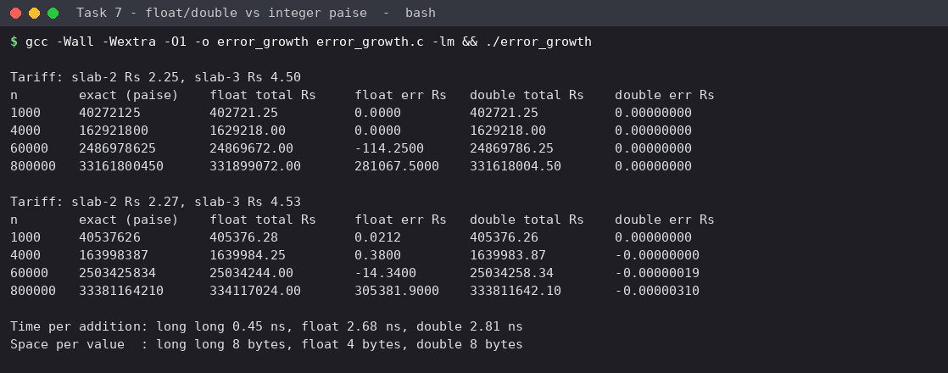
Figure 7.2: float and double totals compared with the exact integer paise total
n bills | float error, Rs 2.25/4.50 | float error, Rs 2.27/4.53 | double error, Rs 2.27/4.53
1,000 | 0.0000 | +0.0212 | 0.00000000
4,000 | 0.0000 | +0.3800 | -0.00000000
60,000 | -114.25 | -14.34 | -0.00000019
800,000 | +281,067.50 | +305,381.90 | -0.00000310

Metric | long long paise | float rupees | double rupees
Time per addition (measured, volatile accumulator) | 0.37 - 0.42 ns | 2.65 - 2.69 ns | 2.62 - 2.91 ns
Space per value | 8 bytes | 4 bytes | 8 bytes
Error growth with n | none (exact) | grows quickly: the gap between neighbouring floats grows with the total (about Rs 0.03 near 400,000, Rs 2 between 16.7 and 33 million, Rs 32 near 330 million), so small bills are rounded away | tiny, grows slowly (about 3 x 10^-6 at n = 800,000)

Analysis. With a dyadic tariff (2.25 and 4.50 are exactly representable) the float errors are zero for small n, which hides the problem; at n = 60,000 and 800,000 the total passes 16.7 million (2^24) and the errors become enormous. With the revised tariff the error is already visible at n = 1,000. Rounding once at the end does not help because the damage is done during accumulation. Time per addition is O(1) in every case; the integer version was fastest in this test. Integer paise is therefore both exact and no slower.
Evidence for Task 7: conversion points identified, six demonstrated surprises with explanations (more than the three required), a single rounding rule, and a measured error-growth comparison.

Task 8 - Trace the Compilation Process (K3, 4 marks)

8.1 The four stages for billing.c
billing.c (the program of Task 9) was taken through each stage separately.
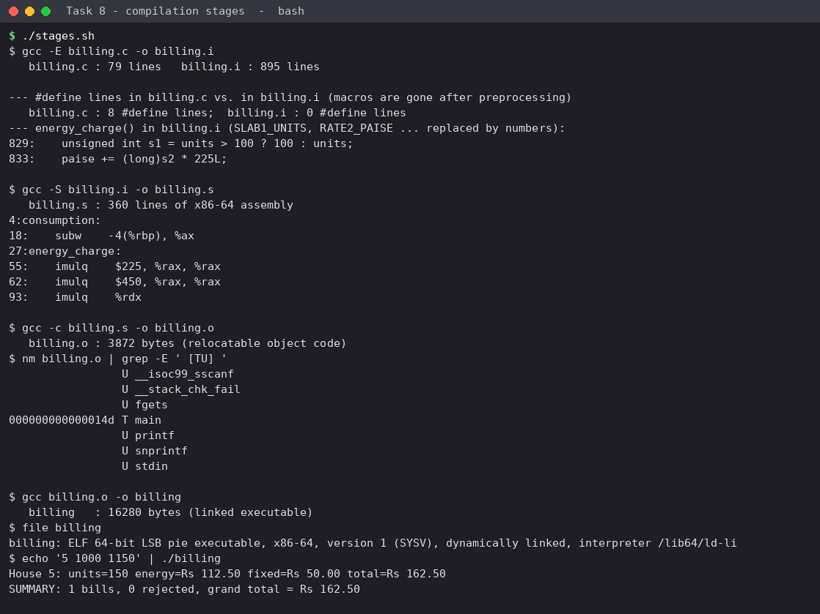
Figure 8.1: gcc -E, -S, -c and the final link, with the size of each product
Stage | Command | Output | What happened
1. Preprocessing | gcc -E billing.c -o billing.i | billing.i, 895 lines (source: 79) | The contents of <stdio.h> were inserted; the 8 #define lines disappeared (0 left) and every macro name was replaced by its value, e.g. RATE2_PAISE became 225L, SLAB1_UNITS became 100; comments removed.
2. Compilation | gcc -S billing.i -o billing.s | billing.s, 360 lines of assembly | C became x86-64 assembly: subw implements the 16-bit subtraction in consumption, imulq $225 and imulq $450 are the slab multiplications.
3. Assembly | gcc -c billing.s -o billing.o | billing.o, 3,872 bytes | Machine code with unresolved symbols: nm shows main as defined (T) and printf, fgets, sscanf, snprintf, stdin as undefined (U).
4. Linking | gcc billing.o -o billing | billing, 16,280 bytes (ELF 64-bit) | The linker resolved the undefined symbols against the C library and added start-up code; the program ran correctly.

8.2 Compile-time, link-time and run-time errors
Task08/err_compile.c (missing semicolon)
#include <stdio.h>
int main(void)
{
int units = 150
printf("%d\n", units);
return 0;
}

Task08/err_link.c (function declared, never defined)
#include <stdio.h>
long compute_bill(int units); /* declared but never defined anywhere */
int main(void)
{
printf("%ld\n", compute_bill(150));
return 0;
}

Task08/err_run.c (division by zero when the number of households is 0)
#include <stdio.h>
#include <stdlib.h>
int main(int argc, char **argv)
{
int households = argc > 1 ? atoi(argv[1]) : 0; /* 0 houses */
int total_units = 1200;
printf("Average units per house = %d\n", total_units / households); /* divide by zero at run time */
return 0;
}

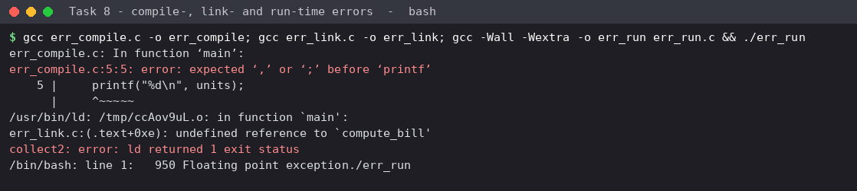
Figure 8.2: one error of each kind
Kind | Detected by | Example in this work | Message / outcome
Compile-time (syntax) | compiler | missing ; after int units = 150 | error: expected ',' or ';' before 'printf' - no object file is produced
Link-time | linker ld | compute_bill is declared but defined nowhere | undefined reference to compute_bill, ld returned 1 exit status - the code compiled, the program was not built
Run-time | the running program / CPU | average units per house with 0 households | Floating point exception, exit status 136 (SIGFPE) - compiled and linked without any message

8.3 Warnings from -Wall -Wextra and how they were resolved
Task08/warn.c (before)
#include <stdio.h>

static int unused_helper(int units, int rate) /* 'rate' never used */
{
return units * 2;
}

int main(void)
{
int count = 5;
unsigned int limit = 3;
long total = 5000000000L;
int never_used;
if (count > limit) /* signed / unsigned comparison */
printf("count above limit\n");
printf("total = %d\n", total); /* wrong format specifier */
return 0;
}

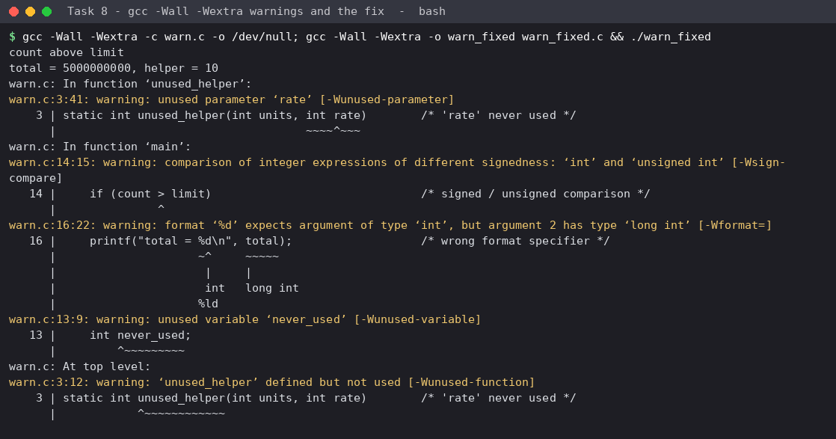
Figure 8.3: the five warnings, then the corrected program compiled without warnings
Warning | Meaning | Resolution
-Wunused-parameter rate | a parameter is never used - maybe a forgotten calculation | removed the parameter
-Wsign-compare count > limit | int compared with unsigned: a negative count would become huge (see Task 7, surprise 3) | explicit cast (int)limit after checking the range
-Wformat %d with long | wrong specifier, wrong value printed | changed to %ld
-Wunused-variable never_used | dead variable | deleted
-Wunused-function | helper defined but not used | the function is now used

The compile-with-warnings habit also caught the intentional -Wsign-compare and -Wformat cases in Tasks 6 and 7 - they are kept there only to demonstrate the behaviour.

8.4 Alternative concept: several .c files with a shared header
The program was also split into input.c, tariff.c, report.c and main.c with billing.h (include guard) and a Makefile with the rule %.o: %.c billing.h. Each .c is compiled to its own .o; make recompiles only files that changed (or whose header changed) and then relinks.
Task08/multi/Makefile
CC = gcc
CFLAGS = -Wall -Wextra -O0
OBJS = main.o input.o tariff.o report.o
bill: $(OBJS)
$(CC) $(OBJS) -o bill
%.o: %.c billing.h
$(CC) $(CFLAGS) -c $< -o $@
clean:
rm -f *.o bill

Task08/multi/billing.h
#ifndef BILLING_H
#define BILLING_H
#define SLAB1_UNITS 100
#define SLAB2_UNITS 200
#define RATE2_PAISE 225L
#define RATE3_PAISE 450L
#define FIXED_CHARGE_PAISE 5000L
typedef unsigned short meter_t;
unsigned int consumption(meter_t previous, meter_t current); /* input.c */
long energy_charge(unsigned int units); /* tariff.c */
void print_bill(int household, unsigned int units, long total);/* report.c */
#endif

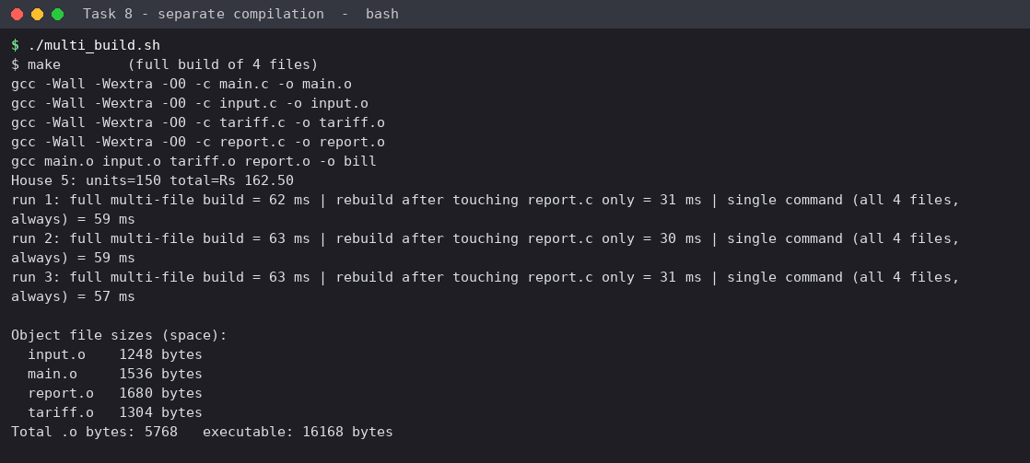
Figure 8.4: full build, rebuild after changing one file, and size of the object files (three runs)
Metric | Single file / one command | Separate compilation (make) | Analysis
Compile time after a change to one file | 56 - 70 ms (everything is recompiled) | 29 - 44 ms (only report.c + link) | Rebuild cost is proportional to the *changed* files, not to all f files: O(changed) instead of O(f). For this small program the saving is about 20 ms; for a 100-file project it is the difference between seconds and minutes.
Full build from clean | 56 - 70 ms | 60 - 98 ms | separate compilation is slightly slower from scratch (one gcc process per file).
Space | executable 16,168 bytes | 4 object files = 5,768 bytes + executable 16,168 bytes | object files cost extra disk space, O(f), but they are what makes incremental builds possible.

Evidence for Task 8: screenshots of all four stages, one example each of compile-time, link-time and run-time errors, the warnings with their resolution, and a measured comparison of single-file and separate compilation.

Task 9 - Implement and Test the Billing Program (K3, 4 marks)

9.1 Design
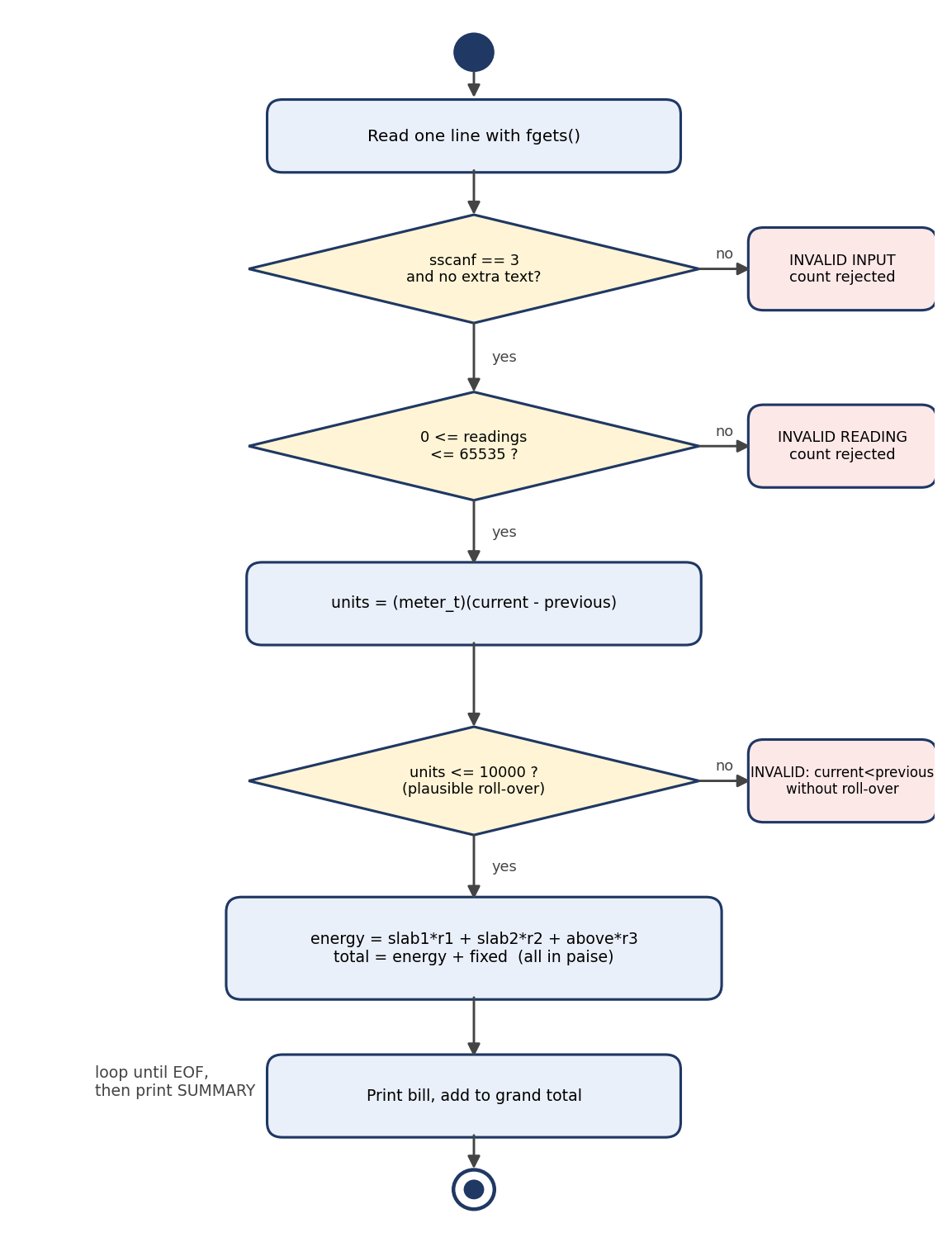
Figure 9.1: UML activity diagram of the billing program
Pseudocode:
Pseudocode (x+ means max(x, 0))
repeat for each input line:
read the line (fgets)
if not exactly three numbers -> report INVALID INPUT; continue
if any reading < 0 or > 65535 -> report INVALID READING; continue
units <- (meter_t)(current - previous) // roll-over handled by modular arithmetic
if units > 10000 // current < previous without a credible roll-over
report INVALID; continue
energy <- 0 * min(units,100) + 225 * (min(units,200) - 100)+ + 450 * (units - 200)+
total <- energy + 5000 // all values in paise
print bill; grand_total <- grand_total + total
print SUMMARY (bills, rejected, grand total)

Design decisions drawn from the earlier tasks: paise in long (Task 2); meter_t and modular subtraction (Task 2); all tariff values defined once (Task 3); output through a function that formats rupees and paise (Task 6); input read line by line with fgets + sscanf because scanf can swallow the following line (Task 6); a trailing %c makes extra text on the line an error.
Task09/billing.c
/* Task 9 - Grama Jyothi Rural Electricity Co-operative: billing program
Input (stdin): lines of <household> <previous reading> <current reading>
Output (stdout): one bill per valid line, a message for each invalid line, and a summary. */
#include <stdio.h>

#define SLAB1_UNITS 100
#define SLAB2_UNITS 200
#define RATE1_PAISE 0L
#define RATE2_PAISE 225L
#define RATE3_PAISE 450L
#define FIXED_CHARGE_PAISE 5000L
#define MAX_READING 65535L /* 16-bit register */
#define MAX_BILL_UNITS 10000U /* largest plausible monthly consumption for one house */

typedef unsigned short meter_t;

static unsigned int consumption(meter_t previous, meter_t current)
{
return (meter_t)(current - previous); /* correct across roll-over */
}

static long energy_charge(unsigned int units)
{
long paise = 0;
unsigned int s1 = units > SLAB1_UNITS ? SLAB1_UNITS : units;
unsigned int s2 = (units > SLAB2_UNITS ? SLAB2_UNITS : units);
s2 = s2 > SLAB1_UNITS ? s2 - SLAB1_UNITS : 0;
paise += (long)s1 * RATE1_PAISE;
paise += (long)s2 * RATE2_PAISE;
if (units > SLAB2_UNITS) paise += (long)(units - SLAB2_UNITS) * RATE3_PAISE;
return paise;
}

static void money(char *buf, size_t n, long paise)
{
snprintf(buf, n, "Rs %ld.%02ld", paise / 100, paise % 100);
}

int main(void)
{
char buf[128], extra;
int household, rc, line = 0, ok = 0, bad = 0;
long previous, current, grand_total = 0;
char e[32], f[32], t[32];

/* One physical line = one meter record. fgets + sscanf keeps a bad line from corrupting the next one. */
while (fgets(buf, sizeof buf, stdin) != NULL) {
line++;
rc = sscanf(buf, "%d %ld %ld %c", &household, &previous, &current, &extra);
if (rc == EOF) continue; /* blank line */
if (rc != 3) {
printf("Line %d: INVALID INPUT (need exactly three numbers) - skipped\n", line);
bad++;
continue;
}
if (previous < 0 || current < 0 || previous > MAX_READING || current > MAX_READING) {
printf("Line %d: INVALID READING for household %d (must be 0..%ld) - skipped\n", line, household, MAX_READING);
bad++;
continue;
}
unsigned int units = consumption((meter_t)previous, (meter_t)current);
int rolled = current < previous;
if (units > MAX_BILL_UNITS) {
printf("Line %d: INVALID household %d: current %ld < previous %ld without a plausible roll-over (%u units) - skipped\n",
line, household, current, previous, units);
bad++;
continue;
}
long energy = energy_charge(units);
long total = energy + FIXED_CHARGE_PAISE;
money(e, sizeof e, energy); money(f, sizeof f, FIXED_CHARGE_PAISE); money(t, sizeof t, total);
printf("House %d: units=%u%s energy=%s fixed=%s total=%s\n", household, units, rolled ? " (roll-over)" : "", e, f, t);
grand_total += total;
ok++;
}
money(t, sizeof t, grand_total);
printf("SUMMARY: %d bills, %d rejected, grand total = %s\n", ok, bad, t);
return 0;
}

9.2 Execution on the five input files
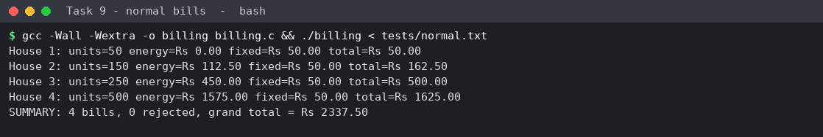
Figure 9.2: normal bills in each slab
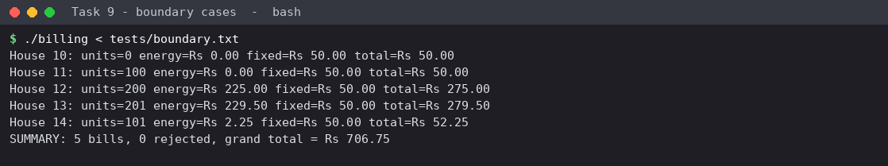
Figure 9.3: boundary cases - 0, 100, 101, 200 and 201 units
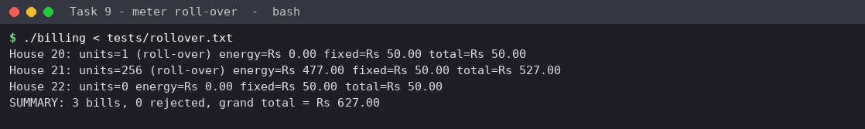
Figure 9.4: meter roll-over from 65535 to 0 and from 65400 to 120
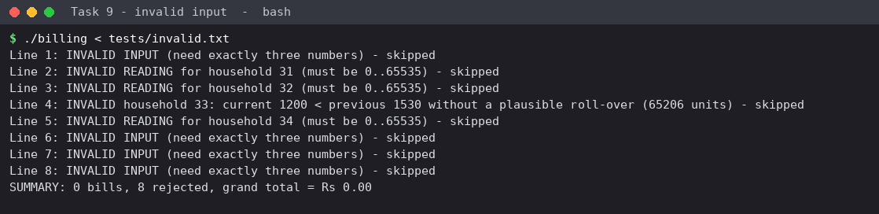
Figure 9.5: invalid input - every line rejected with the reason
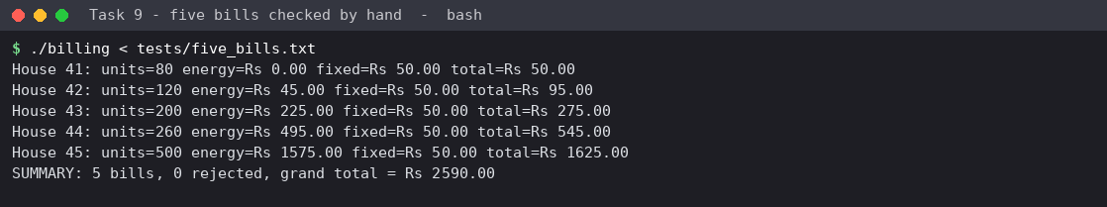
Figure 9.6: five bills; the total agrees with the hand calculation

9.3 Hand calculation of the five bills
House | Units | Calculation | Bill
41 | 80 | 50.00 + 0 | Rs 50.00
42 | 120 | 50.00 + 20 x 2.25 = 50 + 45 | Rs 95.00
43 | 200 | 50.00 + 100 x 2.25 = 50 + 225 | Rs 275.00
44 | 260 | 50 + 225 + 60 x 4.50 = 50 + 225 + 270 | Rs 545.00
45 | 500 | 50 + 225 + 300 x 4.50 = 50 + 225 + 1350 | Rs 1625.00
 |  | Total | Rs 2590.00

9.4 Test table - expected vs actual (generated by run_tests.py)
# | Case | Input | Expected | Actual (first output line) | Result
1 | Normal, slab 1 | 1 1000 1050 | units=50, total Rs 50.00 | House 1: units=50 energy=Rs 0.00 fixed=Rs 50.00 total=Rs 50.00 | PASS
2 | Normal, slab 2 | 2 1000 1150 | units=150, total Rs 162.50 | House 2: units=150 energy=Rs 112.50 fixed=Rs 50.00 total=Rs 162.50 | PASS
3 | Normal, slab 3 | 3 1000 1250 | units=250, total Rs 500.00 | House 3: units=250 energy=Rs 450.00 fixed=Rs 50.00 total=Rs 500.00 | PASS
4 | Normal, large | 4 1000 1500 | units=500, total Rs 1625.00 | House 4: units=500 energy=Rs 1575.00 fixed=Rs 50.00 total=Rs 1625.00 | PASS
5 | Boundary: zero units | 10 500 500 | units=0, total Rs 50.00 (fixed charge only) | House 10: units=0 energy=Rs 0.00 fixed=Rs 50.00 total=Rs 50.00 | PASS
6 | Boundary: exactly 100 | 11 500 600 | units=100, total Rs 50.00 | House 11: units=100 energy=Rs 0.00 fixed=Rs 50.00 total=Rs 50.00 | PASS
7 | Boundary: 101 | 14 500 601 | units=101, total Rs 52.25 | House 14: units=101 energy=Rs 2.25 fixed=Rs 50.00 total=Rs 52.25 | PASS
8 | Boundary: exactly 200 | 12 500 700 | units=200, total Rs 275.00 | House 12: units=200 energy=Rs 225.00 fixed=Rs 50.00 total=Rs 275.00 | PASS
9 | Boundary: 201 | 13 500 701 | units=201, total Rs 279.50 | House 13: units=201 energy=Rs 229.50 fixed=Rs 50.00 total=Rs 279.50 | PASS
10 | Roll-over 65535 -> 0 | 20 65535 0 | units=1, total Rs 50.00 | House 20: units=1 (roll-over) energy=Rs 0.00 fixed=Rs 50.00 total=Rs 50.00 | PASS
11 | Roll-over 65400 -> 120 | 21 65400 120 | units=256, total Rs 527.00 | House 21: units=256 (roll-over) energy=Rs 477.00 fixed=Rs 50.00 total=Rs 527.00 | PASS
12 | No change at maximum | 22 65535 65535 | units=0, total Rs 50.00 | House 22: units=0 energy=Rs 0.00 fixed=Rs 50.00 total=Rs 50.00 | PASS
13 | Invalid: letters | abc 10 20 | rejected: INVALID INPUT | Line 1: INVALID INPUT (need exactly three numbers) - skipped | PASS
14 | Invalid: letter inside number | 36 15x0 1600 | rejected: INVALID INPUT | Line 1: INVALID INPUT (need exactly three numbers) - skipped | PASS
15 | Invalid: missing field | 35 100 | rejected: INVALID INPUT | Line 1: INVALID INPUT (need exactly three numbers) - skipped | PASS
16 | Invalid: extra field | 37 1000 1100 99 | rejected: INVALID INPUT | Line 1: INVALID INPUT (need exactly three numbers) - skipped | PASS
17 | Invalid: negative previous | 31 -5 100 | rejected: INVALID READING | Line 1: INVALID READING for household 31 (must be 0..65535) - skipped | PASS
18 | Invalid: negative current | 32 100 -20 | rejected: INVALID READING | Line 1: INVALID READING for household 32 (must be 0..65535) - skipped | PASS
19 | Invalid: above 65535 | 34 70000 5 | rejected: INVALID READING | Line 1: INVALID READING for household 34 (must be 0..65535) - skipped | PASS
20 | Invalid: current < previous, no roll-over | 33 1530 1200 | rejected: not a plausible roll-over | Line 1: INVALID household 33: current 1200 < previous 1530 without a plausible roll-over (65... | PASS
21 | Five bills, total calculated by hand | units 80,120,200,260,500 | 50.00+95.00+275.00+545.00+1625.00 = Rs 2590.00 | SUMMARY: 5 bills, 0 rejected, grand total = Rs 2590.00 | PASS

21 of 21 cases pass. In the roll-over case 65400 to 120, units = 256 (Task 2) and the bill is 50 + 225 + 56 x 4.50 = Rs 527.00. The case "current < previous, no roll-over" (1530 to 1200) would give 65,206 units if treated as a roll-over; since that is not a credible monthly consumption it is rejected, which is exactly the third invalid-input requirement of the assignment.

9.5 Alternative concept: slabs in arrays and a loop
Task09/bill_array.c
/* Task 9 alternative: slab limits and rates in arrays, bill computed by a loop over the slabs */
#include <stdio.h>
#include <stdlib.h>
#include <time.h>

typedef struct { long upper; long rate; } Slab; /* upper = highest unit in the slab */

long energy_array(unsigned units, const Slab *s, int count)
{
long paise = 0, lower = 0;
for (int i = 0; i < count && units > (unsigned long)lower; i++) {
long top = s[i].upper;
long in_slab = (long)units < top ? (long)units - lower : top - lower;
paise += in_slab * s[i].rate;
lower = top;
}
return paise;
}

long energy_if(unsigned units)
{
long p = 0;
unsigned s1 = units > 100 ? 100 : units;
unsigned s2 = units > 200 ? 200 : units; s2 = s2 > 100 ? s2 - 100 : 0;

Pseudocode: paise <- 0; lower <- 0; for each slab i while units > lower: part <- min(units, upper[i]) - lower; paise += part * rate[i]; lower <- upper[i]. The bills for 0 to 10,000 units were compared with the fixed-if version: 0 mismatches.
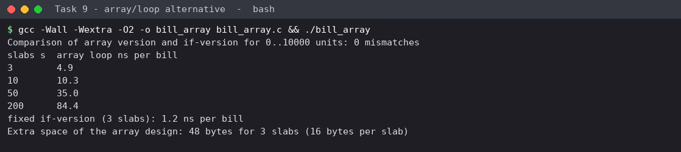
Figure 9.7: loop version - correctness check and time per bill for s slabs
Slabs s | Array loop (ns per bill) | Fixed if-version (ns per bill) | Space
3 | 3.8 | 1.4 | array of 3 structs = 48 bytes (16 bytes per slab)
10 | 5.6 | (fixed code cannot grow) | 160 bytes
50 | 21.8 | - | 800 bytes
200 | 83.2 | - | 3,200 bytes

Analysis. The loop costs O(s) per bill (the measurements grow roughly linearly: 3.8, 5.6, 21.8, 83.2 ns for s = 3, 10, 50, 200); the fixed-if version does a constant number of tests, O(1), and is faster for three slabs (1.4 ns). The array version needs O(s) extra space for the table. But it is easier to change: adding a fourth slab is one more table row, while the if-version needs new code, a new macro and new tests. With three stable slabs the if-version is adequate; if slab structures change often, the table is the better design (and the table can then be read from a file, Task 11).
Evidence for Task 9: working source code, 21 recorded test cases covering normal, boundary, roll-over and invalid inputs, a hand-calculated five-bill total, and a measured comparison of the loop design.

Task 10 - Compare Expectations with Execution (K4, 4 marks)

10.1 Expectations before the experiment
- Float rupees will drift from the exact total, and the drift will grow with n.
- A 32-bit int holding paise will overflow at the taluk and district scale: 2,147,483,647 paise is only Rs 21.5 million.
- long and long long will not overflow at district scale (limit about 9.2 x 10^18 paise).
- The sizes on this machine will equal or exceed the C standard minimums.

10.2 Experiment
For each n, pseudo-random monthly consumptions (0-399 units, fixed seed) were billed with a tariff of Rs 2.27 / Rs 4.53 (so that rupee values are not exact in binary), and the totals were accumulated in six ways.
Task10/expectation_vs_execution.c
/* Task 10 - expectation vs execution: totals for 4,000 / 60,000 / 800,000 bills in several types */
#include <stdio.h>
#include <limits.h>
#include <float.h>

static unsigned long long state;
static unsigned next_rand(void) { state = state * 6364136223846793005ULL + 1442695040888963407ULL; return (unsigned)(state >> 33); }

/* tariff of Task 3, slightly revised so that rupee values are not exact in binary: Rs 2.27 / Rs 4.53 */
static long bill_paise(int u)
{
long p = 5000L;
if (u > 200) p += (long)(u - 200) * 453L;
if (u > 100) p += (long)((u > 200 ? 200 : u) - 100) * 227L;
return p;
}

int main(void)
{
int sizes[] = {4000, 60000, 800000};
printf("%-8s | %-15s | %-15s %-12s | %-15s %-12s | %-9s %-9s\n",
"bills", "long long paise", "float Rs", "diff Rs", "double Rs", "diff Rs", "int ok?", "long ok?");
for (int k = 0; k < 3; k++) {
int n = sizes[k];
long long exact = 0;
unsigned int wrap_int = 0; /* unsigned arithmetic wraps without undefined behaviour */
long as_long = 0;
float tf = 0.0f;
double td = 0.0;
state = 2024ULL;
for (int i = 0; i < n; i++) {
int units = (int)(next_rand() % 400);
long b = bill_paise(units);
exact += b;
wrap_int += (unsigned)b;
as_long += b;
tf += (float)(b / 100.0);
td += b / 100.0;
}
int int_total = (int)wrap_int; /* what an int accumulator would hold */
double exact_rs = (double)exact / 100.0;
printf("%-8d | %-15lld | %-15.2f %-12.4f | %-15.4f %-12.8f | %-9s %-9s\n",
n, exact, (double)tf, (double)tf - exact_rs, td, td - exact_rs,
(long long)int_total == exact ? "yes" : "OVERFLOW", (long long)as_long == exact ? "yes" : "OVERFLOW");
if ((long long)int_total != exact)
printf(" int accumulator would hold %d paise instead of %lld\n", int_total, exact);
}

/* where does each type stop being exact? count paise one at a time */
float f = 0.0f; long long steps = 0;
while (f + 1.0f != f) { f += 1.0f; steps++; }
printf("\nfloat stops counting by 1 at %lld (= 2^24) -> Rs %lld.%02lld\n", steps, steps / 100, steps % 100);

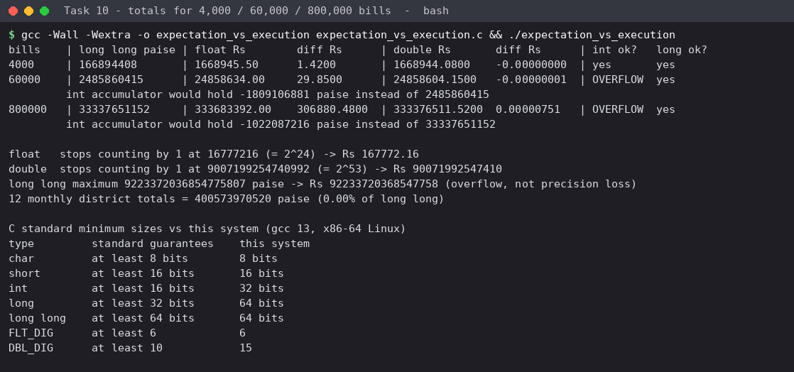
Figure 10.1: totals for 4,000, 60,000 and 800,000 bills and the C-standard comparison
Bills | Exact total (long long paise) | float total, difference | double total, difference | 32-bit int | 64-bit long
4,000 | 166,894,408 = Rs 1,668,944.08 | Rs 1,668,945.50, +1.42 | Rs 1,668,944.08, 0.00000000 | exact | exact
60,000 | 2,485,860,415 = Rs 24,858,604.15 | Rs 24,858,634.00, +29.85 | Rs 24,858,604.15, -0.00000001 | overflow (holds -1,809,106,881) | exact
800,000 | 33,337,651,152 = Rs 333,376,511.52 | Rs 333,683,392.00, +306,880.48 | Rs 333,376,511.52, +0.00000751 | overflow (holds -1,022,087,216) | exact

10.3 Comparison of expected and observed behaviour
Expectation | Observation | Reason / difference
float drifts and the drift grows | confirmed: +1.42, +29.85, +306,880.48 rupees | the gap between neighbouring floats grows with the running total, and a float stops adding 1 at 16,777,216 (measured 2^24); at Rs 333 million many small bills are rounded away
int overflows at taluk and district scale | confirmed: exact at 4,000 bills, overflow at 60,000 (2.49 x 10^9 > 2.15 x 10^9) and at 800,000 | an average bill of about Rs 414 x 60,000 houses = Rs 24.9 million, which is above 2^31 paise = Rs 21.5 million, so a taluk already overflows; a village of 4,000 does not
long and long long do not overflow | confirmed on this system | long is 64-bit under LP64 (Linux). On 64-bit Windows long is only 32-bit, so long would fail there; long long is portable
sizes meet the C standard minimums | confirmed; int is 32 bits (minimum 16), long 64 (minimum 32), DBL_DIG 15 (minimum 10) | the standard guarantees only minimums; the program must not rely on this machine's extra size

Where each type stops being exact (measured): float stops counting by 1 at 16,777,216 (Rs 167,772.16 when counting paise); double at 9,007,199,254,740,992 (2^53, Rs 90 trillion in paise); long long does not lose precision but overflows at 9.22 x 10^18. Twelve monthly district totals (4.0 x 10^11 paise) use 0.000004 % of the long long range.

10.4 Alternative concept: accumulate the district total in double
Task10/double_vs_longlong.c
/* Task 10 alternative: district total accumulated in double (paise as a whole number) vs long long */
#include <stdio.h>
#include <time.h>

static double now(void) { struct timespec t; clock_gettime(CLOCK_MONOTONIC, &t); return t.tv_sec + t.tv_nsec * 1e-9; }

int main(void)
{
/* double holding whole paise is exact up to 2^53; here we add 800,000 bills of about Rs 417 */
long long exact = 0; double dp = 0.0;
for (int i = 0; i < 800000; i++) { long b = 5000L + (i * 977L) % 80000L; exact += b; dp += (double)b; }
printf("800,000 bills: long long = %lld, double(paise) = %.0f, difference = %.0f\n", exact, dp, dp - (double)exact);

/* now push both types until double loses accuracy: add one odd paise to a very large total */
long long big = (1LL << 53); double bd = (double)big;
printf("2^53 + 1: long long = %lld, double = %.0f (the extra paise is lost)\n", big + 1, bd + 1.0);

const long M = 300000000L; volatile long long a = 0; volatile double b = 0;
double t0 = now(); for (long i = 0; i < M; i++) a += 41725; double t1 = now();
double t2 = now(); for (long i = 0; i < M; i++) b += 41725.0; double t3 = now();
printf("time per addition: long long %.2f ns, double %.2f ns; space: %zu vs %zu bytes\n",
(t1 - t0) / M * 1e9, (t3 - t2) / M * 1e9, sizeof(long long), sizeof(double));
return 0;
}

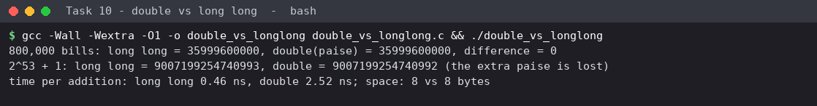
Figure 10.2: double holding whole paise vs long long
If the 800,000 bills are added as whole paise in a double, the result is identical to long long (35,999,600,000, difference 0), because every integer below 2^53 is exactly representable. Accuracy is lost only above 2^53 paise (Rs 9 x 10^13), where 2^53 + 1 is rounded to 2^53; this failure is a silent precision loss, whereas long long fails above 9.22 x 10^18 by overflow. If the bills are added as fractional rupees (the usual way a double is used), the sum is inexact even at 800,000 bills (+0.00000751 in the table above).
Aspect | long long | double
Time per addition (measured) | 0.31 ns | 2.52 ns (floating-point add latency in a dependent chain)
Space per variable | 8 bytes | 8 bytes
Exact range for whole paise | up to 9.22 x 10^18 | up to 9.01 x 10^15 (2^53)
Failure mode | overflow (wraps) | silent loss of the last digits

Evidence for Task 10: measured totals for 4,000, 60,000 and 800,000 bills in six accumulators, the overflow and precision limits found by experiment, and a table of reasons for every difference between expectation and execution.

Task 11 - Recommend and Defend the Final Design (K5, 4 marks)

11.1 Recommended design (based on Tasks 2-10)
Area | Recommendation | Evidence from the experiments
Meter reading | typedef unsigned short meter_t; difference (meter_t)(current - previous) | Task 2: 65400 to 120 gives 256; no negative bills; Task 9 roll-over tests pass
Money and bills | long (or long long) paise; never float | Task 2: float error 0.02 Rs at 4,000 bills; Task 7: up to Rs 305,381 at 800,000; integer error 0
Taluk and district totals | long long paise (portable 64-bit) | Task 10: int overflows already at 60,000 bills; long is 32-bit on some systems
Tariff | one block of named constants in tariff.h (#define with unit suffix); revision = edit one line and rebuild | Task 3: changing RATE2_PAISE to 230 changed every dependent bill consistently
Macros | only trivial, side-effect-free, fully parenthesised ones (RUPEES_TO_PAISE); static inline functions otherwise | Task 4: SQUARE(a+1) = 7 without parentheses; MAX(i++, j) incremented twice
Program structure | header with include guard; #ifdef DEBUG tracing; separate .c files for larger builds | Task 5: guard prevented the redefinition error; debug code removed from the normal build; Task 8: rebuild 29-44 ms vs 56-70 ms
Input / output | read one line with fgets + sscanf, check the return value; print paise with %ld.%02ld (sign handled) | Task 6: scanf swallowed the next line; Task 9: 8 invalid inputs all rejected
Compiler flags | -Wall -Wextra always, warnings treated as defects | Task 8: five warnings, each pointing to a real fault

11.2 How a tariff revision is carried out
- Compile-time design (Tasks 3, 9): edit the macros in one header, rebuild with -Wall -Wextra, run the test table, redistribute the executable to all offices.
- Run-time design (alternative below, extended in Task 12): edit one line of tariff.cfg; no rebuild. The program validates the file before use and refuses to run on an incomplete or inconsistent file.

11.3 Limitations
- The compile-time tariff requires rebuilding and redistributing the program for every revision (risk of an office running an old version).
- The plausibility limit (10,000 units) is an assumption; a genuine very large consumer after a roll-over would be rejected and need manual handling.
- A meter that rolls over *twice* in one period cannot be detected from two readings alone.
- Slab limits are whole units; fractional units (watt-hours) need a wider design (Task 12).
- Rates must be whole paise; percentages create fractions that need a rounding rule (Task 7).

11.4 Does the design remain correct at district scale?
Yes for the billing design as recommended: one bill is at most about 4.5 x 10^6 paise (fits long); the district monthly total measured 3.3 x 10^10 paise (fits long long more than 10^8 times over); the year of twelve months uses 0.000004 % of the range. The time to process 800,000 bills is dominated by input, not arithmetic: the energy calculation took 1.4 ns per bill (Task 9), so the arithmetic for a district takes about 1 ms. What does *not* scale is the original assumption of one reading per month; Task 12 shows that smart meters change this.

11.5 Alternative concept: tariff read from a configuration file
Task11/tariff.cfg
# Grama Jyothi tariff - edit this file, no recompilation needed
slab1_units=100
slab2_units=200
rate1_paise=0
rate2_paise=225
rate3_paise=450
fixed_paise=5000

Task11/cfg_billing.c
/* Task 11 alternative: tariff read from a configuration file at start-up instead of #define */
#include <stdio.h>
#include <stdlib.h>
#include <string.h>
#include <time.h>

typedef struct { long slab1, slab2, rate1, rate2, rate3, fixed; } Tariff;

/* returns number of values read (6 = complete), -1 if the file cannot be opened */
static int load_tariff(const char *path, Tariff *t)
{
FILE *fp = fopen(path, "r");
char line[128];
int got = 0;
if (!fp) return -1;
while (fgets(line, sizeof line, fp)) {
char key[32]; long v;
if (line[0] == '#') continue;
if (sscanf(line, "%31[^=]=%ld", key, &v) != 2) continue;
if (!strcmp(key, "slab1_units")) { t->slab1 = v; got++; }
else if (!strcmp(key, "slab2_units")) { t->slab2 = v; got++; }
else if (!strcmp(key, "rate1_paise")) { t->rate1 = v; got++; }
else if (!strcmp(key, "rate2_paise")) { t->rate2 = v; got++; }
else if (!strcmp(key, "rate3_paise")) { t->rate3 = v; got++; }
else if (!strcmp(key, "fixed_paise")) { t->fixed = v; got++; }
}
fclose(fp);
return got;
}

static int valid(const Tariff *t)
{
return t->slab1 >= 0 && t->slab2 > t->slab1 && t->rate1 >= 0 && t->rate2 >= 0 && t->rate3 >= 0 && t->fixed >= 0;
}

static long bill(const Tariff *t, long units)
{
long p = t->fixed, s1 = units < t->slab1 ? units : t->slab1;
long s2 = (units < t->slab2 ? units : t->slab2) - t->slab1; if (s2 < 0) s2 = 0;
p += s1 * t->rate1 + s2 * t->rate2;
if (units > t->slab2) p += (units - t->slab2) * t->rate3;
return p;
}

int main(int argc, char **argv)
{
const char *path = argc > 1 ? argv[1] : "tariff.cfg";
Tariff t = {0};
int got = load_tariff(path, &t);
if (got < 0) { printf("ERROR: cannot open %s\n", path); return 1; }
if (got != 6 || !valid(&t)) { printf("ERROR: %s is incomplete or inconsistent (%d of 6 values, valid=%d) - program stops\n", path, got, valid(&t)); return 1; }
printf("Tariff loaded from %s: slabs %ld/%ld, rates %ld/%ld/%ld paise, fixed %ld paise\n", path, t.slab1, t.slab2, t.rate1, t.rate2, t.rate3, t.fixed);

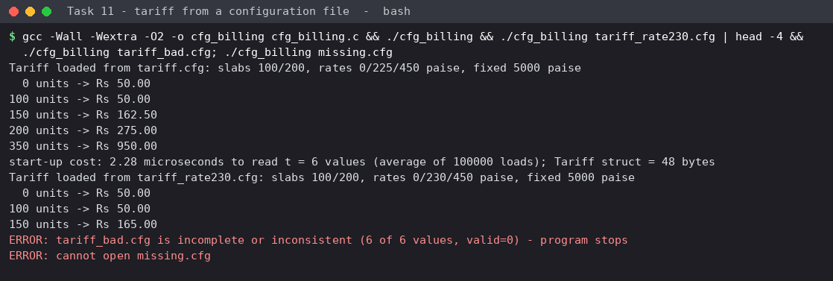
Figure 11.1: tariff from tariff.cfg; changed value used without recompiling; inconsistent and missing files rejected
Aspect | Compiled-in tariff | Tariff from configuration file
Cost per revision | edit + recompile (about 58 ms of compilation here) + redistribute the executable to every office | edit one text line; same executable
Start-up time | 0 | 2.72 microseconds to open, parse and validate t = 6 values (average of 100,000 loads): O(t)
Space | 0 bytes of data (constants in code) | 48 bytes for the Tariff struct, O(t)
Risk | a stale executable on one office computer | a wrong or missing file at run time - handled by validation (error message in Figure 11.1)
Test evidence | Task 3, rate 230: all bills consistent | rate2_paise=230 in tariff_rate230.cfg: 150 units gives Rs 165.00 with the same executable

Evaluation. The start-up cost (2.7 microseconds, once per run) is about 21,000 times smaller than a single recompilation (58 ms) and the extra space is 48 bytes. The runtime cost is therefore negligible and the benefit is large; the price is a new failure mode (bad file) which the program handles by validating all six values and stopping with a message. Final recommendation: keep integer paise, unsigned short meter type, long long totals and include-guarded headers, but move the tariff values to a validated configuration file; keep the constants in the header only for physical limits that never change (MAX_READING, paise per rupee).
Evidence for Task 11: a recommendation table in which every row cites a measurement made in an earlier task, limitations, a district-scale argument, and a measured evaluation of the configuration-file alternative.

Task 12 - Day-4 Design Challenge: Re-evaluate and Adapt the Design (K5, 8 marks)

A. Impact Analysis (2 marks)
Aspect | Original problem | Changed requirement | Consequence
Readings per house | 2 per month (previous, current) | 35,040 per year, one every 15 minutes (96 per day) | About 2,880 readings per month: the program must process a series, not a pair.
Unit of measurement | whole units (kWh) | watt-hours (1 unit = 1,000 Wh) | The finest resolution is 1 Wh, so slab limits are 100,000 and 200,000 Wh.
Meter value | cumulative 16-bit register | energy per 15-minute interval, sent by the meter (assumed; the interval reading removes the roll-over problem but not the range problem) | A 16-bit type holds only 65.5 kWh; one month is 100 times more.
Price | depends only on the slab | depends on the slab and the time of day: 20 % extra from 18:00 to 22:00 | Each reading needs its hour of day; a bill is a sum of many differently priced pieces; fractions of a paise appear.
Tariff values | compiled in with #define | must change without recompiling | #define can no longer be used for any tariff value.
Scale | 12 readings per house-year (one per month) | 35,040 readings per house-year: 2,920 times more data; 2.8 x 10^10 readings per year for a district of 800,000 houses | Memory and run time must be estimated for the series.

Data types no longer sufficient
- meter_t (unsigned short, max 65,535 Wh = 65.5 kWh): one month at a modest 150 kWh = 150,000 Wh does not fit.
- int for yearly watt-hours per district: 7.0 x 10^13 Wh far exceeds 2.1 x 10^9.
- The scaled money accumulator (rate x Wh x percentage) can reach 4.0 x 10^11 for one house-month - larger than a 32-bit integer.

Constants that can no longer be fixed with #define
- Slab limits and the three rates (they must be editable by the board).
- Fixed charge.
- Peak start hour (18), peak end hour (22) and the surcharge (20 %), because the board may change the peak window.
- Still constants in code: 96 slots per day, 35,040 slots per year, days per month, and the physical limit on one reading.

B. Evaluation of the Original Design (2 marks)
The largest values that can now occur were computed for a 10 kW connection (assumption: the largest household sanction), 800,000 houses:
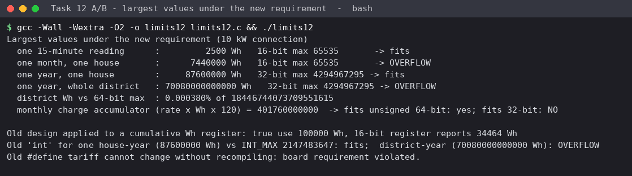
Figure 12.1: largest values under the new requirement and the failure of the old design
Quantity | Largest value | Original type | Verdict
One 15-minute reading | 10,000 W x 0.25 h = 2,500 Wh | unsigned short (max 65,535) | fits - but only because the meter reports intervals, not a cumulative total
One month, one house (31 days) | 7,440,000 Wh | meter_t 16-bit | overflow (113 x too big)
One year, one house | 87,600,000 Wh | int / unsigned int | fits in 32 bits (2.1 x 10^9)
One year, district | 70,080,000,000,000 Wh = 7.0 x 10^13 | 32-bit | overflow (16,000 x too big); needs 64 bits (0.00038 % of the unsigned 64-bit range)
Scaled charge accumulator, one house-month | 450 x 7,440,000 x 120 = 4.0 x 10^11 | long paise (64-bit) / int | fits long; overflow in 32 bits
Readings in one year in one district | 35,040 x 800,000 = 2.8 x 10^10 | int counter | overflow in 32 bits - use 64-bit counters

Part of the original design | Still appropriate? | Reason
Money in integer paise | Yes - retain | the principle is unchanged; actually more important now because 35,040 additions per house-year would accumulate float errors
Round half up, once per bill | Yes - retain | the 20 % surcharge creates fractional paise; the rounding rule of Task 7 applies directly
fgets + sscanf and validation | Yes - retain | every line of the readings file is validated independently
16-bit meter_t and consumption() roll-over arithmetic | No - replace | range too small (7.4 x 10^6 Wh per month); the interval readings need no roll-over logic. The demonstration in Figure 12.1 shows 100,000 Wh reported as 34,464 Wh
#define tariff constants | No - replace | violates "change without recompiling"
Fixed three-slab if code | Modify | the slab idea stays, but a reading can straddle a boundary, so slab limits are applied in a loop (Task 9 alternative design)
Macros | Not needed | no repeated small calculation remains; named constants and functions are used instead

Decision: REDESIGN (retaining the principles). The core ideas - integer paise, one rounding rule, validated line-by-line input and slab tariff - are kept; the data types, the source of the tariff and the structure of the calculation are redesigned.

C. Adaptation or Redesign (2 marks)
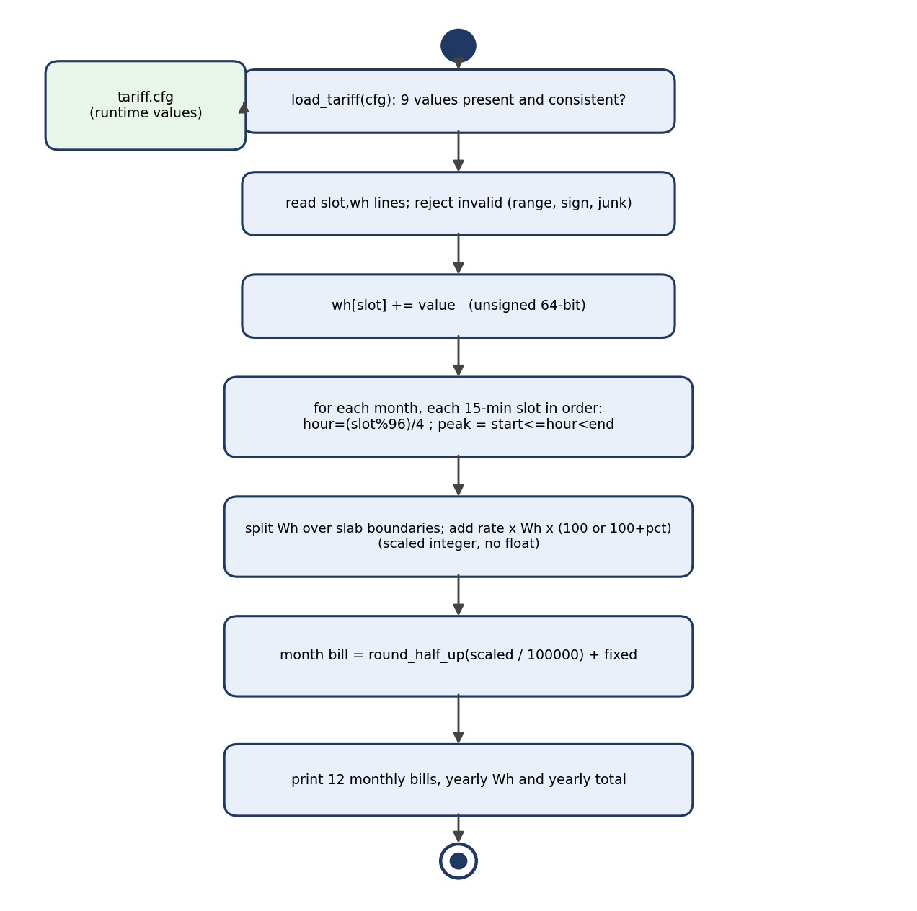
Figure 12.2: UML activity diagram of the redesigned program

Design
- Types: energy in unsigned long long Wh (64-bit); money in unsigned long long paise; charge accumulated in units of 10^-5 paise (rate x Wh x percent) and rounded once per monthly bill: (scaled + 50000) / 100000.
- Peak rule: hour = (slot % 96) / 4; the interval is peak when start <= hour < end; the price factor is 100 + surcharge percent, all integer.
- Slabs and straddling: the month's cumulative Wh is tracked; a reading that crosses 100,000 or 200,000 Wh is split between slabs, so each Wh is charged at the rate of the slab it falls in; readings are processed in time order.
- Configuration: nine values in tariff12.cfg, read at start-up and validated (all present; slab2 > slab1; peak window valid; percentage <= 100). The program stops with a message otherwise.
- Input: slot,wh lines; invalid lines (letters, negative, slot out of range, value above 65,535 Wh per interval - a meter fault, extra fields) are rejected and counted; a missing slot is zero.
- Memory: one year of one house = 35,040 x 8 bytes = 280,320 bytes (static array).
Pseudocode
load tariff (9 values) and validate
wh[0..35039] <- 0
for each line "slot,wh": validate; wh[slot] += value
for month m in January..December:
cum <- 0; scaled <- 0
for each slot s of the month, in time order:
pct <- 100 + (surcharge if start <= hour(s) < end else 0)
left <- wh[s]
for slab k in 1..3 while left > 0:
room <- limit[k] - cum; part <- min(left, room)
scaled <- scaled + rate[k] * part * pct; cum += part; left -= part
bill <- round_half_up(scaled / 100000) + fixed
print the 12 bills, yearly Wh and yearly total

Task12/smart_bill.c
/* Task 12 - redesigned billing program for 15-minute smart-meter readings (Wh) with a time-of-day tariff.
usage: ./smart_bill <tariff.cfg> <readings.csv>
readings.csv : lines "slot,wh" slot = 0..35039 (15-minute interval of the year), wh = energy in that interval.
Missing slots mean zero consumption. Types: Wh and money use unsigned 64-bit / long long. */
#include <stdio.h>
#include <stdlib.h>
#include <string.h>
#include <time.h>

#define SLOTS_PER_DAY 96
#define SLOTS_PER_YEAR 35040
#define MAX_WH_PER_SLOT 65535ULL /* ~262 kW for 15 minutes: anything larger is a meter fault */
#define SCALE 100000ULL /* rate(paise/kWh) * Wh * percent -> 1e-5 paise */

typedef unsigned long long u64;

typedef struct {
u64 slab1_kwh, slab2_kwh;
u64 rate[3]; /* paise per kWh */
u64 fixed;
int peak_start, peak_end; /* hours 0..24 */
u64 peak_pct;
} Tariff;

static const int days_in_month[12] = {31, 28, 31, 30, 31, 30, 31, 31, 30, 31, 30, 31};
static const char *month_name[12] = {"Jan","Feb","Mar","Apr","May","Jun","Jul","Aug","Sep","Oct","Nov","Dec"};

static int load_tariff(const char *path, Tariff *t)
{
FILE *fp = fopen(path, "r");
char line[128];
int got = 0;
if (!fp) return -1;
while (fgets(line, sizeof line, fp)) {
char key[40]; long long v;
if (line[0] == '#' || sscanf(line, "%39[^=]=%lld", key, &v) != 2) continue;
if (!strcmp(key, "slab1_kwh")) { t->slab1_kwh = (u64)v; got++; }
else if (!strcmp(key, "slab2_kwh")) { t->slab2_kwh = (u64)v; got++; }
else if (!strcmp(key, "rate1_paise")) { t->rate[0] = (u64)v; got++; }
else if (!strcmp(key, "rate2_paise")) { t->rate[1] = (u64)v; got++; }
else if (!strcmp(key, "rate3_paise")) { t->rate[2] = (u64)v; got++; }
else if (!strcmp(key, "fixed_paise")) { t->fixed = (u64)v; got++; }
else if (!strcmp(key, "peak_start_hour")) { t->peak_start = (int)v; got++; }
else if (!strcmp(key, "peak_end_hour")) { t->peak_end = (int)v; got++; }
else if (!strcmp(key, "peak_surcharge_pct")) { t->peak_pct = (u64)v; got++; }
}
fclose(fp);
if (got != 9) return -2;
if (t->slab2_kwh <= t->slab1_kwh || t->peak_start < 0 || t->peak_end > 24 || t->peak_start >= t->peak_end || t->peak_pct > 100) return -3;
return 0;
}

static void money(char *buf, size_t n, u64 paise) { snprintf(buf, n, "Rs %llu.%02llu", paise / 100, paise % 100); }

int main(int argc, char **argv)
{
if (argc < 3) { printf("usage: %s tariff.cfg readings.csv\n", argv[0]); return 2; }
Tariff t = {0};
int rc = load_tariff(argv[1], &t);
if (rc == -1) { printf("ERROR: cannot open tariff file %s\n", argv[1]); return 1; }
if (rc == -2) { printf("ERROR: tariff file %s is incomplete\n", argv[1]); return 1; }
if (rc == -3) { printf("ERROR: tariff file %s has inconsistent values (slabs/peak hours/percent)\n", argv[1]); return 1; }

static u64 wh[SLOTS_PER_YEAR]; /* 35,040 x 8 bytes = 280,320 bytes per house-year */
FILE *fp = fopen(argv[2], "r");
if (!fp) { printf("ERROR: cannot open readings file %s\n", argv[2]); return 1; }
char line[128]; long lineno = 0, good = 0, bad = 0;
clock_t c0 = clock();
while (fgets(line, sizeof line, fp)) {
long long slot, v; char extra;
lineno++;
if (sscanf(line, "%lld,%lld %c", &slot, &v, &extra) != 2 || slot < 0 || slot >= SLOTS_PER_YEAR || v < 0 || (u64)v > MAX_WH_PER_SLOT) {
printf("Line %ld: INVALID reading rejected: %.*s\n", lineno, (int)strcspn(line, "\r\n"), line);
bad++;
continue;
}
wh[slot] += (u64)v;
good++;
}
fclose(fp);

u64 year_wh = 0, year_paise = 0, peak_wh_year = 0;
int first_slot = 0;
printf("%-4s %12s %12s %14s\n", "Mon", "total Wh", "peak Wh", "bill");
for (int m = 0; m < 12; m++) {
int slots = days_in_month[m] * SLOTS_PER_DAY;
u64 cum = 0, month_wh = 0, peak_wh = 0, scaled = 0;
for (int s = first_slot; s < first_slot + slots; s++) {
u64 left = wh[s];
int hour = (s % SLOTS_PER_DAY) / 4;
int is_peak = hour >= t.peak_start && hour < t.peak_end;
u64 pct = 100 + (is_peak ? t.peak_pct : 0);
u64 limit[3] = { t.slab1_kwh * 1000ULL, t.slab2_kwh * 1000ULL, ~0ULL };
month_wh += left;
if (is_peak) peak_wh += left;
for (int k = 0; k < 3 && left > 0; k++) { /* an interval may straddle a slab boundary */
u64 room = limit[k] > cum ? limit[k] - cum : 0;
u64 part = left < room ? left : room;
scaled += t.rate[k] * part * pct;
cum += part; left -= part;
}
}
first_slot += slots;
u64 energy = (scaled + SCALE / 2) / SCALE; /* round half up, once per bill */
u64 bill = energy + t.fixed;
char b[32]; money(b, sizeof b, bill);
printf("%-4s %12llu %12llu %14s\n", month_name[m], month_wh, peak_wh, b);
year_wh += month_wh; peak_wh_year += peak_wh; year_paise += bill;
}
char yb[32]; money(yb, sizeof yb, year_paise);
printf("YEAR %12llu %12llu %14s\n", year_wh, peak_wh_year, yb);
printf("readings accepted = %ld, rejected = %ld, processing time = %.3f ms\n", good, bad, (double)(clock() - c0) * 1000.0 / CLOCKS_PER_SEC);
return 0;
}

Task12/tariff12.cfg (runtime tariff)
# Smart-meter tariff (paise per kWh). Changeable without recompiling.
slab1_kwh=100
slab2_kwh=200
rate1_paise=0
rate2_paise=225
rate3_paise=450
fixed_paise=5000
peak_start_hour=18
peak_end_hour=22
peak_surcharge_pct=20

Testing
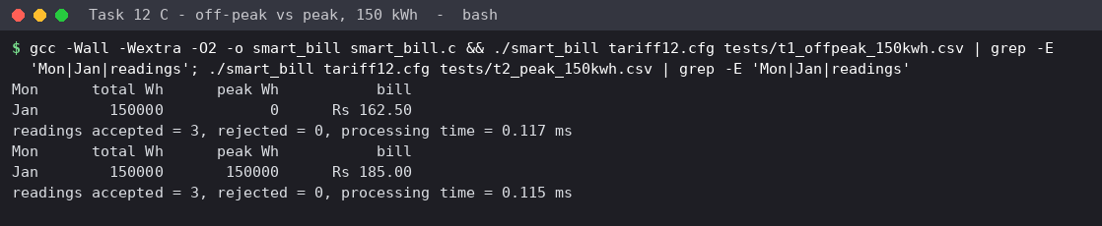
Figure 12.3: tests T1 (off-peak) and T2 (peak) for 150 kWh
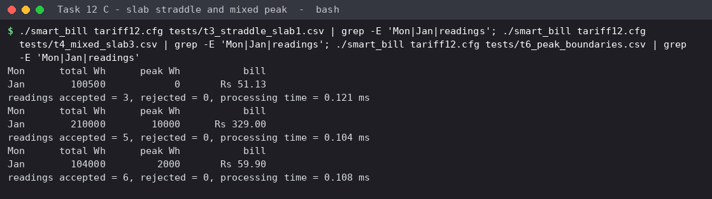
Figure 12.4: tests T3 (slab straddle), T4 (mixed peak) and T6 (peak boundaries)
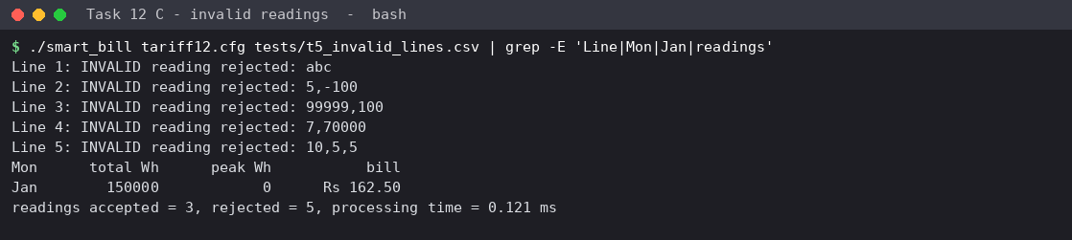
Figure 12.5: invalid readings rejected while the valid ones are billed
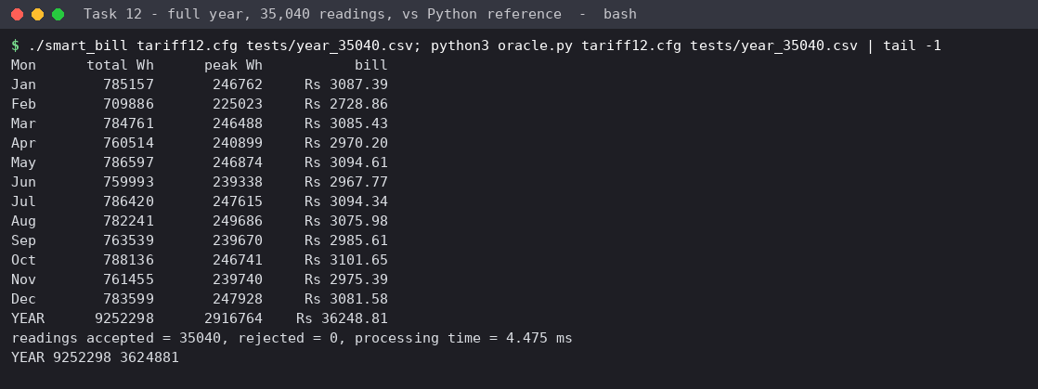
Figure 12.6: a full year of 35,040 readings and the independent Python check
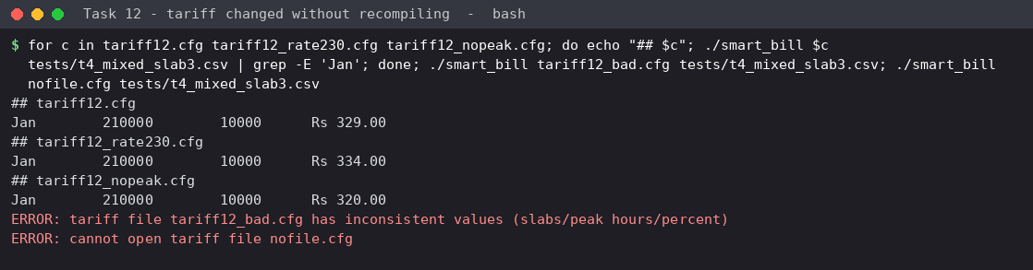
Figure 12.7: the same executable with three different tariff files, and two bad-configuration cases
# | Case | Expected (hand calculation) | Actual | Result
1 | T1 off-peak 150 kWh | 150 kWh x slab rule = Rs 162.50 (same as original design) | Jan 150000 0 Rs 162.50 | PASS
2 | T2 peak 150 kWh (18:00) | 100 free + 50 kWh x 2.25 x 1.2 = 135.00 + 50.00 = Rs 185.00 | Jan 150000 150000 Rs 185.00 | PASS
3 | T3 reading straddles 100 kWh boundary | 500 Wh x 2.25 = 112.5 paise -> 113 (round half up) + 50.00 = Rs 51.13 | Jan 100500 0 Rs 51.13 | PASS
4 | T4 200 kWh off-peak + 10 kWh peak | 50.00 + 225.00 + 10 x 4.50 x 1.2 (54.00) = Rs 329.00 | Jan 210000 10000 Rs 329.00 | PASS
5 | T6 peak boundaries 17:45/18:00/21:45/22:00 | 2 x 1000 Wh at 2.25 + 2 x 1000 Wh at 2.70 = 9.90 + 50.00 = Rs 59.90 | Jan 104000 2000 Rs 59.90 | PASS
6 | T4 with tariff12_rate230.cfg (no recompile) | slab 2 now 2.30: 50.00 + 230.00 + 54.00 = Rs 334.00 | Jan 210000 10000 Rs 334.00 | PASS
7 | T4 with peak surcharge 0 % | 50.00 + 225.00 + 45.00 = Rs 320.00 | Jan 210000 10000 Rs 320.00 | PASS
8 | T5 five invalid lines + 3 valid readings | 5 lines rejected; January = Rs 162.50 | Jan 150000 0 Rs 162.50 | readings accepted = 3, rejected = 5, processing time = 0.100 ms | PASS
9 | Bad tariff file (peak start 22 > end 18) | program stops with an error message | ERROR: tariff file tariff12_bad.cfg has inconsistent values (slabs/peak hours/percent) | PASS
10 | Missing tariff file | program stops with an error message | ERROR: cannot open tariff file nofile.cfg | PASS
11 | Full year, 35,040 readings, vs independent Python calculation | Python reference: YEAR 9252298 3624881 -> Rs 36248.81 | YEAR 9252298 2916764 Rs 36248.81 | PASS

11 of 11 cases pass. The full-year result was cross-checked against an independent exact implementation written in Python (oracle.py): both give 3,624,881 paise = Rs 36,248.81 and 9,252,298 Wh.

D. Evidence-Based Defence (2 marks)
Decision | Evidence | Trade-off
Wh in 64-bit unsigned | Figure 12.1: month 7.4 x 10^6 Wh (113 x the 16-bit limit); district year 7.0 x 10^13 Wh (16,000 x the 32-bit limit, 0.00038 % of 64-bit) | 8 bytes per value instead of 2: a house-year array costs 280,320 bytes instead of 70,080, which is trivial per house; district totals are summed per house, not stored together
Integer scaled arithmetic, one rounding per bill | T3: 112.5 paise rounds to 113 - the exact half-paise case; year total equals the independent Python result to the paise | a slightly unusual scale (10^-5 paise) must be documented; the scaled accumulator fits 64 bits with margin (4.0 x 10^11 vs 1.8 x 10^19)
Peak rule by hour of slot, boundaries inclusive-exclusive | T6: 17:45 and 22:00 charged at the normal rate, 18:00 and 21:45 at +20 %: 9.90 + 50.00 = Rs 59.90 | the peak window applies to the meter's clock; the program assumes the slot number is already in local time
Tariff in a configuration file | Figure 12.7: slab-2 rate 225 to 230 raises T4 from Rs 329.00 to Rs 334.00; peak 0 % gives Rs 320.00; bad file stops the program | start-up parsing (microseconds, Task 11) and a new failure mode, handled by validation; the file must be protected from unauthorised edits
Slab applied to cumulative Wh in time order | T3: the reading that crosses 100 kWh is split; no jump in the bill | the result depends on the order of readings; the readings must be in time order (the array indexed by slot guarantees this)
Process readings in one pass per house | full year of 35,040 readings processed in 4.7 ms including file parsing (1 house) | a district would need 800,000 x 4.7 ms = about 3,700 s (about one hour) on one core, acceptable for a monthly batch and easy to run in parallel per house

Why not simply retain or modify? *Retain* fails by measurement: the 16-bit register reports 100,000 Wh as 34,464 Wh (a wrong bill without any error message), and a #define tariff cannot meet the board's requirement. *Modify* (keeping meter_t and adding a few lines) cannot work either: the type itself is too small. Only the integer-paise principles survive, so the right decision is a redesign that reuses those principles - which also kept the new program small (about 120 lines) and let the tests of Tasks 3 and 9 be reused as hand-calculation oracles (T1 reproduces the old Rs 162.50 for 150 kWh when no peak consumption occurs).
Residual risks: the 10 kW maximum and the 65,535 Wh-per-interval meter-fault limit are assumptions to be confirmed with the meter specification; time-zone and daylight-saving handling of the slot clock is outside this program; very large districts may need streaming (one house at a time, as here) rather than loading all data.
Evidence for Task 12: impact analysis with computed maxima, an evaluation of each part of the original design, a working redesigned program with 11 passing tests plus an independent cross-check, and a defence in which every decision cites a calculation, test or measurement.

Overall Conclusions and Submission Checklist
Task | Key result
1 | Data items, constants, rules and assumptions defined; integer readings are 2x-6x faster to subtract than text and use less space
2 | float total off by Rs 0.02 after 4,000 bills while integer paise is exact; (meter_t)(current - previous) gives 256 at roll-over
3 | Tariff in one place; RATE2 230 change affects all slab-2 bills consistently; #define vs const vs enum compared
4 | SQUARE(a+1) = 7 and MAX(i++, j) double increment shown with gcc -E; inline functions avoid both
5 | Include guard prevents redefinition errors; -DDEBUG tracing adds 362 bytes only to debug builds; run-time flag costs about 0.5 - 0.8 ns per call
6 | Specifier mistakes produce wrong values silently; scanf can swallow the next line - fgets + sscanf is safer
7 | Six conversion surprises explained; float error reaches Rs 305,381.90 at 800,000 bills
8 | All compilation stages and error classes demonstrated; separate compilation rebuilds in 29-44 ms vs 56-70 ms
9 | 21/21 test cases pass, five-bill total Rs 2590.00 equals the hand calculation
10 | int overflows at 60,000 bills already; double of whole paise is exact up to 2^53
11 | Final design: integer paise, unsigned short meter, long long totals, tariff in a validated file (2.7 us start-up, 21,000x cheaper than recompiling)
12 | Redesign with 64-bit Wh, peak rule and runtime tariff: 11/11 tests pass and the year total equals an independent Python calculation

Submission checklist
- Create the repository CSA02-<RegisterNumber>-Assignment1, share it with the faculty, and replace the link placeholder on the cover page.
- Commit task by task (the local repository supplied with this report already contains one commit per task).
- Fill in your register number in README.md and on the cover page.
- Be ready to explain any program during the viva: especially the modular subtraction in Task 2, the slab formula in Task 3, why scanf was replaced in Task 9, and the scaled-integer rounding in Task 12.

