EXPERIMENT 01 – ALTERNATIVE VALUES

Aim
To simulate and compare the Bit Error Rate (BER) of Zigbee, 6LoWPAN, and NB-IoT technologies at different communication distances using an alternative set of assumed parameters.

Short Procedure
- Import NumPy, Matplotlib, and SciPy libraries.
- Define communication distances from 20 m to 1200 m.
- Set the alternative transmission power, reference path loss, path loss exponent, and noise power for each technology.
- Calculate path loss, received power, and SNR at each distance.
- Convert SNR from dB to linear scale and calculate BER using the complementary error function (erfc).
- Plot BER against distance on a logarithmic y-axis and compare the three technologies.

Python Programming Code
import numpy as np
import matplotlib.pyplot as plt
from scipy.special import erfc
# Alternative communication distances
distance = np.linspace(20, 1200, 100)
# Common BER model: BER = 0.5 * erfc(sqrt(SNR_linear))
def calculate_ber(Pt, PL0, n, N, distance):
PL = PL0 + 10 * n * np.log10(distance)
Pr = Pt - PL
SNR_dB = Pr - N
SNR_linear = 10 ** (SNR_dB / 10)
BER = 0.5 * erfc(np.sqrt(SNR_linear))
return BER
# 1. Zigbee - alternative assumed parameters
ber_zigbee = calculate_ber(
Pt=2, # Transmit power (dBm)
PL0=38, # Reference path loss (dB)
n=2.7, # Path loss exponent
N=-105, # Noise power (dBm)
distance=distance
)
# 2. 6LoWPAN - alternative assumed parameters
ber_6lowpan = calculate_ber(
Pt=5,
PL0=42,
n=2.9,
N=-108,
distance=distance
)
# 3. NB-IoT - alternative assumed parameters
ber_nbiot = calculate_ber(
Pt=20,
PL0=30,
n=3.2,
N=-110,
distance=distance
)
# Plot all technologies for comparison
plt.figure(figsize=(8, 5))
plt.semilogy(distance, np.maximum(ber_zigbee, 1e-15), label="Zigbee")
plt.semilogy(distance, np.maximum(ber_6lowpan, 1e-15), label="6LoWPAN")
plt.semilogy(distance, np.maximum(ber_nbiot, 1e-15), label="NB-IoT")
plt.xlabel("Distance (m)")
plt.ylabel("Bit Error Rate (BER)")
plt.title("BER vs Distance Using Alternative Parameters")
plt.grid(True, which="both")
plt.legend()
plt.tight_layout()
plt.show()
# Print BER at the first and last simulated distances
print("Distance:", distance[0], "m")
print("Zigbee BER:", ber_zigbee[0])
print("6LoWPAN BER:", ber_6lowpan[0])
print("NB-IoT BER:", ber_nbiot[0])
print("\\nDistance:", distance[-1], "m")
print("Zigbee BER:", ber_zigbee[-1])
print("6LoWPAN BER:", ber_6lowpan[-1])
print("NB-IoT BER:", ber_nbiot[-1])

Alternative Parameter Values
Technology | Transmit Power Pt (dBm) | Path Loss PL0 (dB) | Path Loss Exponent n | Noise Power N (dBm)
Zigbee | 2 | 38 | 2.7 | -105
6LoWPAN | 5 | 42 | 2.9 | -108
NB-IoT | 20 | 30 | 3.2 | -110
Note: These are illustrative simulation assumptions for demonstrating how parameter changes affect BER. They are not universal or guaranteed real-world specifications for the technologies.

Graphs and Interpretation
The following plots are generated using the alternative parameter values listed in this document. The combined graph compares the three technologies; individual graphs make each curve easier to read.

Combined Comparison: BER vs Distance
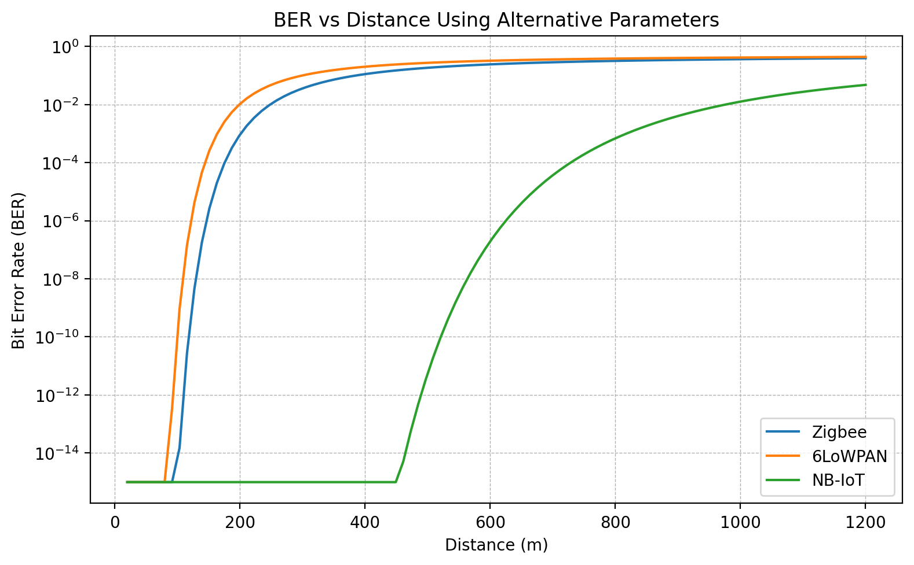

Zigbee: BER vs Distance
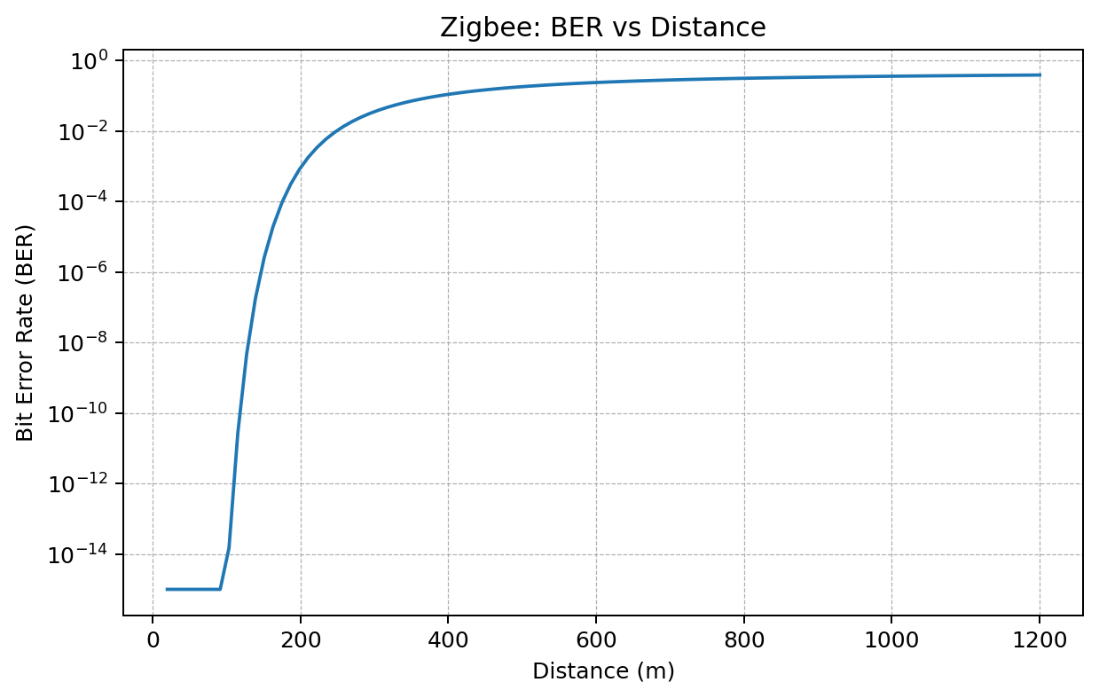

6LoWPAN: BER vs Distance
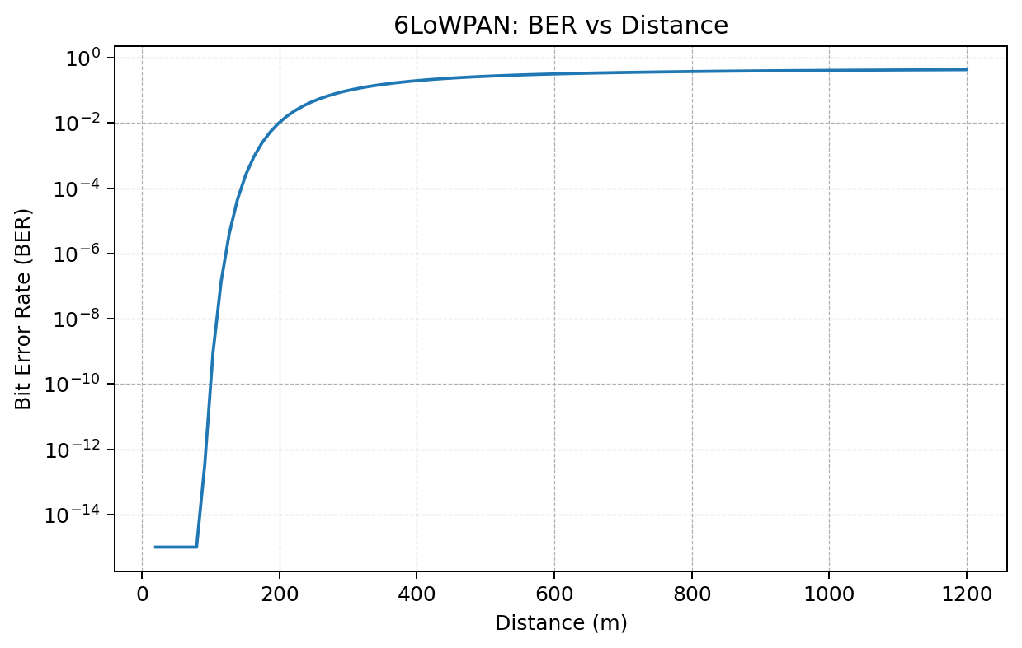

NB-IoT: BER vs Distance
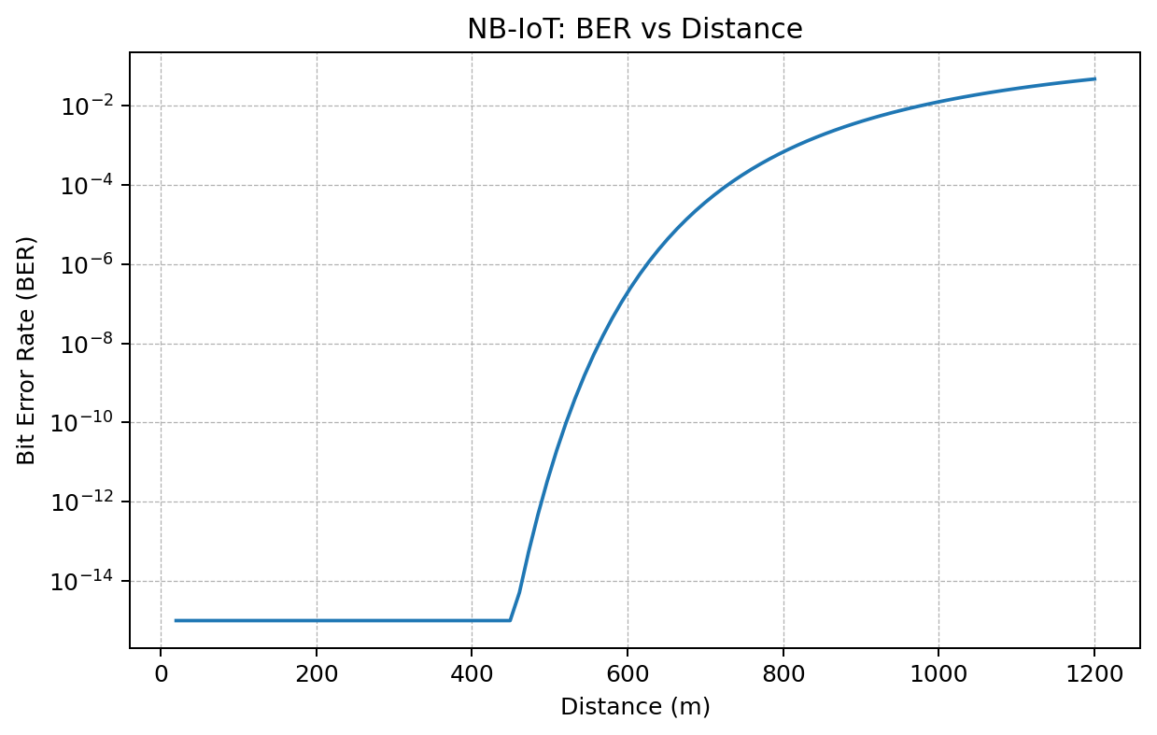

How to Read the Graphs
X-axis: communication distance in metres (m). Moving right means the transmitter and receiver are farther apart.
Y-axis: bit error rate (BER) on a logarithmic scale. Lower values indicate fewer bit errors; higher values indicate poorer link performance.
Each curve shows the calculated BER from the model at the specified distance. Compare curves at the same distance to compare the assumed parameter sets.
These are simulation results from the stated assumptions, not measured field data. The simplified BER formula does not capture every protocol-specific effect.

Result
The BER of Zigbee, 6LoWPAN, and NB-IoT can be simulated using the alternative parameter values. The combined logarithmic plot enables comparison of how communication distance and the assumed link-budget parameters influence the calculated BER. Results are model-dependent and should be interpreted as simulation outputs rather than measured field performance.

