EXPERIMENT 5a
Simulation and Performance Evaluation of RFID/NFC-Based Device Identification and IoE Data Integration using Node-RED and MQTT
OBJECTIVE
The main aim of this experiment is to simulate an RFID/NFC-based device identification system and to see how the data read from a tag can be passed on to other devices over the network. For this, we use Node-RED as the visual programming tool and MQTT as the messaging protocol, so that we can understand how things work in an Internet of Everything (IoE) set-up without needing any physical reader hardware.
Through this experiment we try to achieve the following:
- To understand how an RFID tag can represent the identity of a person or a device.
- To build a small flow in Node-RED where one side acts as the tag and the other side acts as the edge device (reader).
- To publish and subscribe to data using an MQTT broker and check that the message reaches the correct end.
- To observe the performance of the flow, such as whether the connection is stable and how quickly the data is received.
PROCEDURE
Requirements
Node-RED (running on a laptop/PC), an MQTT broker (such as Mosquitto or a public test broker), and a web browser to open the Node-RED editor at localhost:1880.
Steps followed
- Started Node-RED and opened the editor in the browser. A new tab called Flow 1 was used for the experiment.
- Created the first group and named it RFID-TAG. This group represents the tag side, which sends out the identity data.
- Inside this group, dragged an inject node (shown as timestamp in the flow) so that the data could be triggered manually whenever needed.
- Added a function node named USER_DETAILS. In this node, a small JavaScript code was written to create the tag details such as tag ID, user name and a time value, and to put them in the message payload.
- Connected an MQTT out node (MQTT Publisher) after it. The broker address and a topic name were set in the node settings. Once the node showed the green connected label, it was clear that the broker link was working.
- Created the second group and named it EDGE_DEVICE. This is the reader or receiving side.
- Placed an MQTT in node (MQTT Subscriber) here, using the same broker and same topic as the publisher, otherwise the data will not be received.
- Connected it to another function node called RFID_READER, which reads the incoming message, checks the tag details and prepares them for display.
- Finally, linked a debug node to the output so that the received message can be seen in the debug sidebar.
- Clicked the Deploy button at the top right corner to start the flow.
- Pressed the button on the inject node, watched the debug window, and noted down the output. The process was repeated a few times to check whether the result stayed the same each time.
OUTPUT
The screenshot below shows the final Node-RED flow after deployment. The upper group (RFID-TAG) sends the tag data and the lower group (EDGE_DEVICE) receives and displays it. Both MQTT nodes show the status connected.
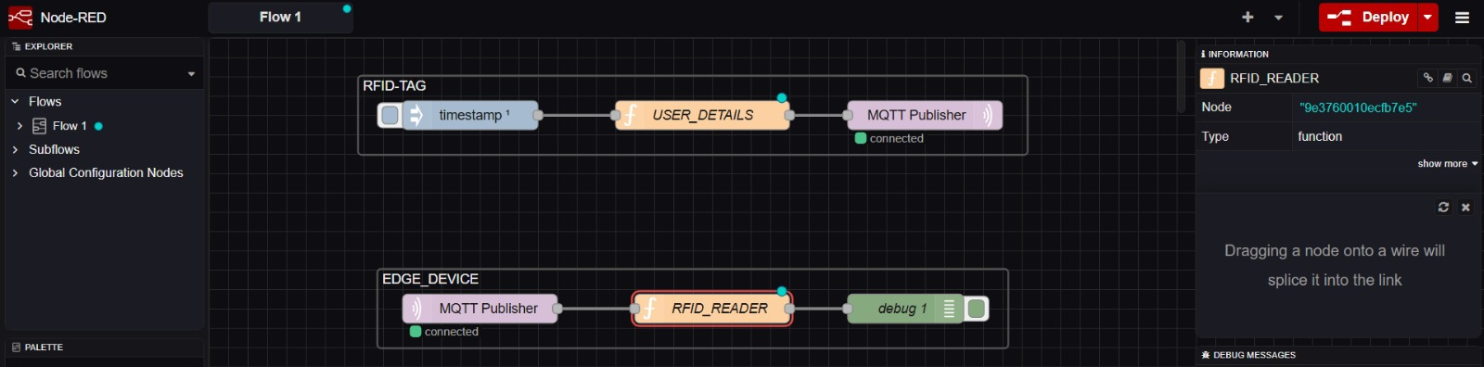
Fig. 5a.1 Node-RED flow for RFID tag and edge device communication using MQTT
RESULT
The RFID/NFC-based device identification was successfully simulated using Node-RED and MQTT. The tag data generated in the RFID-TAG section was published to the broker and was received correctly by the EDGE_DEVICE section, where it was read and shown in the debug window.
From the experiment it was seen that:
- Both MQTT nodes stayed connected to the broker throughout the run.
- The message reached the edge device almost instantly, with no noticeable delay and no loss of data in the trials that were done.
- Using separate groups for the tag and the reader made the flow easy to follow and easy to debug.
Hence, it is concluded that Node-RED together with MQTT is a simple, light-weight and effective way to model device identification and to move the data into an IoE system. The same flow can later be extended to a real RFID/NFC reader, a database or a dashboard.

