EXPERIMENT 6a
Simulation and Performance Evaluation of People–Process–Data–Things IoE Framework using Edge/Fog-to-Cloud Pipeline with MQTT and Node-RED
OBJECTIVE
The main aim of this experiment is to simulate the People–Process–Data–Things (PPDT) framework of the Internet of Everything using an Edge/Fog-to-Cloud pipeline. Here, Node-RED is used to build the flow and MQTT is used to carry the data from one layer to the next, so that we can see how data travels from a device up to the cloud.
Through this experiment we try to achieve the following:
- To understand how people, process, data and things work together in an IoE system.
- To build a three-layer flow in Node-RED: the tag/device layer, the edge/fog layer and the cloud layer.
- To publish and subscribe the scan data through an MQTT broker using a common topic.
- To check the performance of the pipeline, such as connection stability and whether the data reaches the cloud correctly.
PROCEDURE
Requirements
Node-RED (running on a laptop/PC), an MQTT broker (such as Mosquitto or a public test broker), and a web browser to open the Node-RED editor at localhost:1880.
Steps followed
- Started Node-RED and opened the editor in the browser. The tab Flow 1 was used for the experiment.
- Created the first group named RFID-TAG. It has an inject node (timestamp), a function node USER_DETAILS which creates the tag data (tag ID, device ID, timestamp, temperature and status), and an MQTT out node to publish it.
- Created the second group named EDGE_DEVICE. This is the edge/fog layer. It has an MQTT in node to receive the scan data, a function node RFID_READER to read and process it, and a debug 1 node to display it.
- Created the third group named CLOUD. It has another MQTT in node connected to a debug 2 node, which acts as the cloud receiver.
- Set the same broker and the same topic (ioe/device/scan) in all the MQTT nodes. All three showed the green connected label.
- Clicked the Deploy button, then triggered the inject node a few times.
- Opened the debug messages sidebar and noted the data received at the edge and at the cloud.
OUTPUT
The screenshot below shows the final flow with the three groups, RFID-TAG, EDGE_DEVICE and CLOUD. The debug panel on the right shows the scan messages received on the topic ioe/device/scan by both debug 1 (edge) and debug 2 (cloud), for tags such as NFC003, RFID004 and UNKNOWN999.
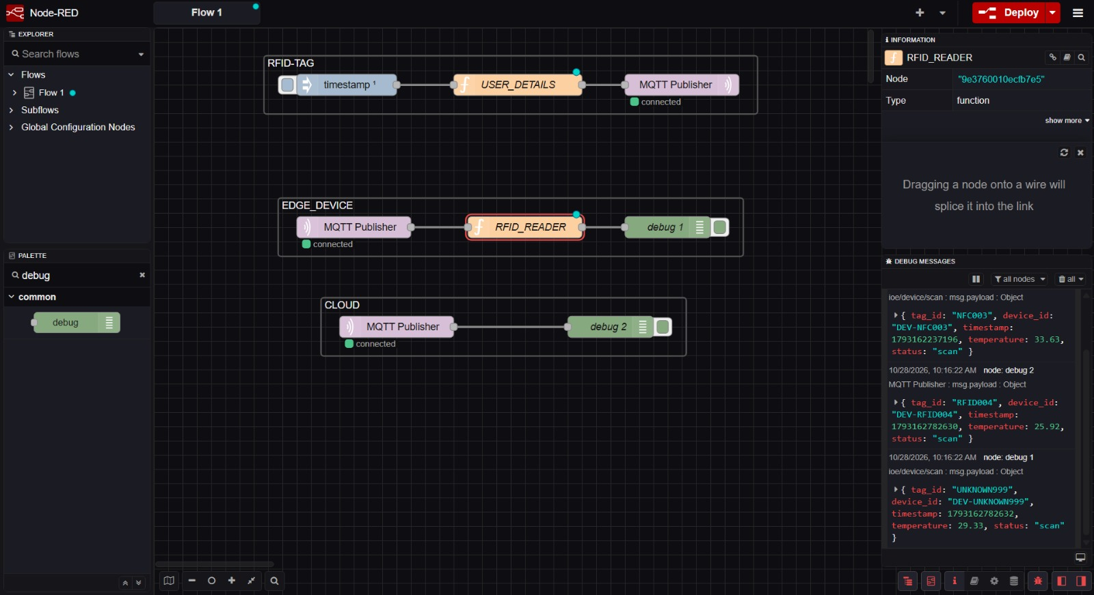
Fig. 6a.1 Edge/Fog-to-Cloud pipeline in Node-RED using MQTT
RESULT
The People–Process–Data–Things IoE framework was successfully simulated using an Edge/Fog-to-Cloud pipeline. The scan data generated at the tag side was published through MQTT, processed at the edge device and received at the cloud with the same values (tag ID, device ID, timestamp, temperature and status).
From the experiment it was seen that:
- All the MQTT nodes stayed connected to the broker throughout the run.
- The messages reached both the edge and the cloud almost instantly, with no noticeable delay and no loss of data.
- Even an unregistered tag (UNKNOWN999) was passed along properly, which shows that the pipeline delivers whatever is scanned.
Hence, it is concluded that Node-RED together with MQTT is a simple, light-weight and effective way to model the PPDT framework and the movement of data from the edge/fog layer to the cloud in an IoE system.

