SIMULATION AND PERFORMANCE EVALUATION OF
CROSS-PLATFORM EDGE AI MODEL DEPLOYMENT
USING ONNX AND PYTORCH MOBILE

1. Aim
To simulate and evaluate cross-platform Edge AI model deployment using PyTorch CPU, ONNX Runtime CPU and Mobile INT8 by comparing inference latency, throughput, speedup, model size, memory usage and accuracy.

2. Software Requirements
• Python 3
• NumPy
• Pandas
• Matplotlib
• Jupyter Notebook, Google Colab or any Python IDE

3. Algorithm / Procedure
- Import NumPy, Pandas and Matplotlib libraries.
- Set the number of test samples and baseline accuracy, model size and memory values.
- Define the three deployment configurations: PyTorch CPU, ONNX Runtime CPU and Mobile INT8.
- Set the relative compute, storage, accuracy and memory factors for each configuration.
- Calculate inference latency by adding preprocessing, inference and postprocessing time.
- Calculate total processing time, throughput and speedup.
- Calculate model storage, memory usage, storage reduction, memory reduction and accuracy retention.
- Display the results in a Pandas DataFrame.
- Generate bar charts for latency, throughput, speedup, model size, memory and accuracy.
- Calculate and print the improvements over the PyTorch CPU baseline.

4. Python Program
import numpy as np
import pandas as pd
import matplotlib.pyplot as plt

# 1. Simulation parameters
N = 10000

A_fp32 = 96.0
M_fp32 = 12.0
RAM_fp32 = 24.0

# Relative computational and storage factors
models = ["PyTorch CPU", "ONNX Runtime CPU", "Mobile INT8"]

compute_factor = np.array([1.0, 0.75, 0.55])
storage_factor = np.array([1.0, 0.90, 0.35])
accuracy_factor = np.array([1.0, 0.998, 0.990])
memory_factor = np.array([1.0, 0.85, 0.40])

# 2. Calculate performance using standard equations
T_pre = 0.3
T_post = 0.2
T_infer = 2.5 * compute_factor

latency = T_pre + T_infer + T_post
total_time = latency * N / 1000
throughput = N / total_time

speedup = latency[0] / latency
model_size = M_fp32 * storage_factor
memory = RAM_fp32 * memory_factor
accuracy = A_fp32 * accuracy_factor

storage_reduction = (M_fp32 - model_size) / M_fp32 * 100
memory_reduction = (RAM_fp32 - memory) / RAM_fp32 * 100
accuracy_retention = accuracy / A_fp32 * 100

# 3. Display results
results = pd.DataFrame({
"Framework": models,
"Latency (ms)": latency,
"Throughput (samples/sec)": throughput,
"Speedup (x)": speedup,
"Model Size (MB)": model_size,
"Storage Reduction (%)": storage_reduction,
"Memory (MB)": memory,
"Memory Reduction (%)": memory_reduction,
"Accuracy (%)": accuracy,
"Accuracy Retention (%)": accuracy_retention
})

print("SIMULATED PERFORMANCE EVALUATION")
print(results.round(2).to_string(index=False))

# 4. Plot comparisons
metrics = [
("Latency (ms)", "Inference Latency"),
("Throughput (samples/sec)", "Throughput"),
("Speedup (x)", "Speedup"),
("Model Size (MB)", "Model Storage"),
("Memory (MB)", "Memory Usage"),
("Accuracy (%)", "Accuracy")
]

for col, title in metrics:
plt.figure(figsize=(7, 4))
plt.bar(models, results[col])
plt.title(title + " Comparison")
plt.ylabel(col)
plt.xticks(rotation=10)
plt.grid(axis="y", alpha=0.3)
plt.tight_layout()
plt.show()

# 5. Display percentage improvements
print("\nIMPROVEMENT OVER PYTORCH CPU")

for i in range(1, len(models)):
print(f"\n{models[i]}")
print(f"Latency improvement: {(latency[0]-latency[i])/latency[0]*100:.2f}%")
print(f"Storage reduction: {storage_reduction[i]:.2f}%")
print(f"Memory reduction: {memory_reduction[i]:.2f}%")
print(f"Accuracy retention: {accuracy_retention[i]:.2f}%")

5. Output

Framework | Latency (ms) | Throughput (samples/sec) | Speedup (x) | Model Size (MB) | Storage Reduction (%) | Memory (MB) | Memory Reduction (%) | Accuracy (%) | Accuracy Retention (%)
PyTorch CPU | 3.0 | 333.33 | 1.0 | 12.0 | 0.0 | 24.0 | 0.0 | 96.0 | 100.0
ONNX Runtime CPU | 2.38 | 421.05 | 1.26 | 10.8 | 10.0 | 20.4 | 15.0 | 95.81 | 99.8
Mobile INT8 | 1.88 | 533.33 | 1.6 | 4.2 | 65.0 | 9.6 | 60.0 | 95.04 | 99.0

6. Graphical Results

Inference Latency Comparison
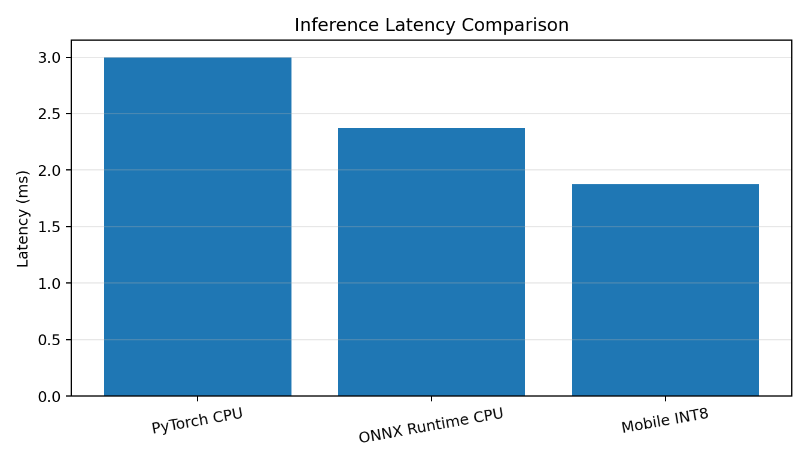

Throughput Comparison
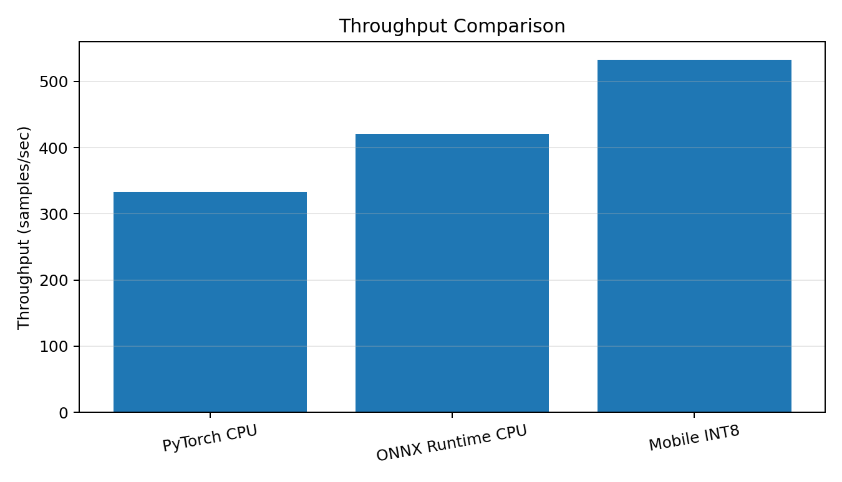

Speedup Comparison
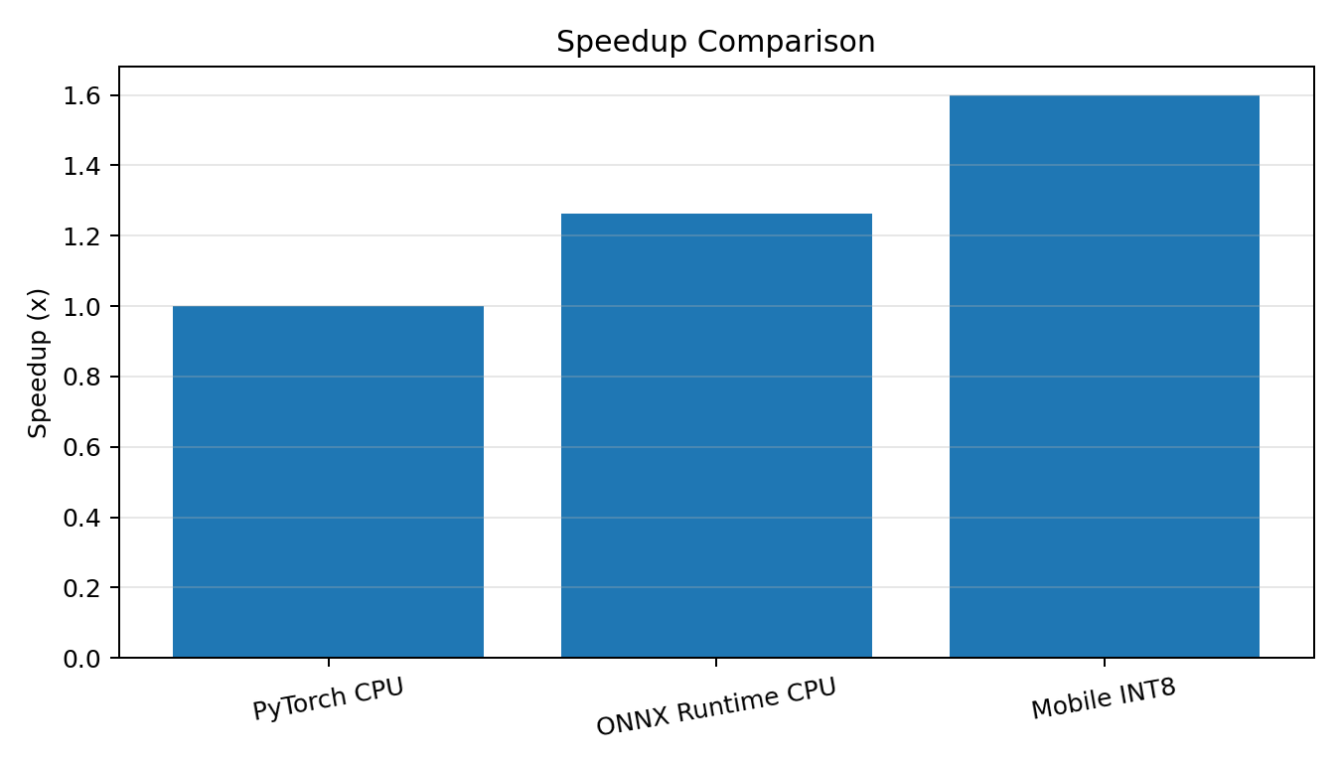

Model Storage Comparison
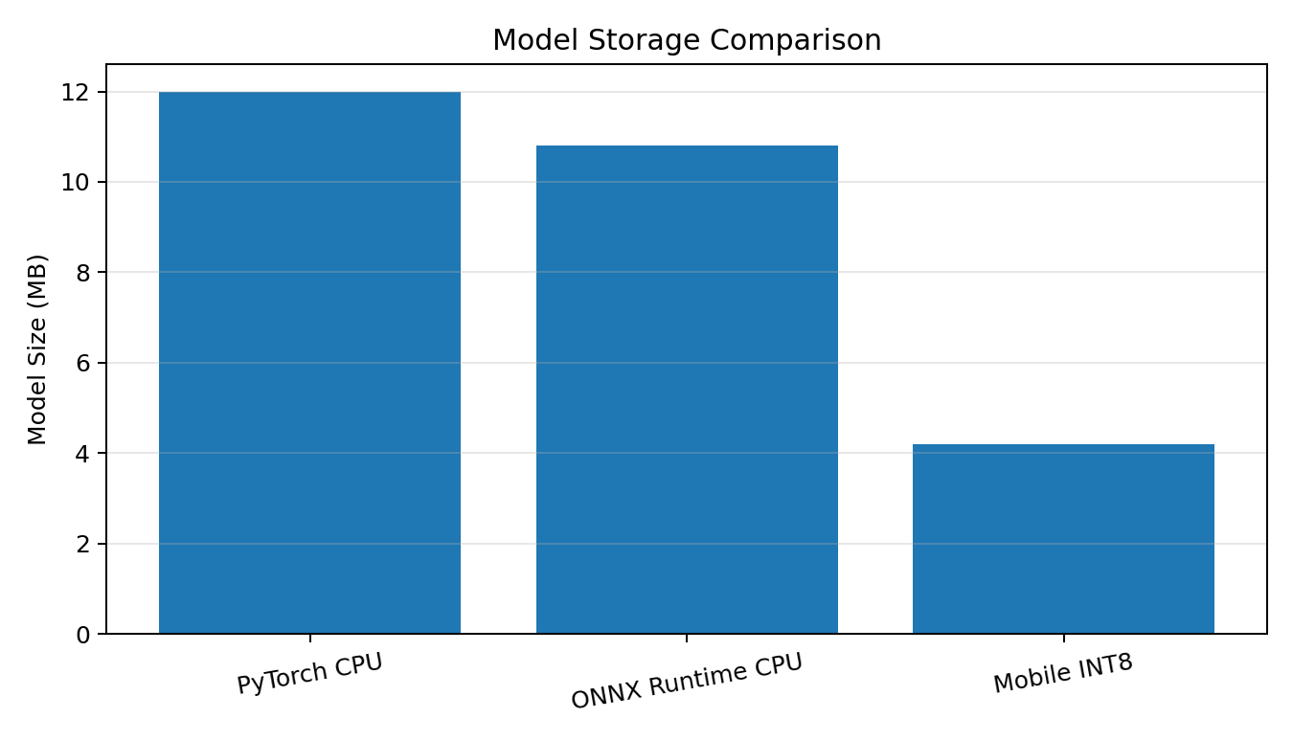

Memory Usage Comparison
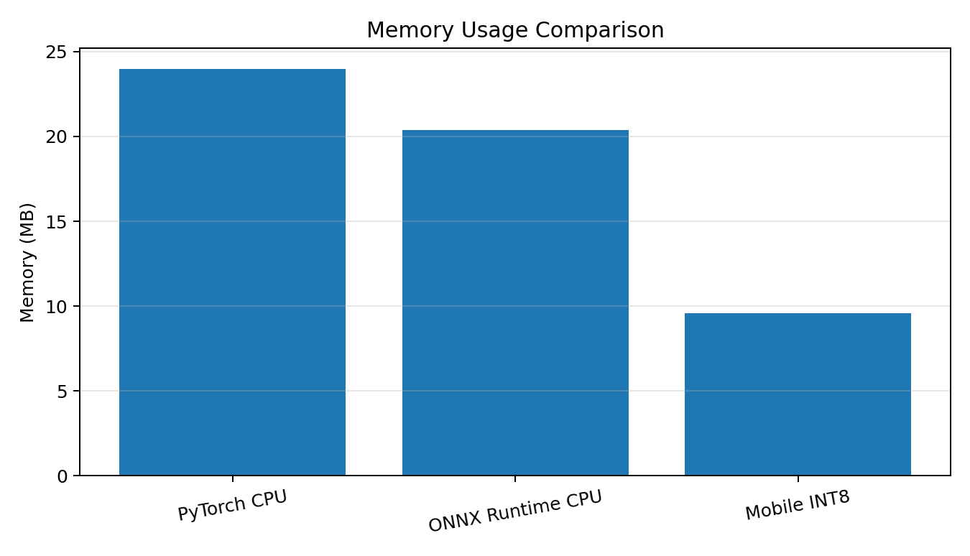

Accuracy Comparison
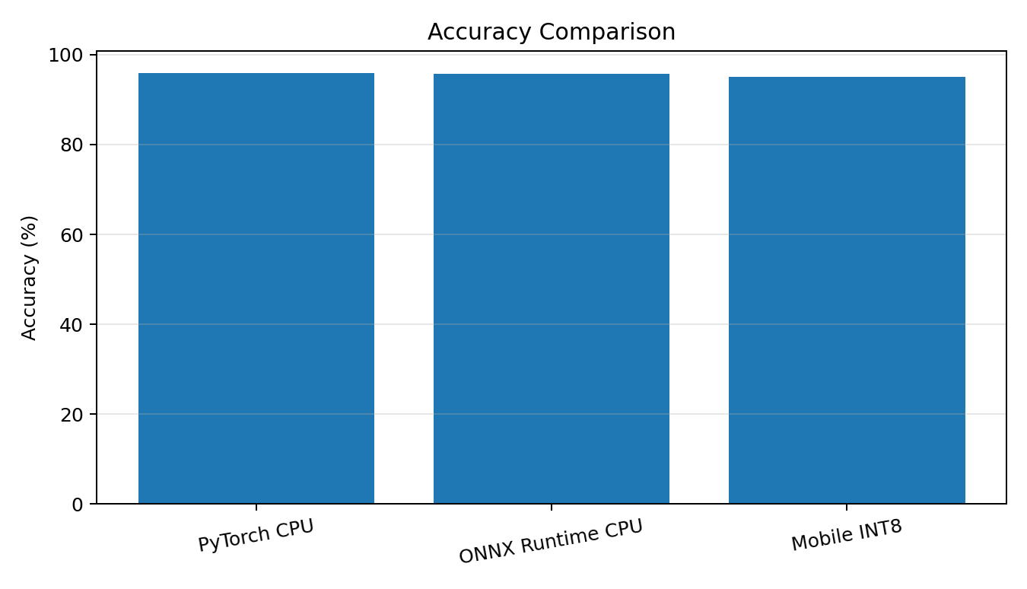

7. Improvement Over PyTorch CPU
Deployment | Latency Improvement | Storage Reduction | Memory Reduction | Accuracy Retention
ONNX Runtime CPU | 20.83% | 10.00% | 15.00% | 99.80%
Mobile INT8 | 37.50% | 65.00% | 60.00% | 99.00%

8. Result
The cross-platform Edge AI deployment simulation was completed successfully. Based on the assumed parameters, Mobile INT8 provides the best resource efficiency and speed, while maintaining 99.00% accuracy retention. ONNX Runtime CPU offers moderate performance and resource improvements with 99.80% accuracy retention.

