EXPERIMENT 3
Benchmarking of 5G/6G Communication for IoE Applications Based on Throughput, Latency, Reliability and Energy Efficiency

AIM
To benchmark the performance of a 5G network for Internet of Everything (IoE) applications based on throughput, latency, reliability, and energy efficiency for different numbers of connected devices.

Short Work Procedure
- Import the Matplotlib library and define the number of IoE devices.
- Set the assumed network capacity, base latency, packet success rate, and energy consumption.
- Calculate offered traffic load and network utilization for each device count.
- Calculate throughput, latency, reliability, and energy efficiency.
- Display the calculated performance values for each device count.
- Plot all four performance metrics in separate graphs using Matplotlib.

Python Program
import matplotlib.pyplot as plt
# Revised number of IoE devices
devices = [20, 60, 120, 180, 240, 320, 400, 480, 560, 640]
# Revised assumed network parameters
capacity = 120 # Mbps
base_latency = 8 # ms
packet_success_rate = 0.97
energy_per_packet = 0.0008 # Joules
# IoE device parameters
packet_size = 1000 # Bytes
packets_per_second = 18
simulation_time = 10 # Seconds
throughput = []
latency = []
reliability = []
energy_efficiency = []
offered_loads = []
for n in devices:
total_packets = n * packets_per_second * simulation_time
offered_load = n * packets_per_second * packet_size * 8 / 1e6
utilization = offered_load / capacity
# 1. Throughput (Mbps)
t = min(offered_load * packet_success_rate, capacity)
# 2. Latency (ms), increasing with congestion
u = min(utilization, 0.95)
l = base_latency + 8 * u / (1 - u)
# 3. Reliability (%), decreasing with congestion
r = 100 * packet_success_rate * max(0, 1 - 0.18 * utilization)
# 4. Energy efficiency (Mbit/J)
successful_packets = total_packets * r / 100
total_energy = total_packets * energy_per_packet * (1 + utilization)
e = successful_packets * packet_size * 8 / total_energy / 1e6
offered_loads.append(offered_load)
throughput.append(t)
latency.append(l)
reliability.append(r)
energy_efficiency.append(e)
print(f"\nIoE Devices: {n}")
print(f"Offered Load: {offered_load:.2f} Mbps")
print(f"Throughput: {t:.2f} Mbps")
print(f"Latency: {l:.2f} ms")
print(f"Reliability: {r:.2f} %")
print(f"Energy Efficiency: {e:.2f} Mbit/J")
# Plot all four performance metrics
metrics = [
(throughput, "Throughput (Mbps)"),
(latency, "Latency (ms)"),
(reliability, "Reliability (%)"),
(energy_efficiency, "Energy Efficiency (Mbit/J)")
]
fig, axes = plt.subplots(2, 2, figsize=(11, 8))
for ax, (values, title) in zip(axes.flat, metrics):
ax.plot(devices, values, marker="o")
ax.set_title(title)
ax.set_xlabel("Number of IoE Devices")
ax.set_ylabel(title)
ax.grid(True)
plt.suptitle("5G Performance Benchmarking for IoE Applications")
plt.tight_layout()
plt.show()

Output Graph
The four-panel graph below shows the revised simulation results for throughput, latency, reliability, and energy efficiency.
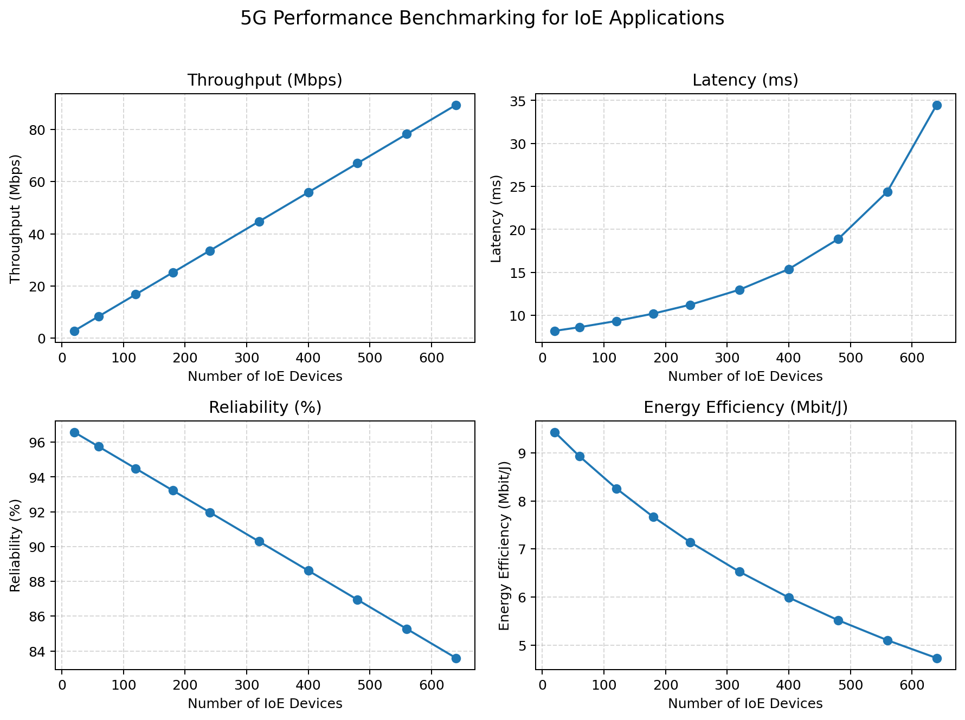

Calculated Output Readings
IoE Devices | Offered Load (Mbps) | Throughput (Mbps) | Latency (ms) | Reliability (%) | Energy Efficiency (Mbit/J)
20 | 2.88 | 2.79 | 8.20 | 96.58 | 9.43
60 | 8.64 | 8.38 | 8.62 | 95.74 | 8.93
120 | 17.28 | 16.76 | 9.35 | 94.49 | 8.26
180 | 25.92 | 25.14 | 10.20 | 93.23 | 7.67

Result
The performance of the assumed 5G network was simulated for the revised numbers of IoE devices. The graphs show throughput increasing with offered traffic until the capacity limit is approached, while latency increases as utilization rises. Reliability and energy efficiency generally decrease as the number of connected devices increases. These are simulated results based on the revised assumptions; actual network performance may differ.

