**Assignment 2 - Operating Systems in Practice Using Logs to Help You Track Down an Issue in Windows**

***Viewing Logs on Windows:***

**Event Viewer** application is used to view logs in Windows.

Step 1: Here, application logs are to be examined. To view application logs, click on **Windows Logs** and select **Application**

Step 2: Locate the logs to be fixed. Click on a log entry to view more details.

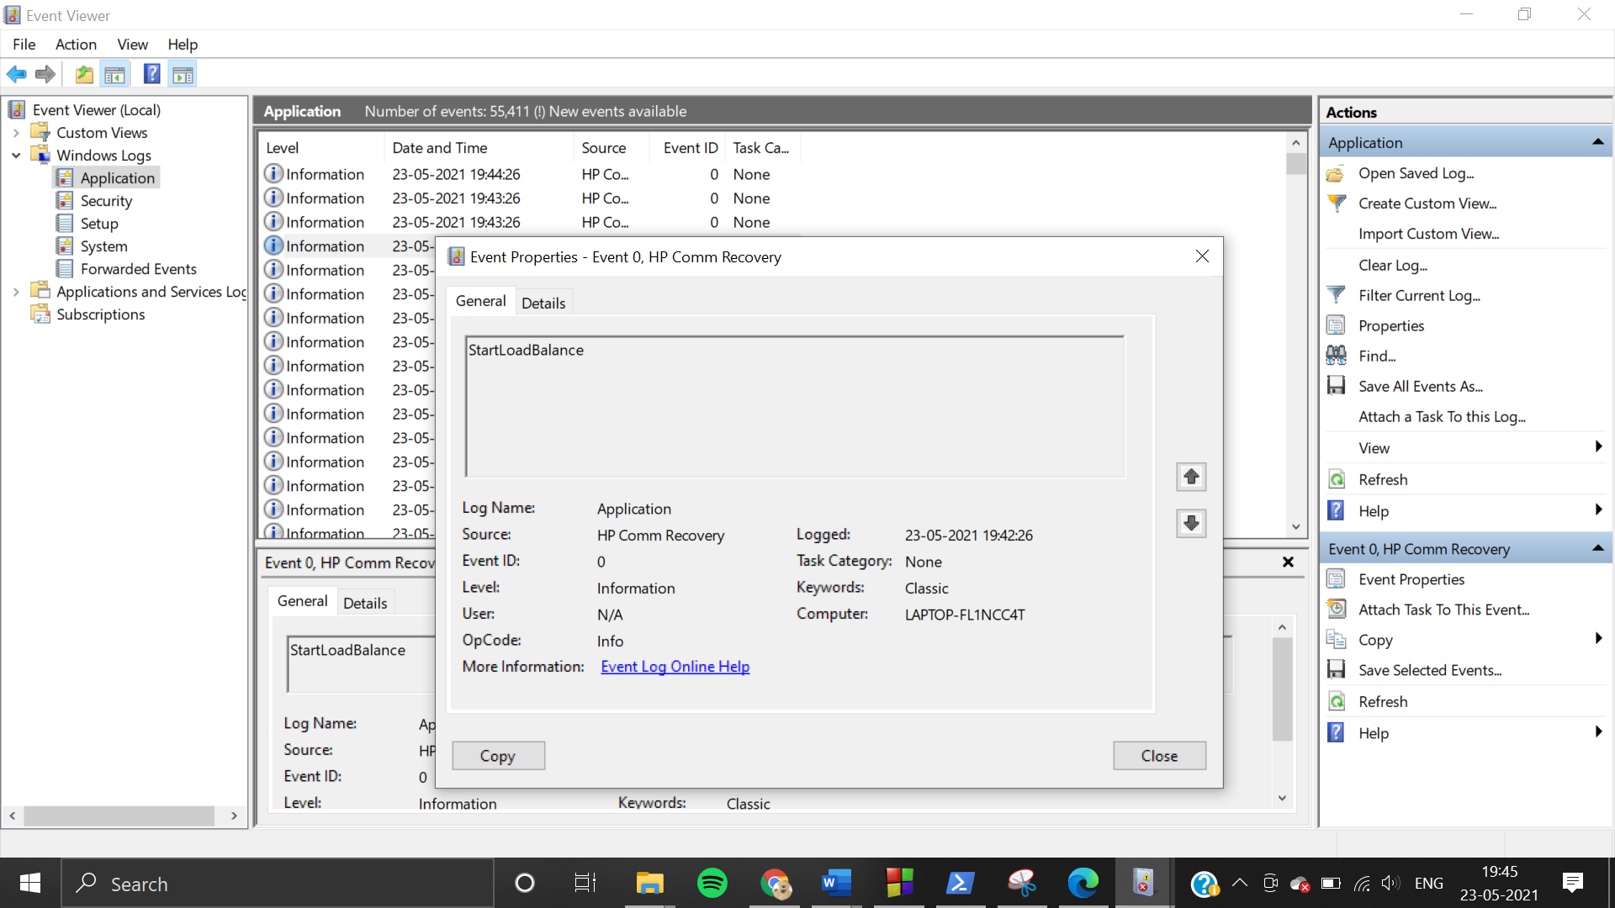

***1.Low Disk Space:***

This log warns about a large file that is taking up disk space, but it does not specify the file name.

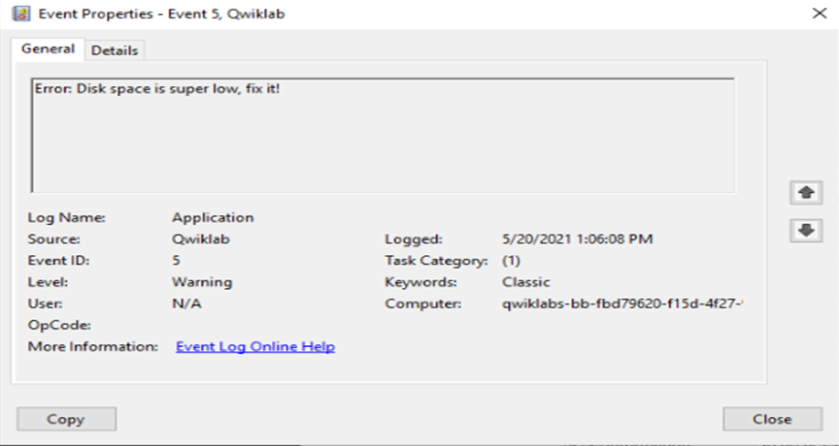

Step 1: Open file explorer and configure the search such that the size of the file is **‘gigantic’** (this locates files whose size exceeds 128 MB).

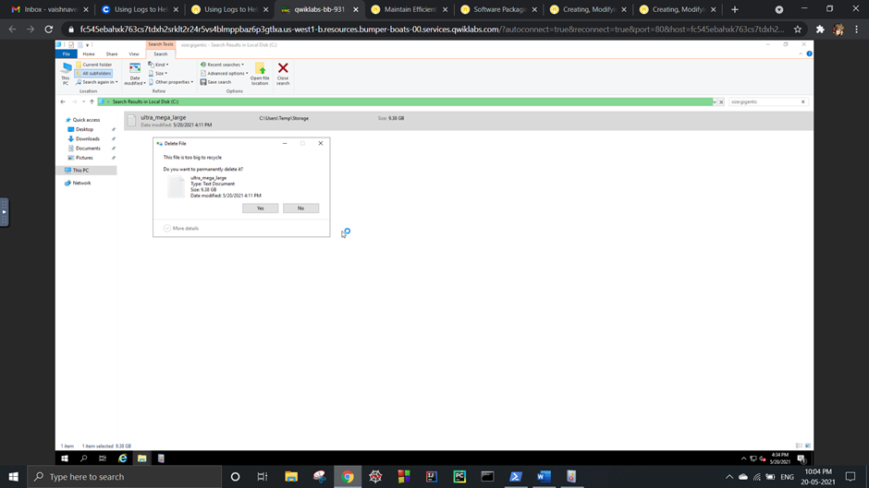

Step 2: Delete the ‘ultra_merge_large’ file (size - 9.38 GB).



***2.Corrupted File:***

This log warns to remove a corrupted file in the C:\ directory.

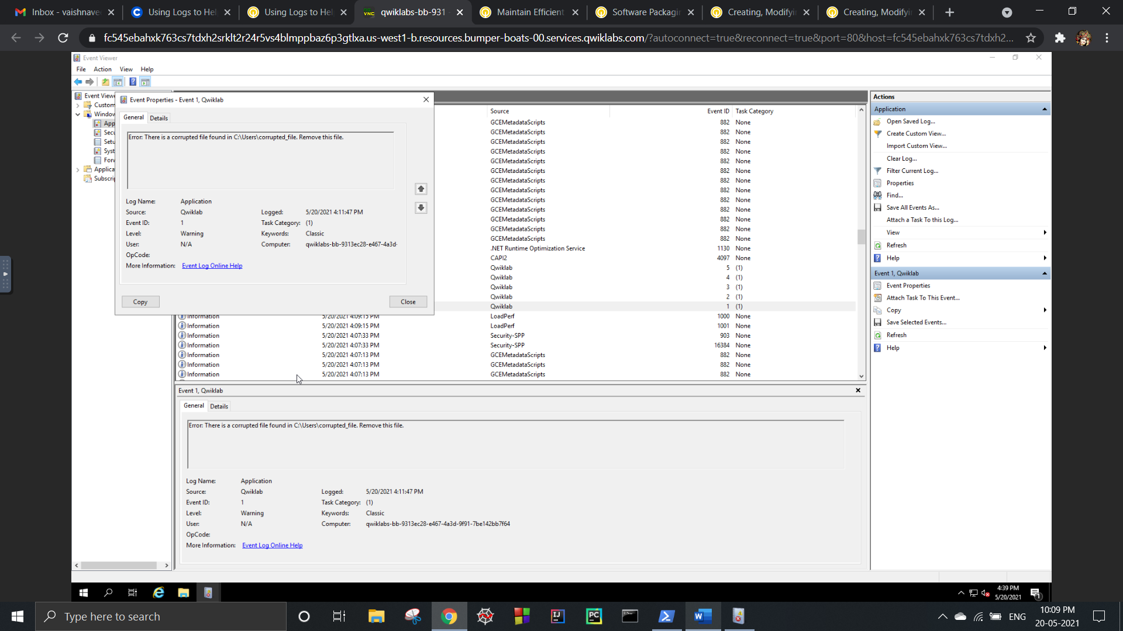

Step 1: Search the file explorer for the path specified in the log (C:\Users\corrupted_file).

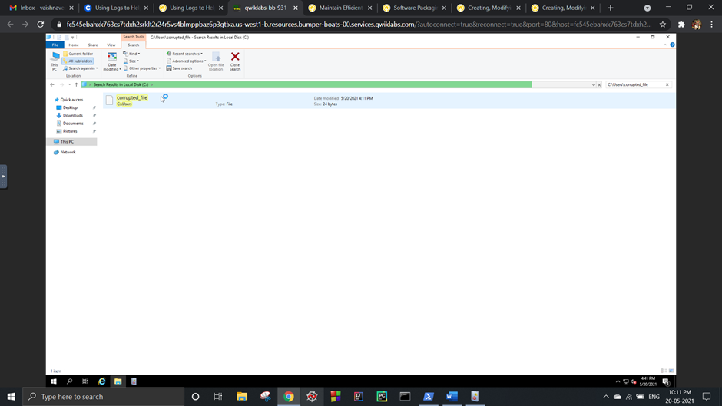

Step 2: Delete the ‘corrupted_file’.

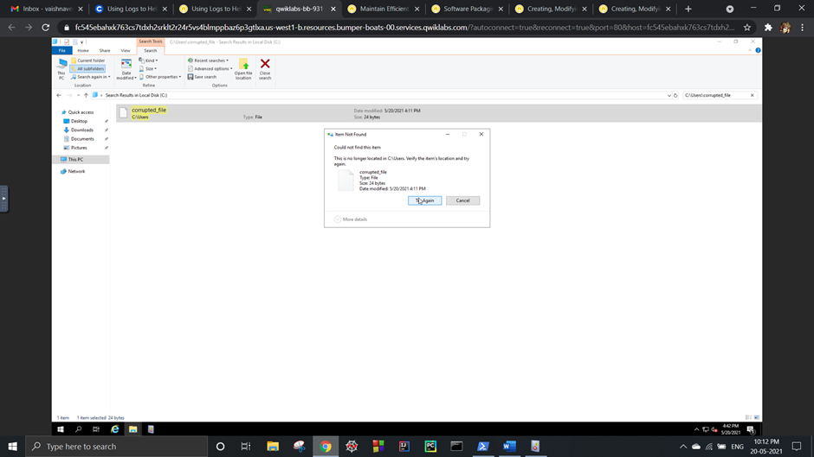

***3.Update VLC:***

This log warns about a software package that is out of date and asks to upgrade to the latest version.

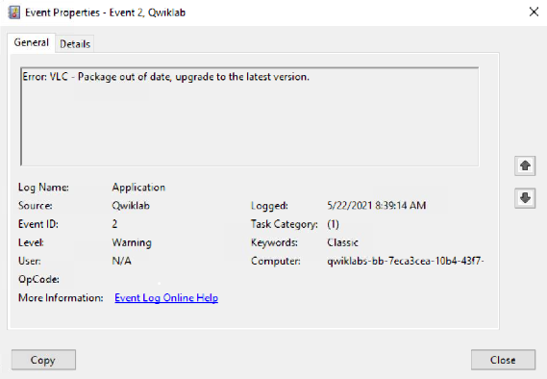

Step 1: Navigate to the directory where the VLC package is located (C:\Users\qwiklabs\Downloads).

Step 2: Now the package can be upgraded by executing the following commands:

$VLC_URL = "https://download.videolan.org/vlc/last/win64/";

$DOWNLOAD_DIR = "C:\users\qwiklabs\Downloads\";

$GET_HTML = Invoke-WebRequest $VLC_URL;

$FILE = $GET_HTML.Links | Select-Object @{Label='href';Expression={@{$true=$_.href}[$_.href.EndsWith('win64.exe')]}} | Select-Object -ExpandProperty href;

$URL = ($VLC_URL+$FILE);

$OUTPUT_FILE = ($DOWNLOAD_DIR+$FILE);

(new-object System.Net.WebClient).DownloadFile($URL, $OUTPUT_FILE);

cmd.exe /c "$OUTPUT_FILE /S"

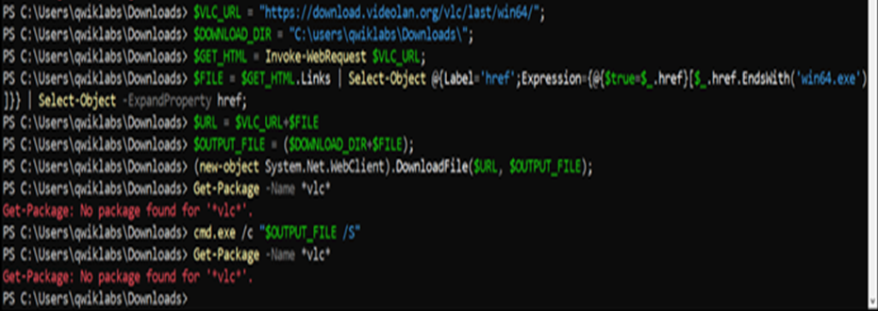

***4.End Malicious Process:***

This log warns about a malicious process (totally_not_malicious.exe) and asks to terminate it.

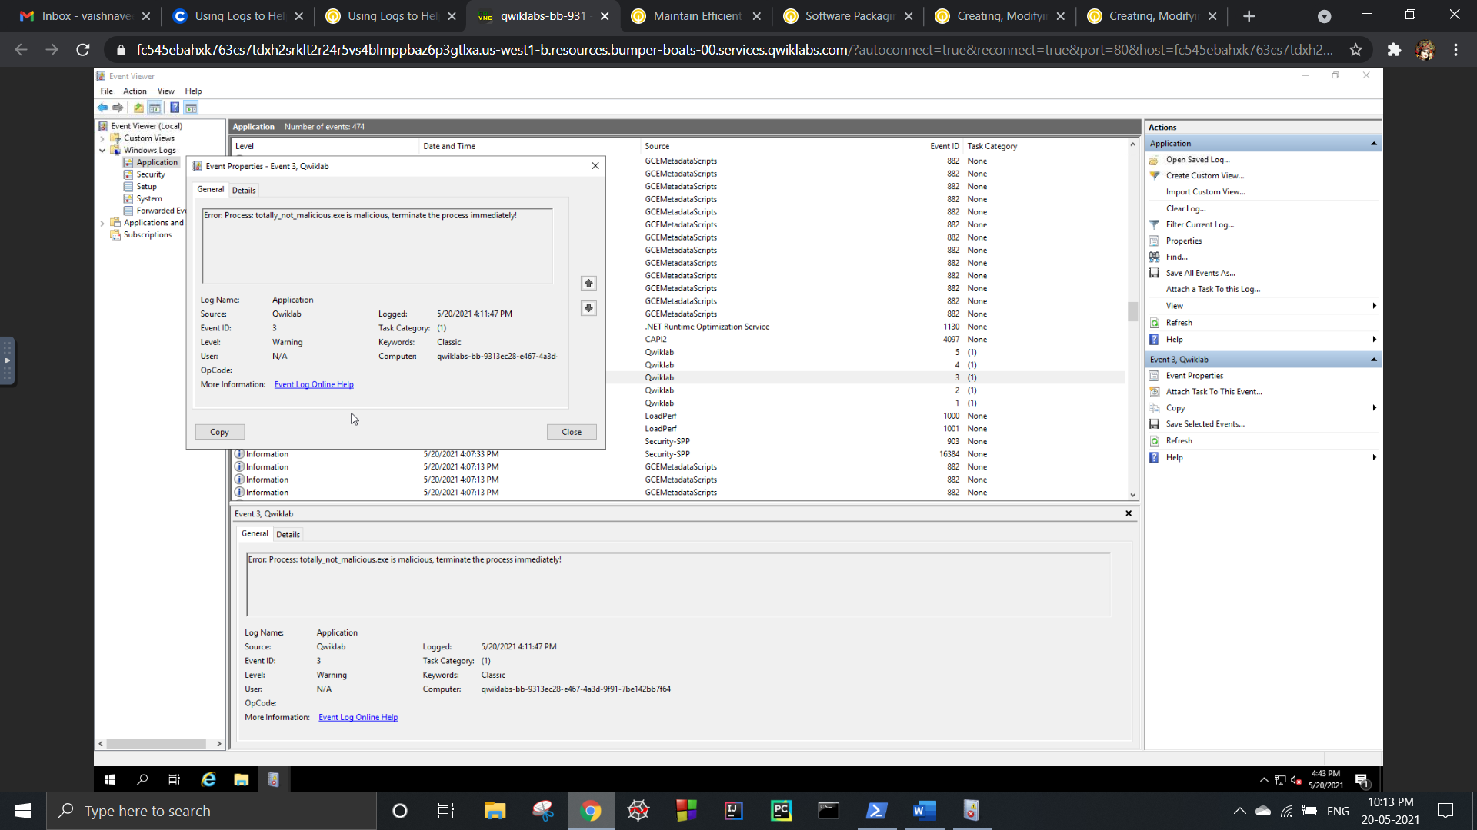

Step 1: Search for the process by its name (totally not malicious) using **Get-Process -Name [process_name].** This gives the process ID.

Step 2: Terminate the process using **taskkill /F /PID [process_id].** Verify termination using **Get-Process -Name [process_name].**

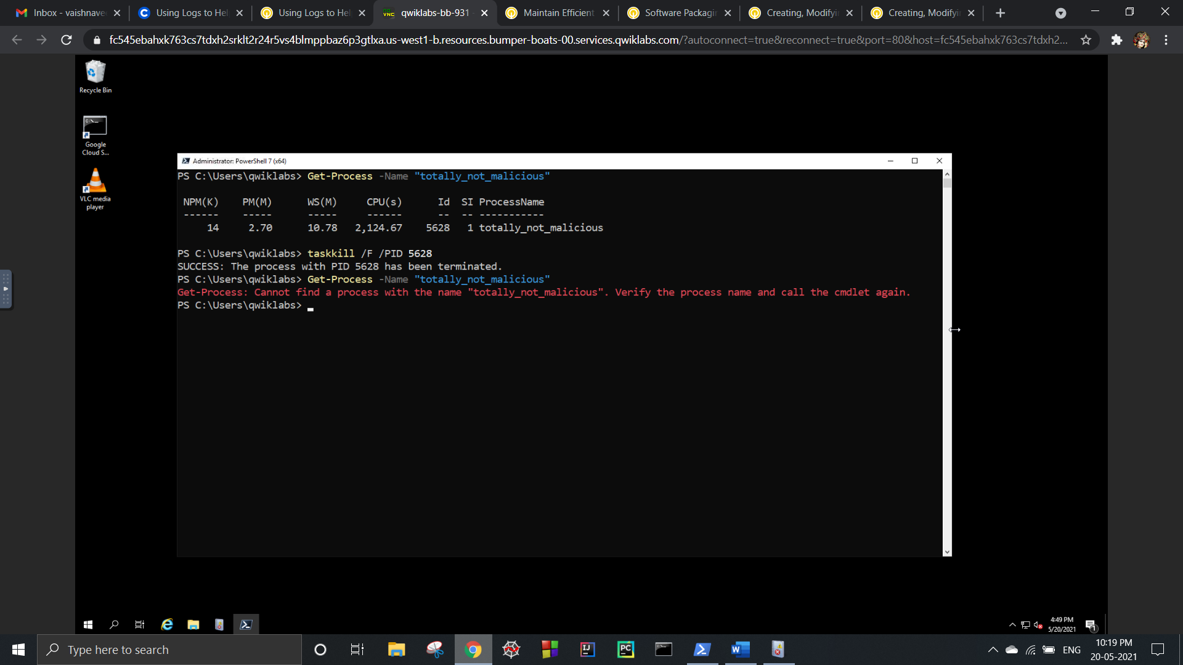

***5.Fix Permissions:***

This log warns that write permission is denied for everyone for the file specified in the path.

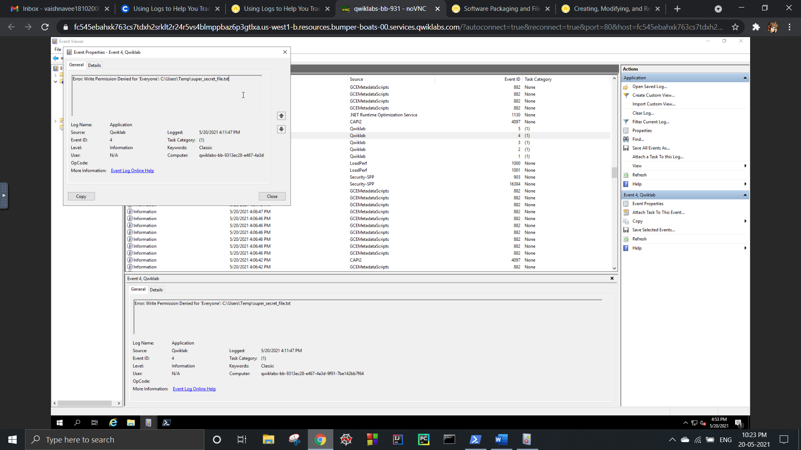

Step 1: View the existing permissions for the specified file using icacls C:\Users\Temp\super_secret_file.txt

Step 2: Grant write permission for Everyone using icacls C:\Users\Temp\super_secret_file.txt /grant “Everyone:(w)”.

