**Computer Networks**

**LABORATORY PROGRAM – 1**

Create a topology and simulate sending a simple PDU from source to destination using hub and switch as connecting devices and demonstrate ping message.

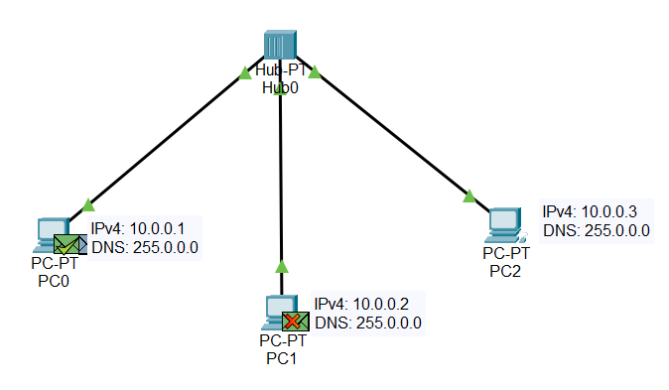



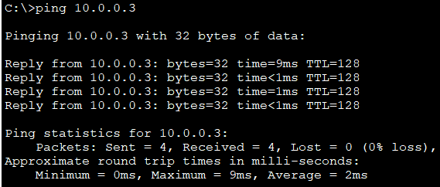

**LABORATORY PROGRAM – 2**

Configure IP address to routers in packet tracer. Explore the following messages: ping responses, destination unreachable, request timed out, reply.

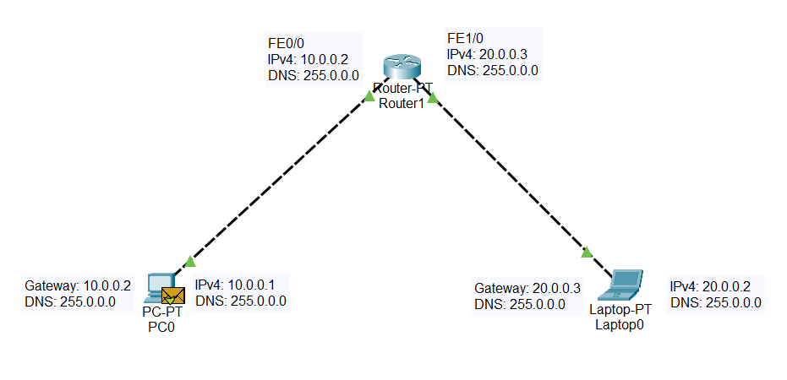

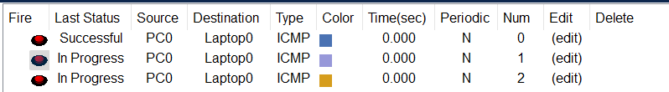

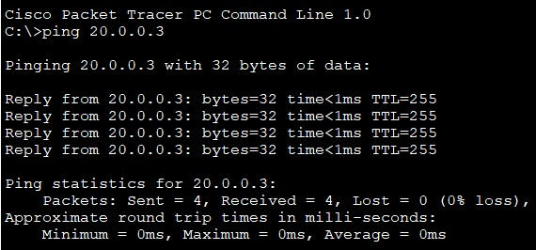

**LABORATORY PROGRAM – 3**

Configure default route, static route to the Router.

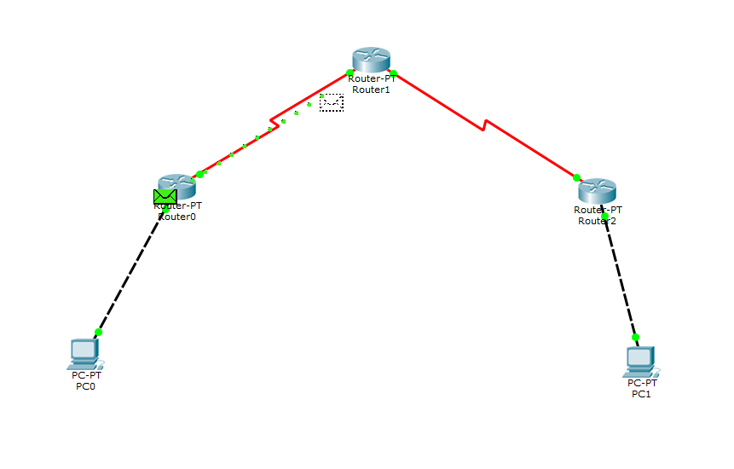



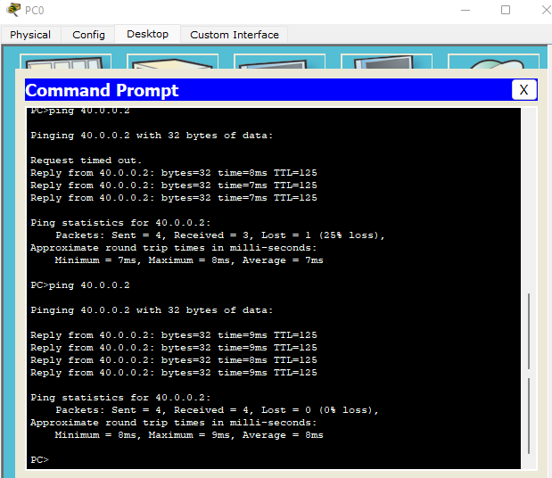

**LABORATORY PROGRAM-4**

Default and static routers.

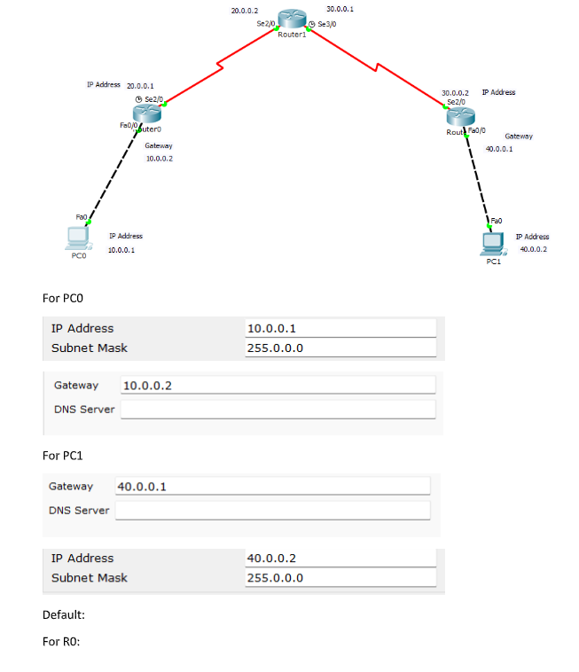

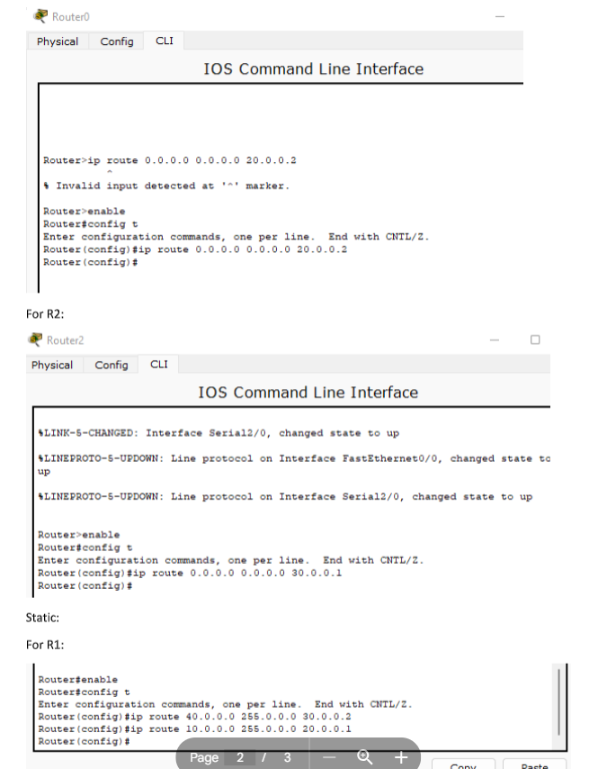

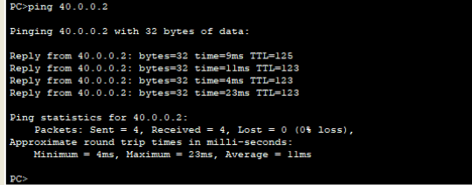

**LABORATORY PROGRAM-5**

To understand the operations of TELNET

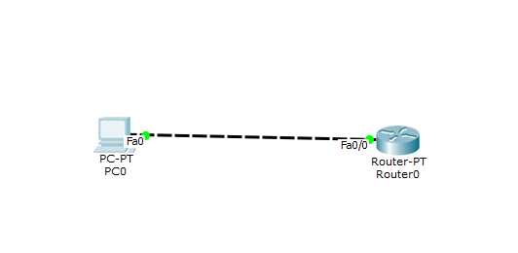

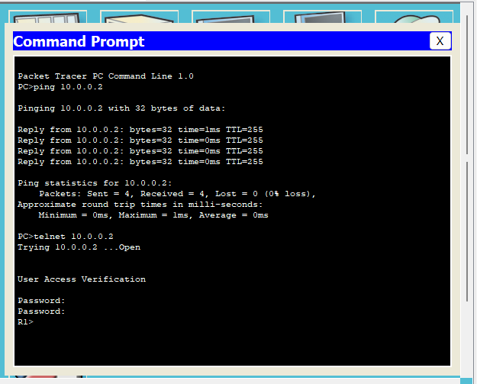

**LABORATORY PROGRAM-7**

Demonstrate the TTL/Life of a packet.

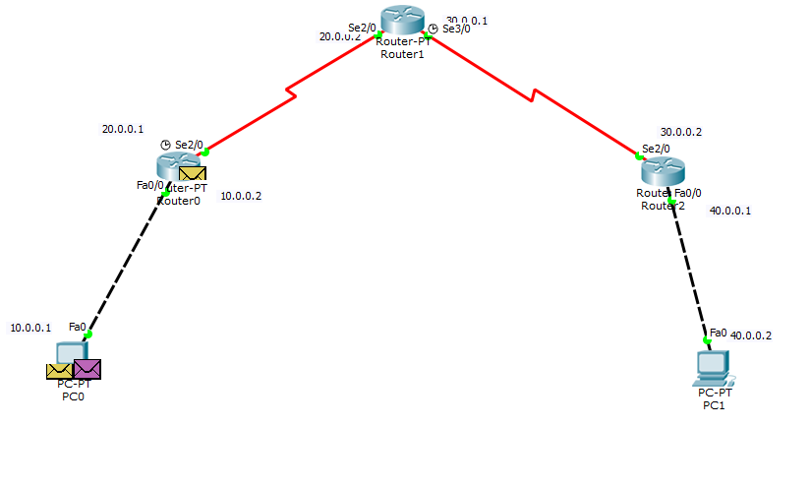

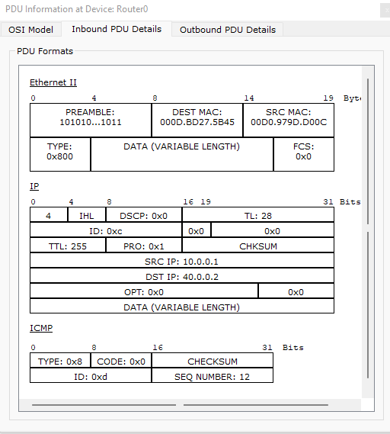

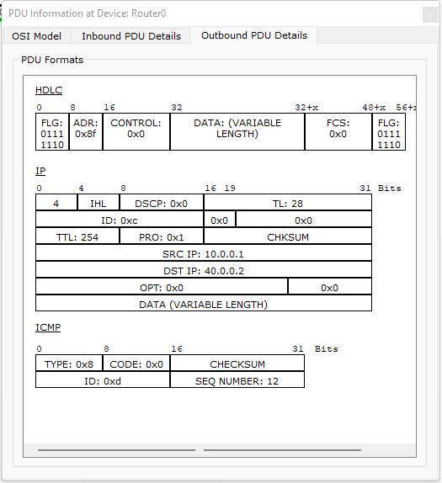



**LABORATORY PROGRAM**

To create a virtual LAN on top of the physical LAN and virtual LAN.

