Unit -1
1. Binary Search:
A company stores employee IDs in ascending order. Write a C program that accepts n employee IDs, searches for a required ID using Binary Search, displays its position when found, reports when it is absent, and counts the number of comparisons. Test the program for both successful and unsuccessful searches.
Source Code:
#include <stdio.h>
int main()
{
int n, i, id, low, high, mid;
int c =0;
printf("Enter number of employees: ");
scanf("%d", &n);
int ar[n];
printf("Enter employee IDs in ascending order:\n");
for(i = 0; i < n; i++)
scanf("%d", &ar[i]);
printf("Enter ID to search: ");
scanf("%d", &id);
low = 0;
high = n - 1;
while(low <= high)
{
c++;
mid = (low + high) / 2;
if(ar[mid] == id)
{
printf("ID found at position %d\n", mid + 1);
printf("Number of comparisons = %d\n", c);
return 0;
}
else if(id < ar[mid])
high = mid - 1;
else
low = mid + 1;
}
printf("ID not found\n");
printf("Number of comparisons = %d\n", c);

return 0;
}

Output:
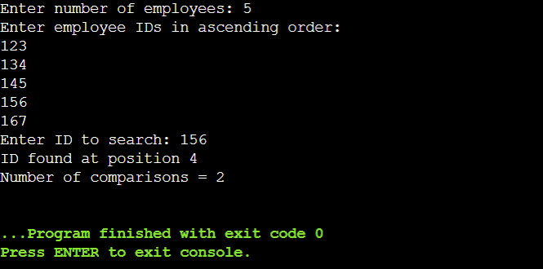

2. Insertion Sort:
A teacher wants to arrange student marks in ascending order and also measure how much rearrangement is necessary. Write a C program using Insertion Sort that accepts n marks, displays the array after every pass, counts the total number of element shifts, and displays the final sorted list and shift count.
Source Code:
#include <stdio.h>
int main()
{
int n, i, j, key;
int count = 0;

printf("Enter number of students: ");
scanf("%d", &n);
int a[n];
printf("Enter marks:\n");
for(i = 0; i < n; i++)
scanf("%d", &a[i]);
printf("\nArray after each pass:\n");
for(i = 1; i < n; i++)
{
key = a[i];
j = i - 1;
while(j >= 0 && a[j] > key)
{
a[j + 1] = a[j];
j--;
count++;
}
a[j + 1] = key;
printf("Pass %d: ", i);
for(j = 0; j < n; j++)
printf("%d ", a[j]);
printf("\n");
}
printf("\nFinal sorted list: ");
for(i = 0; i < n; i++)
printf("%d ", a[i]);
printf("\nTotal number of shifts = %d\n", count);
return 0;
}

Output:
