Unit 3
1. Singly Linked List
Write a C program using a Singly Linked List to create a list, insert data at the beginning and end, search for a specified data, delete a specified data, and display the updated list after each operation. Handle the case when the requested data is not available.
Source Code:
#include <stdio.h>
#include <stdlib.h>
struct Node {
int data;
struct Node *next;
};
struct Node *head = NULL;
void display() {
struct Node *temp = head;
if (head == NULL) {
printf("List is empty\n");
return;
}
while (temp != NULL) {
printf("%d -> ", temp->data);
temp = temp->next;
}
printf("NULL\n");
}
void insertBeginning(int data) {
struct Node *newNode = malloc(sizeof(struct Node));
newNode->data = data;
newNode->next = head;
head = newNode;
display();
}

void insertEnd(int data) {
struct Node *newNode = malloc(sizeof(struct Node));
newNode->data = data;
newNode->next = NULL;
if (head == NULL)
head = newNode;
else {
struct Node *temp = head;
while (temp->next != NULL)
temp = temp->next;
temp->next = newNode;
}
display();
}
void search(int data) {
struct Node *temp = head;
while (temp != NULL) {
if (temp->data == data) {
printf("Data %d found\n", data);
return;
}
temp = temp->next;
}
printf("Data %d not found\n", data);
}
void deleteNode(int data) {
struct Node *temp = head;
struct Node *prev = NULL;
while (temp != NULL && temp->data != data) {
prev = temp;
temp = temp->next;
}

if (temp == NULL) {
printf("Data %d not found\n", data);
return;
}
if (prev == NULL)
head = temp->next;
else
prev->next = temp->next;
free(temp);
printf("Deleted successfully\n");
display();
}
int main() {
int choice, data;
while (1) {
printf("\n1. Insert Beginning");
printf("\n2. Insert End");
printf("\n3. Search");
printf("\n4. Delete");
printf("\n5. Display");
printf("\n6. Exit");
printf("\nEnter choice: ");
scanf("%d", &choice);

switch (choice) {
case 1:
printf("Enter data: ");
scanf("%d", &data);
insertBeginning(data);
break;

case 2:
printf("Enter data: ");
scanf("%d", &data);
insertEnd(data);
break;
case 3:
printf("Enter data: ");
scanf("%d", &data);
search(data);
break;
case 4:
printf("Enter data: ");
scanf("%d", &data);
deleteNode(data);
break;
case 5:
display();
break;
case 6:
exit(0);
default:
printf("Invalid choice\n");
}
}
}

Output:
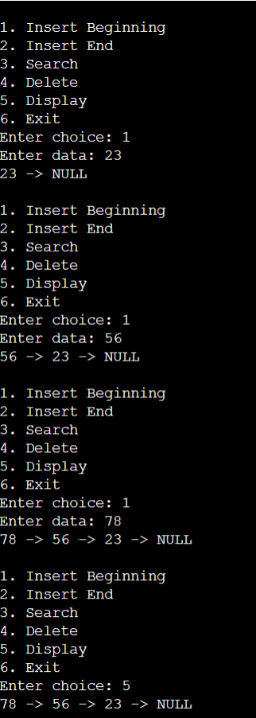

2. Doubly Linked List
Develop a C program for a Doubly Linked List representing a sequence of web pages visited by a user. The program should insert a new page, move forward and backward, delete a specified page, and display the pages from first-to-last and last-to-first while handling beginning and end conditions correctly.
Source Code:
#include <stdio.h>
#include <stdlib.h>
struct Node {
int data;
struct Node *prev;
struct Node *next;
};
struct Node *head = NULL;
struct Node *tail = NULL;
struct Node *current = NULL;

void insert(int data) {
struct Node *newNode = malloc(sizeof(struct Node));

newNode->data = data;
newNode->prev = NULL;
newNode->next = NULL;

if (head == NULL) {
head = tail = current = newNode;
} else {
newNode->prev = tail;
tail->next = newNode;
tail = newNode;
current = newNode;
}
}

void forward() {
if (current == NULL || current->next == NULL)
printf("Cannot move forward\n");
else {
current = current->next;
printf("Current: %d\n", current->data);
}
}

void backward() {
if (current == NULL || current->prev == NULL)
printf("Cannot move backward\n");
else {
current = current->prev;
printf("Current: %d\n", current->data);
}
}

void deleteNode(int data) {
struct Node *temp = head;

while (temp != NULL && temp->data != data)
temp = temp->next;

if (temp == NULL) {
printf("Data not found\n");
return;
}

if (temp->prev != NULL)
temp->prev->next = temp->next;
else
head = temp->next;

if (temp->next != NULL)
temp->next->prev = temp->prev;
else
tail = temp->prev;

if (current == temp)
current = temp->next ? temp->next : temp->prev;

free(temp);
printf("Deleted successfully\n");
}

void displayForward() {
struct Node *temp = head;

while (temp != NULL) {
printf("%d <-> ", temp->data);
temp = temp->next;
}
printf("NULL\n");
}

void displayBackward() {
struct Node *temp = tail;

while (temp != NULL) {
printf("%d <-> ", temp->data);
temp = temp->prev;
}
printf("NULL\n");
}

int main() {
int choice, data;

while (1) {
printf("\n1. Insert");
printf("\n2. Move Forward");
printf("\n3. Move Backward");
printf("\n4. Delete");
printf("\n5. Display First to Last");
printf("\n6. Display Last to First");
printf("\n7. Exit");
printf("\nEnter choice: ");
scanf("%d", &choice);

switch (choice) {
case 1:
printf("Enter data: ");
scanf("%d", &data);
insert(data);
break;

case 2:
forward();
break;

case 3:
backward();
break;

case 4:
printf("Enter data: ");
scanf("%d", &data);
deleteNode(data);
break;

case 5:
displayForward();
break;

case 6:
displayBackward();
break;

case 7:
exit(0);

default:
printf("Invalid choice\n");
}
}
}

Output:
