UNIT 4

1. A system stores unique integer identification numbers using a Binary Search Tree. Write a C program to insert n values, display inorder, preorder and postorder traversals, search for a specified value, and report whether it exists. Use the output to explain why inorder traversal produces sorted values.
Source Code:
#include <stdio.h>
#include <stdlib.h>

struct node
{
int data;
struct node *left;
struct node *right;
};

struct node* create(int data)
{
struct node *newnode;

newnode = (struct node*)malloc(sizeof(struct node));

newnode->data = data;
newnode->left = NULL;
newnode->right = NULL;

return newnode;
}

struct node* insert(struct node *root, int data)
{
if (root == NULL)
return create(data);

if (data < root->data)
root->left = insert(root->left, data);

else if (data > root->data)
root->right = insert(root->right, data);

return root;
}

void inorder(struct node *root)
{
if (root != NULL)
{
inorder(root->left);
printf("%d ", root->data);
inorder(root->right);
}
}

void preorder(struct node *root)
{
if (root != NULL)
{
printf("%d ", root->data);
preorder(root->left);
preorder(root->right);
}
}

void postorder(struct node *root)
{
if (root != NULL)
{
postorder(root->left);
postorder(root->right);
printf("%d ", root->data);
}
}

struct node* search(struct node *root, int key)
{
if (root == NULL || root->data == key)
return root;

if (key < root->data)
return search(root->left, key);
else
return search(root->right, key);
}

int main()
{
struct node *root = NULL;
int n, i, data, key;

printf("Enter number of nodes: ");
scanf("%d", &n);

printf("Enter values:\n");

for (i = 0; i < n; i++)
{
scanf("%d", &data);
root = insert(root, data);
}

printf("\nInorder Traversal: ");
inorder(root);

printf("\nPreorder Traversal: ");
preorder(root);

printf("\nPostorder Traversal: ");
postorder(root);

printf("\n\nEnter value to search: ");
scanf("%d", &key);

if (search(root, key) != NULL)
printf("%d exists in BST\n", key);
else
printf("%d does not exist in BST\n", key);

return 0;
}
Output:
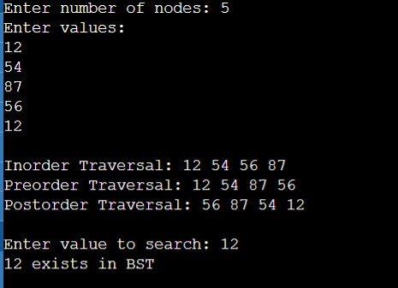

2. Extend a Binary Search Tree program to support deletion. The program should create a BST, delete a user-specified node, correctly handle nodes with zero, one and two children, and display inorder traversal before and after deletion. Test the program separately for all three deletion cases.
Source Code:
#include <stdio.h>
#include <stdlib.h>

struct node
{
int data;
struct node *left;
struct node *right;
};

struct node* create(int data)
{
struct node *newnode;

newnode = (struct node*)malloc(sizeof(struct node));

newnode->data = data;
newnode->left = NULL;
newnode->right = NULL;

return newnode;
}

struct node* insert(struct node *root, int data)
{
if (root == NULL)
return create(data);

if (data < root->data)
root->left = insert(root->left, data);

else if (data > root->data)
root->right = insert(root->right, data);

return root;
}

void inorder(struct node *root)
{
if (root != NULL)
{
inorder(root->left);
printf("%d ", root->data);
inorder(root->right);
}
}

struct node* findMin(struct node *root)
{
while (root->left != NULL)
root = root->left;

return root;
}

struct node* deleteNode(struct node *root, int key)
{
if (root == NULL)
return root;

if (key < root->data)
{
root->left = deleteNode(root->left, key);
}

else if (key > root->data)
{
root->right = deleteNode(root->right, key);
}

else
{
/* Case 1: No child */
if (root->left == NULL && root->right == NULL)
{
free(root);
return NULL;
}

/* Case 2: Only right child */
else if (root->left == NULL)
{
struct node *temp = root->right;
free(root);
return temp;
}

/* Case 2: Only left child */
else if (root->right == NULL)
{
struct node *temp = root->left;
free(root);
return temp;
}

/* Case 3: Two children */
else
{
struct node *temp = findMin(root->right);

root->data = temp->data;

root->right =
deleteNode(root->right, temp->data);
}
}

return root;
}

int main()
{
struct node *root = NULL;
int n, i, data, key;

printf("Enter number of nodes: ");
scanf("%d", &n);

printf("Enter values:\n");

for (i = 0; i < n; i++)
{
scanf("%d", &data);
root = insert(root, data);
}

printf("\nInorder before deletion: ");
inorder(root);

printf("\nEnter node to delete: ");
scanf("%d", &key);

root = deleteNode(root, key);

printf("\nInorder after deletion: ");
inorder(root);

return 0;
}
Output:
