./

Report – Electronic Voting System for college

Course Code: <CODE>



|  |  |  |  |  |  |
| --- | --- | --- | --- | --- | --- |
| **Ver. Rel. No.** | **Release Date** | **Prepared. By** | **Reviewed By** | **Approved By** | **Remarks/Revision Details** |
| 1.0 | 21-9-20 | Lakshitha K S |  |  |  |
| 1.1 | 22-9-20 | Lakshitha K S |  |  |  |
| 1.2 | 23-9-20 | Lakshitha K S |  |  |  |
| 1.3 | 24-9-20 | Lakshitha K S |  |  |  |
|  |  |  |  |  |  |

**Document History**

# 

**Table of Contents**

**PROBLEM STATEMENT……………………………….……….........................................................................4**

**PROJECT DESCRIPTION………………………………………………………………………………………………………..........4**

**RESEARCH……………………………………………………………………………………………………………………………………5**

**REQUIREMENTS………………………………………………………………………………………………............................6**

**DESIGN……………………………………………………………………………………………………………………………………….7-8**

**TEST PLAN………………………………………………………………………………………………………………………………….9**

**TEST CASE…………………………………………………………………………………………………………………………….......9-10**

**CONCLUSION…………………………………………………………………………………………………………………………….11**

1. **Problem Statement**

Voting system for candidates standing for College election. It uses the concept of file handling. The voting of the college elections will be done online such that there is no need to come at the college on the time of elections and the student can vote from the home or from any other place.

Many problems are faced by the people in voting manually:

* Much time is required.
* Reduces the chances of conflicts.
* Reduces the time for ballot counting and many others.

1. **Project Description**

ELECTRONIC VOTING SYSTEM FOR COLLEGE ELECTIONS is an online voting technique. This will surely consume less time as whole the day is being consumed on the day of elections. There is a file which is maintained in which all the names of students with complete information are stored. The scope of this project will be that it will surely increase the voting percentage in university and college elections. Online Voting System will be fast enough to calculate the results and reduce the human efforts, as all the things will be automated. As the statistics shows that the percentage of polling on the day of elections is not satisfactory as majority of students are not coming to vote and thinks is just as a wastage of time. The manual voting system takes long time as there is a lot of paper work first and then human effort is also there for counting of the votes.

Elections are believed to be the key pillars of democracy and voting is one of the electoral processes that ensure the sustenance of democracy in any civil society. It provides a platform for simplifying the electoral process for all institutions that employ voting in decision-making. It is geared towards increasing the voting percentage in Universities and Colleges since it has been noted that with the old voting method (the Queue System or Manual System), the voter turnout has been a wanting case. The Online Voting System calculates the results faster, reduces time spent making long queues at the polling stations during voting, reduces human efforts.

The Objective of Electronic Voting System is to help the organization in automating the whole manual processing of the existing system. The main objective to develop the system is to make the accurate& efficient decision in different tasks at different time at different situations. The existing system is manual so members of the unit generally face a lot of embarrassing situations many times. Now they need to automate the whole process so as to make it more easy and accurate. This project is made as user friendly as possible so that any student can use it with little knowledge of computers. This System supports The project will reduce the tedious job of paperwork by keeping all the details of voter, voting results, candidates data etc. stored in the form of file.

1. **Research**

Most Electoral bodies still use a primitive paper based method during voting. This system is characterized by manual form filling to choose leaders and transfer of the information from manual data capture forms to computerized datasheets. This has led to an excessive number of mistakes making their way into the final vote counts hence leading to confusion at the time of announcing the results. The main advantage of paper-based systems is that ballot papers are easily human auditable. The disadvantages outweigh the advantages. For instance, the need to print ballot papers is a slow, expensive, inflexible, environmentally hostile process. Also, visual impairments, or literacy limitations plus last minute changes to the voters’ register are difficult to accommodate amongst others.

Over the last few years, a number of election observers have suggested that electoral organizations introduce electronic/online voting. A general observation is that as more business is done using electronic media, it should not be difficult to carry out voting using electronic equipment rather than turning up at the polling place on the voting day to use paper and pen. Evidently, the phenomenal use of the Internet as a vehicle for improving communication, access to information and electronic commerce has led to the claim that the Internet could be used as either a replacement to attendance voting or as an additional voting option. Electronic voting is a term encompassing several different types of voting, embracing both electronic means of casting a vote and electronic means of counting votes.

Online Voting System that can achieve the following:

* Conduct free and fair elections.
* Safeguard data and information in the system.
* Reduce workload in the process of conducting elections.
* Keep accurate record of votes.
* Reduce time wasted in announcing election results.
* Eliminate disenfranchising electorates.



1. **Requirements**

## **Functional Requirements:**

* Software Requirements:

Code blocks 20.3

Operating system - windows

* Candidates data should be managed in a file.
* Transparency:

Voters should be able to possess a general knowledge and understanding of the voting process.

* Accuracy:

The system shall record and count all the votes correctly.

* No voter should be able to vote more than once.
* The voter shall be prevented from choosing more than one candidate.
* Cost-effectiveness:

Election systems should be affordable and efficient.

## **Non-functional Requirements:**

The non-functional requirements of this application are usability, availability and reliability.

* Usability:

Usability refers to how easily people relate to an application. The application should be easy to understand, to use and should be implemented in a way that will limit user errors which may result from unintentional manipulation of the data. The application should provide information on the basic functionalities and what the application is about. Furthermore, the application should be familiar to the user and must not require a lot of computer expertise to use it.

* Availability:

The user must be able to control the application to the best of their ability. Given the time voting is open and when it closes, the user can choose to vote within that set time without having wait for their free period like the earlier system encourages.

* Reliability:

The data entered by a user must be promptly and correctly stored in the database. This must be able to recover from hardware failure.

* Performance:

Response time of e-vote should be less than 5 second most of the time.

1. **Design**

* **UML sequence diagram**
* Voting

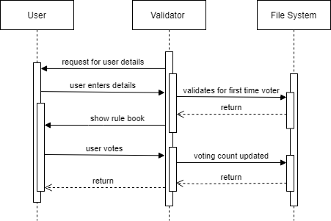

* Add candidate

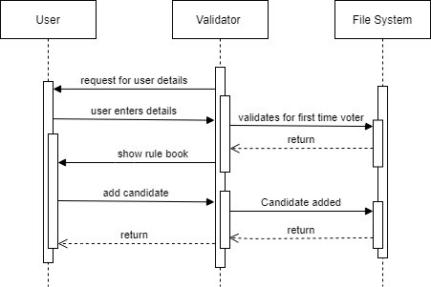

* Live count

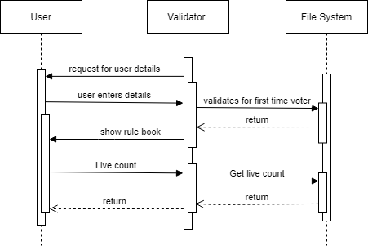

* List of candidate

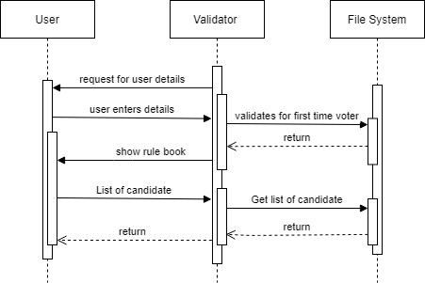

1. **Test plan**

A test plan is a document detailing the objectives and process for a specific test for a software product.

The main test plan of this project are:

* + The user must be able to vote for their desired candidates.
  + Multiple voting of the user should be avoided.
  + The user should be able to add candidate.
  + The user must be able to see voting count of the candidates.
  + Accessibility of list of candidates should be given to user.
  + List of voters must be able to accessed by the user.

1. **Test case:**

* Test case 1:

When the user is voting for the first time.

Expected output:

Application shows the rule book that voter should follow and the voter can proceed by further details.

* Test case 2:

When the user tries to vote again.

Expected output:

Application shows the message “You have already voted”.

* Test case 3:

User selects for voting then the list of the candidates will be displayed and the user will vote for the desired candidate.

Expected output:

The application will display successful voting message to the user.

* Test case 4:

When the user selects for add candidate, the user can add the name of the candidate.

Expected output:

New candidate will be added to the candidate file.

* Test case 5:

When list of voters is selected from the user.

Expected output:

Application will display the voters list.

* Test case 6:

User selects live count.

Expected output:

Application will display the number of votes casted for each candidate.

* Test case 7:

User selects list of candidates.

Expected output:

Application will display names of the candidates.

* Test case 8:

User selects exit.

Expected output:

Application will exit.

1. **Conclusion**

This Online Voting System is simple and indigenous. It has an authentication feature that will manage the Voter’s information. There is a files in which all the names of voters with complete information is stored and it provides the tools for maintaining voter’s vote to every candidate and also computes the total number of votes of every candidate. Online voting offers speed and convenience to the voter and considerable ease to election administrators as they can get election results out more quickly than conventional methods of manual voting since vote counting is just a matter of querying the database.

The success factors include:

* Faster electoral process.
* A better platform for the disabled as well as the outright elimination of multiple voting.
* Finally, the integrated system would avail the electorates the opportunity of casting their votes using the most convenient means.
* The adoption of this system is likely to increase the level of participation in the polity because of the ease of voting and its tendency to eliminate electoral fraud.