TASK 1
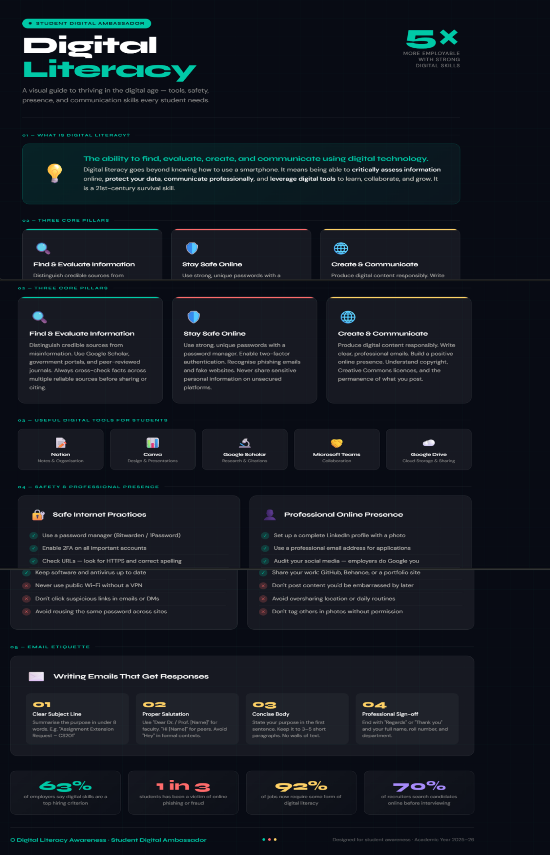 Task 1 – Digital Literacy Awareness Infographic
For this task, I created a one-page digital literacy infographic using HTML and CSS, styled as a dark-themed, print-quality visual document. The design covers all five required topics: what digital literacy is (defined as the ability to find, evaluate, create, and communicate using digital technology), useful digital tools for students (Notion, Canva, Google Scholar, Microsoft Teams, Google Drive), safe internet practices (a dos-and-don'ts checklist), building a professional online presence, and email etiquette. The infographic is divided into five clearly labelled sections with icons, statistics, and colour-coded cards to make content easy to scan. A footer highlights four key statistics — such as 92% of jobs requiring digital literacy — to reinforce why these skills matter. The most interesting challenge was structuring five dense topics into a single page without making it feel cluttered; I used a deliberate visual hierarchy with section labels, colour accents, and varied card sizes to guide the reader's eye naturally from top to bottom.

