Here we have three option as we run the program ,to book slot, to view current booking and to exit we choose our choice and proceed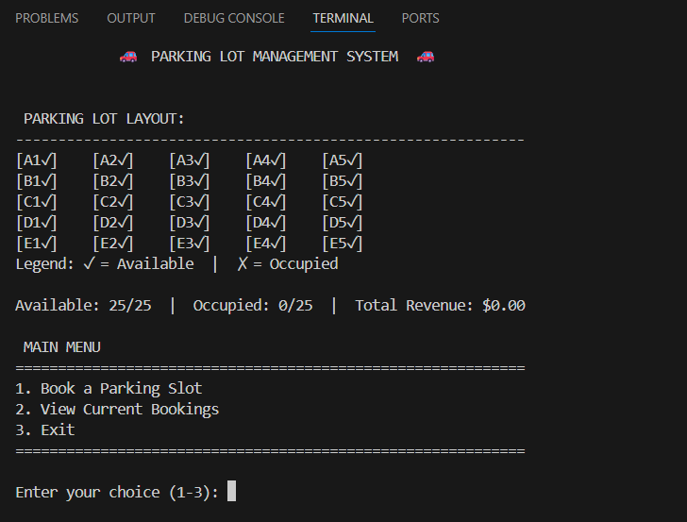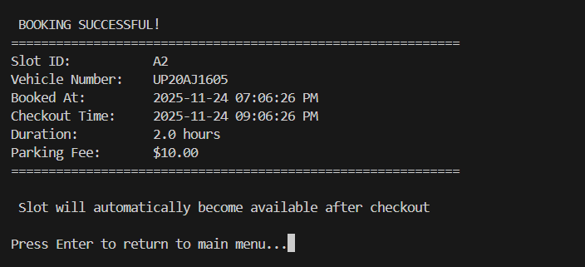 Booking 1st slot as A2 with all the details , after this the slot will be shown as occupied and will not appear in available slots…as shown in the Screen shot we have successfully registered the slot
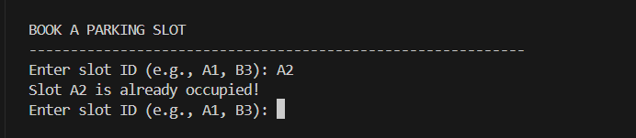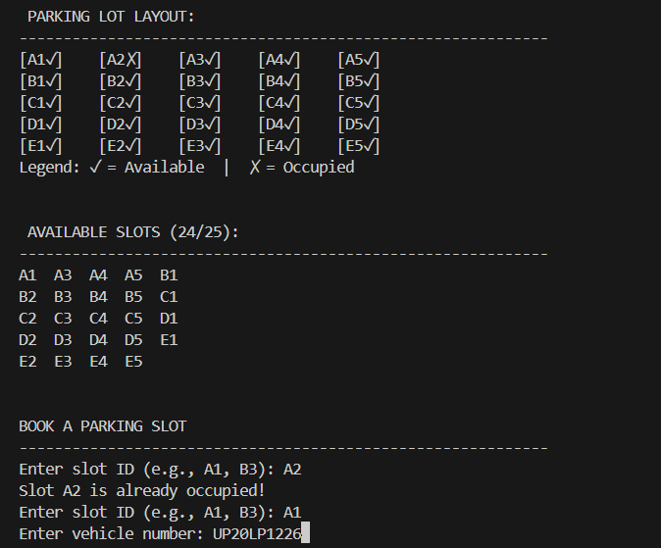Now we can clearly see we can’t book the given slot until the slot is booked and we have to choose from our given options only…A2 is removed from the list as I have already registered a slot for it for a specific time. The slot will reappear after the specific time
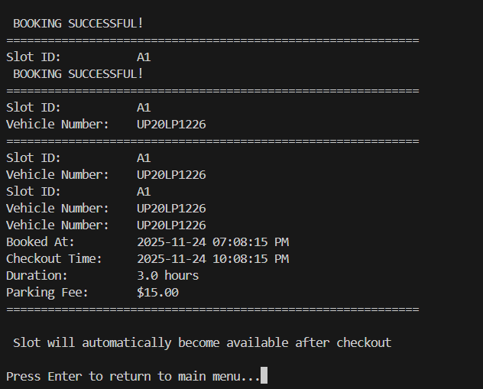now A1 slot is also booked and we cannot book it till next 3 hours
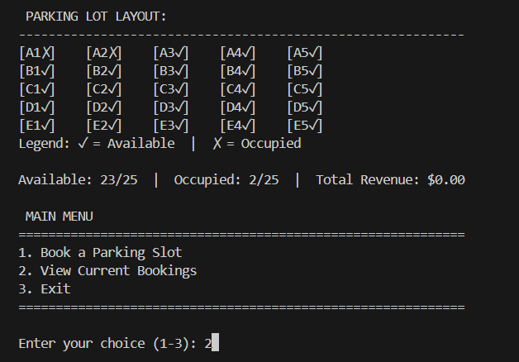
The layout shows that A2 and A1 are both occupied and rest are available and we can book others and as we click view current booking a list appears showing the current booking
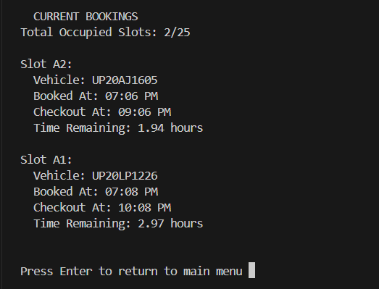
As we press 3 to exit we will get the total revenue generated by the bookings when the time expires and the slot becomes empty again. Right now it shows 0 because currently no bookings are over.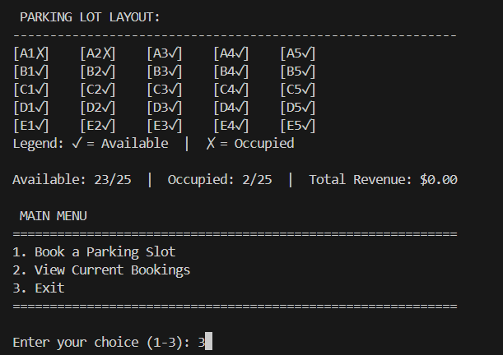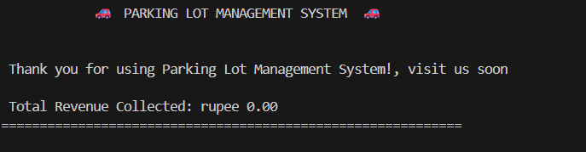

Thankyou

