PROMPT:

Create an image where in a stellar nursery a dying star is exploding with a butterfly planetary nebulla and gases swirling around it in mesmerising patterns , the background must have pulsating beams of starlight, the whole scene must be rich in contrast and the scene can include cathedral ring of dark matter.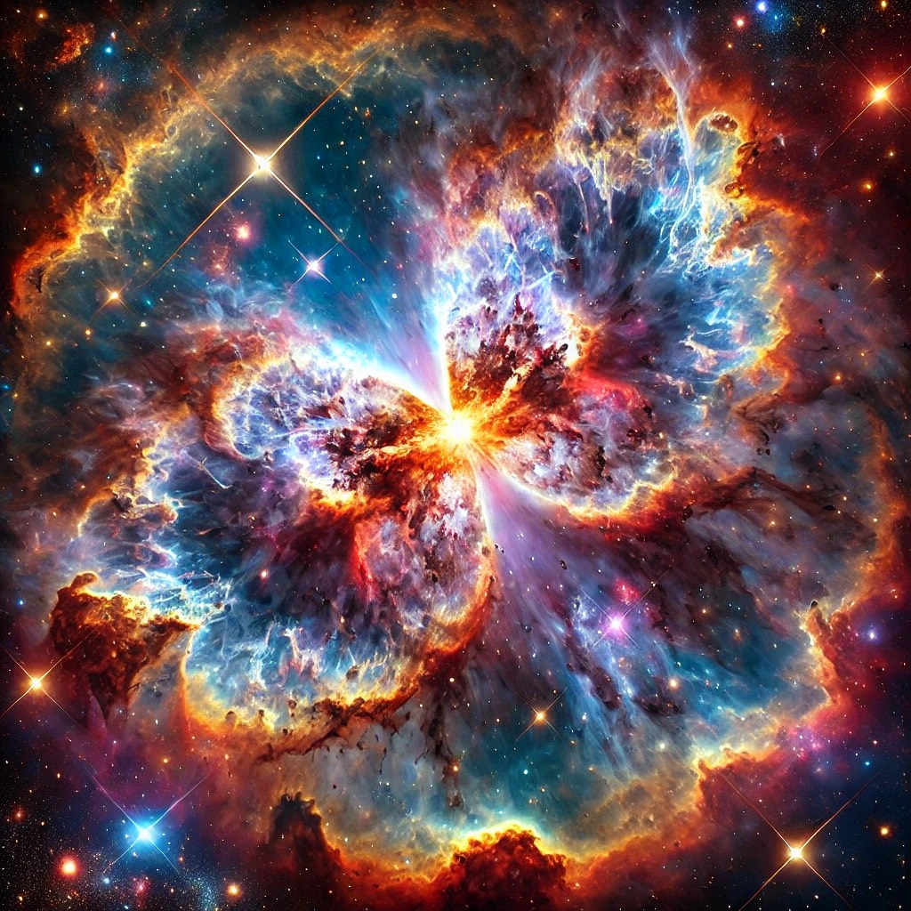

AI AGENT: CHATGPT