

Vigilo | Complete System Solution Pipeline

Contents
WHAT VIGILO IS 2
THE THREE PILLARS 2
COMPLETE SYSTEM ARCHITECTURE 4
COMPONENT BREAKDOWN 6
COMPONENT 1: THE AGENT (Python) 6
Sub-systems: 6
1A. Metrics Collector 6
1B. Prediction Engine 6
1C. Action Engine 6
1D. Local API (FastAPI on localhost:8420) 6
1E. MCP Server (vigilo-mcp) 6
User-facing API: 7
COMPONENT 2: THE RELAY SERVER (Node.js) 7
COMPONENT 3: THE INTERFACES 8
INTELLIGENCE LEVELS 10
DATA FLOW (END TO END) 10
CROSS-PLATFORM MATRIX 11
PACKAGE DEPENDENCIES 11
Agent (Python): 11
Relay (Node.js): 12
Phone App (React Native): 12
SECURITY MODEL 12
COST MODEL (12 MONTHS) 13
EXECUTION ORDER — WHAT TO DO FIRST 13
PHASE 1: FOUNDATION (Week 1-4) 13
PHASE 2: INTELLIGENCE (Week 5-8) 14
PHASE 3: CONNECTIVITY (Week 9-12) 15
PHASE 4: MCP SERVER (Week 13-16) 16
PHASE 5: PHONE APP (Week 17-20) 17
PHASE 6: POLISH + LAUNCH (Week 21-28) 18

WHAT VIGILO IS
Vigilo is a developer-first monitoring agent. It lives on your machine, watches long-running code execution, predicts failures, and takes protective action — accessible from anywhere through open protocols.
The phone is one interface. The CLI is another. Claude Code asking "how's my training going?" through MCP is another. The agent is the product. Everything else is a window into it.

THE THREE PILLARS
1. THE AGENT → The core product (Python)
2. THE PROTOCOL → The distribution strategy (MCP)
3. THE INTERFACES → The access points (CLI, Phone, MCP Clients)
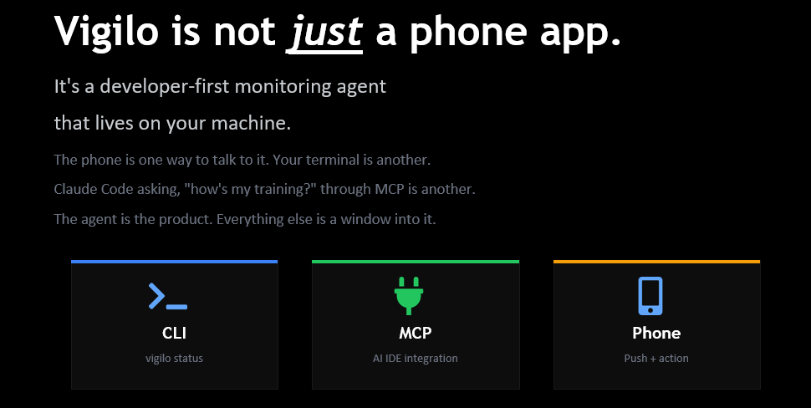

COMPLETE SYSTEM ARCHITECTURE
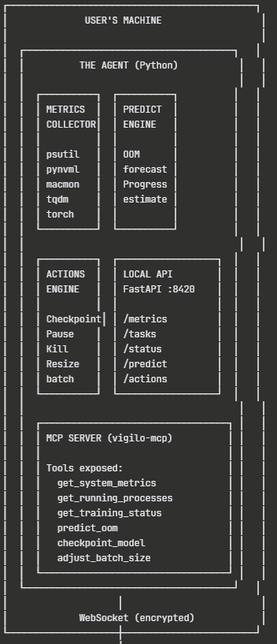
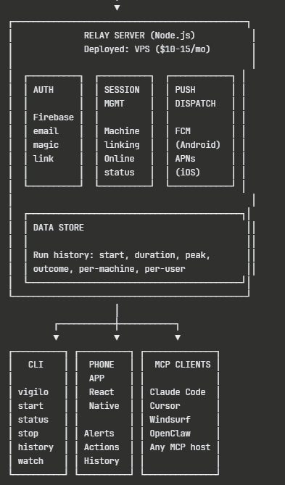

COMPONENT BREAKDOWN

COMPONENT 1: THE AGENT (Python)
What it is: A Python package (pip install vigilo) that runs on the user's machine alongside their code.

Sub-systems:

1A. Metrics Collector
- psutil → CPU, RAM, disk, network (all platforms)
- pynvml → NVIDIA GPU utilisation, VRAM, temperature (Windows/Linux)
- macmon → Apple Silicon GPU, ANE, thermals (macOS)
- torch.cuda → PyTorch CUDA memory tracking (if PyTorch detected)
- tqdm hook → intercept progress bars for ETA estimation
- stdout parser → capture print output for progress detection

1B. Prediction Engine
- OOM Predictor: tracks memory growth rate over time, extrapolates time-to-OOM
- Progress Estimator: uses tqdm data or stdout patterns to estimate completion %
- ETA Calculator: combines progress rate with elapsed time

1C. Action Engine
- Checkpoint: trigger model.save() or equivalent
- Pause: send SIGSTOP to process
- Kill: send SIGTERM/SIGKILL to process
- Resize batch: modify training hyperparameters mid-run (requires framework hooks)

1D. Local API (FastAPI on localhost:8420)
- GET /metrics → current CPU, RAM, GPU, disk
- GET /tasks → list of monitored processes
- GET /status → agent health and configuration
- GET /predict → OOM prediction, ETA
- POST /actions → trigger checkpoint, pause, kill
- WebSocket /ws → live metric stream to relay server

1E. MCP Server (vigilo-mcp)
- Built on Anthropic's MCP Python SDK
- Exposes tools via JSON-RPC 2.0
- get_system_metrics → same as /metrics
- get_running_processes → same as /tasks
- get_training_status → ML-specific: epoch, loss, ETA, progress %
- predict_oom → time-to-OOM with confidence
- checkpoint_model → trigger safe checkpoint (L3 action)
- adjust_batch_size → modify batch size (L3/L4 action)

User-facing API:
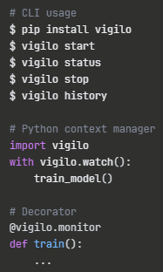

COMPONENT 2: THE RELAY SERVER (Node.js)
What it is: A lightweight server deployed on a VPS that sits between the agent and all remote interfaces. It handles auth, stores run history, and dispatches push notifications.
Why it exists: The agent runs on localhost. The phone needs to reach it from anywhere. The relay is the bridge.
Sub-systems:
2A. Authentication (Firebase Auth)
- Email-based registration (magic link or verification code)
- On first vigilo start, prompt for email
- Email becomes the user identity key
- Phone app logs in with same email → sees all connected machines
2B. Session Management
- Track which machines are online
- Handle reconnection (agent drops and reconnects WebSocket)
- Route commands from phone/MCP back to correct agent instance
2C. Data Store (SQLite or Postgres)
- Run history: start_time, end_time, duration, peak_cpu, peak_ram, peak_gpu, outcome (completed/OOM/killed/error)
- Per-machine, per-user
- Queryable from phone app and CLI
2D. Push Dispatch
- Firebase Cloud Messaging (FCM) for Android
- Apple Push Notification Service (APNs) for iOS
- Trigger conditions: OOM warning, crash detected, run complete
- Payload includes: metric snapshot + available actions
Tech stack:
- Node.js + Express/Fastify
- WebSocket (ws library) for agent ↔ relay
- Firebase Admin SDK for auth + push
- SQLite for MVP data store (migrate to Postgres if needed)
- Deployed on DigitalOcean / Railway ($10-15/mo)

COMPONENT 3: THE INTERFACES
3A. CLI (Built into the Python agent)
- vigilo start → start monitoring daemon
- vigilo stop → stop monitoring
- vigilo status → show current metrics
- vigilo history → show past runs
- vigilo watch <pid> → monitor specific process
- vigilo config → set email, thresholds, policies
- No additional installation required — ships with pip install vigilo
3B. Phone App (React Native)
- Thin and focused: notification inbox + live status + action buttons
- NOT a full dashboard
- User flow: get push alert → tap → see status → tap Checkpoint/Kill → close
- 5-second interaction design
- Screens: notification list, live status, run history, settings
- Action buttons send commands: relay → WebSocket → agent → execute
- TestFlight (iOS) + internal testing (Android)
3C. MCP Clients (No code from you)
- Claude Code, Cursor, Windsurf, OpenClaw connect to Vigilo MCP server
- User adds Vigilo to their MCP config (2-minute setup)
- Then asks naturally: "How's my training going?"
- AI tool calls vigilo MCP tools → gets live data → responds conversationally
- You build the server; the ecosystem builds the clients
3D. OpenClaw Skill
- Publish Vigilo as an OpenClaw skill
- OpenClaw users install it and get monitoring through their messaging platform
- Leverages OpenClaw's exec/process tool pattern

INTELLIGENCE LEVELS
Level | Capability | What it does | When
L0 | Observe | "CPU at 85%, RAM at 72%" | Month 1
L1 | Alert | "OOM in ~12 min" | Month 2
L2 | Recommend | "Suggest: checkpoint now" | Month 6
L3 | Act (consent) | Phone button: [Checkpoint] | Month 5
L4 | Act (auto) | Auto-checkpoint per policy | Month 7+

Most monitoring tools stop at L0. Vigilo is designed to reach L3 in v1, L4 in v2.

DATA FLOW (END TO END)
Scenario: Developer starts training, walks away, OOM approaching
1. Developer runs: with vigilo.watch(): train_model()
2. Agent starts collecting metrics every 5 seconds
3. Agent detects RAM climbing: 72% → 78% → 84% → 89%
4. Prediction Engine calculates: "OOM in ~18 minutes"
5. Agent sends alert to Relay via WebSocket
6. Relay dispatches push notification via FCM/APNs
7. Developer's phone buzzes: "⚠️ RAM at 89%. OOM in ~18 min."
8. Developer taps notification → thin app opens
9. Developer sees live status + taps [Checkpoint]
10. Phone sends command to Relay
11. Relay routes command to Agent via WebSocket
12. Agent triggers model.save() + reduces batch_size
13. Training continues safely
14. Run logged in history: "Peak RAM: 93%, checkpointed at epoch 7"
Scenario: Developer asks Claude Code
1. Developer in Claude Code: "How's my training going?"
2. Claude calls vigilo MCP tool: get_training_status()
3. MCP server queries local agent API
4. Returns: { cpu: 87, ram: 92, gpu: 78, eta: "~2h", risk: "OOM ~18m" }
5. Claude responds: "78% done but RAM is critical. Checkpoint now."
6. Developer: "Do it"
7. Claude calls: checkpoint_model()
8. Agent saves checkpoint

CROSS-PLATFORM MATRIX
Feature | macOS (Apple Si) | Windows/Linux
CPU/RAM/Disk | psutil | psutil
GPU monitoring | macmon | pynvml (NVIDIA)
Thermal data | powermetrics | N/A (or NVIDIA thermal)
Neural Engine | macmon (ANE) | N/A
PyTorch CUDA | N/A (MPS instead) | torch.cuda
Process management | psutil + signal | psutil + signal
Daemon mode | launchd | systemd / Windows Service

PACKAGE DEPENDENCIES

Agent (Python):
- psutil — system metrics (all platforms)
- pynvml — NVIDIA GPU (Windows/Linux)
- macmon — Apple Silicon (macOS, called via subprocess)
- fastapi + uvicorn — local API server
- websockets — relay connection
- mcp (Anthropic SDK) — MCP server
- tqdm — progress bar interception
- torch (optional) — PyTorch-specific hooks
- click — CLI framework

Relay (Node.js):
- express or fastify — HTTP server
- ws — WebSocket server
- firebase-admin — auth + push notifications
- better-sqlite3 or pg — data storage

Phone App (React Native):
- react-native — framework
- @react-native-firebase/messaging — push notifications
- react-navigation — screen navigation
- zustand or redux — state management

SECURITY MODEL
Agent ↔ Relay: WebSocket over TLS (wss://)
Authenticated with email token
Agent never exposes ports to internet

Relay ↔ Phone: HTTPS REST + Firebase Auth
JWT token per session

MCP Server: Localhost only (stdio transport)
No network exposure
Inherits host app security (Claude, Cursor)

Agent Actions: L3 requires explicit user confirmation
L4 requires user-defined policy
No action without consent by default

COST MODEL (12 MONTHS)
Item | Monthly | Annual
VPS (relay server) | $10-15 | $120-180
Firebase (auth + push) | (free tier) | (free tier)
Apple Developer Account | $8.25 | $99
Google Play Developer | $2.08 | $25 (one-time)
LLM API (recommendations) | $5-15 | $60-180
Domain (vigilo.dev) | Approx. $1 | Approx. $12
TOTAL | Approx. $30/mo | < $400

EXECUTION ORDER — WHAT TO DO FIRST
This is the build sequence. Each step depends on the one before it.

PHASE 1: FOUNDATION (Week 1-4)
Do these first. Nothing else works without them.
Step 1: Set up Python package structure
→ vigilo/ directory, setup.py, pyproject.toml
→ Target: pip install -e . works locally

Step 2: Build the Metrics Collector
→ psutil wrapper: cpu_percent(), virtual_memory(),
disk_usage(), net_io_counters()
→ Polling loop: collect every 5 seconds
→ Store in memory as time-series (last 30 min)

Step 3: Build the CLI (basic)
→ vigilo start: start metrics daemon as background process
→ vigilo status: print current metrics to terminal
→ vigilo stop: kill the daemon

Step 4: Build the Local API
→ FastAPI on localhost:8420
→ GET /metrics returns current snapshot
→ GET /tasks returns monitored processes
→ This is your internal communication bus
At end of Phase 1: You can pip install vigilo, run vigilo start, and see live system metrics via vigilo status or curl localhost:8420/metrics.

PHASE 2: INTELLIGENCE (Week 5-8)
Make it smart. This is what differentiates Vigilo from htop.
Step 5: Build OOM Prediction Engine
→ Track memory readings over time
→ Calculate growth rate (linear regression on last N samples)
→ Extrapolate: "At this rate, OOM in X minutes"
→ Confidence threshold: only alert if >70% confident

Step 6: Build Progress Detection
→ tqdm hook: monkey-patch tqdm to report to Vigilo
→ stdout parser: regex match common patterns
("Epoch 3/10", "Step 150/1000", "42% complete")
→ ETA calculation: elapsed / progress_pct * remaining_pct

Step 7: Add GPU Monitoring
→ pynvml: GPU utilisation, VRAM usage, temperature
→ Auto-detect: if NVIDIA GPU present, enable
→ Add GPU metrics to /metrics endpoint

Step 8: Build the Context Manager API
→ with vigilo.watch(): train_model()
→ Auto-start monitoring on enter
→ Auto-log run on exit (duration, peak metrics, outcome)
→ Detect crashes via exception handling
At end of Phase 2: Vigilo predicts OOM, tracks training progress, monitors GPU, and wraps your code with vigilo.watch().

PHASE 3: CONNECTIVITY (Week 9-12)
Get data off the machine and into your pocket.
Step 9: Build the Relay Server
→ Node.js + Express + ws library
→ WebSocket endpoint for agents to connect
→ REST endpoints for phone app to query
→ Deploy to DigitalOcean ($10/mo droplet)

Step 10: Add Email Authentication
→ Firebase Auth: email magic link
→ On vigilo start: prompt for email (first time only)
→ Store auth token locally (~/.vigilo/config.json)
→ Relay validates token on WebSocket connect

Step 11: Add WebSocket Streaming
→ Agent connects to relay via wss://
→ Streams metric snapshots every 10 seconds
→ Relay stores latest state per machine
→ Handle reconnection (exponential backoff)

Step 12: Add Push Notifications
→ Firebase Cloud Messaging setup
→ Relay sends push on: OOM warning, crash, completion
→ Push payload: { type, machine, metrics, actions[] }
→ For now, raw push (no app yet) — tapping opens web status page
At end of Phase 3: You get push notifications on your phone when your training is about to crash. No app yet — just raw push alerts.

PHASE 4: MCP SERVER (Week 13-16)
Plug into the AI ecosystem. This is your distribution.
Step 13: Build MCP Server
→ Use Anthropic MCP Python SDK
→ Register tools: get_system_metrics, get_running_processes,
get_training_status, predict_oom
→ Server reads from local API (localhost:8420)
→ Transport: stdio (standard for local MCP servers)

Step 14: Test with Claude Desktop / Claude Code
→ Add to claude_desktop_config.json:
{ "vigilo": { "command": "vigilo", "args": ["mcp"] } }
→ Ask Claude: "How's my system doing?"
→ Verify tool calls work end-to-end

Step 15: Add Action Tools to MCP
→ checkpoint_model → POST /actions { type: "checkpoint" }
→ pause_process → POST /actions { type: "pause" }
→ kill_process → POST /actions { type: "kill" }
→ These are L3 actions — user must confirm in Claude

Step 16: Write MCP Integration Documentation
→ "Connect Vigilo to Claude Code in 2 minutes"
→ Config examples for Cursor, Windsurf
→ This becomes your first distribution material
At end of Phase 4: Anyone using Claude Code can ask "how's my training going?" and get live metrics from Vigilo.

PHASE 5: PHONE APP (Week 17-20)
Build the thin mobile interface.
Step 17: Scaffold React Native App
→ Expo or bare React Native
→ Firebase Auth (email login, same as agent)
→ Navigation: Alerts, Status, History, Settings

Step 18: Build Alert Screen
→ Fetch push notification history from relay
→ Display: timestamp, machine, alert type, metrics
→ Tap to expand: full metric snapshot

Step 19: Build Live Status Screen
→ WebSocket from phone → relay → latest agent data
→ Show: CPU, RAM, GPU bars, training progress, ETA
→ Show: OOM risk indicator

Step 20: Build Action Buttons
→ [Checkpoint] [Pause] [Kill]
→ Tap sends command to relay → relay sends to agent
→ Confirmation dialog before destructive actions
→ Show result: "Checkpoint saved at epoch 7"

Step 21: Build Run History Screen
→ Fetch from relay data store
→ List: run name, duration, peak metrics, outcome
→ Tap to see detailed timeline

Step 22: TestFlight / Internal Beta
→ iOS: TestFlight submission
→ Android: internal testing track
At end of Phase 5: You have a working phone app that shows alerts, live status, and action buttons.

PHASE 6: POLISH + LAUNCH (Week 21-28)
Step 23: macOS Apple Silicon (macmon integration)
Step 24: Rule-based recommendation engine
Step 25: OpenClaw skill publication
Step 26: Agent policy system (auto-actions)
Step 27: LLM-powered recommendations
Step 28: Documentation site
Step 29: PyPI stable release
Step 30: App Store + Google Play submission
Step 31: Community launch (Reddit, HN, Kaggle)
Step 32: Iterate on user feedback

QUICK REFERENCE: FIRST 5 THINGS TO DO
1. Create the Python package structure (pip install -e .)
2. Write the psutil metrics collector (5-second polling loop)
3. Build the CLI: vigilo start, vigilo status, vigilo stop
4. Build the FastAPI local API on localhost:8420
5. Build the OOM prediction engine (memory growth extrapolation)
Everything else builds on top of these five.

