Library Management System
Python Console Application — Project Report

1. Problem Statement
The objective of this project is to develop a console-based Library Management System using Python. The application allows a librarian to manage books in a collection by performing operations such as adding new books, viewing all books, issuing books to members, returning issued books, searching for a specific book, and counting the number of available books.

2. Project Structure
The project follows a modular structure, separating the data model, utility functions, and the main program logic into different files for clarity and maintainability:
LibraryManagement/
├── main.py
├── book.py
└── library_utils.py

2.1 book.py
This module defines the Book class, which represents a single book in the library. Each book object stores the following attributes:
- book_id — a unique identifier for the book
- title — the title of the book
- author — the name of the author
- is_issued — a boolean flag indicating whether the book is currently issued
The class also defines three methods:
- issue_book() — marks the book as issued if it is currently available
- return_book() — marks the book as returned if it was issued
- display() — prints the book's details and current status (Issued / Available)

2.2 library_utils.py
This module contains utility functions that operate on a list of Book objects:
- search_book(book_list, book_id) — searches for a book by its ID and returns the matching object, or None if not found
- count_available_books(book_list) — counts and returns the number of books that are not currently issued
- display_all_books(book_list) — displays the details of every book in the list, or a message if the list is empty

2.3 main.py
This is the entry point of the application. It imports the Book class and the utility functions, initializes an empty list to hold book records, and runs a menu-driven loop that lets the user repeatedly choose an operation until they choose to exit.

3. Menu Options
The application presents the following menu to the user on every iteration of the program loop:
Option | Function
1 | Add Book
2 | View All Books
3 | Issue Book
4 | Return Book
5 | Search Book
6 | Count Available Books
7 | Exit

4. Implementation Screenshots

4.1 book.py — Book Class Implementation
The screenshot below shows the implementation of the Book class in book.py, including its constructor and the issue_book(), return_book(), and display() methods.
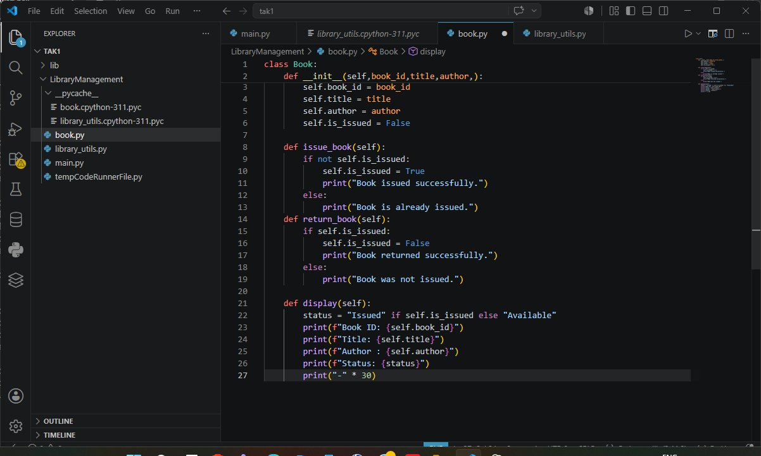
Figure 1: book.py — Book class definition with issue, return, and display methods

4.1.1 Code Walkthrough
The __init__() constructor initializes a new Book object with the book_id, title, and author passed in by the caller, and sets is_issued to False by default since a newly added book is always available.
The issue_book() method checks whether the book is already issued. If it is not, it sets is_issued to True and prints a success message; otherwise, it informs the user that the book is already issued.
The return_book() method performs the reverse check: if the book is currently issued, it sets is_issued back to False and confirms the return; if the book was never issued, it prints an appropriate message instead of changing the state.
The display() method derives a human-readable status string (“Issued” or “Available”) based on is_issued, then prints the book ID, title, author, and status, followed by a separator line of dashes for readability when multiple books are listed.

4.2 library_utils.py — Utility Functions
The screenshot below shows library_utils.py, containing the search_book(), count_available_books(), and display_all_books() functions used by the main program.
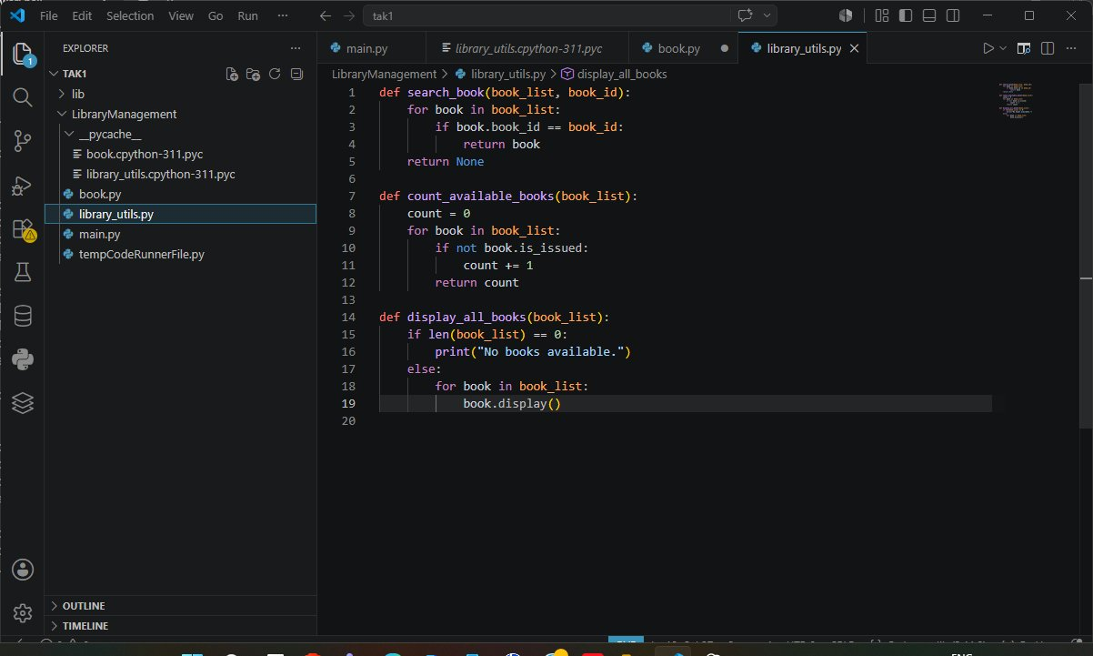
Figure 2: library_utils.py — search, count, and display utility functions

4.3 main.py — Menu-Driven Program
The screenshot below shows the main.py file, which imports the Book class and utility functions, initializes the book list, and implements the menu loop that drives the application.
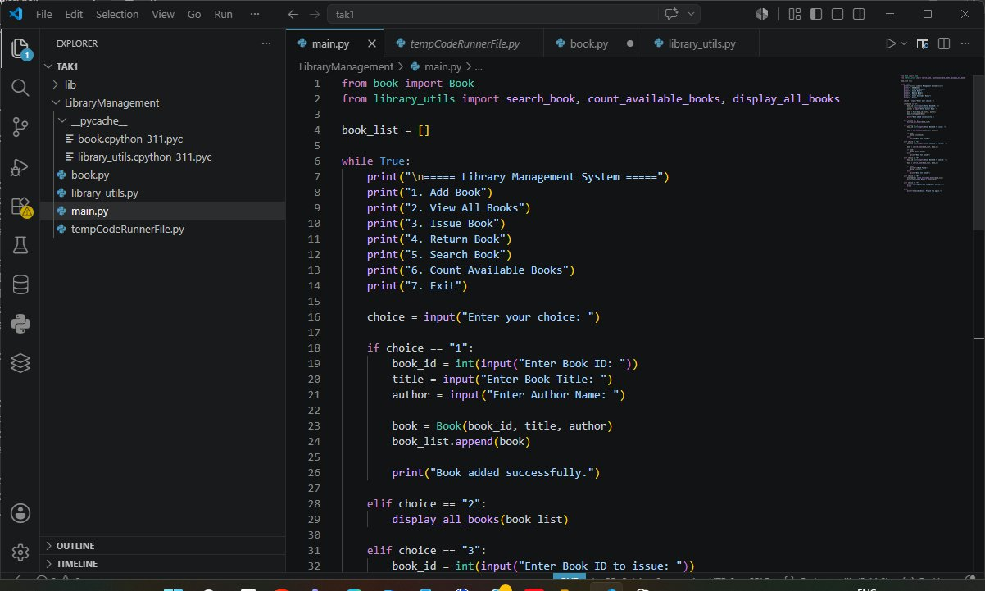
Figure 3: main.py — program entry point and menu logic

4.3.1 Code Walkthrough
At the top of main.py, the Book class is imported from book.py, and the search_book(), count_available_books(), and display_all_books() functions are imported from library_utils.py. An empty list, book_list, is then created to hold all Book objects for the duration of the program's execution.
The program enters an infinite while True loop that prints the menu shown in Section 3 on every iteration, then reads the user's choice using input(). Based on the choice entered, the appropriate branch of the if / elif chain is executed.
When the user selects option 1 (Add Book), the program prompts for a book ID, title, and author, constructs a new Book object with these values, and appends it to book_list before confirming that the book was added successfully.
When the user selects option 2 (View All Books), the program simply calls display_all_books(book_list), which iterates over every book in the list and prints its details using the display() method shown in Figure 1. Later options (Issue Book, Return Book, Search Book, Count Available Books, and Exit) follow the same pattern, delegating to the relevant Book method or library_utils function for the selected book ID.

4.4 Program Execution Output
The screenshot below shows the program running in the terminal. A book is added (Book ID 1001, titled “Baahubali” by Rajamouli), and the View All Books option is then used to display its details and status.
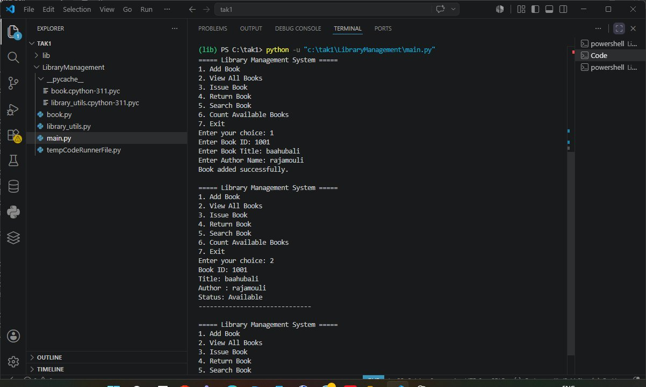
Figure 4: Terminal output showing Add Book and View All Books in action

5. Result
The Library Management System was implemented successfully using a modular Python structure. The program correctly performs all required operations: adding a book, displaying all books with their issue status, issuing and returning books, searching by book ID, and counting available books. The menu-driven interface allows the librarian to repeatedly select operations until choosing to exit, fulfilling all requirements outlined in the problem statement.

6. Conclusion
This project demonstrates the practical application of object-oriented programming and modular design in Python. By separating the data model (book.py), utility logic (library_utils.py), and user interface (main.py), the codebase remains organized, readable, and easy to extend with additional features such as file-based persistence or a graphical interface in the future.

