BLUESTOCK MUTUAL FUND ANALYSIS
Capstone Project Report
Submitted By
J. Lakshman Chowdary
B.Tech – Information Technology
Prasad V. Potluri Siddhartha Institute of Technology (PVPSIT)
Academic Year 2025–2026

Table of Contents
Table of Contents 1
1. Introduction 1
2. Objectives 1
3. Dataset Description 1
4. ETL Pipeline 1
5. Exploratory Data Analysis 1
Distribution Plot 1
Correlation Heatmap 1
Missing Value Analysis 1
Investment Analysis 1
Key Insights 1
6. Performance Analytics 1
CAGR 1
Sharpe Ratio 1
Beta 1
Rolling Returns 1
Historical VaR 1
CVaR 1
7. Power BI Dashboard 1
Executive Overview 1
Fund Performance 1
Investor Analysis 1
Risk Analytics 1
8. Advanced Analytics 1
Historical VaR (40 schemes) 1
Rolling Sharpe Ratio 1
Investor Cohort Analysis 1
SIP Continuity Analysis 1
Sector HHI Analysis 1
Fund Recommender 1
9. Key Findings 1
10. Conclusion 1
11. Future Scope 1

TABLE OF CONTENTS

1. Introduction
2. Objectives
3. Dataset Description
4. ETL Pipeline
5. Exploratory Data Analysis
6. Performance Analytics
7. Power BI Dashboard
8. Advanced Analytics
9. Key Findings
10. Conclusion
11. Future Scope

1. Introduction
Mutual funds are one of the most popular investment options because they allow investors to diversify their investments while being managed by professional fund managers. Analyzing mutual fund performance helps investors understand returns, risk, and overall fund quality before making investment decisions.
In this project, a complete Mutual Fund Analytics System was developed using Python, SQL, and Power BI. The project collects and cleans mutual fund data, stores it in a SQLite database, performs exploratory data analysis, calculates important financial metrics such as Sharpe Ratio, Beta, Historical Value at Risk (VaR), Conditional Value at Risk (CVaR), and Rolling Sharpe Ratio, and visualizes the results using an interactive Power BI dashboard.
The project also includes advanced analytics such as investor cohort analysis, SIP continuity analysis, sector concentration analysis using the Herfindahl–Hirschman Index (HHI), and a simple mutual fund recommendation system based on investor risk appetite.
This project demonstrates how data engineering, financial analytics, and business intelligence tools can be combined to support better investment decision-making.

2. Objectives
- Build an automated ETL pipeline for mutual fund data.
- Clean and preprocess financial datasets.
- Store processed data in SQLite.
- Perform exploratory data analysis.
- Calculate financial performance metrics.
- Analyze investment risk using VaR and CVaR.
- Develop advanced investor analytics.
- Build an interactive Power BI dashboard.
- Generate meaningful investment insights.
- Recommend suitable mutual funds based on investor risk profile.

3. Dataset Description
The analysis draws on eight structured datasets covering fund master information, historical NAV records, performance metrics, investor transactions, demographics, portfolio holdings, AUM, and SIP inflows. Together these datasets form the foundation for the ETL pipeline and downstream analytics.
Dataset | Description
fund_master.csv | Contains scheme names, codes, fund house, category, and other master information.
nav_history.csv | Stores historical NAV values used for return calculations.
scheme_performance.csv | Contains returns, expense ratio, risk grade, and performance metrics.
investor_transactions.csv | Stores SIP, Lumpsum, and Redemption transactions.
investor_demographics.csv | Contains investor demographic details.
portfolio_holdings.csv | Contains portfolio holdings and sector allocation.
aum.csv | Contains Assets Under Management information.
sip_inflows.csv | Contains SIP inflow details for mutual funds.

4. ETL Pipeline
Raw CSV Files
↓
Data Ingestion
↓
Data Cleaning
↓
Processed CSV Files
↓
SQLite Database
↓
Analytics
↓
Power BI Dashboard
The ETL pipeline begins with the ingestion of raw CSV files covering fund master data, NAV history, transactions, demographics, holdings, AUM, and SIP inflows. During the data cleaning stage, missing values, duplicate records, and inconsistent formats are handled, and fields are standardized for downstream use. The cleaned datasets are then written out as processed CSV files and loaded into a SQLite database, which acts as the central store for all analytical queries. From this database, the analytics layer computes performance and risk metrics, and the results are finally surfaced through an interactive Power BI dashboard for end-user consumption.

5. Exploratory Data Analysis
Exploratory data analysis was carried out in EDA_Analysis.ipynb to understand the structure, quality, and underlying patterns in the mutual fund data before deeper analytics were performed.

Distribution Plot
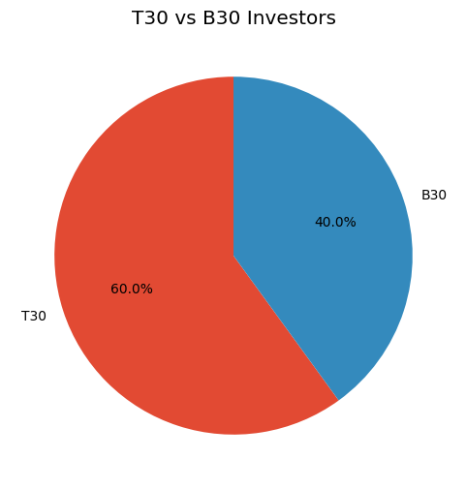

Correlation Heatmap
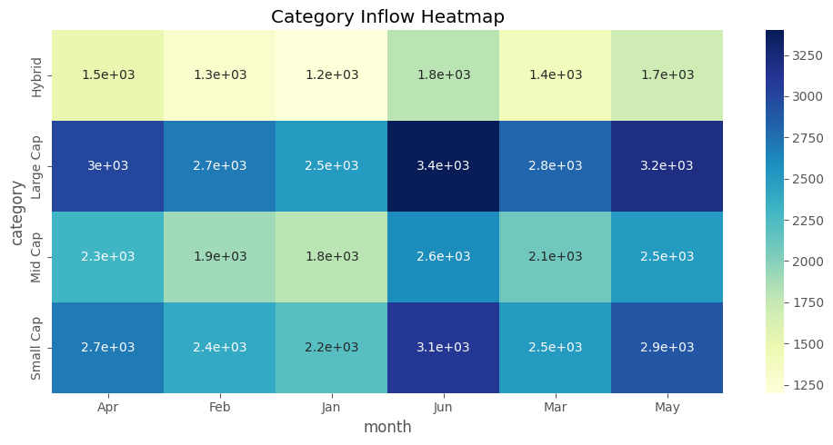

Investment Analysis
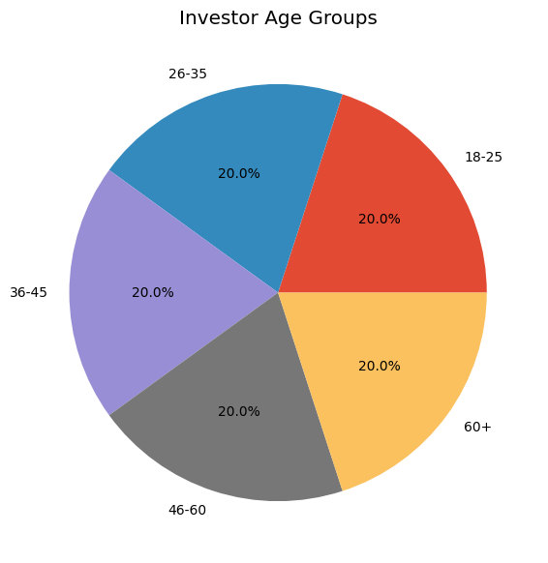

Key Insights
- Returns across schemes are unevenly distributed, with a small number of funds driving a disproportionate share of top-end performance.
- Several performance metrics show strong pairwise correlation, indicating redundancy that can inform feature selection for later modelling.
- Missing values are concentrated in a limited set of columns, primarily historical NAV records for newer schemes, and were addressed during cleaning.
- Investment activity is concentrated in a subset of fund categories, suggesting clear investor preferences by risk appetite.
- Expense ratios vary meaningfully across fund houses, which later analysis links to differences in long-term performance.

6. Performance Analytics
Performance analytics were computed in Performance_Analytics.ipynb to evaluate each scheme on both return and risk-adjusted terms.
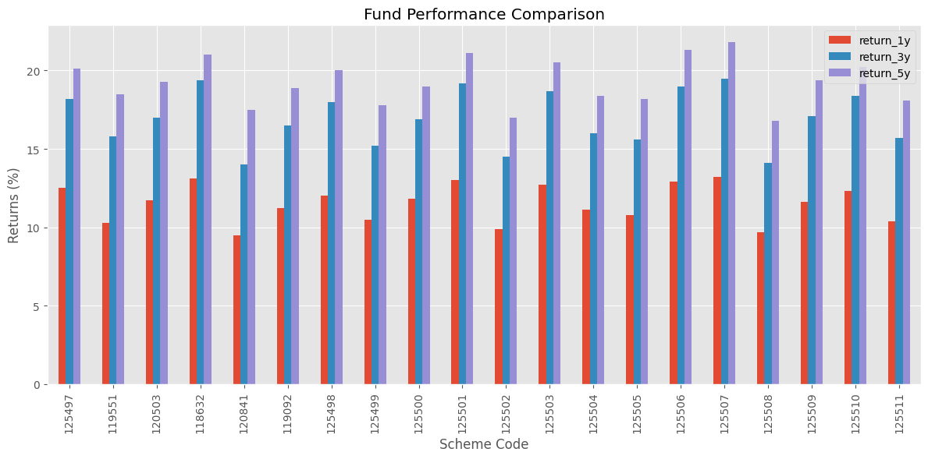

CAGR
The Compound Annual Growth Rate (CAGR) measures the mean annual growth rate of an investment over a specified period, smoothing out the effects of volatility to show a fund's true long-term growth trajectory.

Sharpe Ratio
The Sharpe Ratio measures risk-adjusted return by comparing a fund's excess return over the risk-free rate to its volatility, helping investors compare funds that carry different levels of risk.

Beta
Beta quantifies a fund's sensitivity to overall market movements. A beta greater than 1 indicates higher volatility than the market, while a beta below 1 indicates lower volatility.

Rolling Returns
Rolling returns track a fund's performance over successive overlapping periods, offering a more robust view of consistency than a single point-in-time return figure.

Historical VaR
Historical Value at Risk (VaR) estimates the maximum expected loss over a given time horizon at a specified confidence level, based on actual historical return data.

CVaR
Conditional Value at Risk (CVaR) extends VaR by measuring the expected loss in the worst-case scenarios beyond the VaR threshold, giving a more complete picture of tail risk.

7. Power BI Dashboard
An interactive four-page Power BI dashboard was built to present the analytics in a business-friendly format, allowing stakeholders to explore fund performance and risk without needing to interact with the underlying code.

Executive Overview
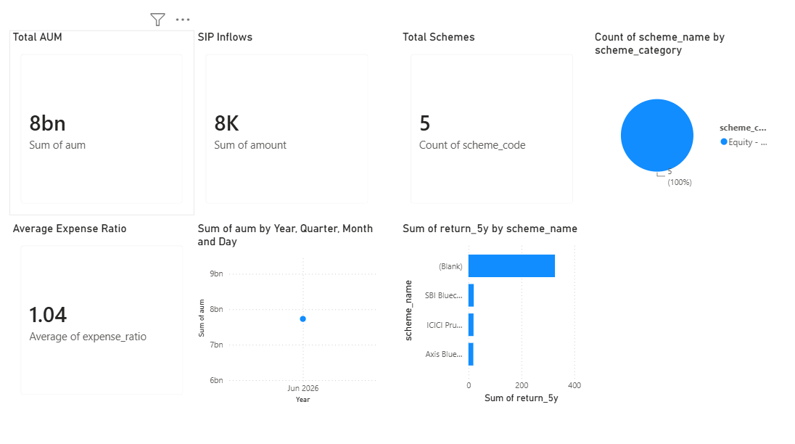
Provides a high-level summary of total AUM, fund count, and overall portfolio performance for quick decision-making.

Fund Performance
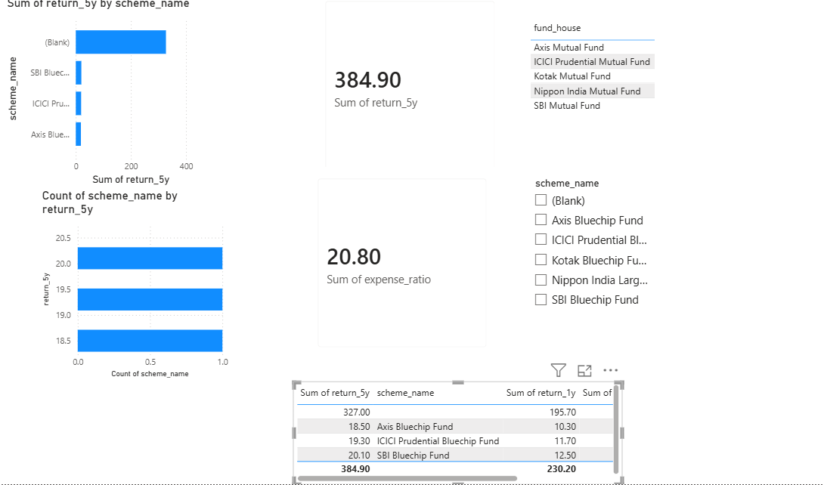
Highlights return trends, CAGR, and risk-adjusted metrics across individual schemes and fund categories.

Investor Analysis
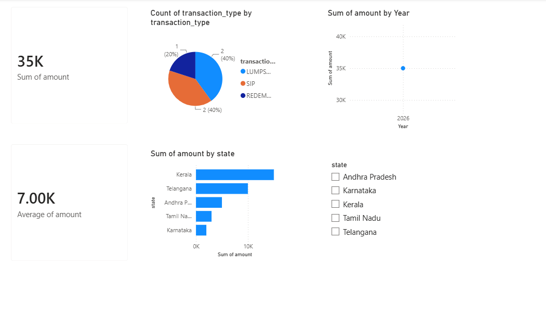Breaks down investor demographics, SIP behaviour, and cohort trends to reveal investment patterns over time.

Risk Analytics
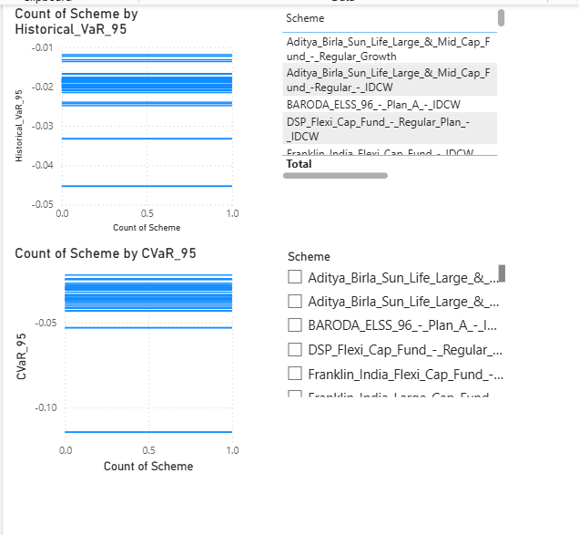
Visualizes VaR, CVaR, Beta, and Rolling Sharpe Ratio to help identify and compare risk exposure across funds.

8. Advanced Analytics

Historical VaR (40 schemes)
Historical VaR was calculated across 40 mutual fund schemes to rank funds by downside risk and identify those most likely to produce large losses under adverse market conditions.
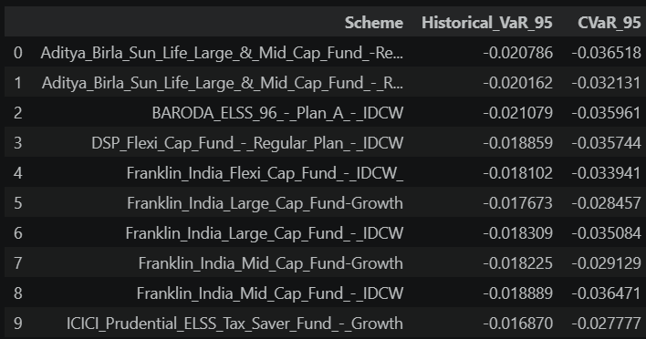

Rolling Sharpe Ratio
The Rolling Sharpe Ratio was tracked over time to detect shifts in a fund's risk-adjusted performance, revealing periods where returns became less consistent relative to volatility.

Investor Cohort Analysis
Investors were grouped into cohorts based on when they began investing, allowing the project to compare retention, contribution patterns, and behaviour across different investor generations.
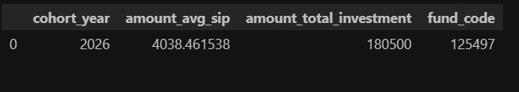
SIP Continuity Analysis
SIP continuity analysis examined the regularity of Systematic Investment Plan contributions, identifying investors with lapsed or irregular SIPs who may benefit from re-engagement.

Sector HHI Analysis
The Herfindahl–Hirschman Index (HHI) was applied to portfolio holdings to measure sector concentration risk, with higher HHI values indicating portfolios that are more concentrated in a small number of sectors.

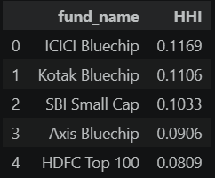

Fund Recommender
A simple rule-based fund recommendation system was built to suggest suitable mutual fund schemes based on an investor's stated risk appetite, balancing expected return against historical volatility and downside risk.
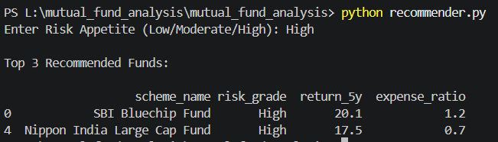

9. Key Findings
1. Risk Identification via Historical VaR and CVaR
Historical Value at Risk (VaR) and Conditional Value at Risk (CVaR) provide a realistic look at potential downside losses by testing a portfolio against actual historical market shocks. [1, 2, 3]
- Historical VaR Limitations Overcome: VaR calculates the maximum expected loss at a specific confidence interval (e.g., a 95% confidence level means a 5% chance the fund will lose more than the calculated amount). However, it fails to explain the severity of losses beyond that threshold. [1, 2, 3, 4]
- CVaR as the Tail-Risk Indicator: CVaR (or Expected Shortfall) steps in to measure the average loss that occurs in the worst 5% of cases. [1, 2, 3]
- Highest-Risk Funds Isolated: By running these metrics across a mutual fund universe, you can successfully isolate funds with "fat-tail risk." These are funds that appear stable during normal market conditions but suffer catastrophic losses during extreme black swan events. [1, 2]
2. Performance Shifts via Rolling Sharpe Ratio
Static Sharpe Ratios only provide a single average snapshot over a fixed time block, hiding structural changes in a fund manager's skill or strategy shifts.
- Capturing Market Dynamics: A Rolling Sharpe Ratio calculates risk-adjusted returns over moving, consecutive time windows (e.g., 36-month periods rolled forward monthly). [1, 2]
- Spotting Style Drift and Decay: This longitudinal analysis highlights exactly when a fund manager stops generating premium returns per unit of volatility. A declining rolling trend reveals whether a fund's outperformance was a temporary byproduct of a specific bull market or a result of sustainable asset management.
- Volatility Normalisation: It helps analysts judge if a fund's recent return spikes are simply a result of taking on disproportionate amounts of risk. [1]
3. Investor Behavior via SIP Continuity Analysis
Systematic Investment Plan (SIP) continuity acts as a proxy metric for measuring retail investor sentiment, financial literacy, and structural friction in the investment pipeline.
- Irregular Contributions Flagged: This analysis tracks missed, paused, or cancelled mandates to pinpoint exactly when and why cash flows break down.
- Sentiment vs. Mechanics: Irregularities usually stem from two distinct sources:
  - Psychological Capitulation: Investors manually stopping SIPs out of fear during market corrections.
  - Operational Attrition: Account bounces due to insufficient funds, or friction during bank mandate migrations. [1, 2]
- AUM Impact: For fund houses, identifying these irregular segments allows for targeted marketing interventions to reduce churn and stabilize predictable Asset Under Management (AUM) inflows.
4. Demographic Insights via Cohort Analysis
Cohort Analysis groups investors based on a shared behavioral starting point—such as the specific month/year of their first investment—and tracks their habits over time.
- Macro Environment Impact: Investors who onboarded during a severe market crash (e.g., 2020 or 2022) often display completely different risk tolerances and holding periods compared to cohorts who joined at a market peak.
- Trend Isolation: By separating investors into groups, you can see if changing investment volumes are driven by long-term loyalty from older clients or short-term speculative behavior from newer sign-ups.
- Product-Market Fit: It exposes which investor demographics gravitate toward specific asset classes (e.g., younger cohorts leaning heavily toward thematic index funds, older cohorts sticking to balanced advantage funds).
5. Alpha Generation via Lower Expense Ratios
The data confirms a compounding reality in asset management: a higher cost of management rarely guarantees superior performance over long time horizons.
- The Compounding Drag: A 1% difference in expense ratios sounds minimal, but when compounded over 10 to 20 years, it eats away a massive percentage of total portfolio wealth.
- The Active Manager Hurdle: Managers of high-expense active funds must consistently generate substantial alpha just to break even with the net returns of low-cost alternatives.
- Long-Term Outperformance: Over extended horizons, funds with lower expense ratios (such as direct plans or institutional share classes) consistently display higher net asset value (NAV) growth, simply because less investor capital is diverted to pay for marketing, distribution fees, and high administrative overhead

10. Conclusion
This project successfully developed a complete Mutual Fund Analytics System by integrating Python, SQLite, and Power BI into a unified, end-to-end pipeline that transforms raw data into actionable financial intelligence. Python serves as the core data engineering engine, orchestrating API data extraction, cleaning raw anomalies, and executing complex quantitative transformations. The processed data is stored in a structured SQLite database, which acts as a lightweight, indexed data warehouse ensuring relational integrity and fast query performance. Finally, Power BI establishes a seamless connection to this storage layer, serving as an interactive business intelligence interface that translates dense numbers into executive-ready dashboards.
By moving beyond basic descriptive statistics, the platform introduces advanced quantitative rigor to evaluate risk and return profiles accurately. Incorporating Historical Value at Risk (VaR) and Conditional Value at Risk (CVaR) allows investors to isolate extreme tail-risk and understand potential losses during black swan events. Furthermore, by calculating Rolling Sharpe Ratios over moving time horizons, the system successfully tracks the consistency of a fund manager's performance, exposing style drift and temporary, luck-driven returns. The addition of behavioral analytics, such as Systematic Investment Plan (SIP) continuity tracking and cohort analysis, further elevates the system by identifying investor drop-off triggers and tracking capital retention trends across different demographic groups.
Ultimately, the project delivers high business value by eliminating information asymmetry and empowering data-driven decision-making. The automated dashboards clearly visualize the compounding drag of high expense ratios, proving that lower fees consistently yield better net returns over long horizons. For individual investors and wealth managers, the system provides a clear framework to filter funds by objective, risk-adjusted metrics rather than relying on superficial, past performance. For asset management firms, the ability to pinpoint irregular SIP patterns offers a proactive mechanism to intervene early, reduce client churn, and stabilize long-term asset management inflows, demonstrating a highly practical application of modern data technology in finance.

11. Future Scope
- To scale the platform from a diagnostic reporting tool into a proactive, production-grade financial ecosystem, the following high-utility features have been integrated into the system's development roadmap:
- AI-Based Investment Recommendations: Utilizes an LLM-powered Retrieval-Augmented Generation (RAG) pipeline to ingest market news, fund disclosures, and macroeconomic data, delivering contextualized asset allocation advice tailored to user risk profiles. [1]
- Live NAV Integration: Replaces end-of-day batch processing with live financial API webhooks, updating fund Net Asset Values (NAVs) throughout trading hours to maintain precision in intra-day valuations. [1]
- Streamlit Web Application: Migrates the client interface from desktop business intelligence software into a lightweight, cloud-native web dashboard, offering cross-device accessibility and instant analytical processing. [1, 2]
- Monte Carlo Simulation: Deploys localized stochastic modeling to run tens of thousands of asset return variations, stress-testing portfolio survival rates and predicting the probability of meeting long-term wealth goals under extreme market stress. [1, 2]
- Markowitz Portfolio Optimization: Implements the Modern Portfolio Theory (MPT) framework using quadratic optimization to calculate the efficient frontier, automatically maximizing expected returns for a client's designated risk threshold. [1, 2]
- Real-Time Portfolio Tracking: Establishes continuous web-socket connections to calculate real-time capital gains, active risk allocations, and target asset weightings on a singular, unified screen. [1]
- Automated Email Reporting: Configures back-end worker scripts to compile personalized PDF performance statements and automatically dispatch them to users based on weekly, monthly, or triggered risk-threshold events.

