Loan Assignment:

1.First Page to get Customer Details:

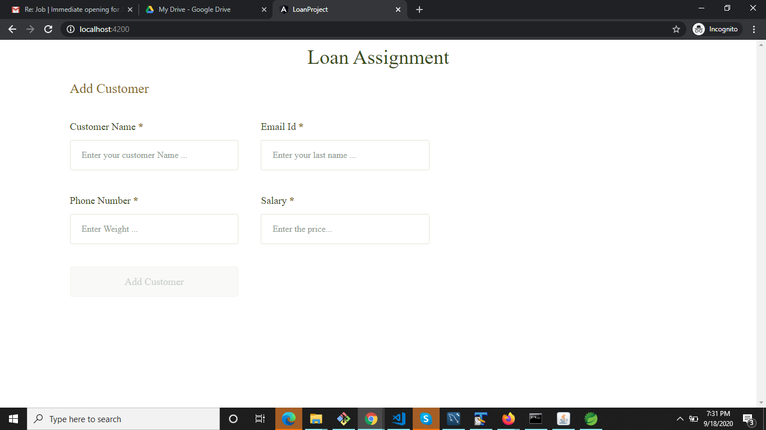

2. After Successful creation of Customer, page redirects to Loan Creation:

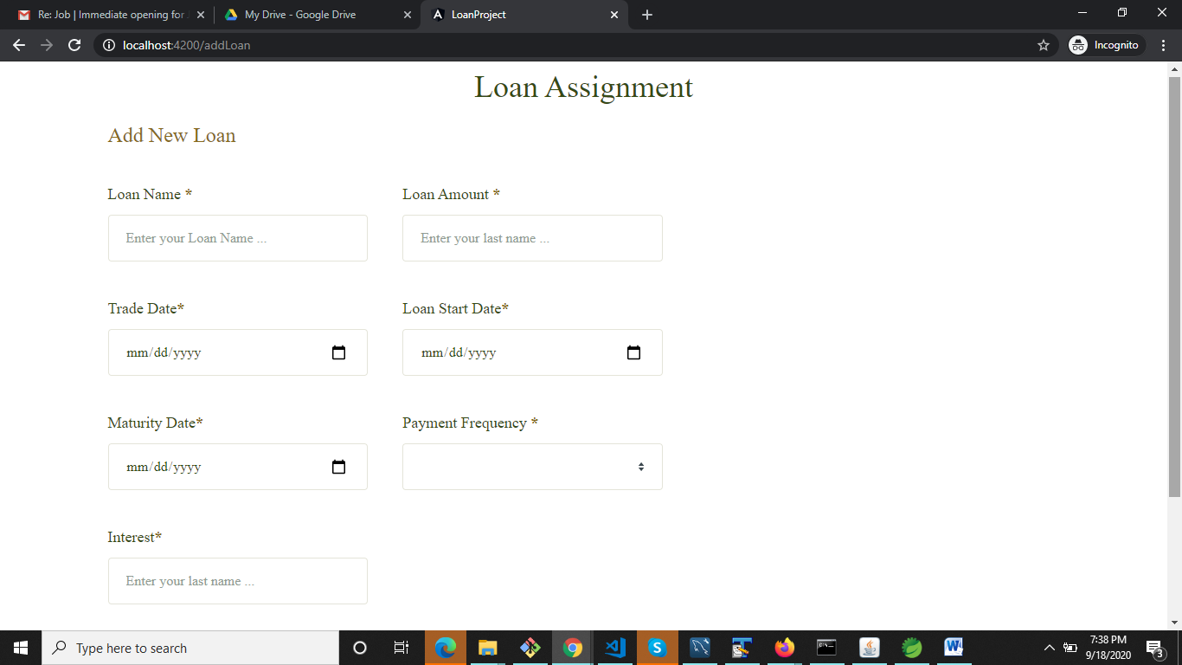

3.After Loan Creation:

Create Button is to create new Loan.

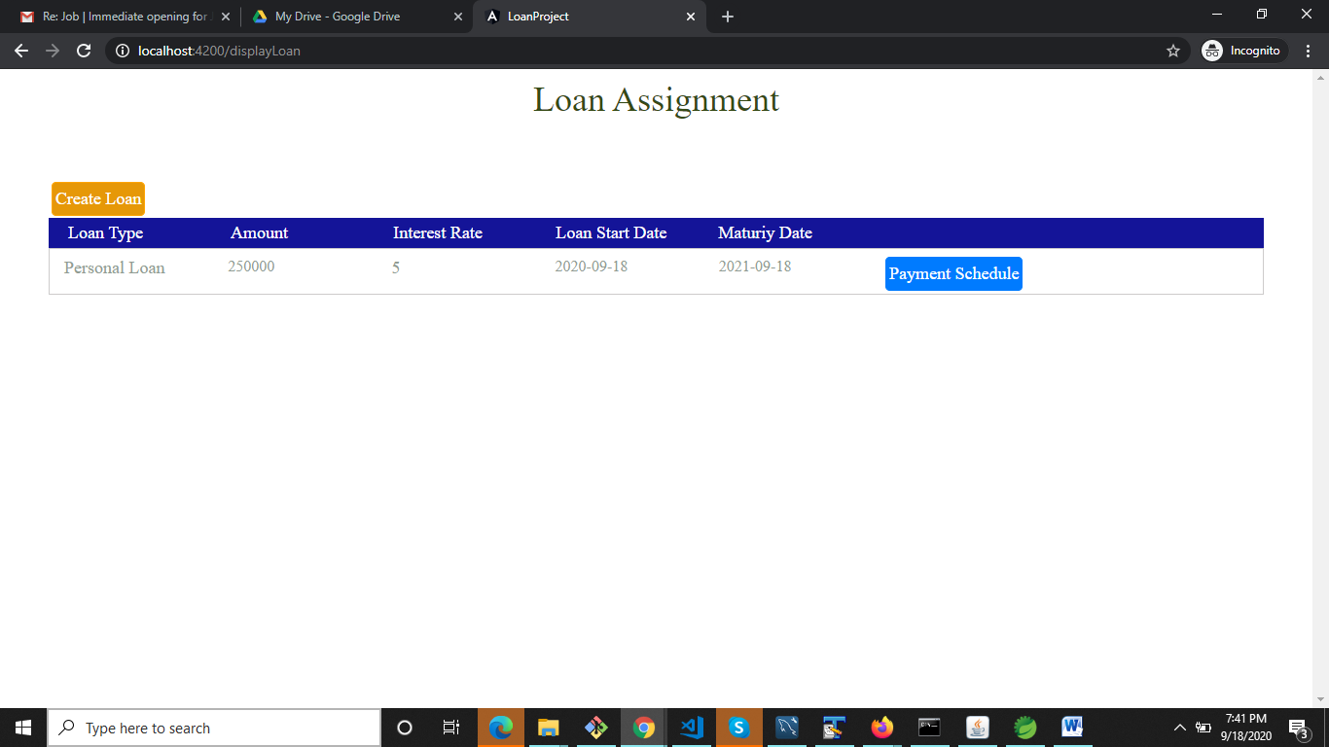

**Payment Schedule** button is used to view the Schedules:

