**Jenkins**

**Installation:**

1. Download Jenkins from <https://jenkins.io/download/>
2. Choose Generic Java package (.war)

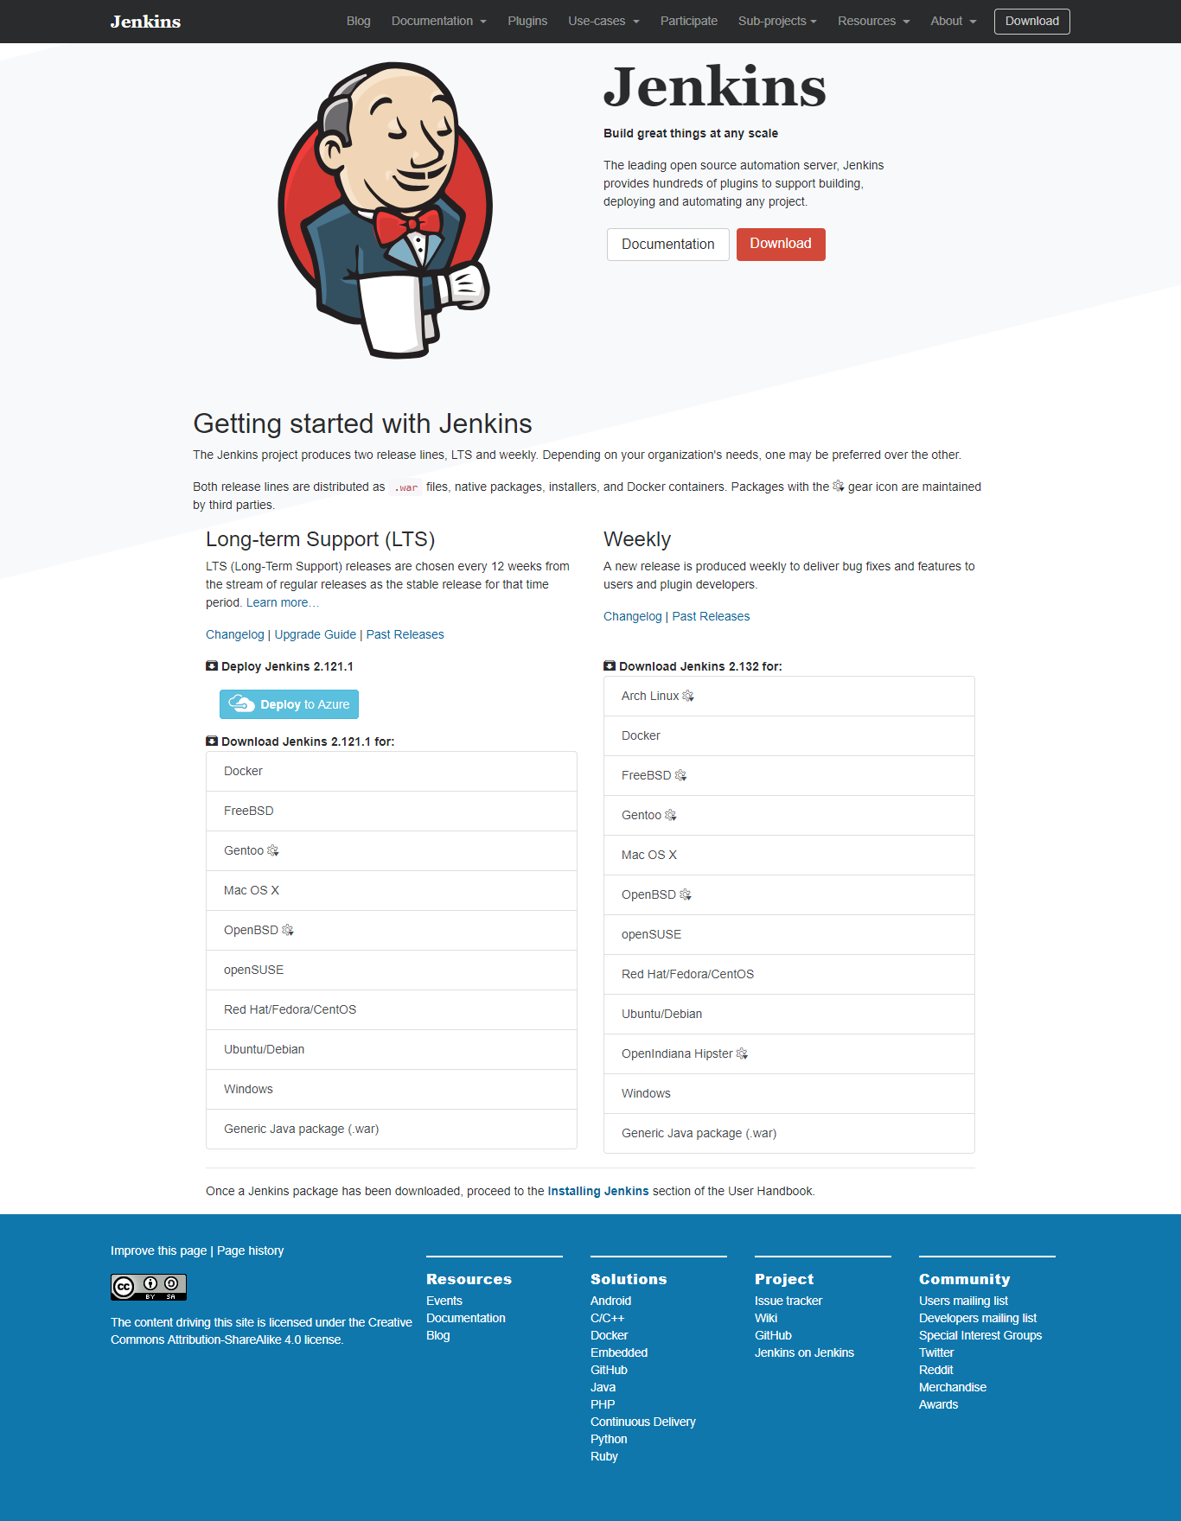

**Starting Jenkins**

* Copy the war file and placed in webapps Tomcat Folder C:\Users\apache-tomcat-9.0.0.M17\webapps.
* Open the command prompt. From the command prompt, browse to the directory where the jenkins.war file is present. Run the following command
* C:/Users/apache-tomcat-9.0.0.M17/webapps>Java –jar Jenkins.war
* Next run the tomcat server using command “startup.bat”.

Open the browser and go to the link − **http://localhost:8080/jenkins**. Jenkins will be up and running on tomcat.

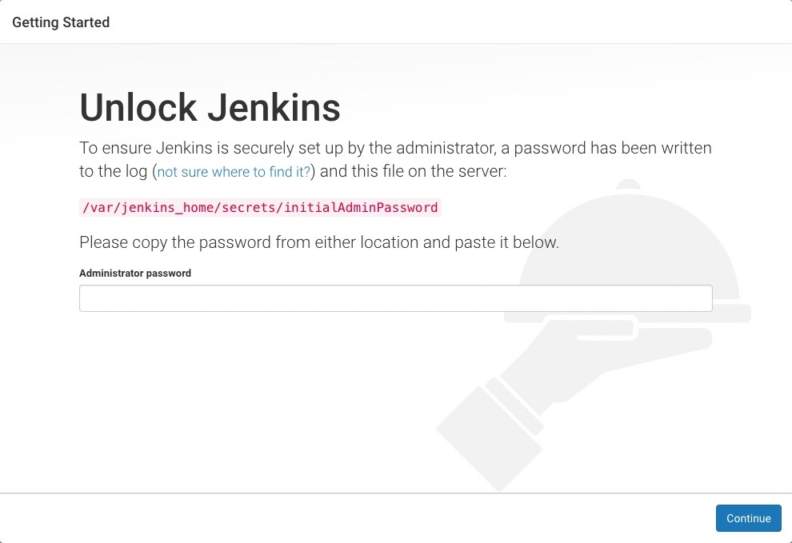

The initial password is located in the .jenkins/secrets/initialAdminPassword.

Now I will install plugins. As you see in the below snapshot there are two options i.e. either I can go with suggested plugins or I can select plugins on my own.

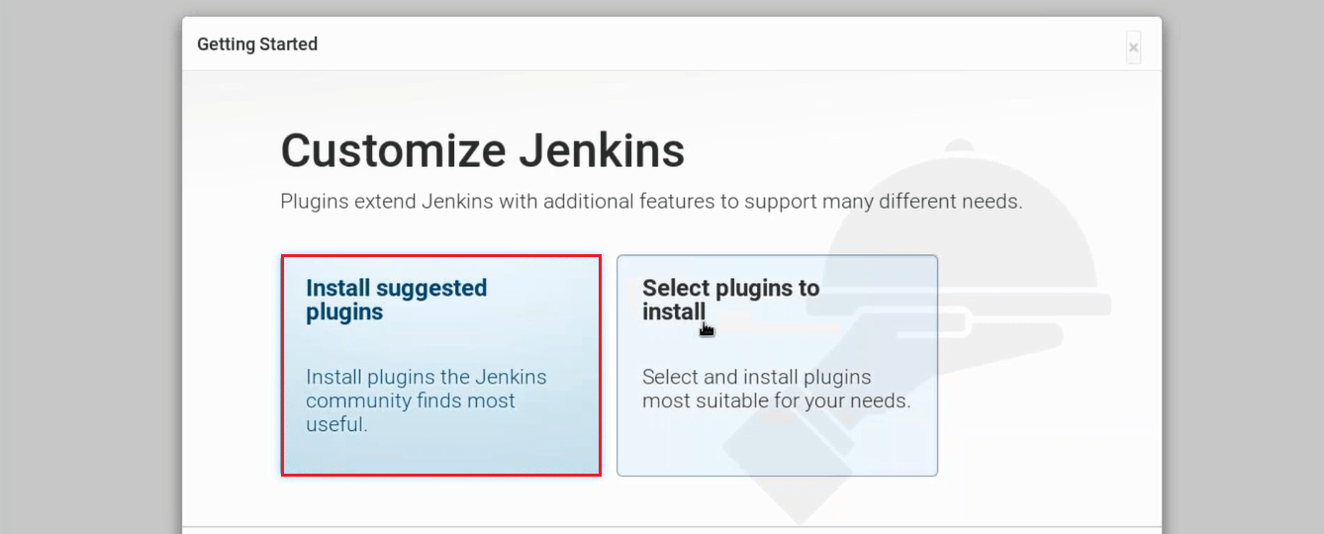

I will go with **Install Suggested Plugins.**

Snapshot below will give you a list of plugins that will be installed when you click on **Install Suggested Plugins**.

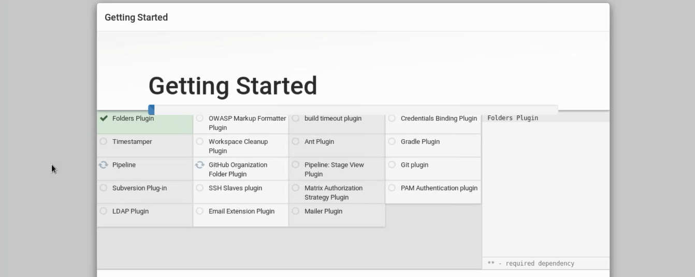

Once the plugins are installed, you will be directed to a page where you have to Create First Admin User. Please fill your relevant details.

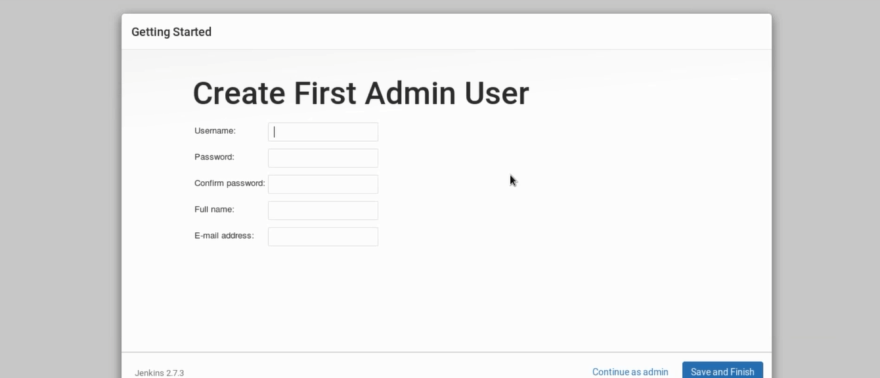

After filling this form, click on save and finish.

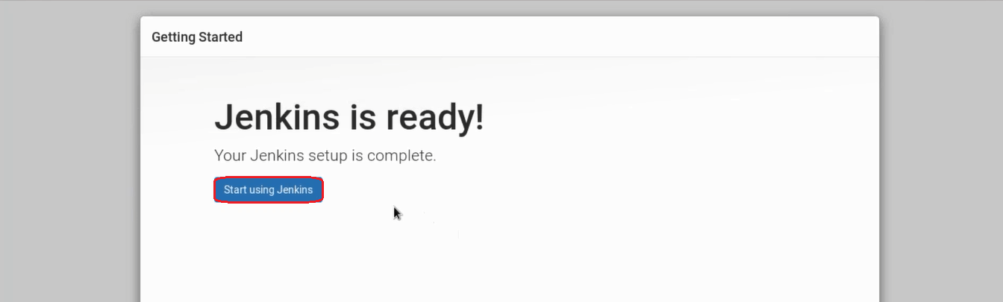

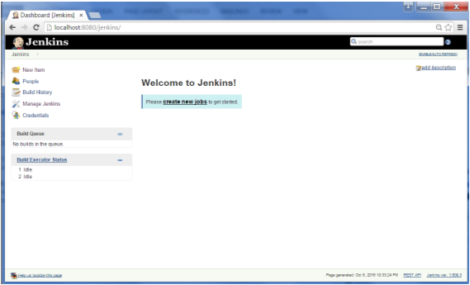

**Creating and configuring user on Jenkins**

a) To create a user go to Manage Jenkins->Manage Users->Create User->Provide the required information

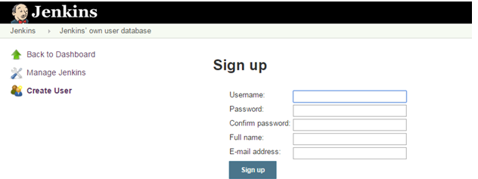

b) Go to Manage Jenkins->Configure Global Security  
-Check Enable security  
-In Security Realm, select Jenkins own user database and check Allow users to sign up  
-In authorization, there are multiple options select as per requirement  
-Save once done

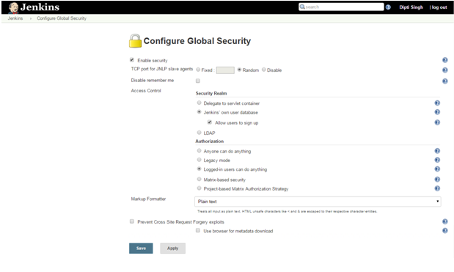

## Step 3 – Configuring System

a) Go to Manage Jenkins->Configure System->Environment Variables

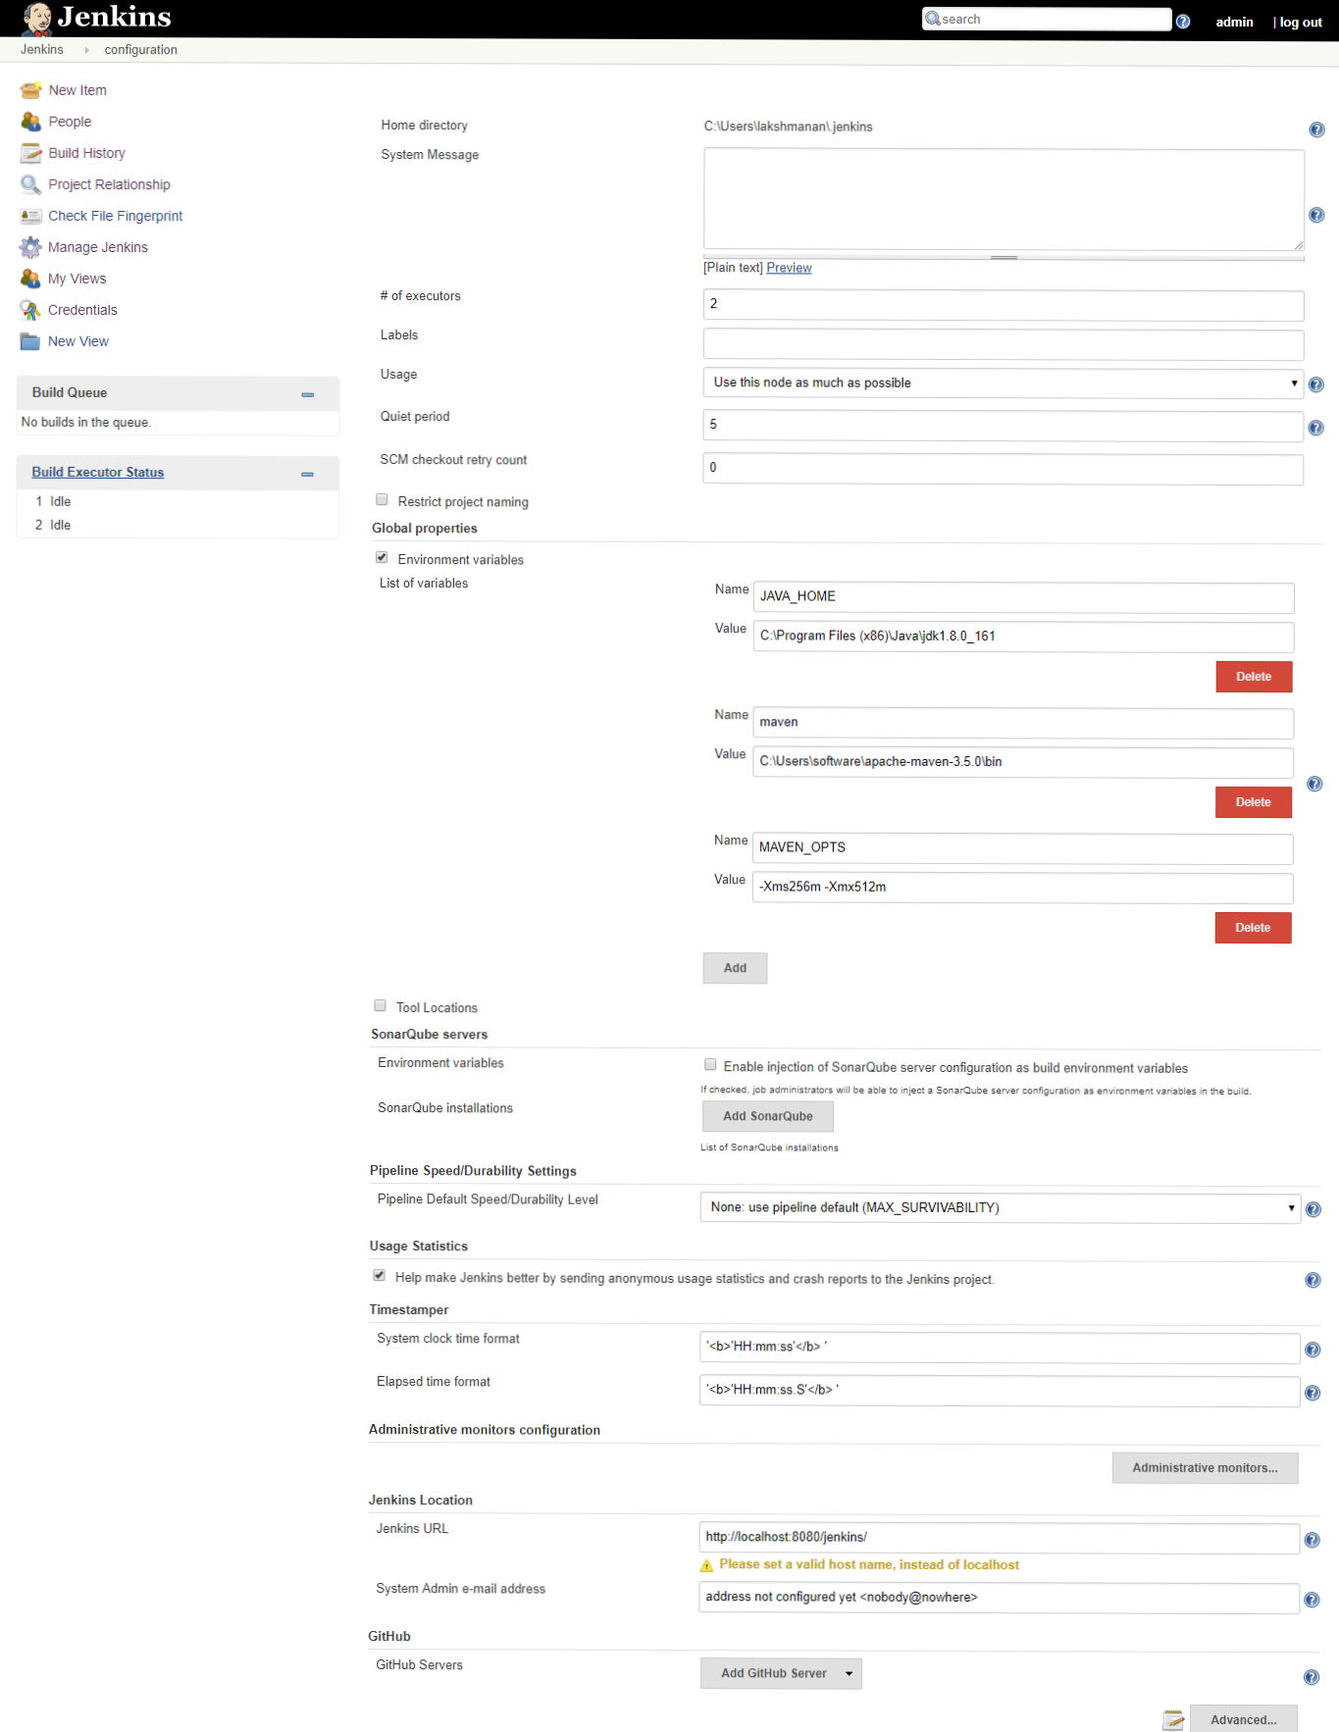

**Email Configuration**:

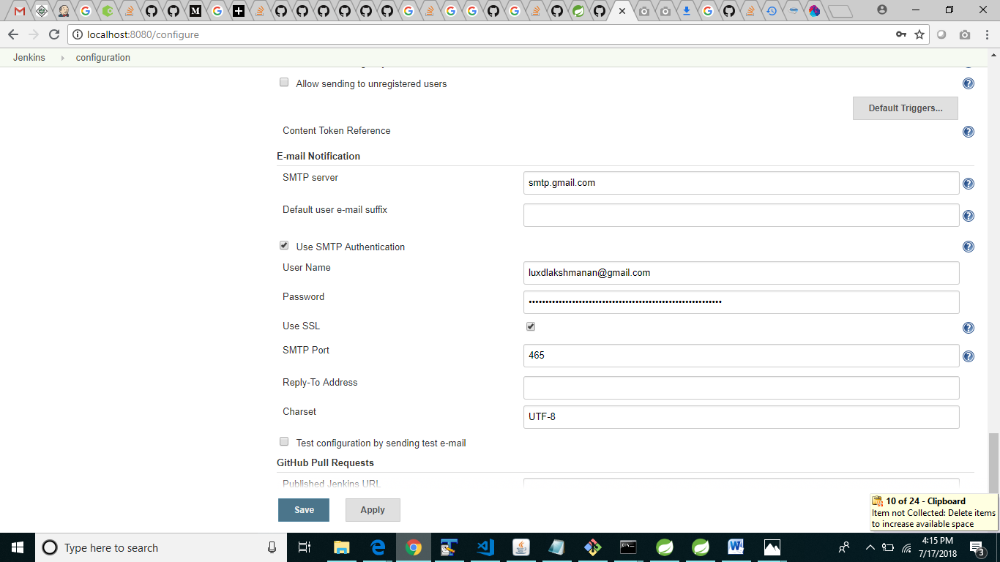

**Creating Job:**

* Create a new job using New Item.
* Enter a name of the job and choose Freestyle project.

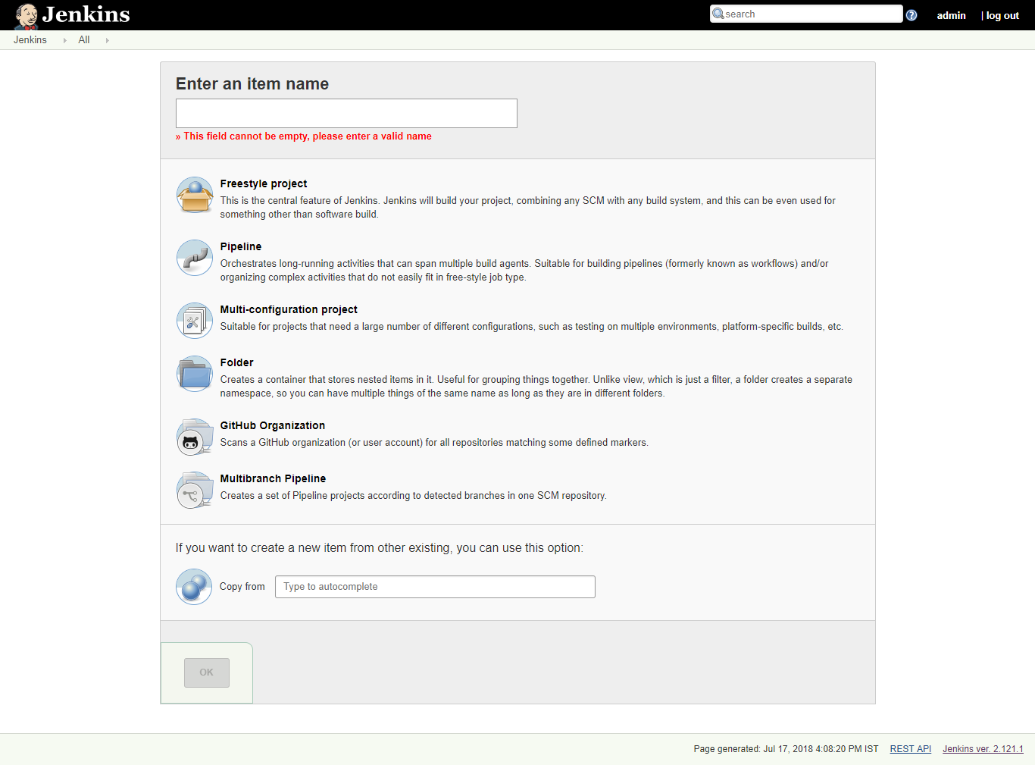

* Configure github in your job by Configure -> Source Code Management
* Give your github credential in Credential Column.

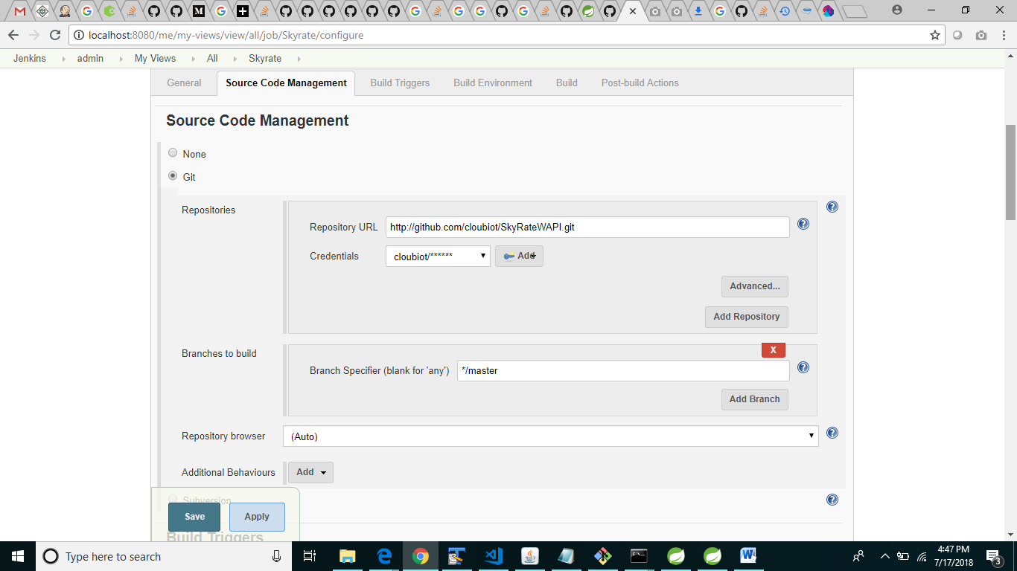

**Build Triggers:**

* Choose “Github hook trigger for GITScm polling” for continuous integration when github is pushed.
* At the same time need to configure Github for hooks. In order to add the hook url to git. Go to repository settings -> Integration & Services.
* Add service by choosing “Jenkins(GitHub plugin)”.
* Give the Jenkins hook Url.

**Build:**

* Choose Maven for Java Project and set “clean install” in Goals.

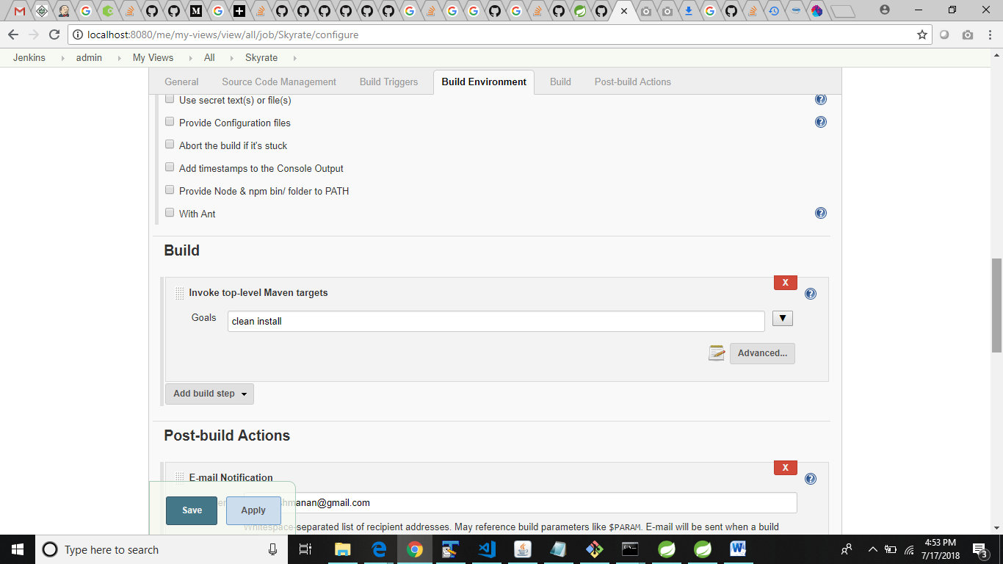

**Post Build Actions:**

Enable Email notification for every build.

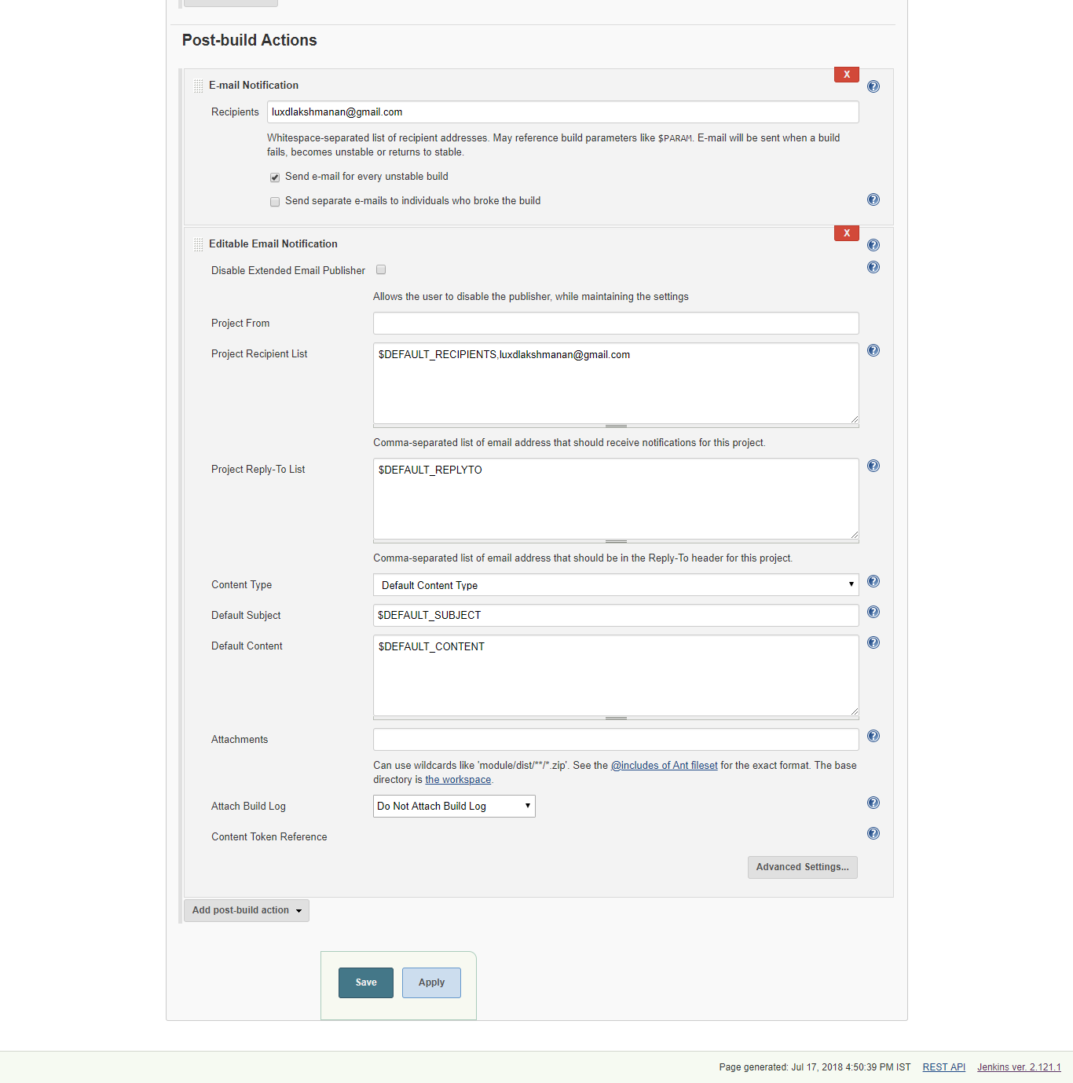

Configuration for the job related to java is done.

Now give Build Now .

After running the job the email is send to the given respective users.

Jenkins for Angular:

1.Change the Git Url in configure.

2.Add NodeJs Plugin in Manage Jenknins -> Manage Plugins

Choose Available tab

Search for “NodeJs Plugin” and click “Install without restart”

3. 