LAKSHMANAN C

*Student*

# PROFILE

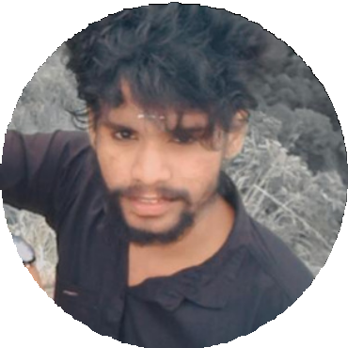

I am BCA student.

I consider my self a

responsible and orderly person.

I am looking foward for my first work

experience.

# CONTACT ME

8667072790

lakshmananthedon777@gma il.com

12/74,

pandalur, Gudalur,

The Nilgiris.

# EDUCATION

## BHARATHIYAR UNIVERSITY

*BCA*

## GOVERNMENT ARTS AND SCIENCES COLLEGE

*2021-2024*

# LANGUAGE

English. Tamil.

# COMPUTER SKILLS

C

Pyhon Java