AWS Core Services Lab – S3, Glue, CloudWatch, Athena

Overview :
This project demonstrates the use of core AWS services to build a simple data analytics workflow. The goal is to upload a dataset into Amazon S3, process it using AWS Glue, monitor using CloudWatch, and query the data using Amazon Athena.
The dataset used is an e-commerce sales dataset, and SQL queries are executed in Athena to analyze the data.

Workflow of the Project :
The complete workflow followed in this lab is:
- Upload CSV dataset to Amazon S3
- Create IAM Role with required permissions
- Configure AWS Glue Crawler to scan the dataset
- Monitor crawler execution using CloudWatch
- Query data using Amazon Athena
- Export results as CSV files

Dataset Description :
- Dataset Type: E-commerce Sales Data
- Format: CSV file
- Storage Location: Amazon S3

AWS Services Used :
- Amazon S3
Amazon S3 is used to store the dataset in the cloud. The CSV file is uploaded into an S3 bucket, which acts as the data source for querying.
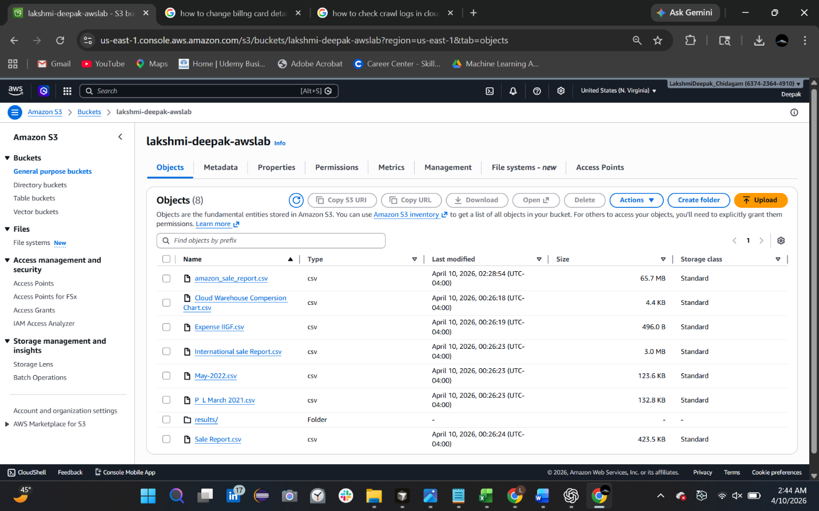

🔹 2. AWS IAM
IAM is used to create a role that provides necessary permissions for AWS Glue to access S3 data.
Permissions used:
- AmazonS3FullAccess
- AWSGlueServiceRole
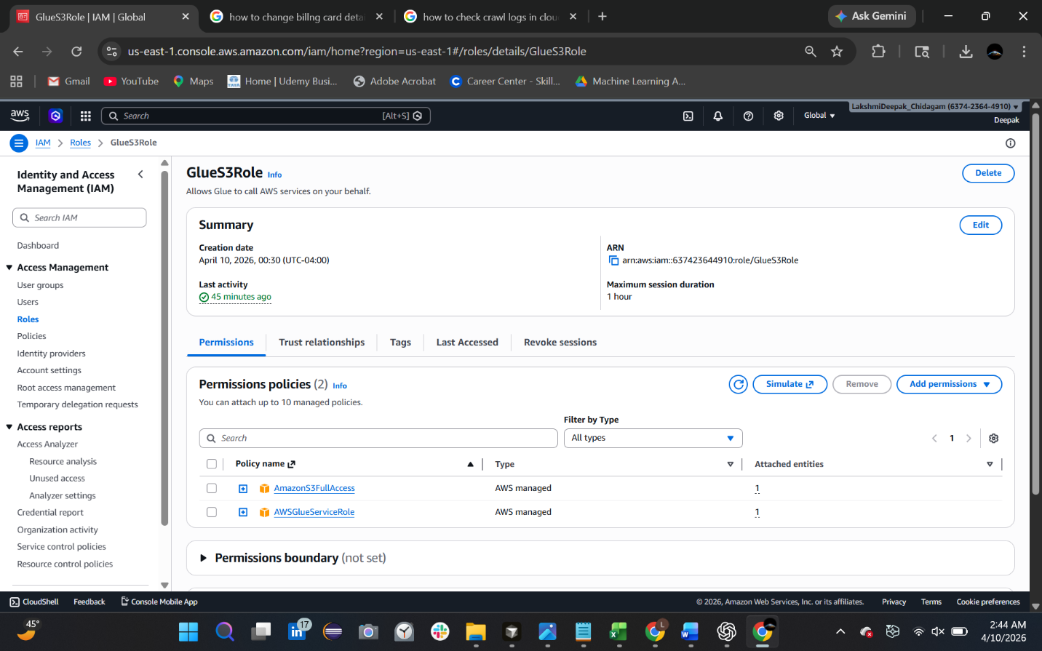
- IAM Role (GlueS3Role) with attached policies
3. AWS Glue
AWS Glue is used to create a data catalog by scanning the dataset stored in S3. A crawler is configured to read the CSV file and generate a table schema.
Initially, a Glue crawler was created to automatically detect the schema. However, the generated table did not correctly retrieve data rows due to parsing issues.
- Glue Crawler configuration
- Glue Tables view showing created table

🔹 4. Amazon CloudWatch
CloudWatch is used to monitor the execution of the Glue crawler. It provides logs that help in debugging issues related to data crawling and table creation.
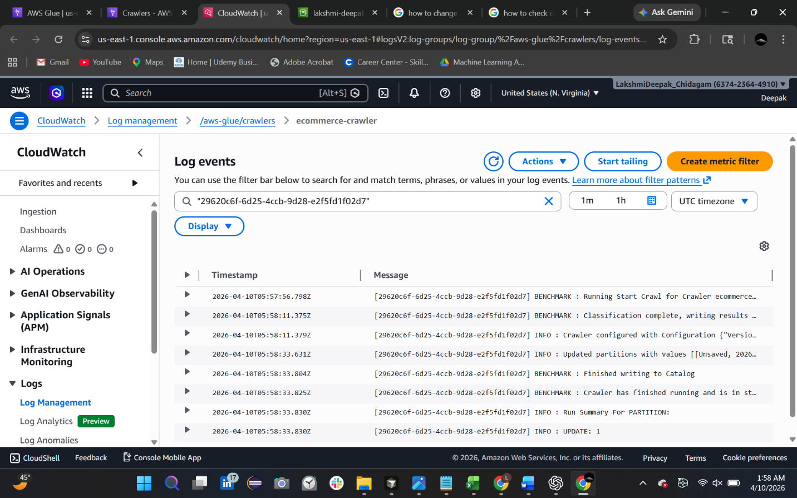
- CloudWatch logs showing crawler execution status

🔹 5. Amazon Athena
Amazon Athena is used to run SQL queries directly on the data stored in S3. It allows serverless querying without needing any database setup.
Since the Glue-generated table had issues, a new external table was created manually in Athena to correctly map the dataset.
- Athena query editor showing successful query execution

🗄️ Table Used for Analysis
Due to issues with the Glue-generated table, a manual table was created in Athena.
Table Name:
fixed_table
This table correctly maps to the S3 dataset and allows successful querying of data.
📤 Output and Submission
- All SQL queries were executed in Amazon Athena
- The results of each query were downloaded as CSV files
- Screenshots of query outputs were captured for verification
The outputs demonstrate successful data retrieval and analysis from the dataset stored in Amazon S3.

⚠️ Challenges Faced
During the implementation of this lab, the following challenges were encountered:
- The table created using AWS Glue did not return any data rows
- Only column names were visible, but no records were displayed
- This issue was caused by incorrect parsing of the CSV file

✅ Solution Implemented
To resolve the issue:
- A new external table (fixed_table) was manually created in Amazon Athena
- The correct file format and S3 location were specified
- After this, the data was successfully retrieved and queried

🎯 Conclusion
This lab successfully demonstrates how to:
- Store data in Amazon S3
- Use AWS Glue for metadata management
- Monitor processes using CloudWatch
- Perform serverless querying using Amazon Athena
It highlights the importance of correct data configuration and shows how AWS services can be integrated for efficient data analysis without managing infrastructure.

