**Bonam Venkata Chalamayya Engineering College, Odalarevu**

A

Project Report

on

**“Fake News Detection”**

For the Course

**Machine Learning**

**SUBMITTED BY**

**Lakshmi Gowri Mattaparthi**

**Third Year Computer Science and Engineering.**

**SUBMITTED TO**

**Pianalytix**

**Machine Learning Team**

**23 December, 2020**

**CONTENTS**

1. Abstract
2. Introduction
3. Observations
4. Conclusion
5. Reference Page

**ABSTRACT**

The main aim of the project comes up with the applications of NLP (Natural Language Processing) techniques for detecting the ‘fake news’, that is, misleading new stories that comes from the non-reputable sources. With the current usage of social media platforms, consumers are creating and sharing more information than ever before some of which are misleading with no relevance to reality. In this work, we propose to use machine learning ensemble approach for automated classification of news articles. Our study explores different textual properties that can be used to distinguish fake contents from real. By using those properties, we train a combination of different machine learning algorithms using various ensemble methods and evaluate their performance on real world data sets.

The task of classifying news manually requires in-depth knowledge of the domain and expertise to identify anomalies in the text. In this research we discussed the problems of classifying fake news articles using machine learning models and ensemble techniques. The data we used in our work is collected from the World Wide Web and contains news articles from various domains to cover most of the news rather than specifically classifying political news. We extracted different textual features from the articles and used the feature set as an input to the models. Fake news detection has many open issues that require attention of researchers. Likewise, real time fake news identification in videos can be another possible future detection.

**INTRODUCTION**

The main objective of this project is to detect whether an article is fake or real. Detecting of fake news online is important in today’s society as fresh news content is rapidly being produced as a result of the abundance of technology that is present. In the world of false news, there are seven main categories and within each category, the piece of fake news content can be visual- and/or linguistic-based. While many of these methods of detecting fake news are generally successful, they do have some limitations.

**DEVELOPMENT TOOLS: -**

1. We used Jupyter notebook.
2. We used Kaggle for the data to access data and to analyze on it.
3. Language: Python
4. Libraries: Pandas, numpy, sklearn, word cloud, nltk
5. Anaconda environment

**SYSTEM REQUIREMENTS:**

**On client side**

* Operating System(any)
* Python editor (Wing IDE, Online editor, Command prompt)

**On server side**

* Jupyter notebook/google Collab
* Installing libraries
* Python

**FEATURES:**

* Fully Informative data
* User friendly
* Inexpensive

**OBSERVATIONS:**

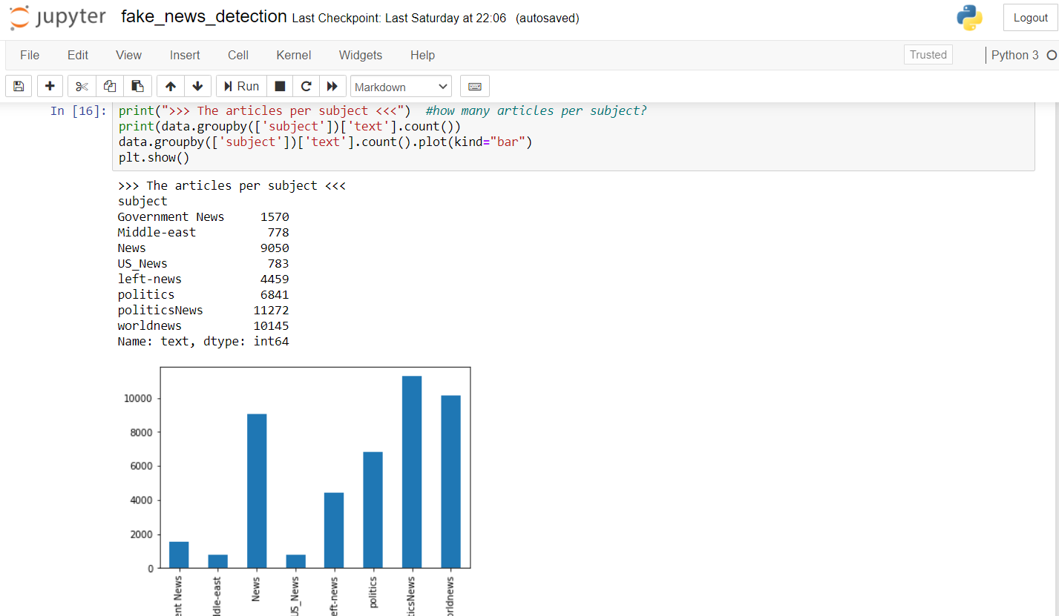

Fig. 1 Graphical representation

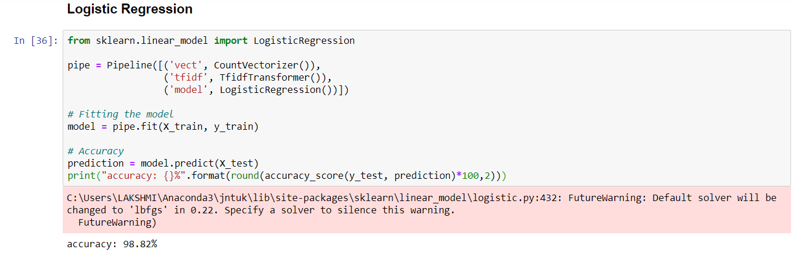

Fig. 2 Logistic Regression

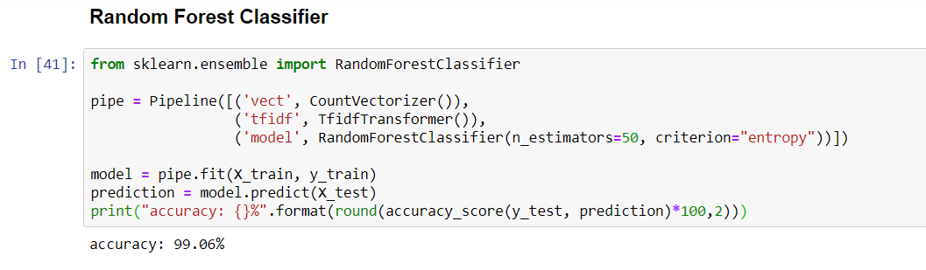

Fig. 3 Random Forest

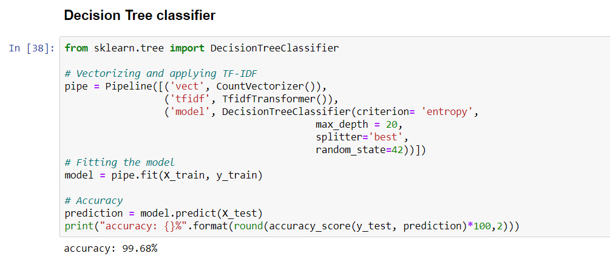

Fig. 4 Decision Tree



Fig. 5 word cloud

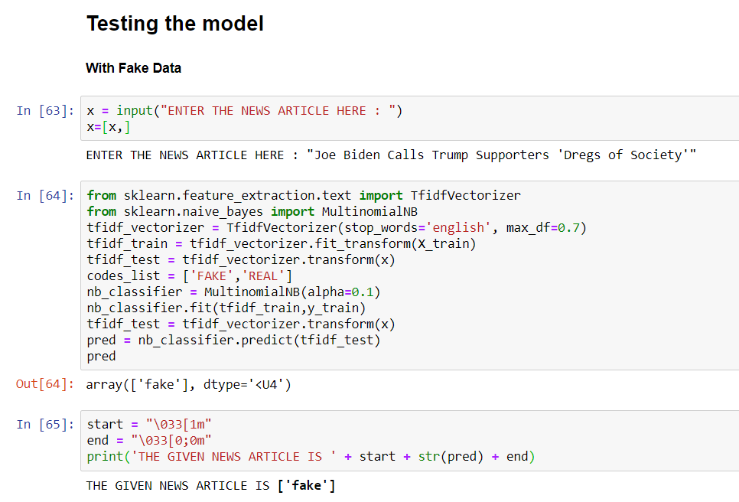

Fig. 6

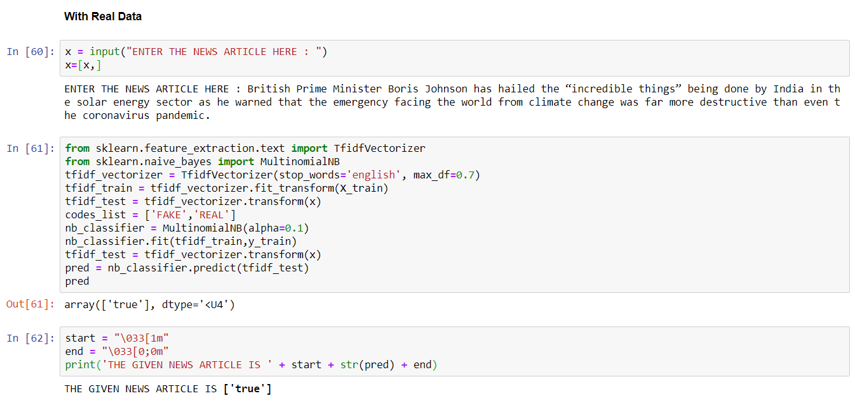

Fig. 7

**CONCLUSION:**

We predicted whether an article is fake or real. The Downloaded data is clear and good. Due to this online resources, now-a-days it is difficult to find whether a news is fake or real. By using artificial intelligence, we can predict the fake news easily. The task of classifying news manually requires in-depth knowledge of the domain and expertise to identify anomalies in the text. In this research, Fake news detection has many open issues that require attention of researchers. For instance, in order to reduce the spread of fake news, identifying key elements involved in the spread of news is an important step. Graph theory and machine learning techniques can be employed to identify the key sources involved in spread of fake news. Likewise, real time fake news identification in videos can be another possible future direction.

**REFERENCE PAGE**

1. All the source code and csv files are found in this…. <https://github.com/Lakshmi-Gowri/fake-news-detec>
2. <https://www.kaggle.com/c/fake-news>
3. <https://www.kaggle.com/jruvika/fake-news-detection>.