UI Automation Testing Approach

ChangeLog

Version | Change Date | By | Description
1 | 27 July2022 | Lakshmi NVenkatesan | Initial Version

Introduction
This document provides the automation testing plan for testing the requirements that are a part of Technical Assessment. This document highlights the testing process that will be carried out by the testing team.

Scope

In Scope

Purpose of this document is to describe the Test Plan for system under test planned for Technical Assessment.
Below is the list of items that are in scope
- Documentation
- Configuration
- Framework Creation
- Cloud Repository
- CI/CD Pipeline

Out of Scope
Non functional testing is out of scope

Assumptions
Following are the assumptions identified for the given system under test
- Clickable buttons available in the web application upon clicking will change the text on the button.
- Upon clicking on the buttons on the left side of web application, the canvas value changes dynamically.
- Edit and delete button in the table upon clicking on the web application is not having any effect in the web application while writing the automation script.

UI Automation Framwork

Structure of the framework
Let’s talk about the structure of the framework and the different files & folders in the framework
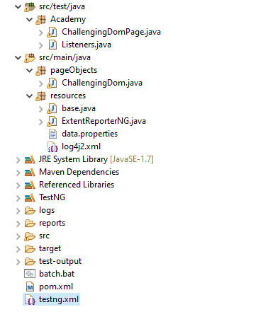
The above screenshot illustrates a standardized maven project. As per the above maven project, all the tests and Listeners are kept in the ‘src/test/java‘ and remaining files (such as config.properties, element locators (POM classes), utility files, test data, etc.,) kept under ‘src/main/java‘.
Language: In this Project Java language is used. Even though Selenium supports multiple languages, Java language is just because most of the automation developers have knowledge on Selenium with Java.
POM: As per the Page Object Model, it maintained a class for every web page. Each web page has a separate class and that class holds the functionality and members of that web page. Separate classes for every individual test.

Packages: We have separate packages for Pages and Tests. All the web page related classes come under the Pages package and all the tests related classes come under Tests package.

Base Class: Base class (base.java) deals with all the common functions used by all the pages. This class is responsible for loading the configurations from properties files, Initializing the WebDriver, Implicit Waits, Extent Reports, and also to create the object of FileInputStream which is responsible for pointing towards the file from which the data should be read.

Properties file: This file (data.properties) stores the information that remains static throughout the framework such as browser-specific information, application URL, screenshots path, etc.
All the details which change as per the environment and authorization such as URL, Login Credentials are kept in the data.properties file. Keeping these details in a separate file makes it easy to maintain.

Screenshots: Screenshots will be captured and stored in a separate folder and also the screenshots of failed test cases will be added to the extent reports.

TestNG: Using TestNG for Assertions, Grouping, and Parallel execution.

Maven: Using Maven for build, execution, and dependency purpose. Integrating the TestNG dependency in the POM.xml file and running this POM.xml file using Jenkins.

Version Control Tool: Used GitHub as a repository to store the test scripts.

Jenkins: By using Jenkins CI (Continuous Integration) Tool test cases can be executed on a daily basis and also for nightly execution based on the schedule.

Extent Reports: For the reporting purpose, we are using Extent Reports. It generates beautiful HTML reports. We use the extent reports for maintaining logs and also to include the screenshots of failed test cases in the Extent Report.

TestNG.xml: TestNG.xml file contains the TestNG configurations using which we can run a particular method, group, or test class and at the same time configure the tests to run in parallel.

UI Test Scenarios
Below are the scenarios covered as part of the automation:

- NoofRowsandColumn() –
  - It Provides the Number of Rows and Columns in the Table

- ValidateBlueButton() –
  - It fetches the Text in Blue Button and then print the footer number .
  - It Clicks the Blue Button
  - It fetches the After Text in Blue Button and then print the new footer number .

- ValidateParagraphText()
  - Validates the Paragraph Text below the Page title

- ListTableData()
  - It prints the Table data in all the Rows and column along with the Row and Column Value

- ValidateAppTitle()
  - Validate the Title of the page

- TestCanvas()
  - Fetches the footer canvas value and print the Dynamic number

- VerifyButton()
  - Verify the 3 button in the web Page

- VerifyElementalSelenium()
  - Verify the Elemental selenium footer link.
  - On clicking the link, it navigates to the new tab.
  - It switches to the new window and fetch the current URL
  - Close the new tab and switch back to the default tab.

- VerifyForkMeOnGithub()
  - Verify the ForkMeOnGithub link
  - On clicking the link, it navigates to the new URL
  - It fetches the new URL
  - Navigate back to the previous Page.

- ValidateEditButton()
  - Click the Edit Button in the Table
  - Fetch the new URL addition and print the URL

- ValidateDeleteButton()
  - Click the Delete Button in the Table
  - Fetch the new URL addition and print the URL

