Chapter 5 Conclusion and Future Scope of Work
5.1 Conclusion
The present project, titled Fish Catch Prediction and Juvenile Risk Assessment System, was developed as apractical and sustainability-oriented decision support framework for fishing operations. The implementedsystem combines fisheries landing information, sea surface temperature, maturity-based biological inputs,and field observations to predict fish availability, estimate catch quantity, assess juvenile risk, andrecommend safer alternative zones.
A major strength of the proposed work is that it does not stop with a single prediction output. Instead, itintegrates classification, regression, risk assessment, and recommendation in one workflow. The systempredicts whether fishing conditions are favorable, estimates the likely catch quantity, checks whether thefish population is dominated by juvenile fish, and guides the user toward safer nearby zones when the riskis high.
The project also demonstrates multiple machine learning pipelines. Fish availability is treated as aclassification problem, catch quantity is modeled as a regression problem, and juvenile risk is assessedthrough both an exact maturity-based rule and an environmental fallback model. In the latest validation, theBoosting model produced the best availability accuracy of 68.18 percent, the Random Forest regressorachieved the lowest quantity RMSE of 37039.02, and the juvenile-risk model reached 77.27 percent accuracywith a weighted F1-score of 0.7538.
Another important contribution is the maturity-based exact juvenile rule. Whenever species name, observedfish length, and maturity length are available, the system applies a biologically meaningful formula toestimate juvenile risk directly. When such values are not available, the environmental fallback layer isused so that the application remains functional. Therefore, the project demonstrates an executable andacademically valid tabular machine learning system that is suitable for final-year project presentation andfuture extension.
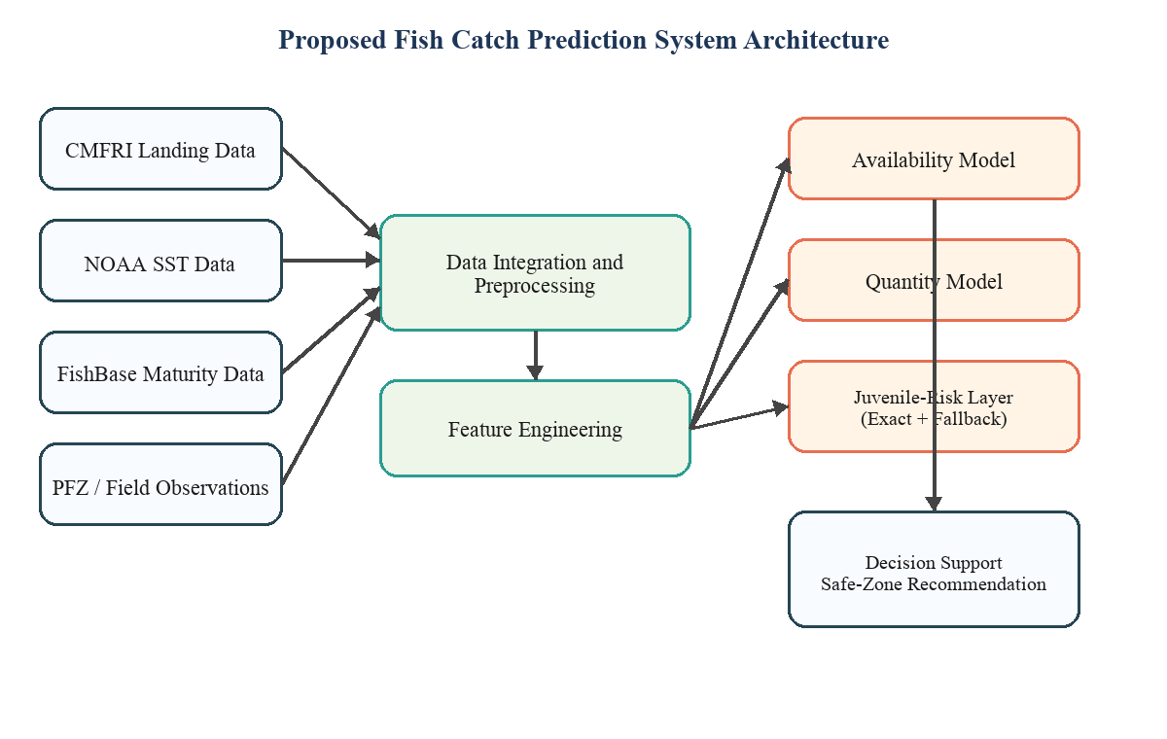
Figure 5.1 Block diagram of the proposed fish catch prediction and juvenile-risk assessment system.

5.2 Contributions of the Proposed System
The proposed system makes both technical and practical contributions in the area of fisheries decisionsupport. First, it integrates fish availability prediction, catch quantity estimation, juvenile-riskassessment, and safe-zone recommendation within a single working application. This makes the system moreuseful and more realistic than a project that focuses on only one output.
Second, the project uses domain-relevant real-world sources such as CMFRI landing data, NOAA sea surfacetemperature records, FishBase maturity information, and PFZ-style field observations. Third, it implementsmultiple algorithmic paths including Random Forest, Boosting, Hybrid modeling, and a separate juvenile-riskpipeline. This enables comparative analysis and justified model selection.
The fourth contribution is the use of exact maturity-based juvenile logic, which improves the biologicalauthenticity of the system. The fifth contribution is the safe-zone advisory mechanism, which transforms themodel outputs into a practical recommendation. Finally, the project includes testing, validation, andalgorithm demonstration support, making it suitable for viva presentation and technical review.
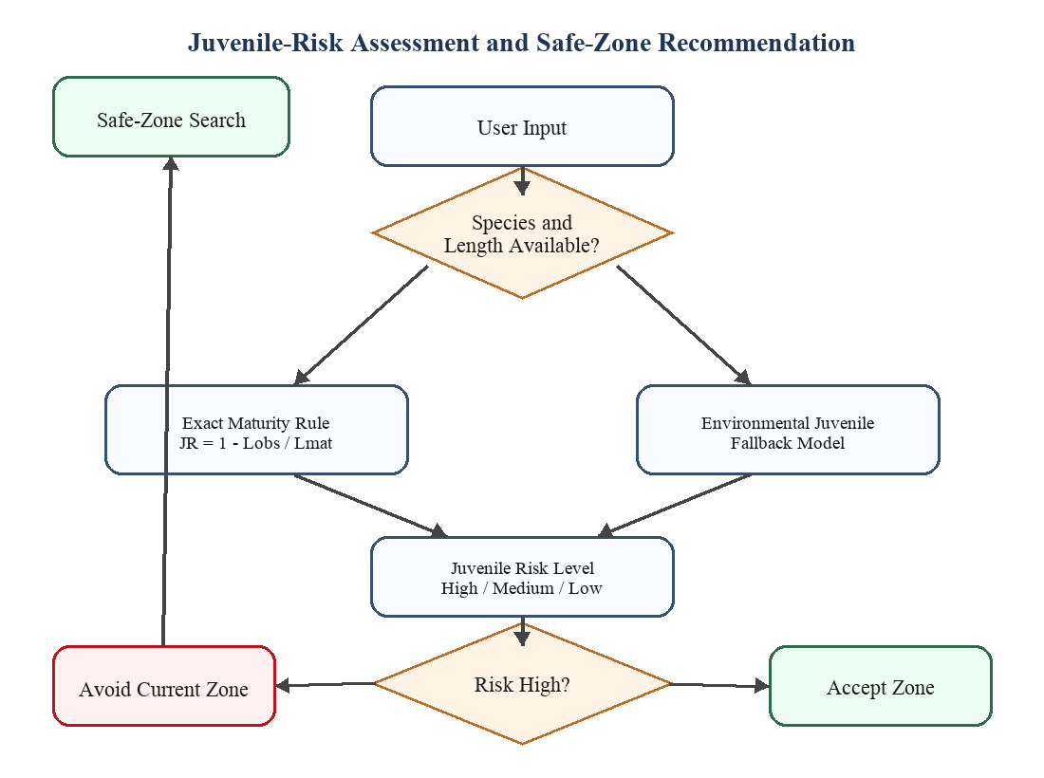
Figure 5.2 Exact and fallback juvenile-risk assessment workflow with safe-zone recommendation.

5.3 Practical Implications and Applications
The proposed system has practical significance in fisheries planning. It can support fishers in identifyingfavorable zones by estimating whether a given region is likely to provide usable catch. Such guidance canreduce unnecessary travel, save fuel, and improve decision making under uncertain marine conditions.
The juvenile-risk module is particularly valuable from a sustainability perspective. Catching juvenile fishon a large scale affects stock replenishment and future fishery productivity. By comparing observed fishlength against maturity length, the system introduces a biologically meaningful safeguard and supportsresponsible fishing practices.
The catch quantity estimation component can also support storage planning, labor allocation, and localmarket coordination. In addition, the project can serve as a reference implementation for marine analytics,applied machine learning, and environmental decision support. Its modular design makes it suitable forfuture transformation into a broader web or mobile advisory platform.
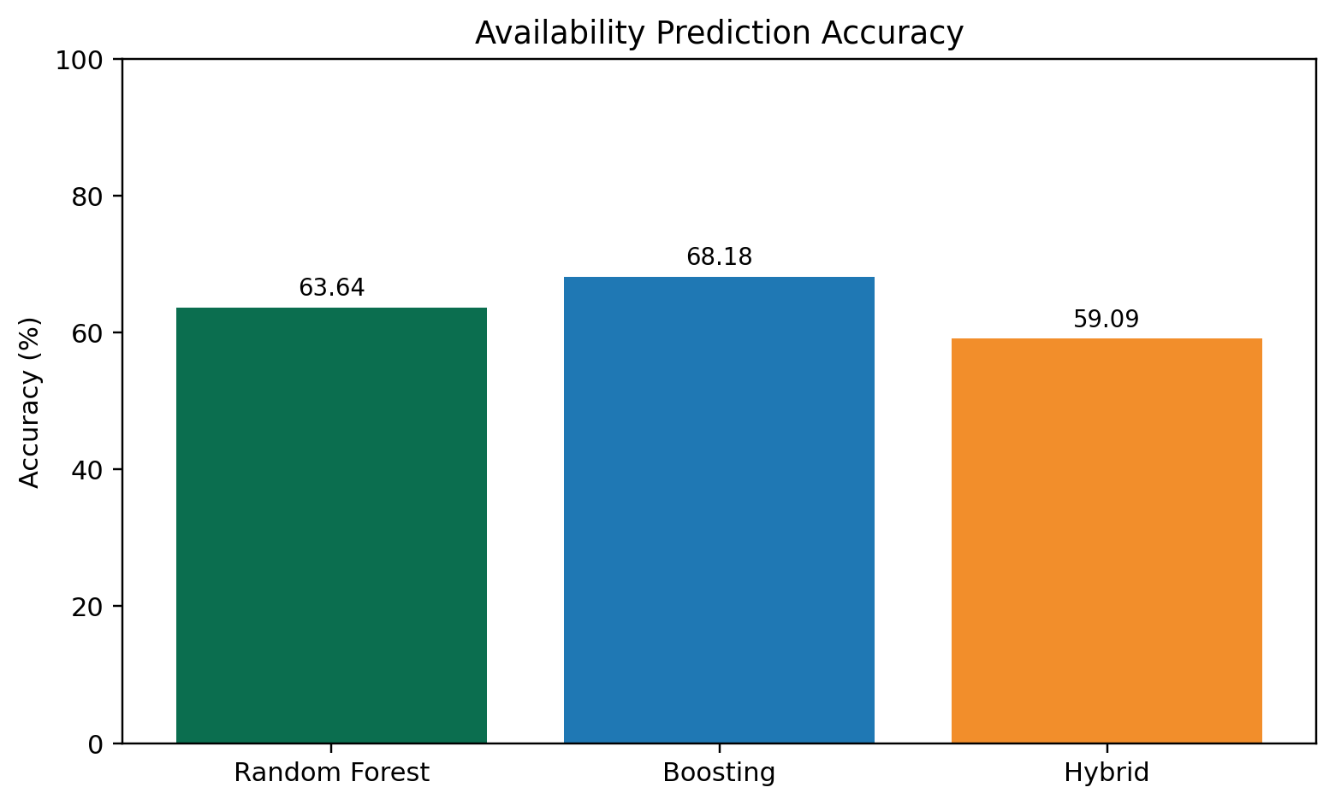
Figure 5.3 Comparison of fish availability accuracy across the implemented models.
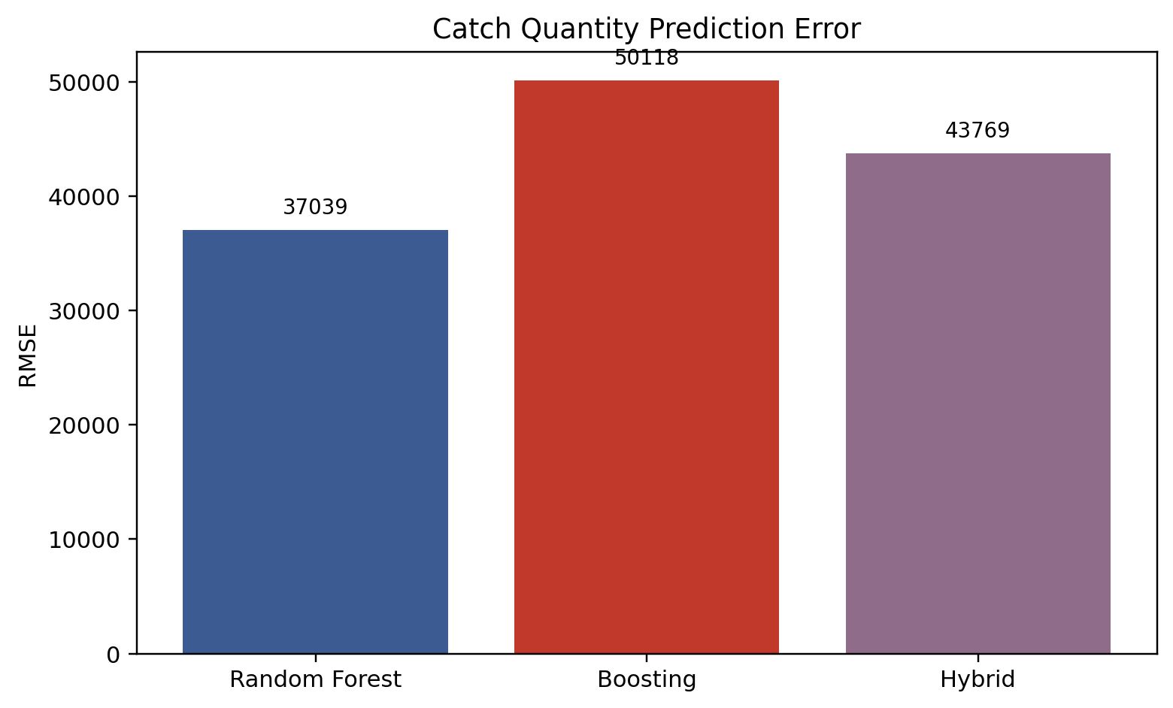
Figure 5.4 Comparison of catch quantity prediction error across the implemented models.
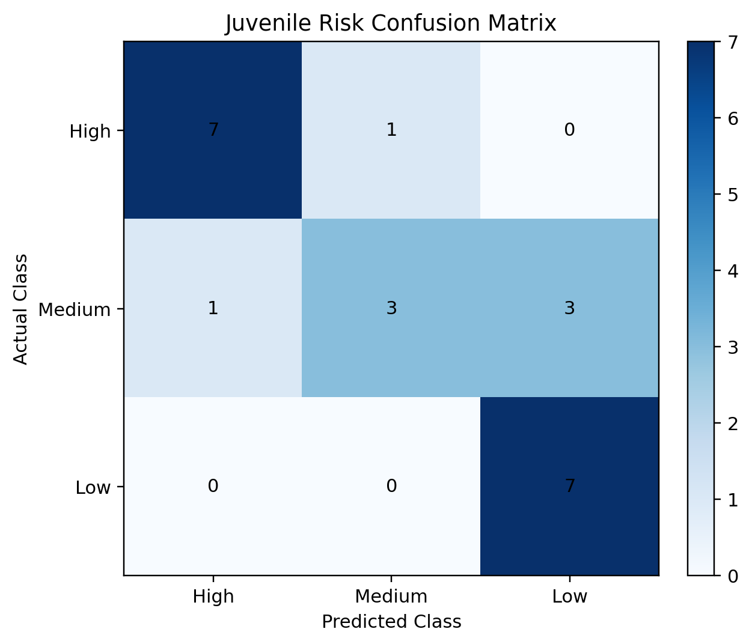
Figure 5.5 Confusion matrix of the juvenile-risk assessment model.

5.4 Recommendations for Future Work
Although the project has achieved its goal as a working prototype, several extensions can improve itspractical strength. The first requirement is a larger dataset with monthly, district-level, harbor-level, orfishing-zone-level records. A richer dataset would allow the models to capture seasonal variation and localpatterns more accurately.
The second important direction is the addition of more oceanographic variables such as salinity, chlorophyllconcentration, currents, mixed layer depth, and improved dissolved oxygen measurements. These variables areecologically relevant and may improve both classification and regression performance.
Further work should also enable native XGBoost execution and wider hyperparameter tuning. Another majorimprovement is the collection of more exact juvenile field observations, which would make the juvenile layermore statistically strong and biologically grounded. Future versions may additionally include uncertaintyreporting, model explainability, GPS-assisted mobile access, and long-term validation against officialadvisories and fisheries records.
Overall, the current work provides a strong academic prototype with clear scope for data expansion, modelrefinement, and field deployment. Its modular architecture, real-world orientation, and sustainability focusmake it a suitable base for future research and practical fisheries applications.
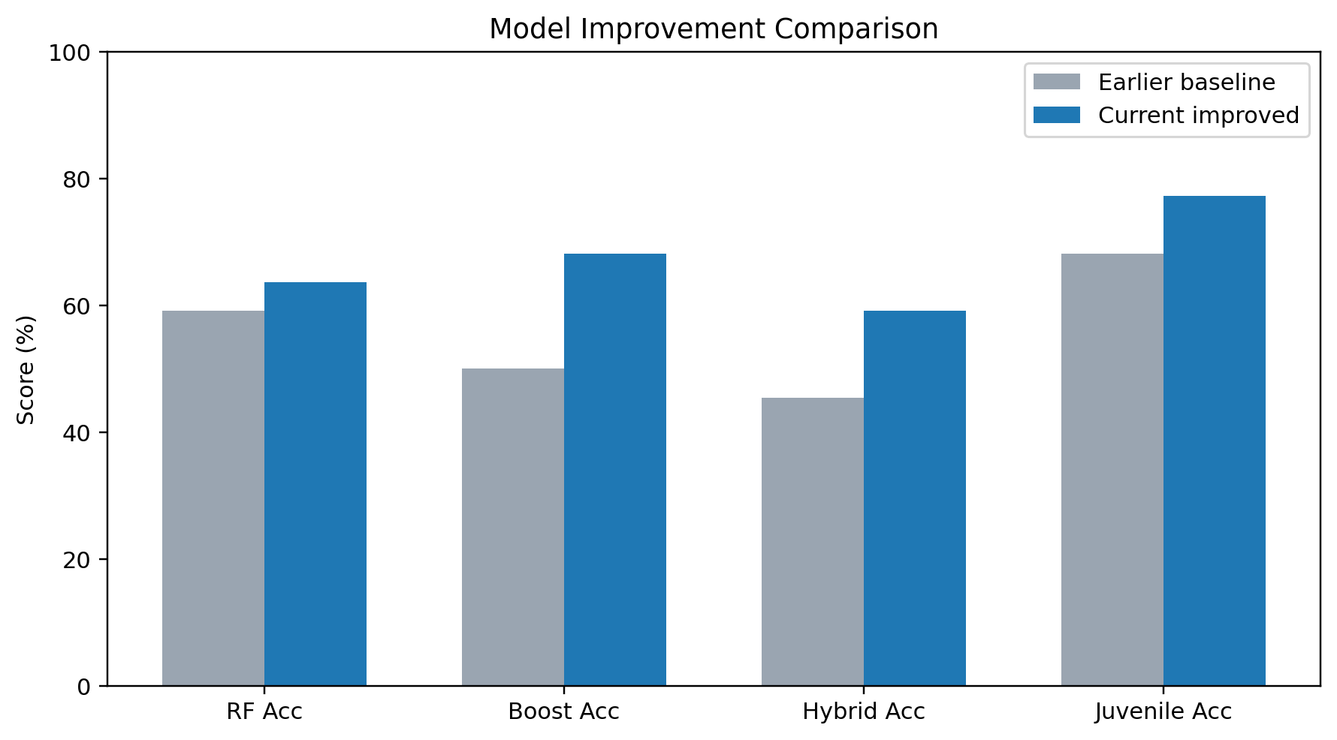
Figure 5.6 Performance comparison before and after improvement of the implemented models.
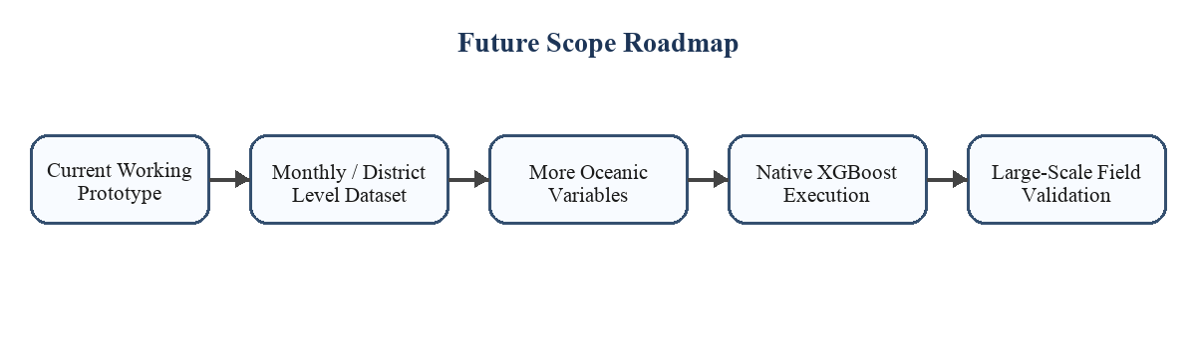
Figure 5.7 Future roadmap for improving data scale, algorithm quality, and field deployment.

