Task2 - Database Creation, Table Design, and SQL Query Execution Using Dataset 1

Importing the dataset into Sqlite:
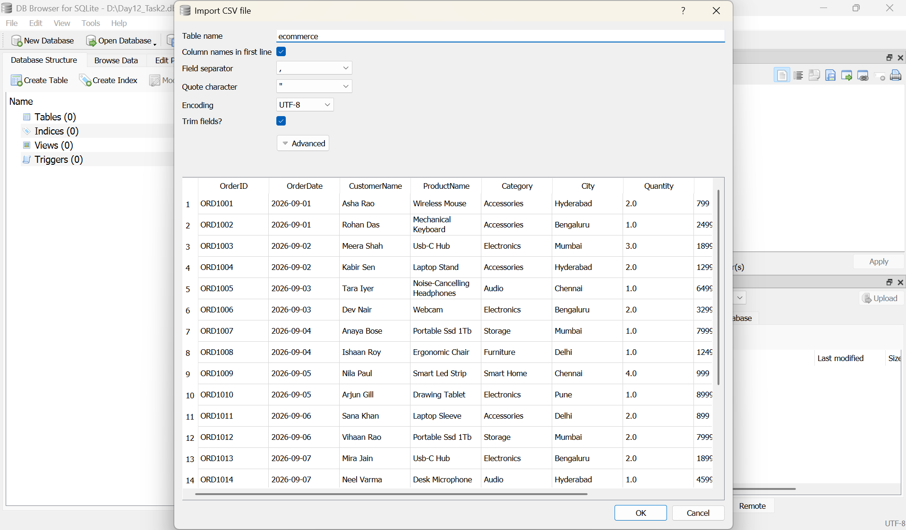

Executing SQL Queries on the dataset:
Query 1: Display all records
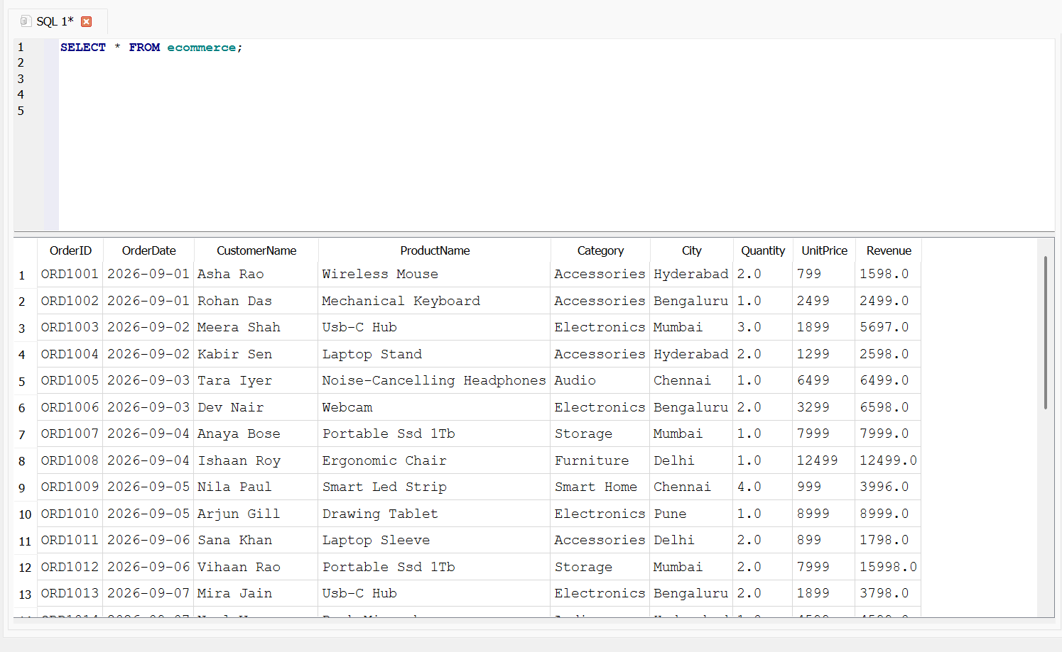
Query 2: Check the total number of records
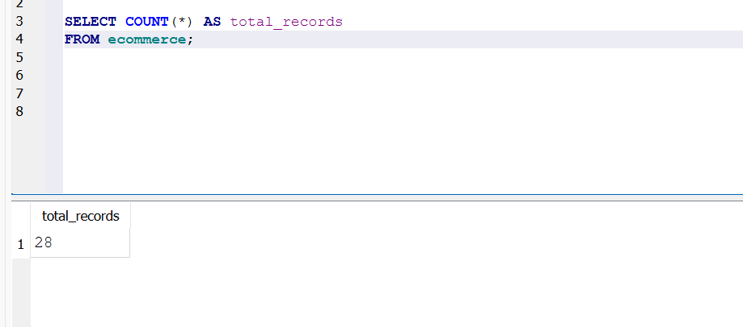

Query 3: Filter orders from Chennai (WHERE)
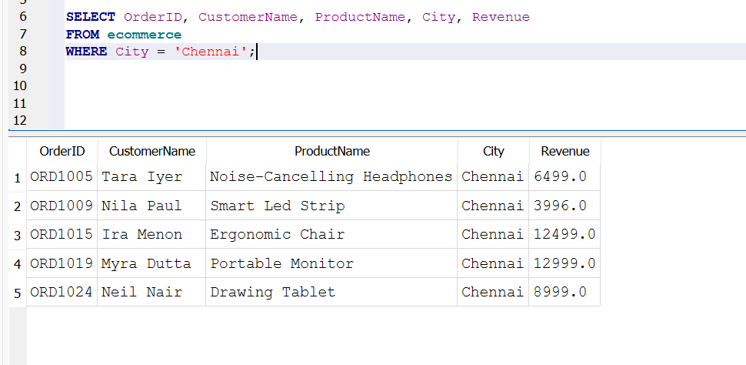
Query 4: Sort products by price (ORDER BY)
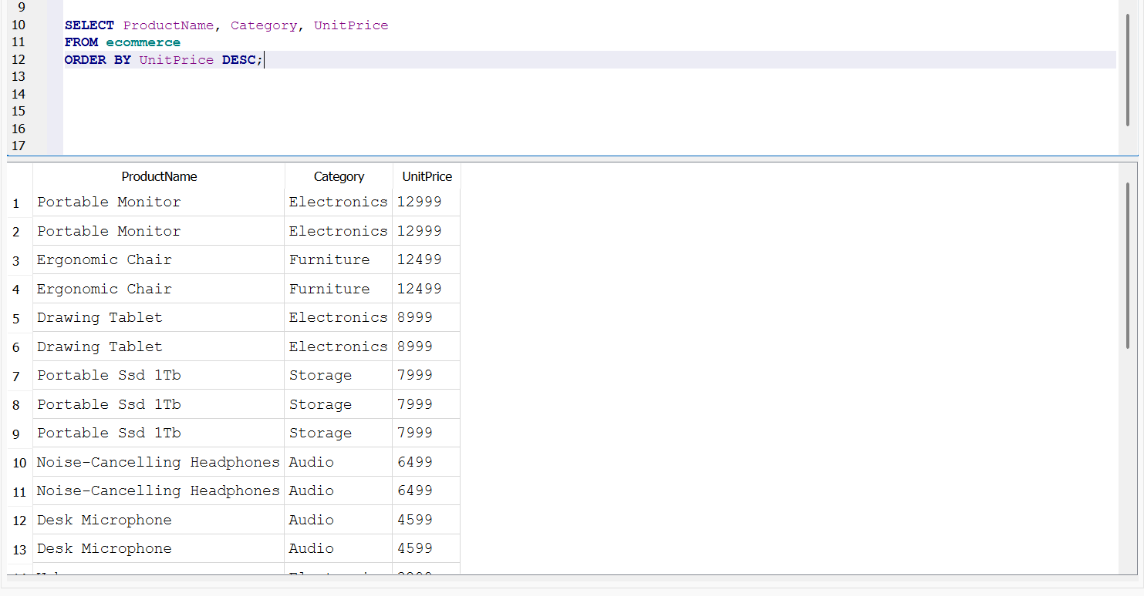

Query 5: Calculate overall sales statistics (aggregate functions)
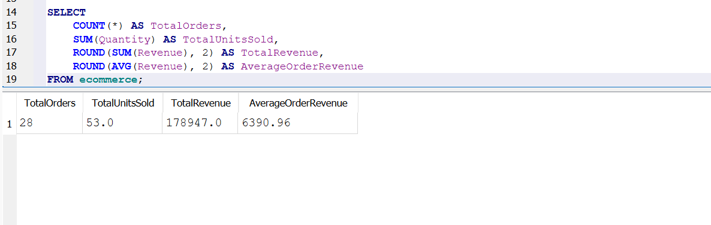
Query 6: Calculate revenue by city (GROUP BY)
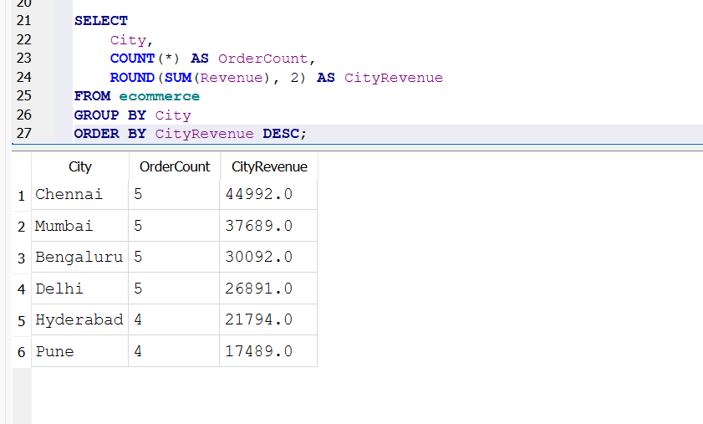
Query 7: Find categories with revenue above 20,000 (HAVING)
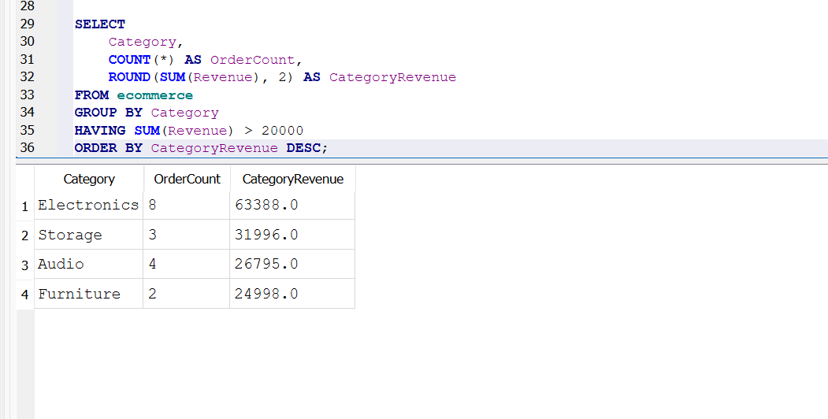

Query 8: Find orders containing at least two units (WHERE and ORDER BY)
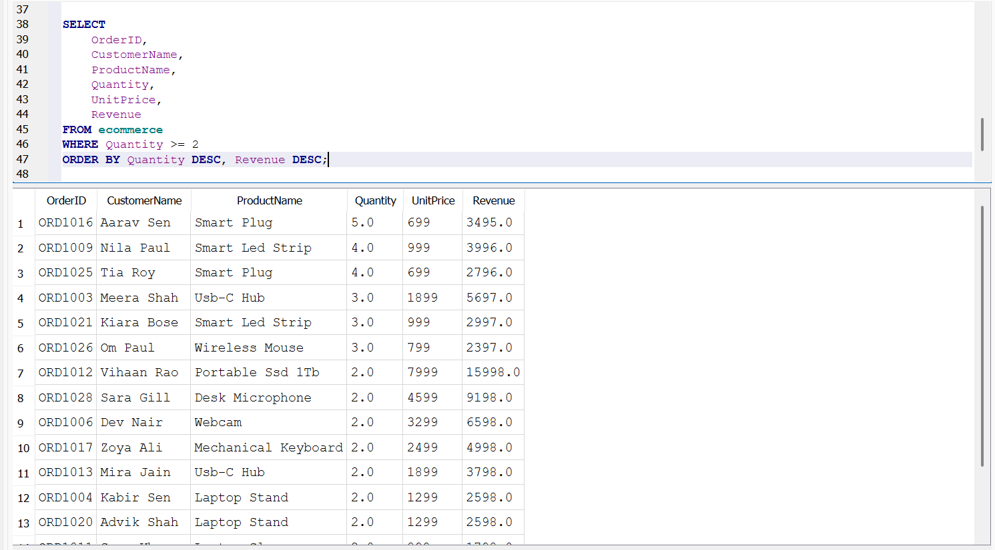
Query 9: Find the top 10 products by units sold (GROUP BY and aggregates)
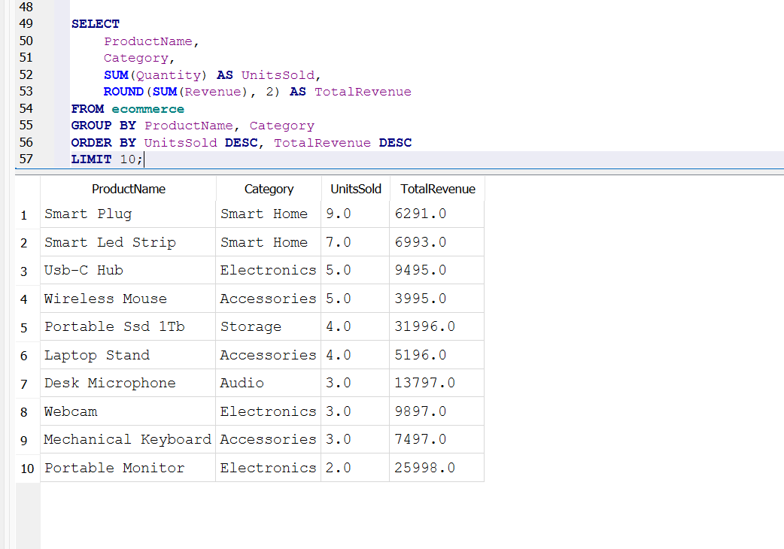

Query 10: Join Orders and Products
