Task3 - Database Creation, Table Design, and SQL Query Execution Using Dataset 2

Executing SQL Queries:
Query 1 — Display all records
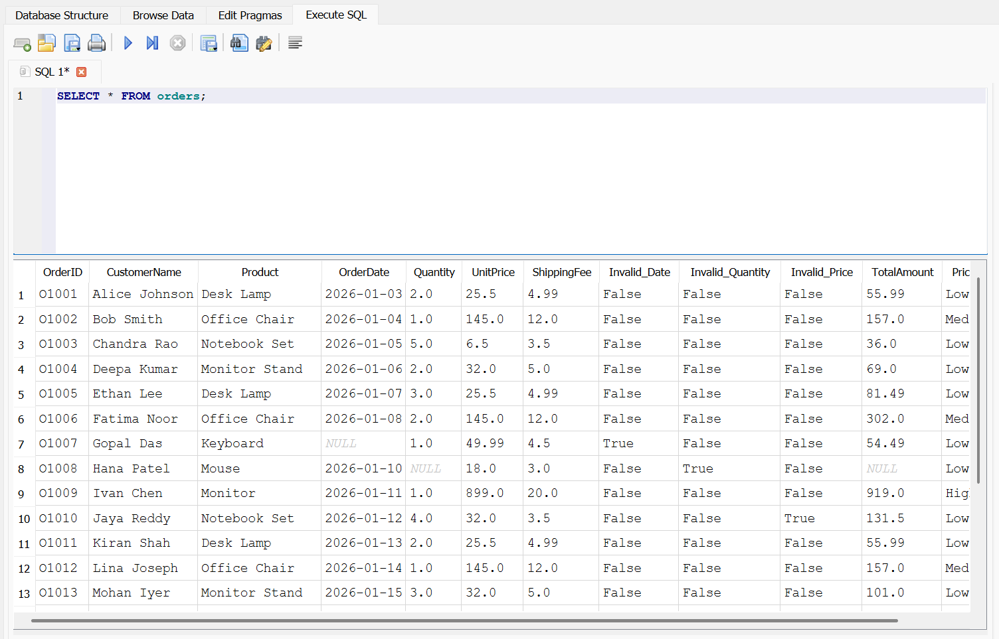
Query 2 — Filter orders with quantity greater than one
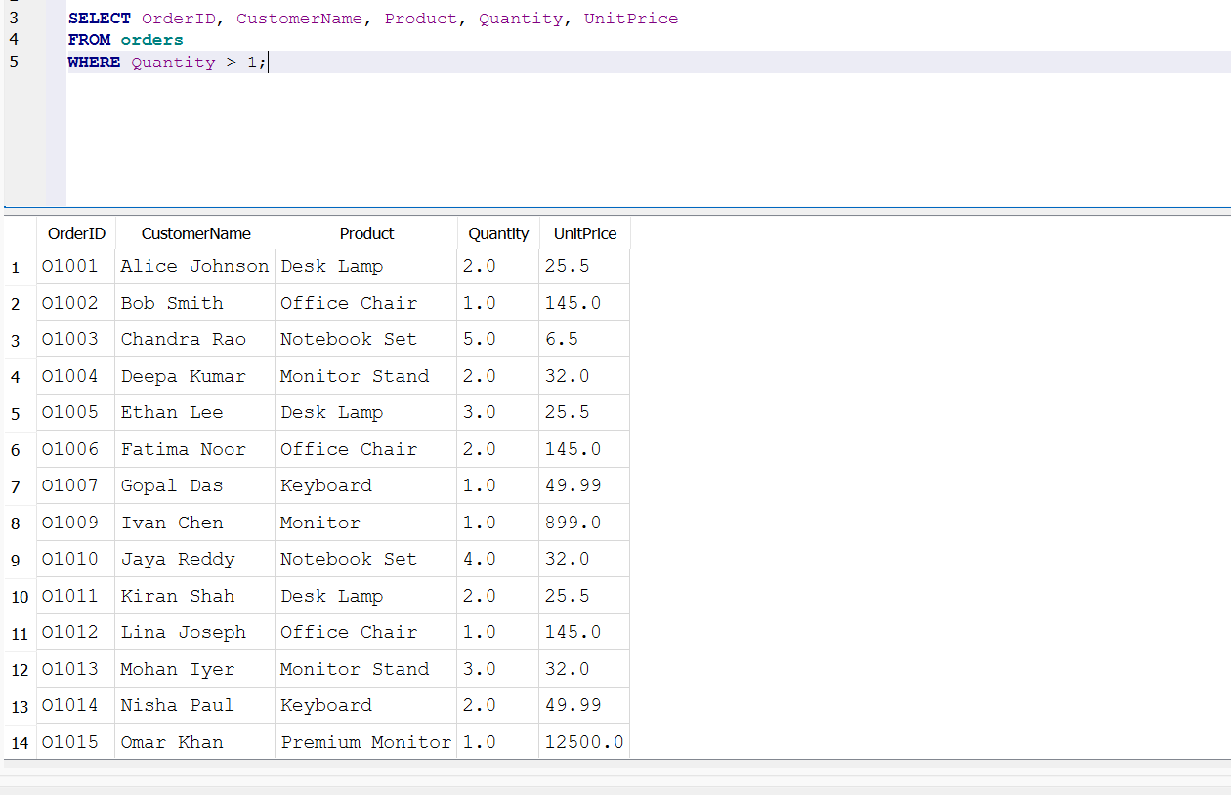
Query 3 — Sort products by unit price
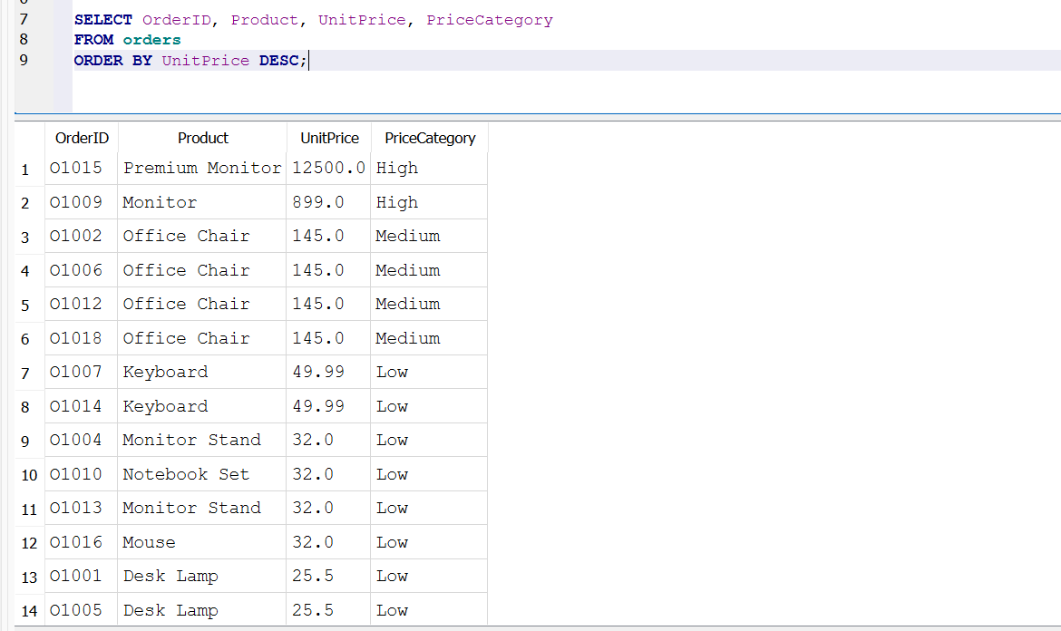
Query 4 — Calculate summary statistics
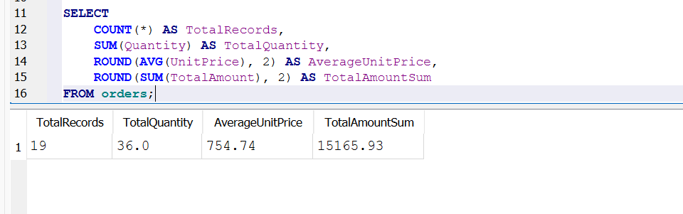
Query 5 — Calculate total amount by product (GROUP BY)
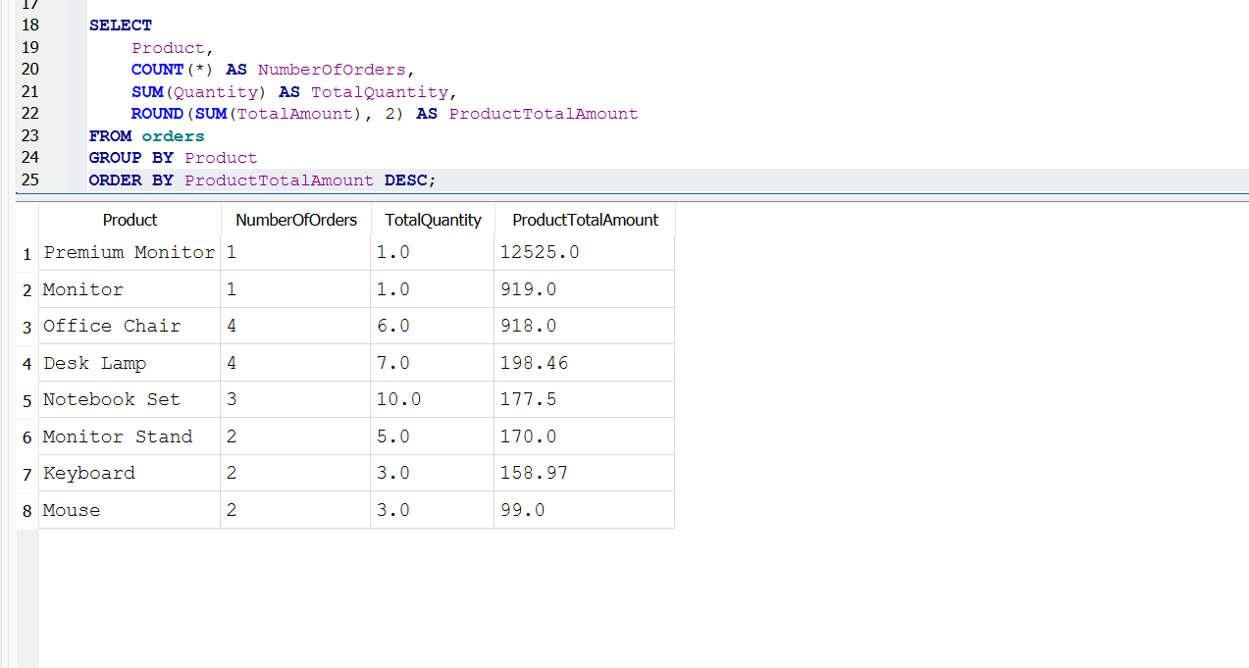
Query 6 — Find products with total amount above 1,000 (HAVING)
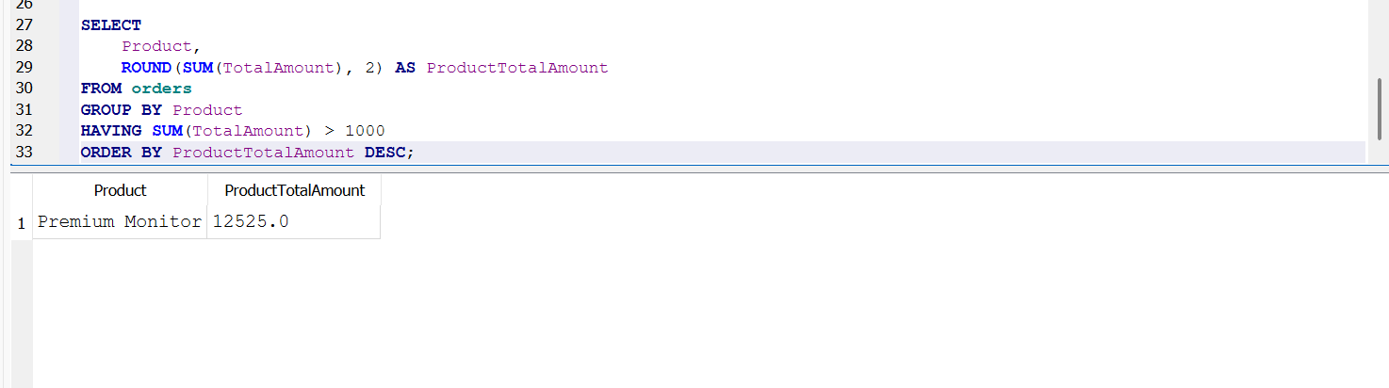
Query 7 — Find records containing invalid data (WHERE)
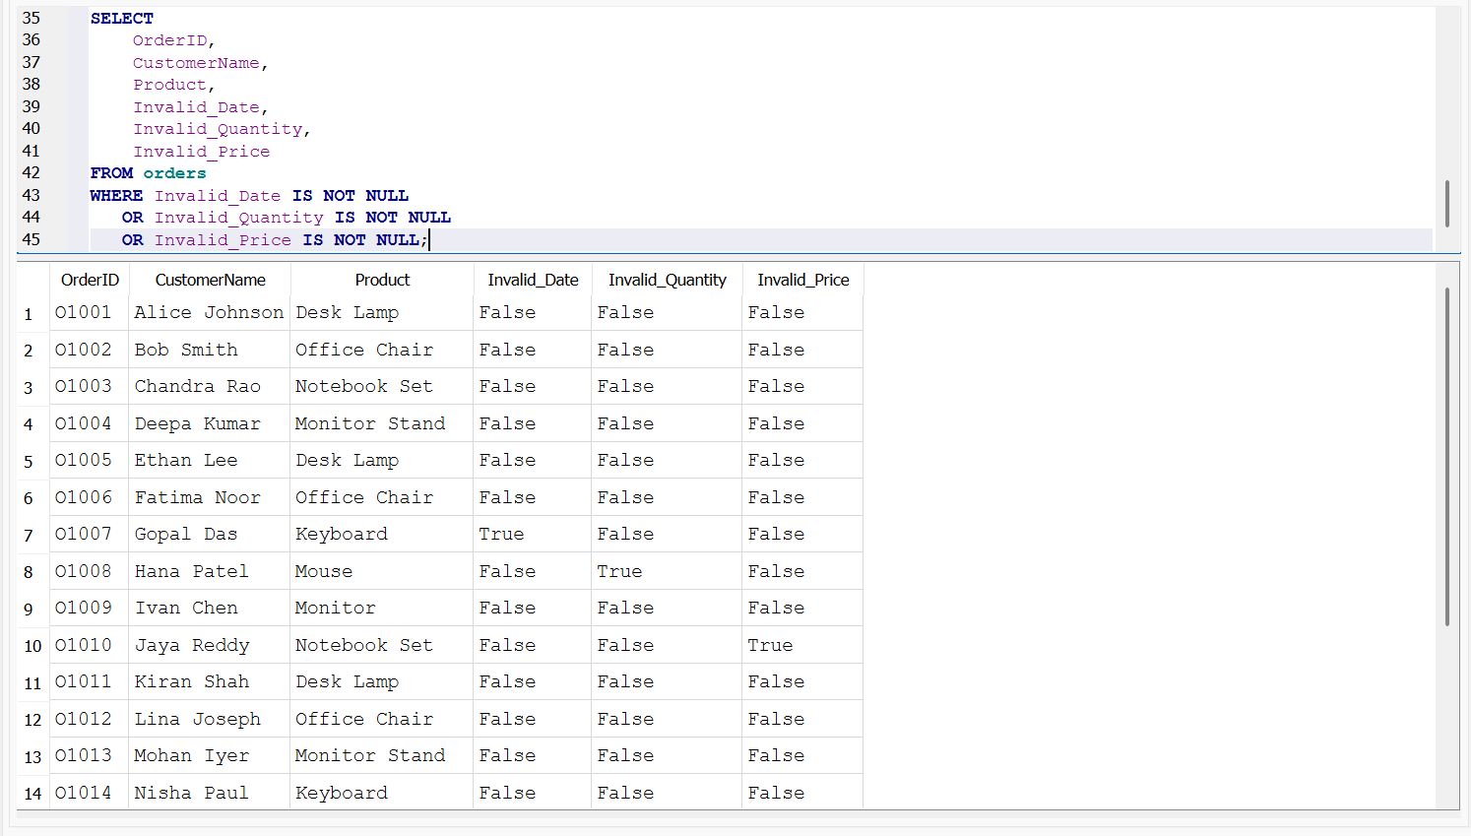

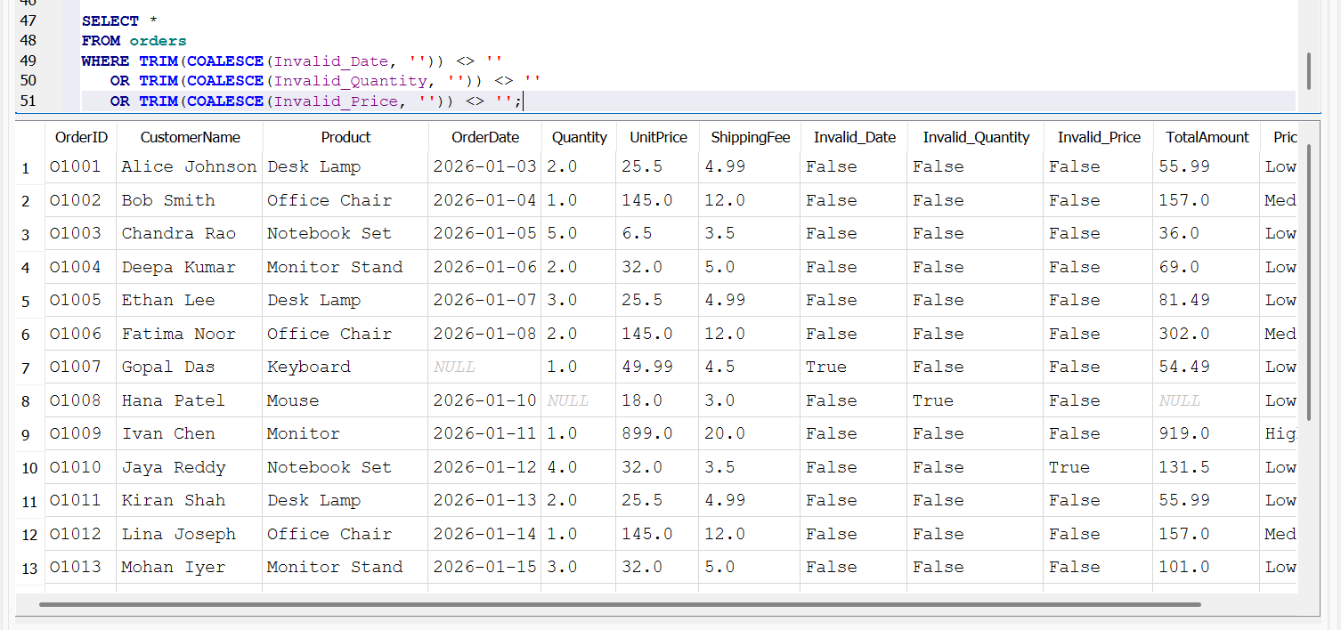
Query 8 — Count orders by price category (GROUP BY and HAVING)
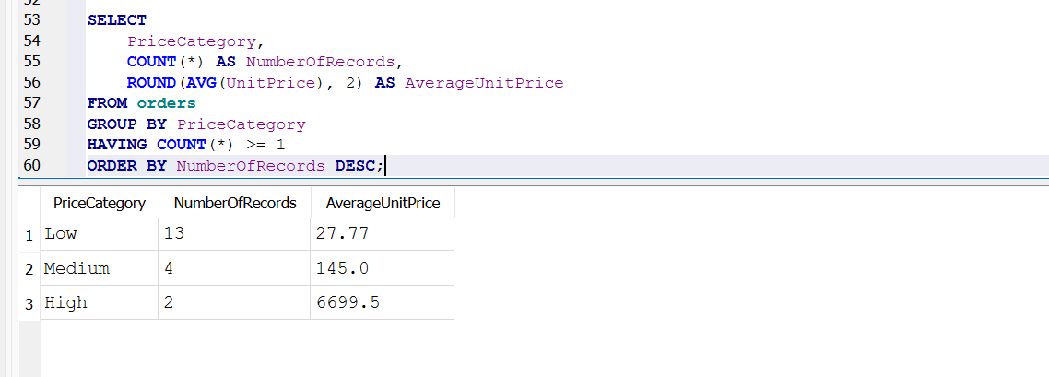
Query 9 — Demonstrate a JOIN
