BUSINESS STORYTELLING WITH DATA
Sales Insights, Business Interpretation & Recommendations

1. Introduction
This report interprets the e-commerce Sales Performance Dashboard created by connecting Snowflake to Power BI. The supplied practical describes 25 sales records and visualizes revenue by city, month, category, product, customer type and sales channel, along with order status and payment method. The goal is to turn dashboard results into business observations, explain their importance and recommend practical actions.

2. Step-by-step procedure to perform the analysis
- Open the report: Open the completed Sales Performance Dashboard (.pbix) in Power BI Desktop and go to Report view.
- Review KPI cards: Record Total Orders, Total Revenue, Total Units Sold and Total Discount.
- Review all visuals: Inspect Revenue by City, Monthly Revenue, Revenue by Category, Orders by Status, Revenue by Sales Channel, Top Products by Revenue, Revenue by Customer Type and Payment Method Distribution.
- Use slicers: Select a city or category, observe how the cards and charts change, then clear the selection before testing another filter.
- Compare patterns: Identify the largest and smallest contributors, month-to-month changes, order-status issues and concentration in products or categories.
- Capture evidence: Take screenshots of the full dashboard and filtered views. Record exact values shown in Power BI.

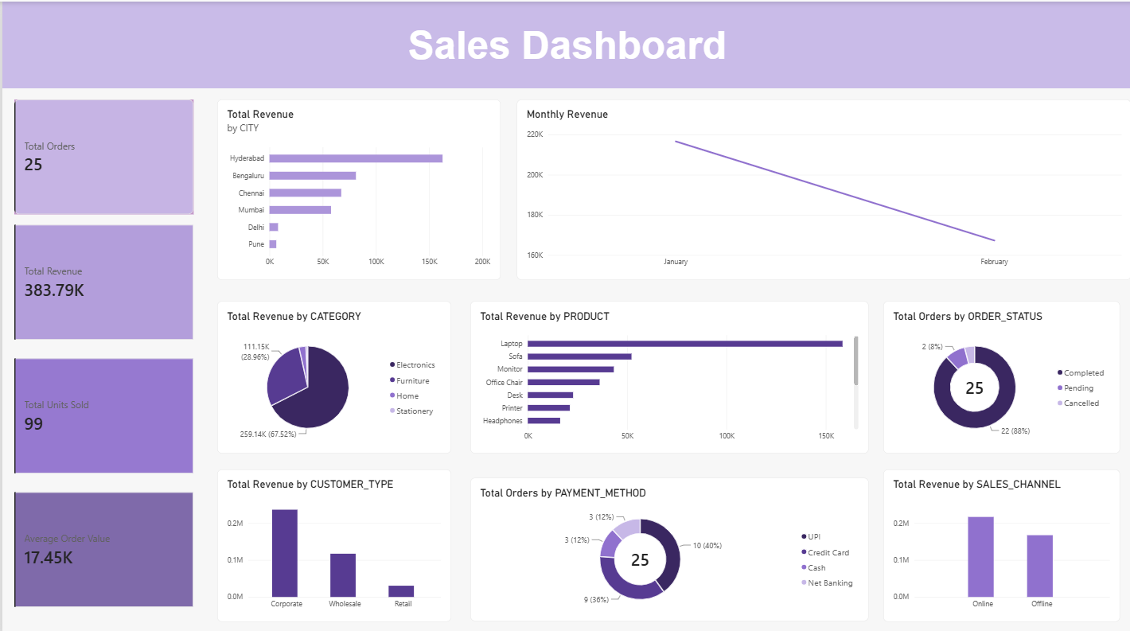

3. Analysis of every dashboard visualization

3.1 KPI cards
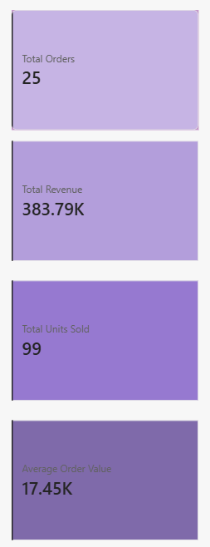
Observation: The dashboard screenshot displays 25 Total Orders, approximately ₹383.79K Total Revenue, 99 Total Units Sold and approximately ₹17.45K Total Discount.
Business interpretation: These cards summarize transaction volume, revenue, sales volume and discounting. Revenue should be considered together with orders and units so that a change in sales value is not misread.
Recommendation: Track the KPIs over comparable periods. Review whether discounts are generating additional orders or merely reducing the amount collected.
Note: Values use rounded K notation in the screenshot; verify exact figures in Power BI.

3.2 Revenue by City
Observation: Hyderabad is the largest city contributor. The filtered view on page 18 shows Hyderabad with 5 orders and ₹162,650 revenue. Bengaluru, Chennai and Mumbai follow; Delhi and Pune are much smaller.
Business interpretation: Revenue is concentrated in a few cities. Hyderabad is the strongest observed market, although the result could be influenced by a small number of high-value orders.
Recommendation: Protect the Hyderabad customer base. Compare its product mix and sales channel with other cities. Test small, measurable campaigns in Delhi and Pune before committing more inventory or advertising.
Note: Only 25 transactions are represented, so city rankings are directional rather than proof of long-term market size.
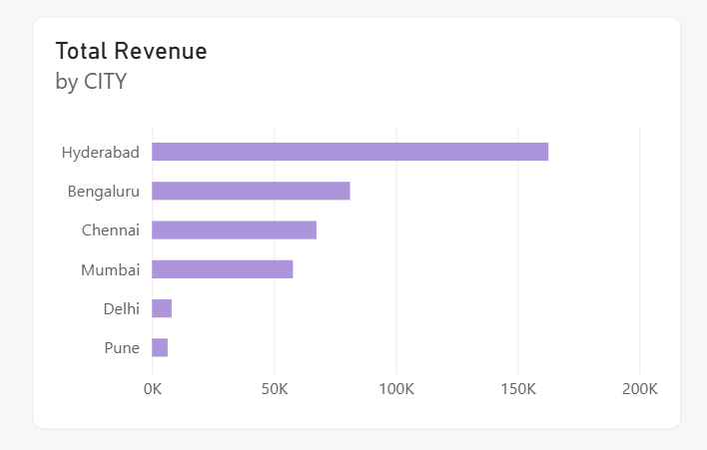

3.3 Monthly Revenue

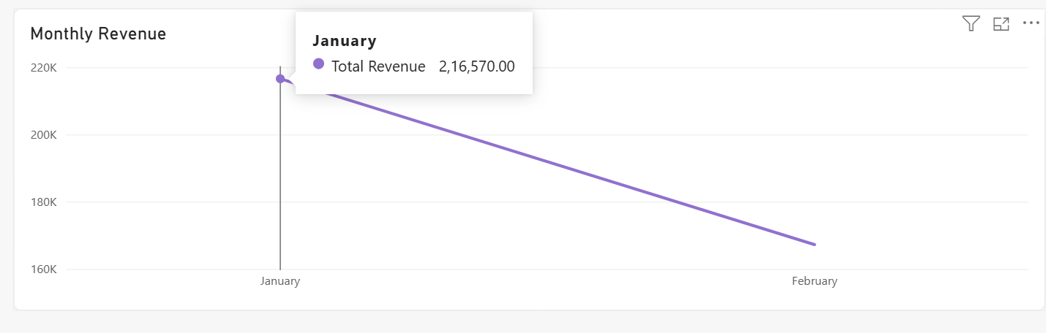
Observation: The chart shows January revenue of ₹216,570 and a lower February value of approximately ₹167K.
Business interpretation: The two-month view indicates a decline from January to February. Possible explanations include fewer orders, lower quantities, a product-mix change, discounts or an incomplete February period.
Recommendation: Check that both months cover comparable dates. Compare monthly order count, units sold, average order value and category mix; investigate stock and campaign activity before acting.
Note: Two months cannot establish seasonality or a sustained annual trend.

3.4 Revenue by Category

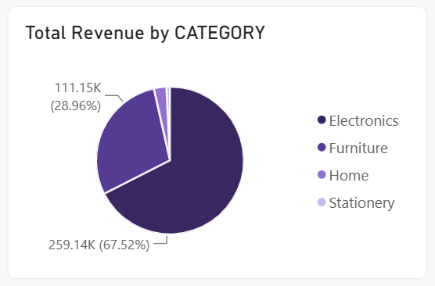
Observation: Electronics contributes approximately ₹259.14K (67.52%); Furniture contributes approximately ₹111.15K (28.96%). Home and Stationery make up the small remaining share.
Business interpretation: Electronics is the main revenue engine. The concentration is a strength but also makes total performance dependent on Electronics demand and supply.
Recommendation: Maintain availability of leading Electronics products, monitor stock-outs and supplier reliability, and use complementary offers to cross-sell Furniture. Test focused promotions for Home and Stationery.
Note: Amounts and percentages are read from the supplied dashboard image and are rounded.

3.5 Orders by Status

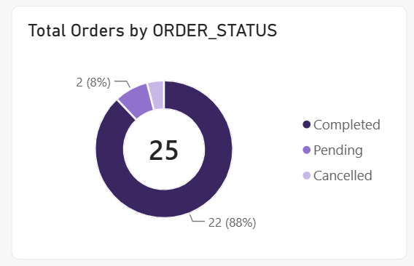
Observation: The donut chart shows 25 orders: 22 Completed (88%), 2 Pending (8%) and 1 Cancelled (4%).
Business interpretation: Most orders are completed, but three are not. Pending orders may indicate fulfilment or payment delays; cancellations may reflect customer or operational friction.
Recommendation: Follow up pending orders, categorize cancellation reasons and monitor the completion rate. Review payment failures, stock availability and delivery delays.
Note: The chart counts orders; it does not show the revenue value at risk.

3.6 Revenue by Sales Channel

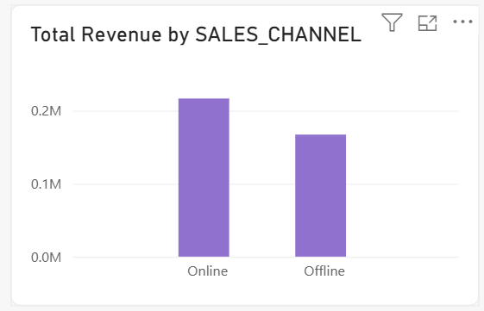
Observation: Online revenue is visibly higher than Offline revenue, approximately ₹0.21M versus ₹0.17M by the chart scale.
Business interpretation: Online appears to be the stronger revenue channel, while Offline still contributes materially.
Recommendation: Improve the online shopping journey and campaign performance. Compare conversion, average order value, returns and fulfilment costs before shifting more budget online.
Note: Revenue is not profit; channel-level costs and margins are not shown.

3.7 Top Products by Revenue

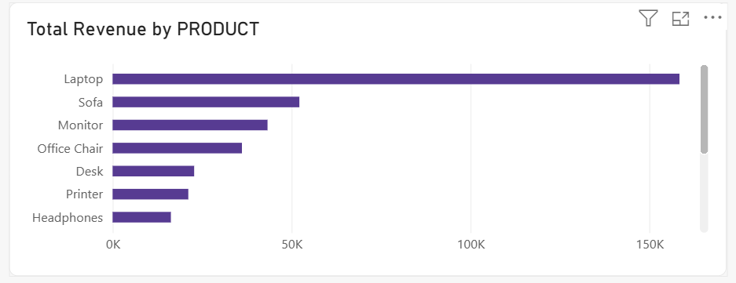
Observation: Laptop is the clear leading product, with revenue above ₹150K on the chart. Sofa, Monitor, Office Chair, Desk, Printer and Headphones follow at lower levels.
Business interpretation: A small number of products drive a large share of revenue. Dependence on the leading Laptop product creates inventory and demand risk.
Recommendation: Prioritize reliable Laptop inventory. Test bundles with complementary products such as monitors or accessories. Evaluate lower-ranked products using margin and stock turnover, not revenue alone.
Note: The visual title says Top 5, but the supplied screenshot appears to show more than five bars. Check the Top N filter if exactly five are required.

3.8 Revenue by Customer Type

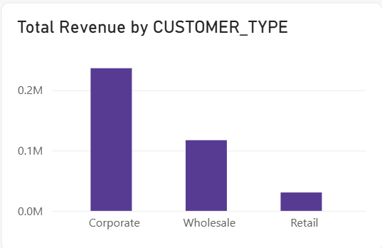
Observation: Corporate contributes the most revenue, Wholesale is second and Retail is the smallest contributor.
Business interpretation: Business customers appear important to the revenue mix. Larger order values may explain the difference, but the chart does not show customer counts or profitability.
Recommendation: Strengthen corporate relationships, offer suitable volume packages and maintain reliable fulfilment. Test retail promotions and measure incremental revenue without excessive discounting.
Note: Customer Type is a segment label, not a unique customer ID. Unique customer counts cannot be calculated from this dataset.

3.9 Payment Method Distribution
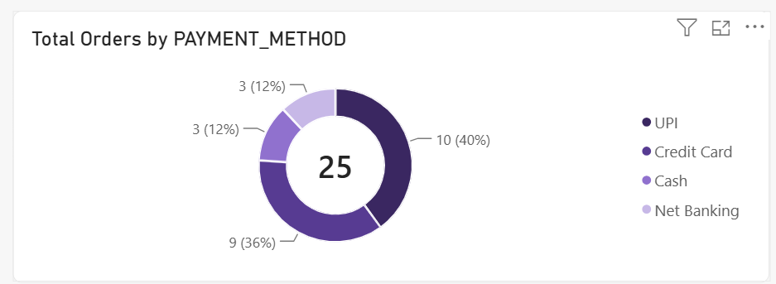
Observation: UPI accounts for 10 orders (40%), Credit Card 9 (36%), Cash 3 (12%) and Net Banking 3 (12%).
Business interpretation: UPI and Credit Card together account for 76% of orders, so digital payments dominate this sample. Cash and Net Banking still serve a smaller group.
Recommendation: Keep UPI and card payments reliable. Monitor payment failures by method and retain alternatives for customers who need them.
Note: The chart counts orders, not payment success rates or transaction fees.

3.10 Slicer examples
l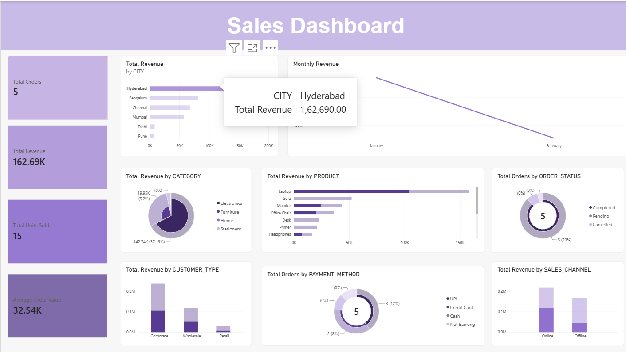
Observation: The city-filter screenshot shows Hyderabad selected, with 5 orders and ₹162,650 revenue. The category-filter screenshot shows Electronics selected, with 12 orders and ₹259,140 revenue (67.52%).
Business interpretation: Slicers change the report context and help isolate the locations or categories driving the totals.
Recommendation: Compare cities within the same category and categories within the same city. Record KPI changes and clear each filter before the next test.
Note: Values depend on the current report filters and refresh state.

4. Five important business insights

Insight 1 – Revenue is concentrated in Electronics
Observation: Electronics generates approximately ₹259.14K, or 67.52% of revenue; Furniture contributes approximately ₹111.15K (28.96%).
Business interpretation: Electronics is the main revenue engine, but high concentration creates exposure if demand, supply or pricing changes.
Actionable recommendation: Protect availability of leading Electronics products, track their margins and stock-outs, and use bundles or cross-selling to grow Furniture, Home and Stationery.

Insight 2 – Hyderabad is the strongest city in the displayed sample
Observation: Hyderabad leads the city chart; its filtered view reports ₹162,650 from 5 orders. Bengaluru, Chennai and Mumbai follow, while Delhi and Pune contribute less.
Business interpretation: Hyderabad is the strongest observed market. Its revenue may be driven by a few high-value orders, so compare order count and average order value.
Actionable recommendation: Retain Hyderabad customers and identify its best-selling products and channel mix. Run small campaigns in lower-contribution cities and measure results before increasing spend.

Insight 3 – Revenue declined from January to February
Observation: January revenue is ₹216,570 and February revenue is approximately ₹167K.
Business interpretation: The dashboard indicates a month-to-month decrease. It may be caused by fewer orders, lower units sold, product mix or partial-month data.
Actionable recommendation: Verify comparable date coverage, then compare monthly orders, units, average order value and category revenue. Investigate stock and campaign activity.

Insight 4 – Most orders are completed, but three need attention
Observation: 22 of 25 orders (88%) are completed, 2 (8%) pending and 1 (4%) cancelled.
Business interpretation: Completion is high, but pending and cancelled orders may represent fulfilment delays, payment issues or lost sales.
Actionable recommendation: Follow up pending orders, classify cancellation reasons and monitor completion rate weekly. Add an order-ageing view if needed.

Insight 5 – Online and Corporate segments are important contributors
Observation: Online revenue is higher than Offline (about ₹0.21M versus ₹0.17M by chart scale), and Corporate is the largest customer-type revenue segment.
Business interpretation: Digital sales and business customers are important to the current revenue mix. Higher revenue does not necessarily mean higher profit.
Actionable recommendation: Improve the online buying experience and maintain corporate/wholesale relationships. Compare margins, fulfilment costs, payment fees and repeat purchases before allocating more budget.

5. Data limitations to mention
- The practical describes 25 records, which is a small sample. Treat the findings as indicative, not conclusive.
- The dashboard covers January and February only; it cannot establish annual seasonality.
- No product cost, operating expense or margin fields are shown. Therefore, revenue charts cannot identify the most profitable product, city or channel.
- There is no genuine CUSTOMER_ID field. Customer Type cannot be used to calculate unique customers or retention.
- The order-status chart counts orders, not the value of pending or cancelled orders.
- Some dashboard values are rounded. Use exact Power BI values in a final financial submission.

6. Conclusion
The dashboard suggests that Electronics, Hyderabad, Online sales and Corporate customers are important contributors to observed revenue. January is stronger than February in the two-month view, and 88% of orders are completed. Recommended priorities are to protect the leading category and city, investigate the monthly decline, resolve pending orders, and evaluate channel and customer-segment performance using profitability and fulfilment measures. Validate these conclusions with a larger dataset and additional cost and customer-level fields.

