**Project Quality Management**

**Quality Management Plan**

Project quality is defined as the degree to which the project deliverables  meet the requirements.  A **Quality Management Plan** is the component of the Project Management Plan which ensures that the requirements are met.

A good quality management plan contains the following 4 parts.

1. Quality Standards
2. Quality Assurance
3. Quality Control
4. Quality Inspection

**Quality Metrics:**

1. Fixed Defects Percentage = (Defects Fixed / Total Defects Reported) * 100
2. Failed Test Cases Percentage = (Number of Failed Tests / Total number of tests executed) * 100
3. Accepted Defects Percentage = (Defects Accepted as valid by team / Total defects reported) *100
4. Passed Test Cases Percentage = (Number of Passed Tests / Total number of tests executed) * 100
5. Executed Tests or Test Execution Coverage Percentage = (Number of tests run / Total number of tests to be run) *100
6. Requirements Coverage = (Number of requirements covered / Total number of requirements) *100
7. Number of bugs per test = Total number of defects / Total number of tests
8. Test design efficiency = Number of tests designed / Total time

**Quality Roles and Responsibilities:**

| **Name** | **Role** | **Quality Responsibility** |
| --- | --- | --- |
| Sai Sri Lakshmi Vancha | Web Developer | Quality Approver |
| Gopi Amara | UI developer | Quality Assurance |
| Mallikarjuna Bodepudi | Team Lead | Quality Auditor |
| Sai Sri Lakshmi Vancha | Project Manager | Quality Monitoring |

|  |  |  |  |
| --- | --- | --- | --- |
| **S No** | **Defect Level** | **Defect Name** | **Measurements** |
| 1 | High-Level Defects | Wrong Estimation,  Not allocating work to an ideal individual,  Planning error | Project estimation should be proficient more suitably and sufficient time should be given to evaluate the project.  Project Manager should have a better than average data of the partners and their abilities and dole out work in like way.  Care must be taken in the arranging stage, so that later shocks are evaded. |
| 2 | Mid-level Defects | Bugs,  Integration issues | Bugs are standard in any project so suitable testing and quality affirmation should be actualized.  Exactly when modules are united together and attempted on a whole a couple issues may develop so the testing gathering should have enough learning of the extensive number of modules |
| 3 | Low-level Defects | Screen Resolution,  Hard-disk specifications | Screen resolution of the PCs won't not be awesome which may not be a tremendous issue but instead work should be conceivable better if it is as per the particulars |

**Project Resources Management**

**Resource Management Plan**

The Resource Management Plan is to organize and lead the project team as well as other resources

**Project Organizational Charts**

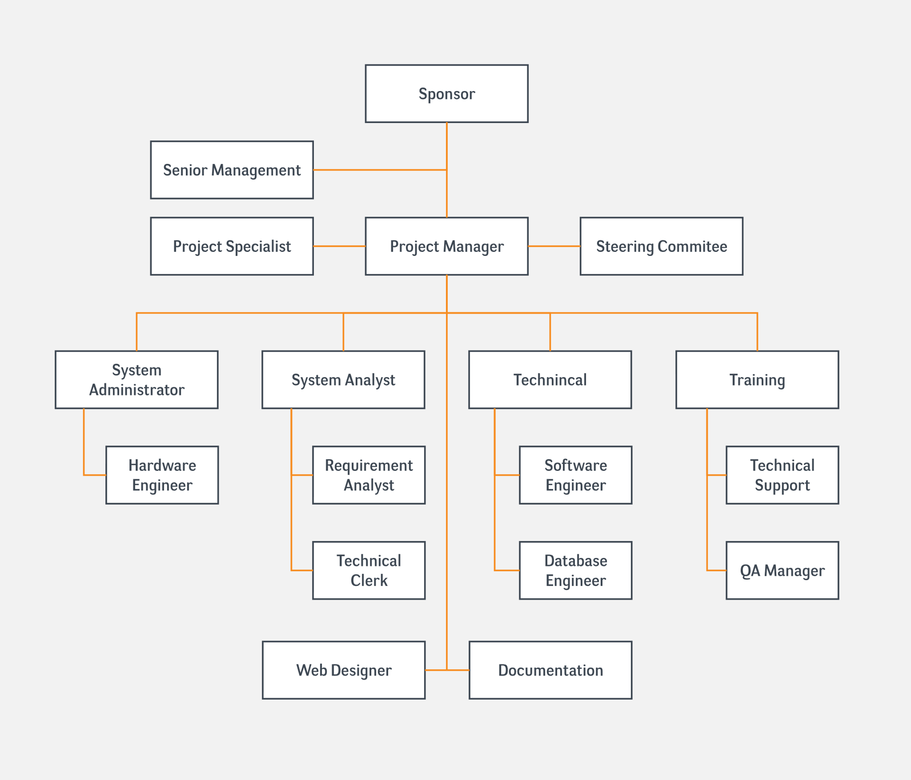

**Responsibility Assignment Matrices**

**Project Communications Management**

**Communication Management Plan**

**1. Introduction**

* This document determines the information and communication needs of all the stakeholders which also tells what and when information is needed by them and how the information is accessed by them.
* The contact details of all the stakeholders along with their responsible documents is provided in Stakeholder communications analysis as shown in the below table.

**2. Collection and filing structure for gathering and storing project information**

* The project related information can be collected through face-to-face interactions, by interviewing and through productive meetings with the stakeholders effectively.
* Project information like confidential documents can be stored using Google tools which provides easy access to all the stakeholders.

**3. Distribution structure (what information goes to whom, when, and how)**

* If there is/are any changes in requirements and plan of the project, the Project Manager is the primary communicator for the project distributing information according to this Communications Management Plan and the same is also discussed with the client and project team by conducting formal meetings.
* Daily progress reports, day-to-day status reports and pending task details are sent to the team lead, project manager and client through emails.

**4. Format, content, and level of detail of key project information**

* Key project information is documented in such a way that should follow a standard template which is available in the online share point.
* The template itself says what content need to be included in it. Also, the level of detail of the information can be decided depending on the requirement of the persons accessing documents.

**5. Production schedule and resources for producing key project information**

* Status reports and progress reports are submitted to the stakeholders which helps them to know the status of the project and how well the resources are being utilized.
* Standard templates that are available in the company’s online file sharing system should be used for both progress and status reports. Where, Status reports is used to tell where the project stands at that particular time and progress reports lists all the delivered tasks in a certain period of time.

**6. Technologies, access methods, and frequency of communications**

* Technologies like MS project helps in creating Gantt charts with the help of WBS.
* Documents can be shared and accessed across all the stakeholders within an organization using share point, SVN and google tools like google docs, google sites and google slides. Project status meetings are conducted on weekly basis and scrum meetings are held on daily basis with all the stakeholders.

**7. Method for updating the communications management plan**

* Communications management plan can be updated by using collaborative tools like SharePoint portal, SVN and other google tools.

**8. Escalation procedures**

* If any issues occur in the project, that needs to be resolved in a systematic way by raising tickets and solving them based on priority of the issue without missing SLAs.

**9. Stakeholder communications analysis**

|  |  |  |  |  |
| --- | --- | --- | --- | --- |
| **Stakeholders** | **Document Name** | **Document Format** | **Contact Person** | **Due Date** |
| Project Manager | Project status report | Email | vanchalakshmi@gmail.com | Every week |
| Administrator | Project status report | Email | gopi3ka@gmail.com | Every week |
| Team member | Project documents | Email | gopi3ka@gmail.com | Daily |
| Team member | Project documents | Email | vanchalakshmi@gmail.com | Daily |
| Team member | Project documents | Email | emani@sahvan.org | Daily |
| Sponsor | Budget analysis report | Report | nwmissouri.edu | One month before project commences |
| Tester | Test reports | Report | bmallikarjuna66@gmail.com | End of each task |

**Project Risk Management**

**Risk Management Plan**

1. **Methodology:**

We will recheck every possible deliverable before reporting it to sponsors. We can know the faults and problems in prior and solve the problems to complete that task.

1. **Roles and responsibilities:**

The responsibility of all the tasks and deliverables related to risk is given to risk team. Risk team should get approval for all the accomplished tasks from risk manager.

1. **Budget and schedule:**

Risk management should be done every week to identify any risks in the project. There is always risk on costingsof the project, as when the project starts there are bound to be changes as the project’s proceeds.

1. **Risk categories:**

There are different categories of risk involved such as

* People risk
* Technical risk
* Financial risk
* Market risk.

1. **Risk probabilities and impact:**

We are going to measure the risk probabilities in terms of dollars, human resources and usage of website i.e., how are we going to affect financially maintaining all the records of employees.

1. **Revised stakeholders’ tolerance:**

We will be informing stakeholders about each deliverable weekly once to mitigate risks. As stakeholders are aware of every phase of project, they will be ready to accept a little amount of risk.

1. **Tracking:**

As mentioned earlier, we are going to review our project every week, which makes the risk management easy. All the lessons learned while identify and reducing the risks are going to be documented and shared using MS Word and google documents respectively.

1. **Risk documentation:**

Report the documentation as hard and soft copy to management.

**Risk Register**

**Risk Mitigation Strategies**

|  |  |  |  |
| --- | --- | --- | --- |
| **Risk Rank** | **Major Risks** | **Strategies to mitigate risks** | **Responsibility** |
| 1 | Market Risk | * Take the product into market making it familiar to the customers * Keep track of similar products | Program manager  Project manager |
| 2 | Financial Risk | * The cash inflow and outflow at each stage should be noted * Allocate an excess cost of 10 – 20% for the project | Financial Manager  Program manager  Project Manager |
| 3 | Technical Risk | * Experience of the employees matters * Define scope clearly * Review about each and every deliverable with project and program manager | Programmer  Program manager |
| 4 | People Risk | * Employee should be recruited from diversified location | CEO  Program manager |
| 5 | Structure/ process risk | * Define the requirements and project objectives properly * All the stakeholders need to have a detailed information about each deliverable | Program manager  Project manager |