# Data to solve this problem:

To solve this problem, I will need:

* Data from Foursquare API, to get the neighbourhoods of each preferred location.
* Use plotting libraries to plot each neighbourhood in the map, depicting the spread of preferences in his desired locations.
* Based on K-mean algorithm, I’ll find out a Centroid, which will show the proximity of each condition.
* Based on location of Centroid, I’ll rank each location.
* The best ranked location will be the one which has all the conditions met.
* This top location will be suggested for Mr. John for consideration.

Sample data would look like this:

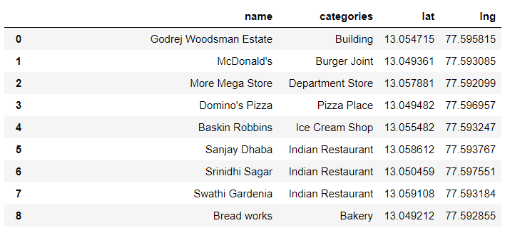

# Tools needed:

As a Data Scientist, I’ll be using below data science tools to address this problem:

* Foursquare API.
* Geopy, Nominatim
* Matplotlib
* Folium
* Requests
* Pandas
* Numpy
* Sklearn, KMeans
* Json
* A notebook (Jupyter)