ASSIGNMENT 1 – Git and GitHub
Table of Contents

1. CHECKING THE STATUS 2
2. CREATING A BRANCH 5
3. ADDING FILES TO A BRANCH 7
4. ADDING COMMITS WITH MEANINGFUL MESSAGES 11
5. OPENING A PULL REQUEST 12
6. MERGING AND DEPLOYING TO MAIN BRANCH 14

CHECKING THE STATUS

The command to check status of files in a folder - git status

Prepare your Folder
Create a folder (for example - ‘Git test’) on your local computer.
Add a file in the folder
Checking git status using – Git Bash
Right click the folder and select ‘Open Git Bash here’ (under ‘show more options’), following window appears
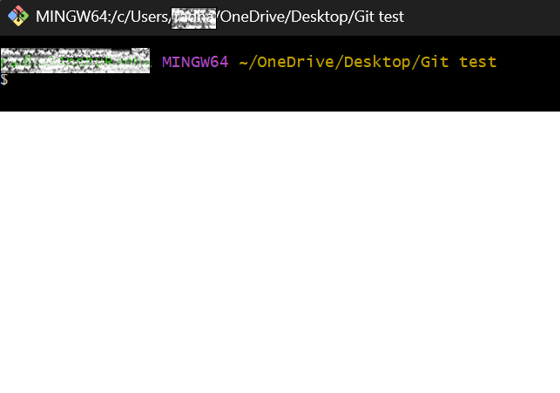
If the folder is not initialised using command ‘git init’ the following window appears with a message – “not a git repository”
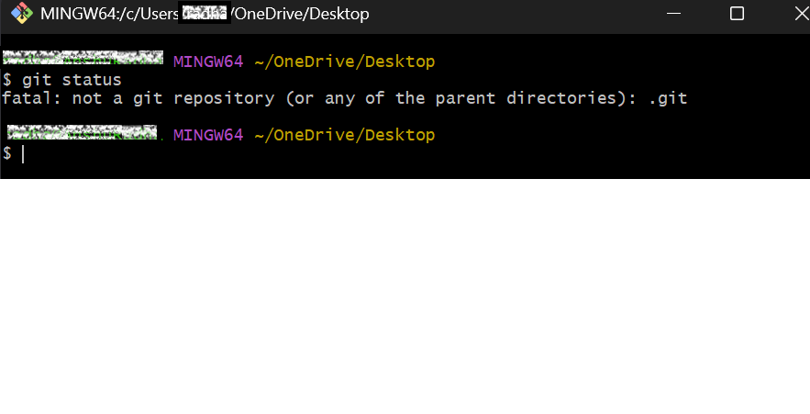
Once the folder is initialised using the command ‘git init’, Type ‘git status’ as shown in image below to check the status of files in the folder
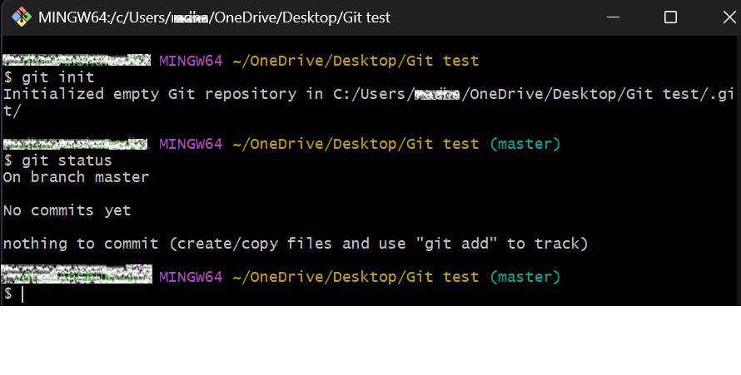

Checking git status using - Terminal
Right click the folder and select ‘Open in Terminal’ and type ‘git status’. If the folder is not initialised, Terminal will show the message – ‘not a git repository’
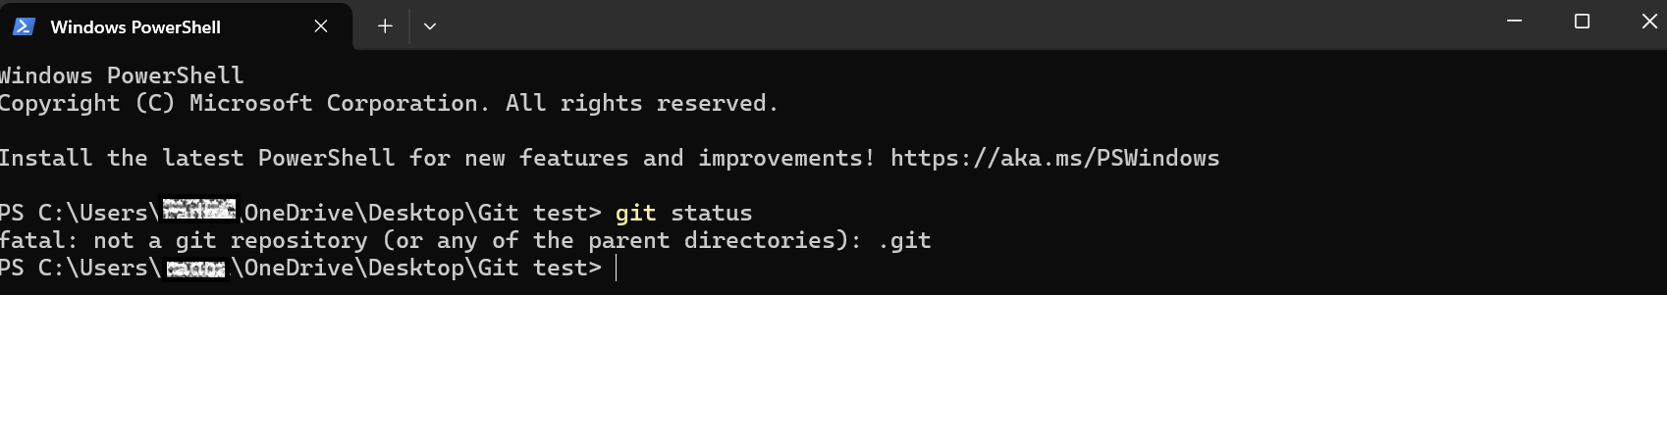
Once the folder initialised using the command ‘git init’, Type ‘git status’ as shown in image below to check the status of files in the folder
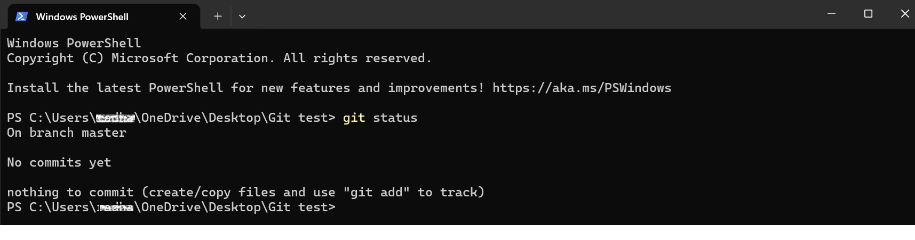

Checking git status using – VS code
Right click the folder and select ‘Open with code’
In VS Code, click the 3 dots (…) menu and select Terminal – ‘New terminal’ as shown below
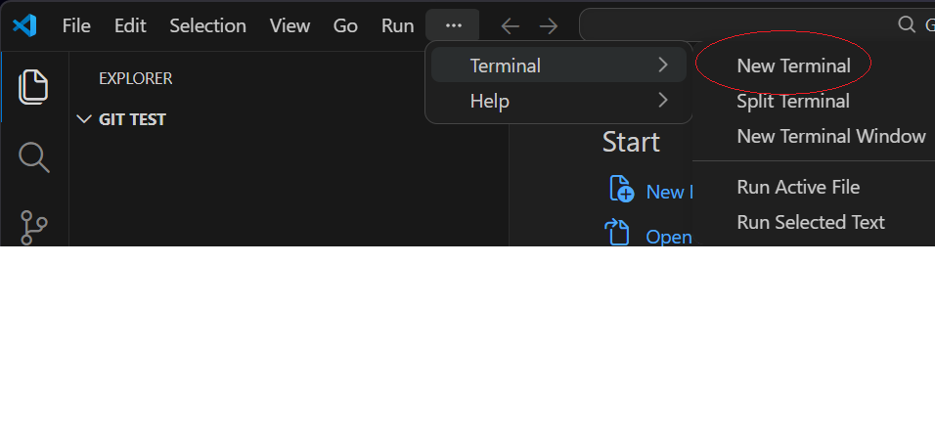

Click on ‘v’ icon next to the + on the top right-hand side of the Terminal and select ‘Git Bash’ as shown below
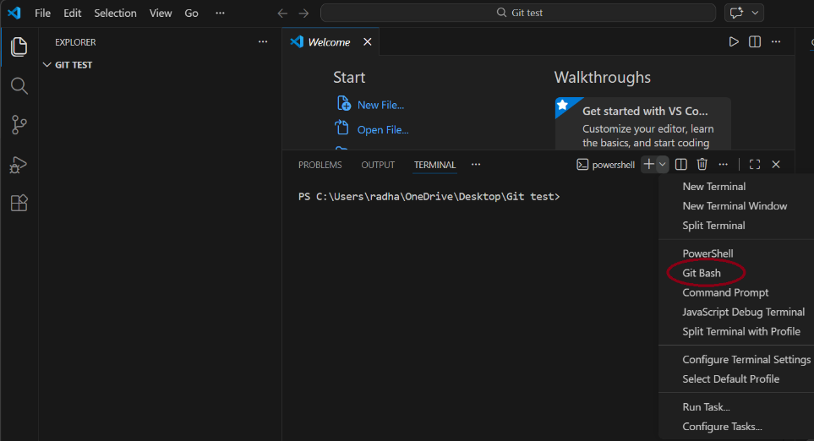
Type ‘git status’, following window appears with a message – ‘not a git repository’, If the folder is not initialised,
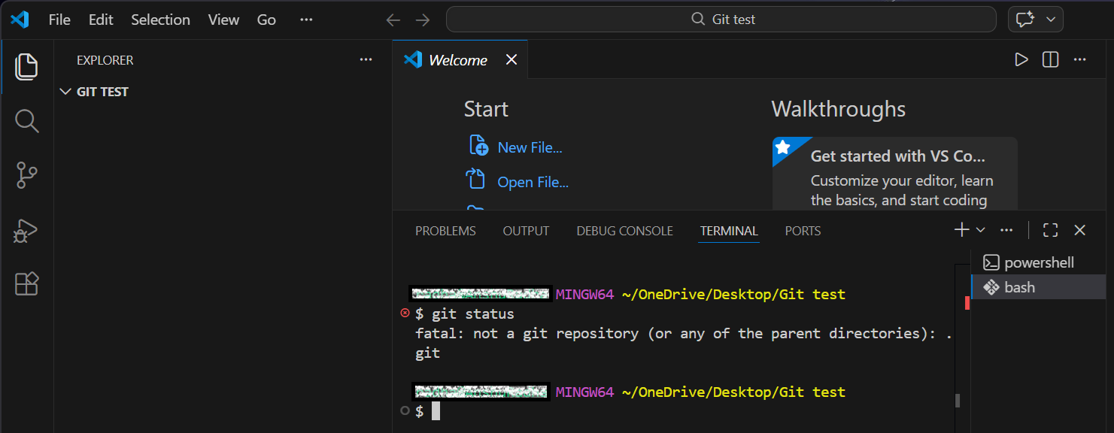

Once the folder initialised using the command ‘git init’, Type ‘git status’ as shown in image below to check the status of files in the folder
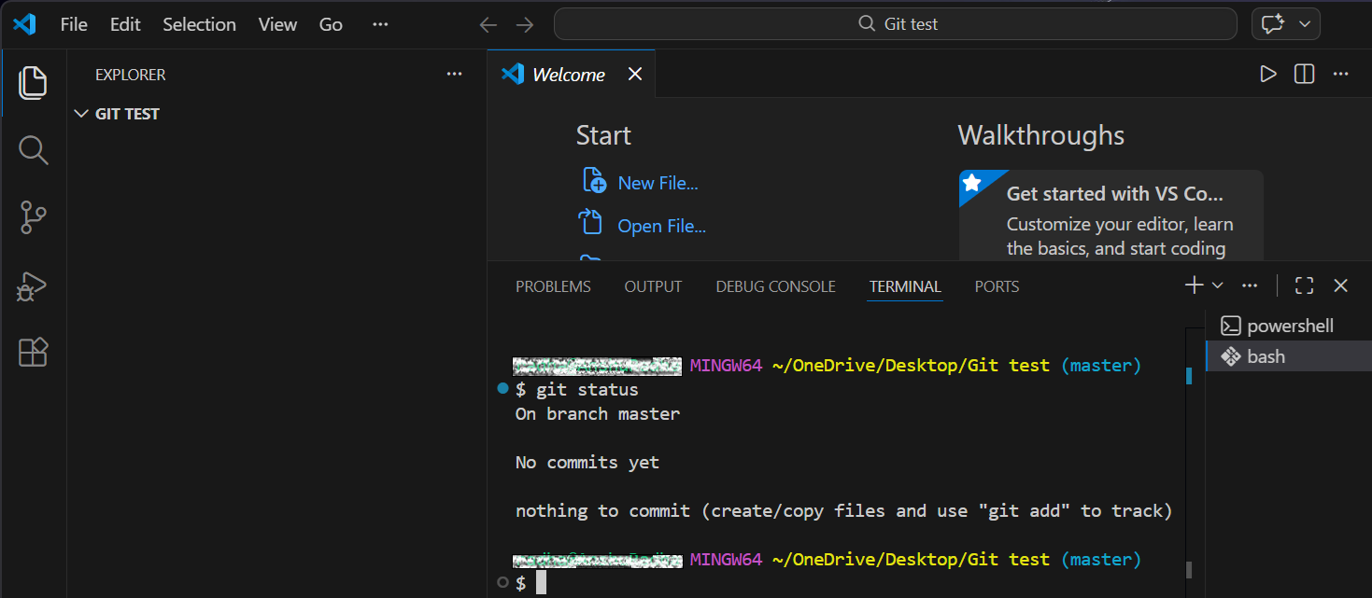

CREATING A BRANCH

There are two ways to create a ‘Branch’
In Local repository
The command to create new branch - git branch branch-name

Steps to follow:
Right click on the folder and select ‘Open Git Bash here’ (under ‘show more options’) or terminal or VS code as mentioned in the section above.
Type-in git branch to show existing branches
- Make the current folder as main branch using command
git branch -M main
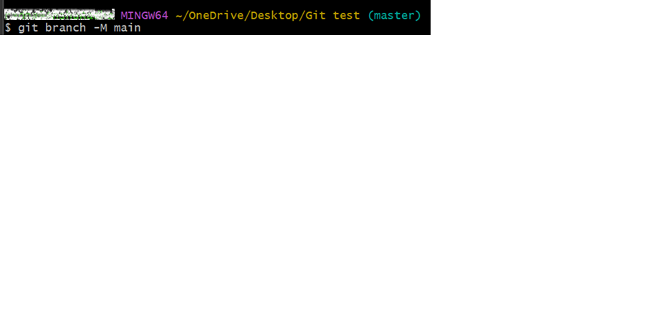
- Connect to remote repository using the command
Git remote add origin link
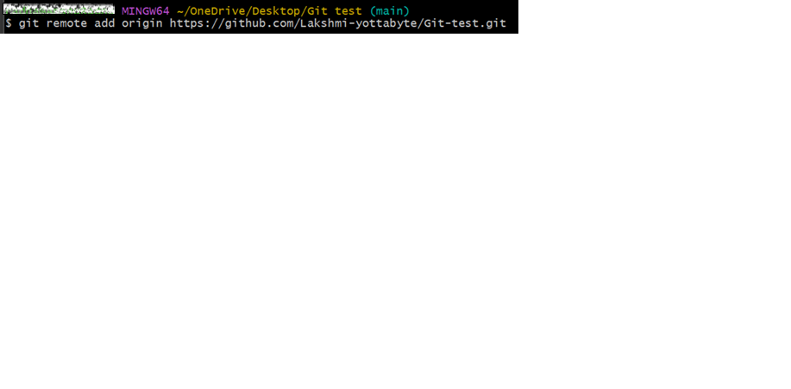
- Push the files in the folder to remote repository using command
git push -u origin main
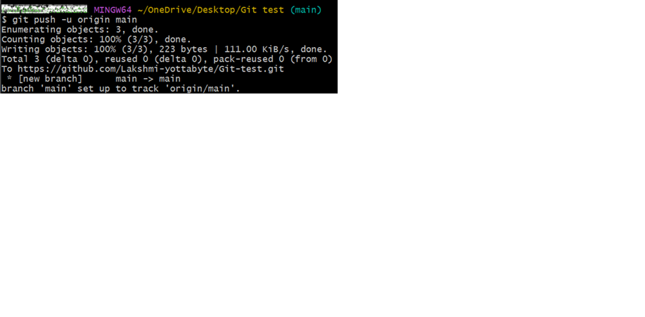
- Create a branch using the command
git branch branch-name
Here branch name is ‘B1’
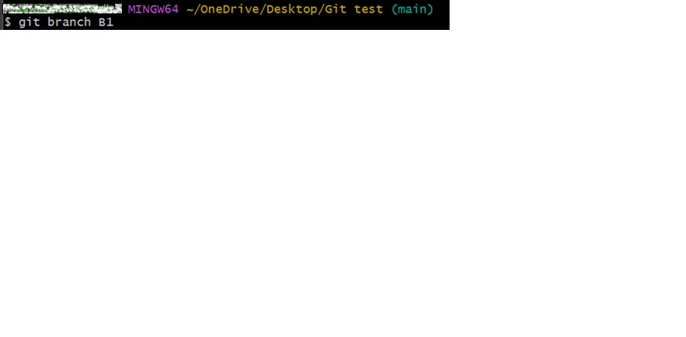
Check the branches in repository using command
git branch
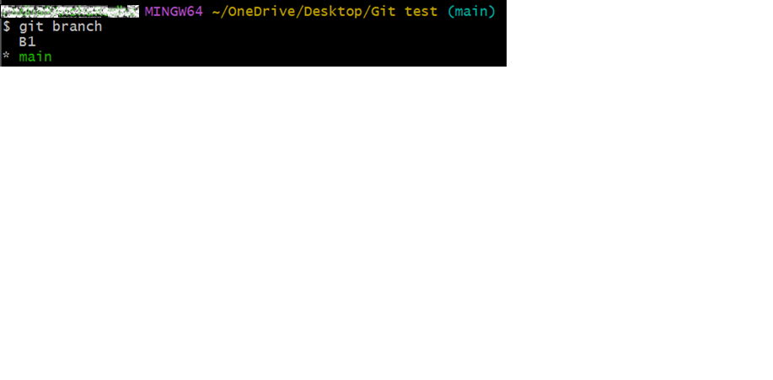

In Remote Repository
- On GitHub, navigate to main 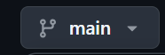 on top left side.
- Select ‘View all branches’ from dropdown menu.
- Click ‘New branch’
- Enter New branch name
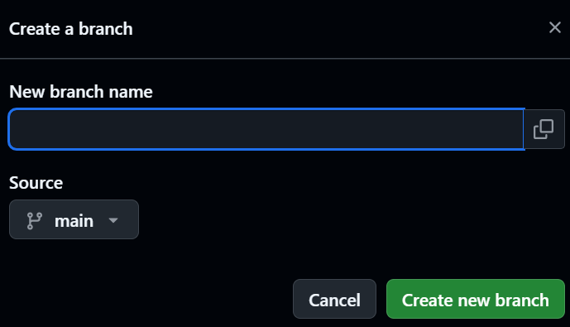
- Click ‘Create new branch’

ADDING FILES TO A BRANCH

The command to add files - git add filename

There are two ways to add file(s) to a ‘Branch’

Local Repository
- Switch to branch where files need to be added using command
Git checkout branch-name
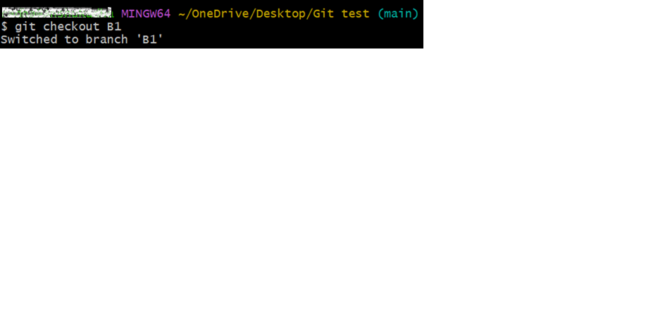
- Add a file to your local folder. For example, “File-2 “
- Add file to the branch using command
git add file-name
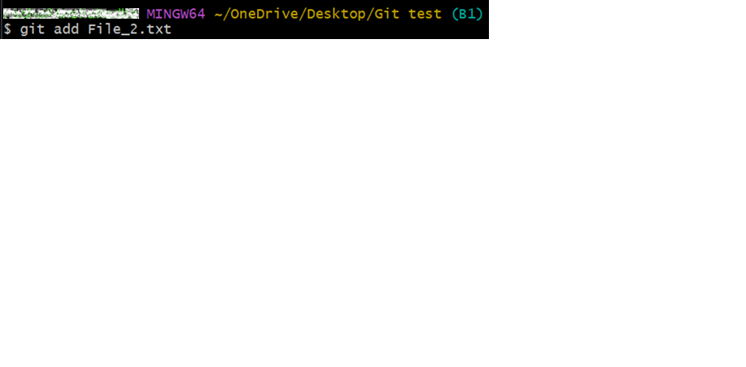
- Commit the file using command
git commit -m “short note about commit”
- push the file to remote using command
git push -u origin branch-name
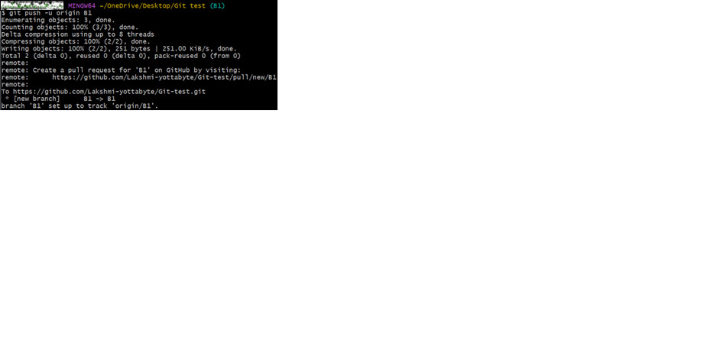

OUTPUT
File-2 added to branch ‘B1’ (see below screenshot)
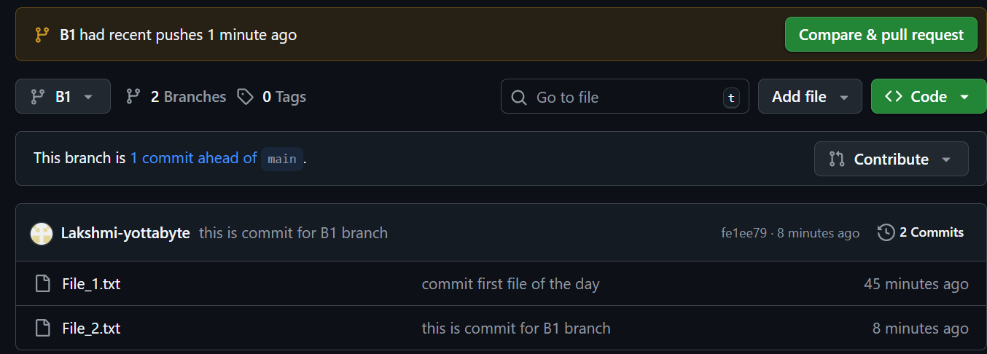

In Remote Repository
To add a file to a branch in repository, First select the branch
Select Branch
  - On GitHub, navigate to main  on top left side.
  - Select ‘View all branches’ from dropdown menu.
  - Under , select the branch
Add file
  - Click on , which appears on the top left of the page.
  - Click on the drop-downlist, two option appears:
      - Create new file
      - Upload files

- Create new file

- To create a ‘new file’, select ‘Create new file’ and add the details.
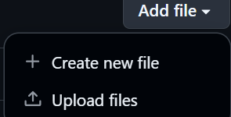
- Click on ‘commit changes’  to save the changes.
After clicking, the following window appears
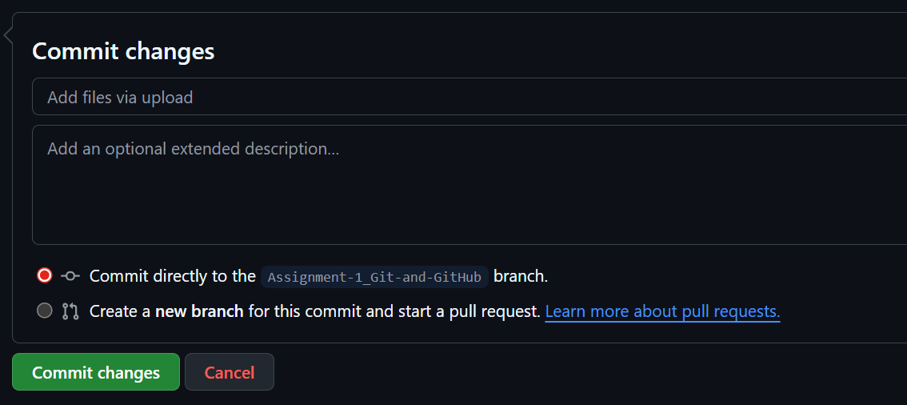
- In the first text box – briefly add what changes were made

- In the second text box, add brief explanation of the changes made for clarity and help with future reference.

- Now choose where the changes should be applied – on the main or to a branch.
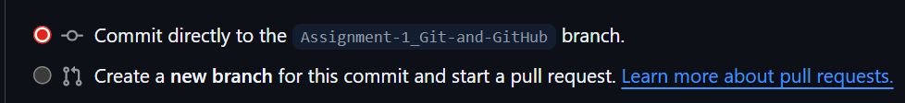
- Finally, click on ‘commit changes’ to complete the process.


- Upload files

- To upload files, select ‘Upload files’ from drop-down list
The following window appears
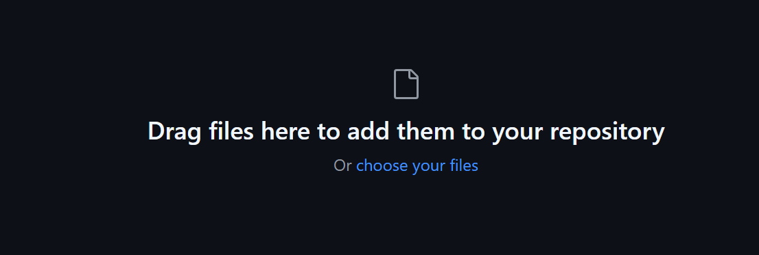
- Either drag and drop the files to add them to the repository or click on ‘choose your files’

- Now, commit changes as described above to complete the process.
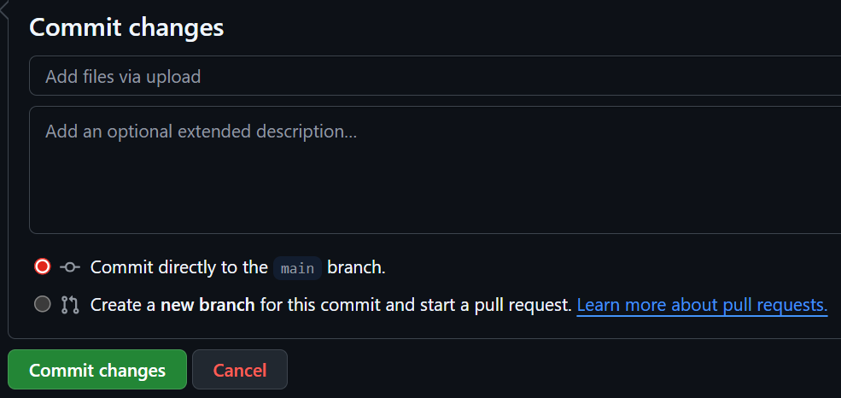

ADDING COMMITS WITH MEANINGFUL MESSAGES

When any changes made to a repository, those updates must be ‘committed’ to save them.
- On GitHub, ‘Commit changes…’option appears on top left-hand side. Click on ‘Commit changes’ to proceed.

After clicking, the following window appears

- In the first text box – briefly add what changes were made

- In the second text box, add brief explanation of the changes made for clarity and help with future reference.

- Now choose where the changes should be applied – on the main or to a branch.

- Finally, click on ‘commit changes’ to complete the process.


OPENING A PULL REQUEST

- Click on ‘Compare & pull request’ on top-right hand side of the page
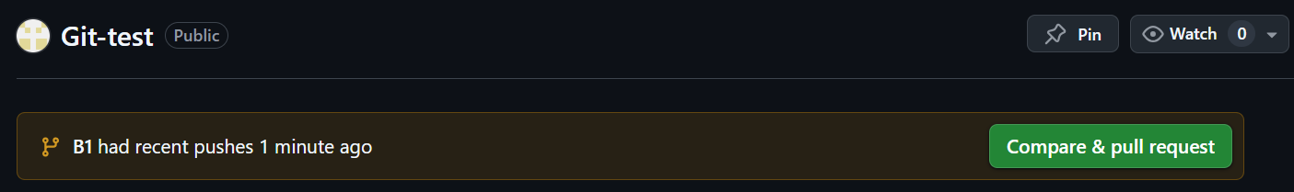
The ‘Open pull request’ window appears - see image below
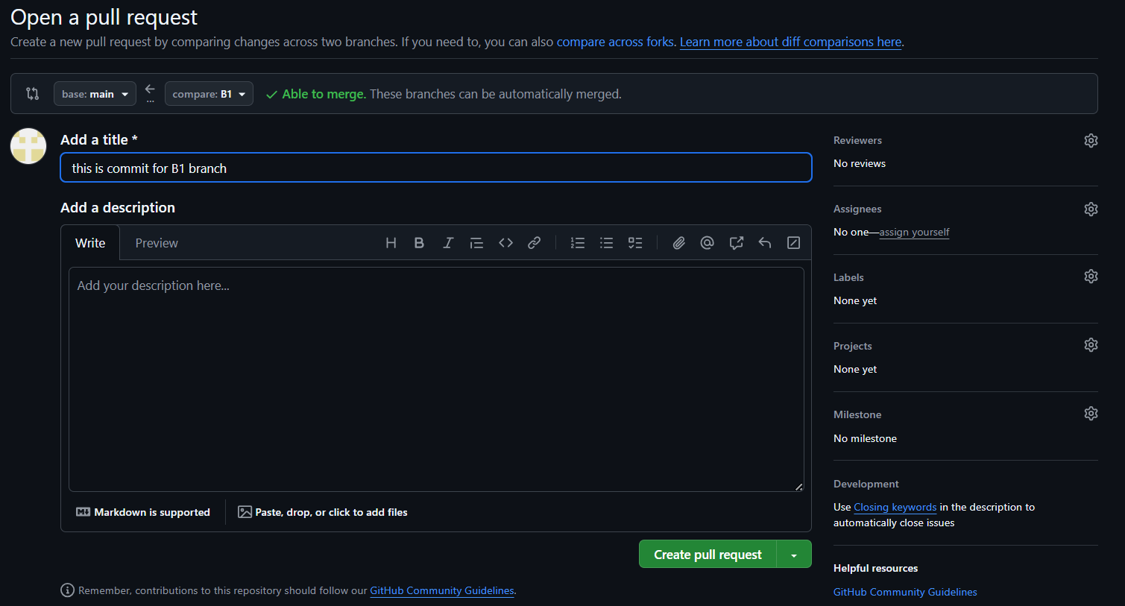
- Enter a ‘title’ in the top text box
- Add brief description about the request in the description field
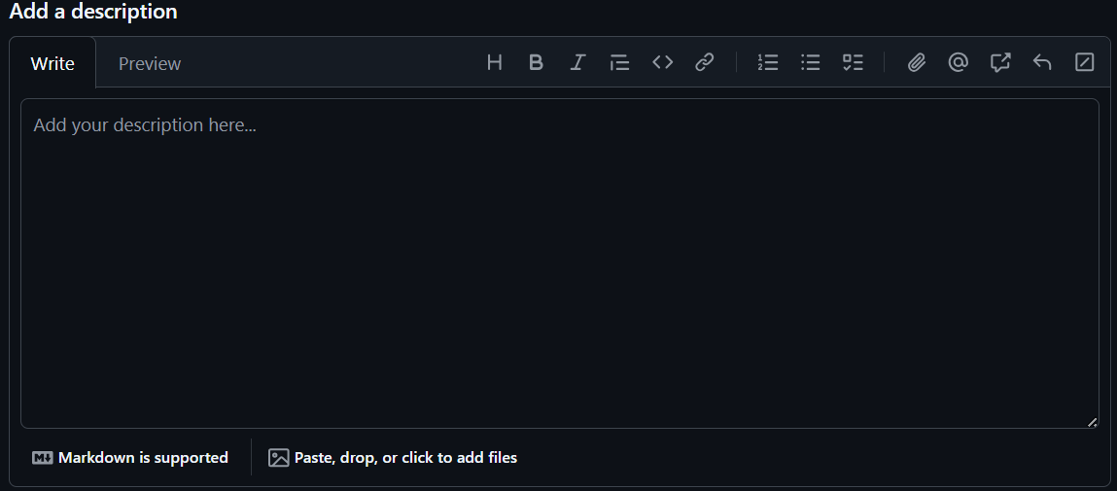
- Click ‘Create pull request’


MERGING AND DEPLOYING TO MAIN BRANCH

GitLab will automatically check for conflicts. If there are no conflict, to shows a conformation message
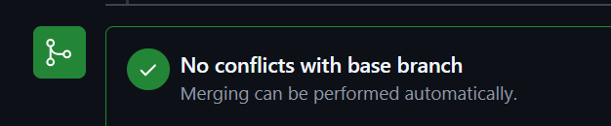

- Click on ’Merge pull request’


The following confirmation window appears
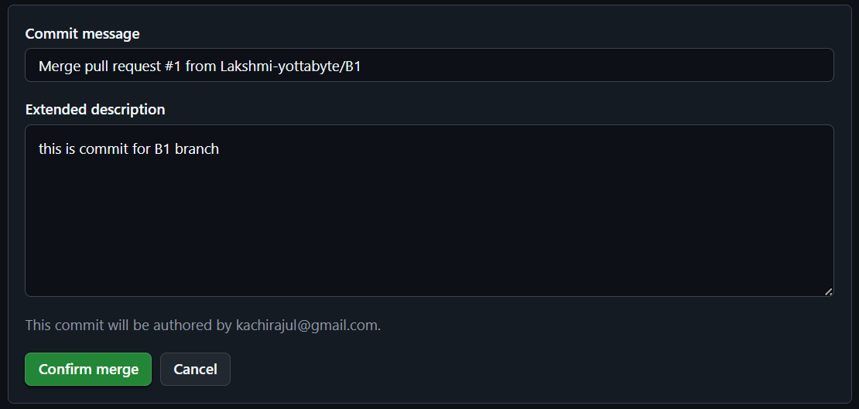
- Click ‘Confirm merge’ to merge the changes to the ‘Main branch’. Once it merged, the following message appears

- Add a comment in the comment box
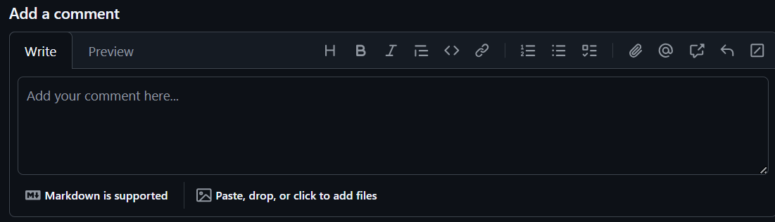
- Click on ‘Close pull request’ to close the request and complete the process.
