* Hospital table sperate it for patient details has 2 entities, Optionality.
* Blood bag and inventory merge it
* In person convert to donor and Donor convert it to VISIT
* Organization center to Blood drive.
* Optionality should be there in both ends
* Recipient as associative entity
* Unit count collected

LATEST ERD

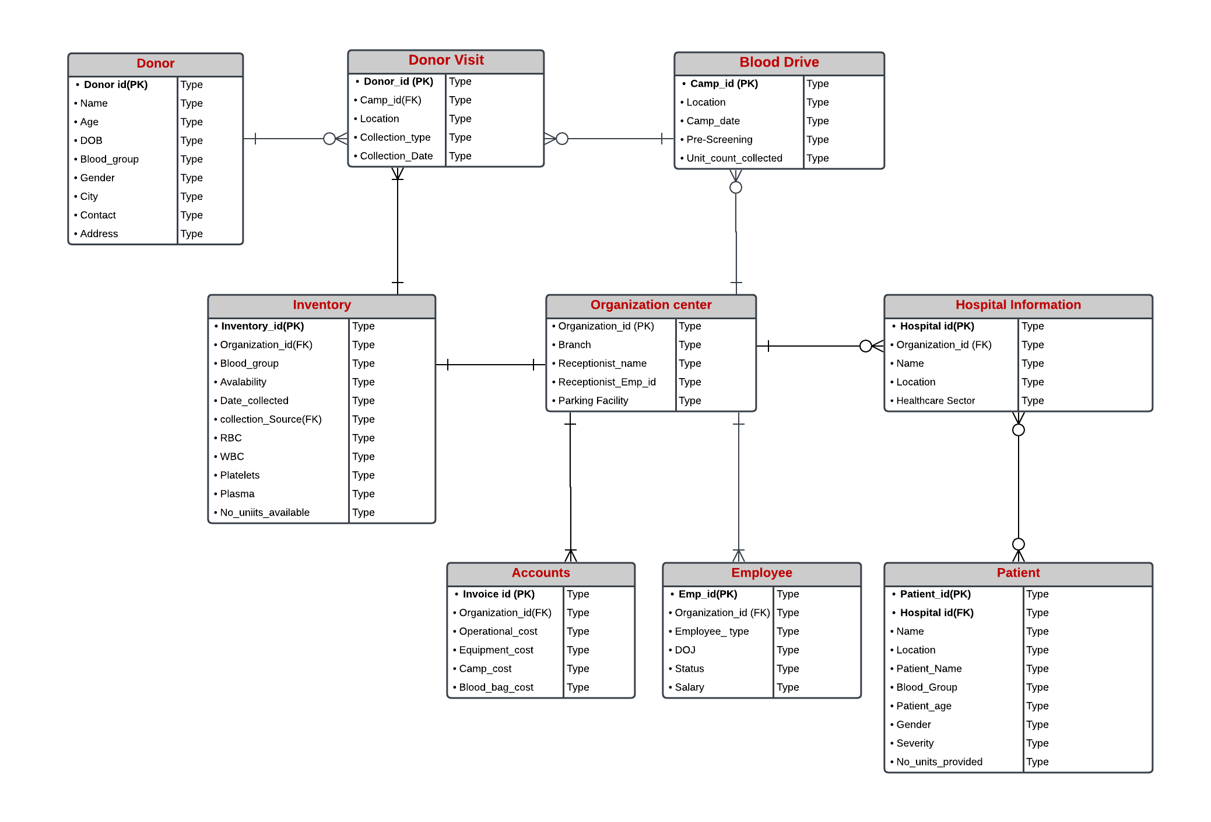

* I have edited all the tables organization center patient, etc., check on all the entities and objects.
* Cardinality and Optionality we need to discuss again