**Padala V V Durga Lakshmi**

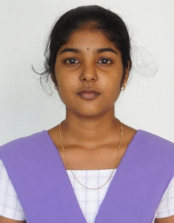

**D.NO:2-58,pathuru,**

**Mallepalli,Andhra Pradesh,533435**

**MOBILE NO:7288958689**

**EMAIL** :18a95a0507@aec.edu.in

**Technical Skills :**

* + Languages
    - C
    - C++
    - JAVA

**Other Skills :**

* + Hard working
  + Logical thinking

**Academic:**

|  |  |  |  |  |
| --- | --- | --- | --- | --- |
| Specification | Passing Year | Institution | Stream | Marks in % |
| **BTECH** | 2022 | Aditya Engineering College,Surampalem | Computer  Science | 8.5 GPA(upto 2-1 semester,next semesters yet to happen) |
| **Diploma** | 2019 | Aditya Engineering College,K=Surampalem | Computer  Engineering | 93.7% |
| **10th** | 2016 | Surya Teja(E.M) School,Gandepalli | - | 9.5 |

**Certifications:**

Spoken tutorial certification for completion of C training

Microsoft certification for html5

**Hobbies :**

* Listening music
* Watching Tv
* Knowing historical things

**Personal Profile :**

**Nationality :** Indian

**Gender :** Female

**Date of Birth :** 12/01/2001

**Languages :** Telugu,English

**Declaration :**

I hereby declare that above information is correct to the best of my knowledge and belief.

**Place : Mallepalli**

**Date : 20-10-2020 (p v v durga lakshmi)**