**Gurukula Automation Framework Details**

* **Framework Structure:**

**This is the cucumber framework with TestNG I have used . It runs automated tests written in a behaviour (BDD) style.** **Gherkin is the language that Cucumber uses to define test cases**

**Below are the jars I have used for this Automation Project:**

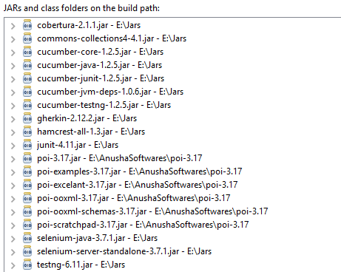

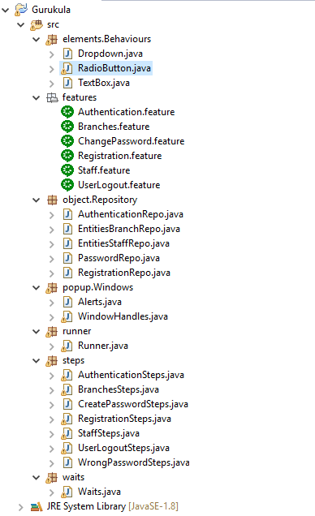

**Explanation about Framework Structure: [Package wise]**

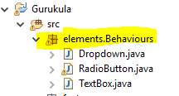

**Description:** To define different type of elements behaviour generally which are available on web page.

**Ex:** Dropdown is a class which will have all the methods as static that we are going to use for a web element. This is just to avoid the multiple object creation every time.

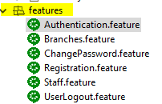

**Description: Used Cucumber Framework to maintain the scenarios is Gherkin language.**

**It is good to always write our scenarios using cucumber so that business can also easily understand the functionality by looking into the lines written in simple English.**

**We can also reuse the scenario line in any other feature file which will automatically executes the step behind this.(Reusability)**

* **Have used Background concept**
* If we want to execute the same steps for another scenarios in same feature file. We can maintain those steps under Background so that those steps will be executed for every scenario.
* We can also run our tests based on annotations

For ex: I have used @SmokeTest and @RegressionTests to run the tests as group and also used @annotations for scenarios to run specific scenario using runner file.

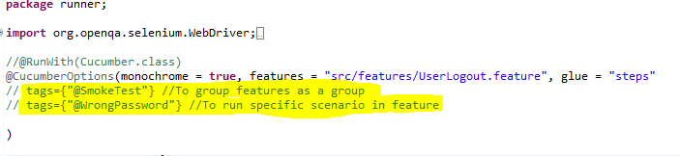

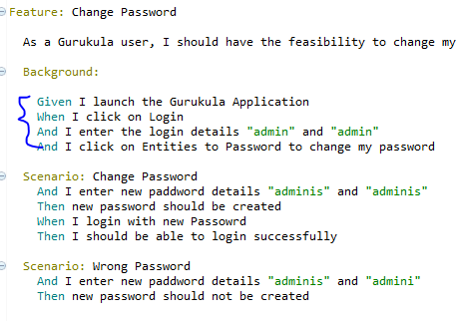

* **Have used Data Table concept**
* **Data Table is generally used to run our scenario with multiple test data**

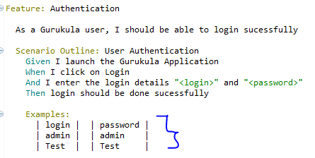

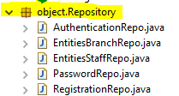

**Description:**

**This is POM(Page Object Model) where each web page related elements are placed in separate java files.**

**Note: For most of the elements id/name/classname are not available so have used xpath to identify elements. Generally we will be having id/name/classname for elements in rare cases we go for xpath.**



**For Alerts and to Handle Windows maintaining a separate class to use these when ever required using Inheritance.**



**This is Cucumber Junit runner class. This class will use the Junit annotation @RunWith(), which tells JUnit what is the test runner class. It more like a starting point for Junit to start executing your tests.**

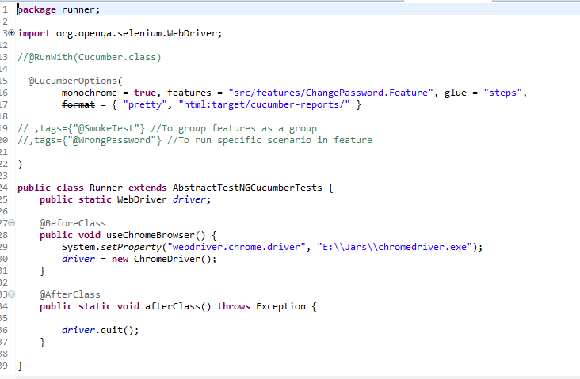

* **Have used the TestNG annotations @BeforeClass and @AfterClass to use the chrome driver to launch gurukula application and to close all the driver instances once done.**

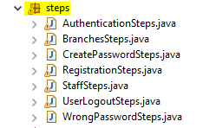

**This pakage consists steps files which methods are generated from each feature file.**



**Maintaining a separate class for different types of waits**

* **Implicit Wait**
* **Explicit Wait**
* **Fluent Wait**



**RegistrationData.xlsx is the test data file which I have used the test data to fill up the details during Registration in Gurukula. I have used the Apache POI jar to read data from excel.**

**Features and Scenarios Automated:**

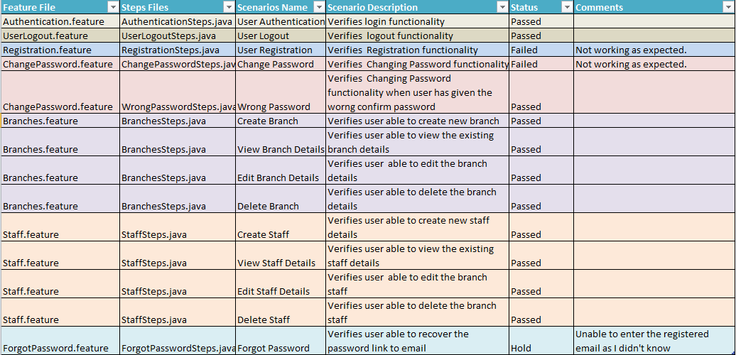

**Defects Identified in GURKULA Application**

|  |  |  |
| --- | --- | --- |
| **Functionality** | **Defects Identified** | **Severity** |
| Registration | Showing the "Your password is required to be at least 5 characters" but password strength is becoming green when I entered numeric | Medium |
| Registration | Not able to register. Showing the error message "Registration failed! Please try again later" even I entered the correct details | High |
| Registration | For login and email while typing showing the previous names/emails as suggestions. | Low |
| Forgot Password | Your e-mail is required to be at least 5 characters. Email which we provide can have many characters. Its is incorrect to display this validation while filling up the email | Low |
| Change Password | Not able to change the password even when new password and confirm password matches. Displaying An error has occurred! The password could not be changed. | Medium |
| Change Password | Showing the "Your password is required to be at least 5 characters" but password strength is becoming green when I entered numerics.Either the message displaying should show the correct message like what the user have to give. | Medium |
| Forgot Password | Your e-mail is required to be at least 5 characters. Email which we provide can have many characters. Its incorrect to display this validation while filling up the email | Low |
| User Login | Automatic Login is not working. Not remembering the login and Password when I check Automatic login again asking to provide the details | Medium |
| Create New Branch | Previous details are populating while filling up the name and code text fields | Low |
| Create New Branch | While creating new branch a pop window is opening. When I click on any side of parent web page then pop window is closing | Medium |
| Create New Staff | While creating new staff a pop window is opening. When I click on any side of parent web page then pop window is closing | Medium |
| Create New Staff | Displaying empty space in Branch dropdown | Low |

**Reports :**

**I have generated two reports**

* **One is which TestNG has generated emailable-report.html**

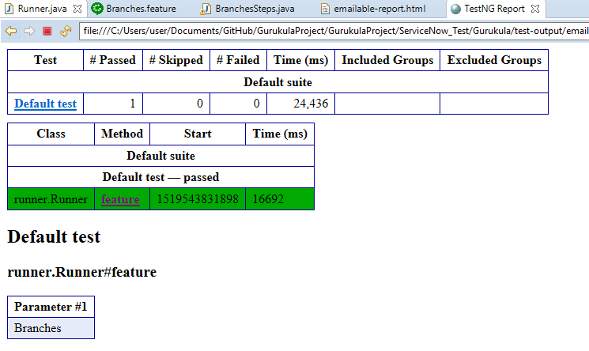

* **Second is the report generated by Cucumber index.html which will be placed in target folder . As all the scenarios are passed showing in Green if failed will highlight in Red.**
* **We can also generate the cucumber reports in jenkins**

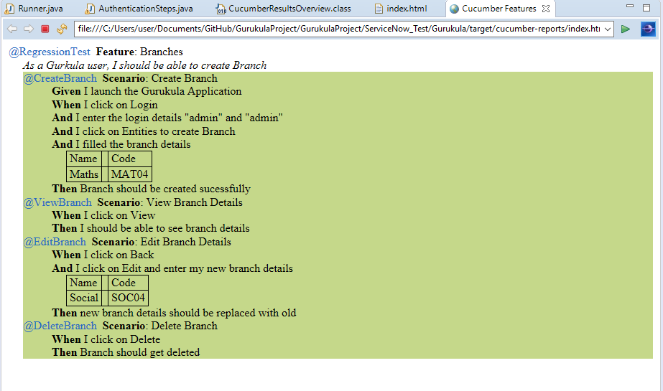

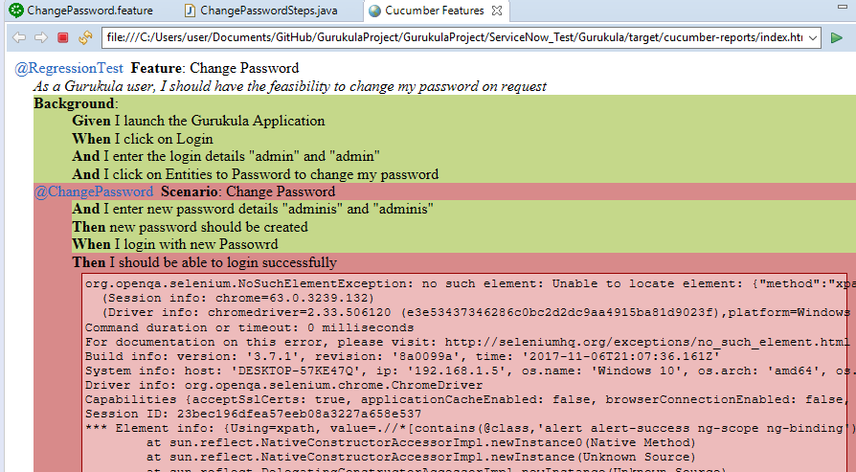

**Note:**

* **To run the tests use the below format. Change the feature file name which ever you want to run in place of highlighted text.**
* **To run individual scenario use the below**

**tags={“@CreateBranch”}**

