MULTILEVEL PASSWORD AUTHENTICATION

A MINI PROJECT REPORT SUBMITTED TO
Swarnandhra College of Engineering and Technology in partial fulfillment of the requirements for the award of
the degree

MASTER OF COMPUTER APPLICATIONS

By

KADALI.LAKSHMI BHAVANI
(24A21F0056)
Under the guidance of

V. MADHULATHA

Assistant professor



DEPARTMENT OF MASTER OF COMPUTER APPLICATIONS
SWARNANDHRA COLLEGE OF ENGINEERING AND TECHNOLOGY
(AUTONOMOUS)
(Approved by AICTE & Permanently Affiliated to JNTUK) (Accredited by NAAC with “A” Grade)
SEETHARAMPURAM, NARASAPUR-534280
2024-2026

DEPARTMENT OF MASTER OF COMPUTER APPLICATIONS
SWARNANDHRA COLLEGE OF ENGINEERING AND TECHNOLOGY
(AUTONOMUS)
Seetharampuram, Narasapur-534 280.



CERTIFICATE

This is to certify that this project work entitled “MULTILEVEL PASSWORD AUTHENTICATION” is the Bonafide work of MS. KADALI.LAKSHMI BHAVANI who carried out the work under my supervision, and submitted in partial fulfillment of the requirements for the award of the degree, Master of Computer Applications, during the academic year 2024-2026.

Project Coordinator Project Supervisor

Dr.B.GOHIN Dr.B.GOHIN
Associate Professor Associate Professor

Head of Department
Mr. A.N.L. KUMAR
Head Of the Department of MCA

DECLARATION

I certify that

The work contained in the project work is original and has been done by me under the guidance of my supervisor The work has not been submitted to any other University for the award of any degree or diploma.The guidelines of the University are followed in writing this report.

Date: KADALI.LAKSHMI BHAVANI
(24A21F0056)

ACKNOWLEDGEMENT

I extend my heartfelt gratitude to the Almighty for giving me strength in proceeding with this project title “MULTILEVEL PASSWORD AUTHENTICATION”.

I express my heartfelt gratitude to my parents for supporting me in all the ways in every walk of my life.

I express my sincere thanks to Honorable Sri. K.V. Satyanarayana, Chairman of our college for making necessary arrangement for doing the project.

I wish to express my gratitude to Dr. S. Suresh Kumar, principal of our college, for giving us permission to carry out this project.

I express my sincere thanks to Mr. A.N.L. Kumar, Head of the Department of M.C.A. for his learned suggestions and encouragement which made this project a successful one.

I convey my sincere thanks to my project guide V.MADHULATHA, Assistant Professor, Department of MCA for his learned suggestions and encouragement which made this project a success.

I express my sincere thanks of all the faculty members of our Department of MCA for their valuable support throughout this project work.

I wish to express my thanks to my friends for their enthusiasm, support and encouragement for the completion of this project.

KADALI.LAKSHMI BHAVANI

Regd. No.24A21F0056

MULTILEVEL PASSWORD AUTHENTICATION

ABSTRACT
This project presents a Multi-Factor Authentication (MFA) web application using Python Flask, demonstrating secure login through multiple verification levels: password, OTP, security question, and symbol recognition. The objective is to enhance practical security awareness and prevent unauthorized access through a real-world workflow and modern UI.

Multi-Factor Authentication Using Flask WebApplication
Multi-factor authentication (MFA) is an essential strategy for securing web applications against unauthorized access and credential-based attacks. This project presents a four-stage authentication system using Python Flask, combining traditional password login with OTP verification, security question validation, and symbol recognition. The application demonstrates secure password storage, session-based user flow, time-based OTP logic, and modern web design. The project aims to illustrate security fundamentals and practical web development for student and enterprise learning alike.

Index

S.No | Topic | Page No
1 | Chapter 1: Introduction
 | 1.1 Project Overview
 | 1.2 Problem Statement
 | 1.3 Project Objectives
 | 1.4 Project Scope
2 | Chapter 2: Literature Survey
3 | Chapter 3: System Analysis
 | 3.1 Requirement Gathering
 | 3.2 Feasibility
 | 3.3 SWOT Analysis
4 | Chapter 4: System Requirements Specification
 | 4.1 Functional Requirements
 | 4.2 Non-Functional Requirements
5 | Chapter 5: System Design
 | 5.1 Architecture Design

6 | Chapter 6: Implementation
 | 6.1 Algorithms
 | 6.3 Source Code
7 | Chapter 7: Testing
 | 7.1 Test Plan
8 | Chapter 8: Implementation Results
 | 8.1 Screenshots
 | 8.2 Output Screens
 | 8.3 Performance Metrics
9 | Chapter 9: Conclusion and Future Scope
 | 9.1 Conclusion
10 | Chapter 10: References
11 | Appendices
 | Appendix A: User Manual
 | Appendix B: Installation Guide

1.Introduction

1.1 Project Overview
Modern web applications require strong authentication beyond just passwords. This project implements a four-layer MFA process with password, OTP, security question, and symbol selection using Flask. The system is designed to educate and demonstrate secure user authentication in academic and practical environments.

1.2 Problem Statement
Traditional password-only authentication is vulnerable to attacks. Secure web flows require multiple independent verification layers.

1.3 Project Objectives
- Develop a multi-layer authentication system in Flask.
- Ensure secure session-based access control.
- Design a user dashboard after full verification.
- Provide clear error feedback for authentication issues.
- Provide a secure file-access/dashboard after complete authentication.

1.4 Project Scope

The scope of this project includes Focused on user authentication and UI/UX demonstration. Data uses Python structures but may expand to DB for larger deployments.

2. Literature Survey
Most web apps use only username/password logins. Research proves multi-layer systems reduceattacks. Flask and Werkzeug offer modern security features.
Recent research shows MFA reduces attack surface for phishing, brute-force, and session hijacking.
Flask provides easy route, session, and modular authentication design for web projects.

3. System Analysis

Requirement Gathering
- Python 3.7+, Flask, Werkzeug
- Browser access
- HTML5, CSS3, JS for timers
Functional:
- User registration (password, security Q&symbol setup)
- Login (password check)
- OTP verification (30 sec timer, inline error)
- Security Q&A
- Symbol selection
- Session-tracked dashboard
Non-Functional:
- Responsive web design (desktop & mobile)
- User error feedback and timeouts
- Only authenticated users can access download dashboard

3.2 Feasibility
Runs on all major systems; open-source; easy for users.
- Technical: Runs on all OS with Python 3+
- Economic: Open-source stack
- Operational: Simple UI, secure session, easy codebase

SWOT Analysis
- Strengths: Multi-layer security, modern UI, error feedback
- Weaknesses: Demo uses Python dicts
- Opportunities: Extensible for research
- Threats: No third-party login/OAuth

4.System Requirements Specification
- Hardware: Basic desktop/laptop
- Software: Python 3.8+, Flask, browser
- Network: Offline/demo mode (localhost); can upgrade for deployment

4.1 Functional Requirements
Registration, password hashing, OTP, security Q&A, symbol, session dashboard
- Secure user registration
- Multi-layer login
- File download only after complete authentication

4.2 Non-Functional Requirements
Minimal dependencies, responsive UI, error handling, session protection
- Modern glassmorphic UI
- Inline error messages
- Code easily modifiable for DB upgrade

5.System Design

5.1 Architecture Design
[User]
|
[Registration]
|
[Login + Password]
|
[OTP Verification (30s, 6 digits)]
|
[Security Question]
|
[Symbol Verification]
|
[Dashboard with file access]

5.2 Screen Flow
- Registration
- Login
- OTP
- Security Question
- Symbol Picker
- Dashboard + File List

6.Implementation

- Framework: Python Flask
- Password Hashing: Werkzeug (generate_password_hash, check_password_hash)
- Sessions: Flask inbuilt session handling
- OTP: random.choices(string.digits, k=6), 30 second expiry
- File Download: Flask send_from_directory after authentication
Key Code (Dashboard route with files):
python
@app.route('/dashboard')
def dashboard():
username = session.get('username')
if not username:
return redirect(url_for('login'))
files_list = os.listdir('files') if os.path.exists('files') else []
return render_template('dashboard.html', username=username, files=files_list)
Frontend: HTML5, Modern CSS; JavaScript for showing/hiding file list

6.1 Algorithms
- Password hashing: PBKDF2 via Werkzeug
- OTP: random.choices with expiry
- Sessions: track and redirect

6.3 Source code

from flask import Flask, request, render_template, redirect, url_for, session, send_from_directory
from werkzeug.security import generate_password_hash, check_password_hash
import random
import string
import time
import os

app = Flask(__name__)
app.secret_key = 'yoursecretkey'

# Dummy user data, replace with DB integration
users = {}

# OTP store
otp_store = {}

# Home / Login page
@app.route('/', methods=['GET', 'POST'])
def login():
error = None
if request.method == 'POST':
username = request.form['username']
password = request.form['password']
user = users.get(username)
if user and check_password_hash(user['password'], password):
session['username'] = username
return redirect(url_for('otp'))
else:
error = "Invalid username or password"
return render_template('login.html', error=error)

# Registration route
@app.route('/register', methods=['GET', 'POST'])
def register():
msg = None
if request.method == 'POST':
username = request.form['username']
password = request.form['password']
security_q = request.form['security_q']
security_a = request.form['security_a']
symbol = request.form['symbol']
hashed_password = generate_password_hash(password)
users[username] = {
'password': hashed_password,
'security_q': security_q,
'security_a': security_a,
'symbol': symbol
}
msg = "Your registration is completed."
return render_template('register.html', msg=msg)
return render_template('register.html', msg=msg)

# OTP generation
@app.route('/otp', methods=['GET', 'POST'])
def otp():
username = session.get('username')
error = None
otp_code = None
if request.method == 'GET':
if not username:
return redirect(url_for('login'))
otp_code = ''.join(random.choices(string.digits, k=6))
otp_store[username] = {'otp': otp_code, 'expiry': time.time() + 30}
return render_template('otp.html', otp_code=otp_code, error=error)
else:
user_otp = request.form['otp']
data = otp_store.get(username)
if not data:
error = "OTP Invalid or expired"
else:
otp_code = data['otp']
expiry = data['expiry']
if time.time() > expiry:
error = "OTP Expired"
elif user_otp != otp_code:
error = "OTP Incorrect"
if error:
return render_template('otp.html', otp_code=otp_code, error=error)
else:
return redirect(url_for('security_question'))

# Security question level
@app.route('/security_question', methods=['GET', 'POST'])
def security_question():
username = session.get('username')
user = users.get(username)
error = None
if request.method == 'POST':
answer = request.form['answer']
if answer == user['security_a']:
return redirect(url_for('symbol'))
else:
error = "Wrong Security Answer"
return render_template('security_question.html', question=user['security_q'], error=error)

# Symbol recognition level
@app.route('/symbol', methods=['GET', 'POST'])
def symbol():
username = session.get('username')
user = users.get(username)
error = None
symbols = ['🌟', '🔥', '🌈', '💧']
if request.method == 'POST':
selected_symbol = request.form['symbol']
stored_symbol = user['symbol']
if selected_symbol == stored_symbol:
return redirect(url_for('dashboard'))
else:
error = "Wrong Symbol! Please try again."
return render_template('symbol_recognition.html', symbols=symbols, error=error)

# Dashboard route with file listing
@app.route('/dashboard')
def dashboard():
username = session.get('username')
if not username:
return redirect(url_for('login'))

files_list = os.listdir('files') if os.path.exists('files') else []
return render_template('dashboard.html', username=username, files=files_list)

# Logout route
@app.route('/logout', methods=['POST', 'GET'])
def logout():
session.pop('username', None)
return redirect(url_for('login'))

# Secure route for file download
@app.route('/download/<filename>')
def download_file(filename):
if "username" not in session:
return redirect(url_for('login'))
return send_from_directory('files', filename)

if __name__ == '__main__':
app.run(debug=True)

7.Testing
. Testing
Test Step | What is tested | Expected Result
Login | Wrong PW | Error message
OTP | Expired, wrong, correct | Errors, success, timeouts
Security Q | Wrong/correct | Error, then pass
Symbol | Wrong/correct | Error, then pass
Dashboard | Files display | User can download files

8.Implementation Results

8.1 Screenshots
Register page: a register is a small, fast storage location within a CPU used to hold temporary data and instructions during processing.

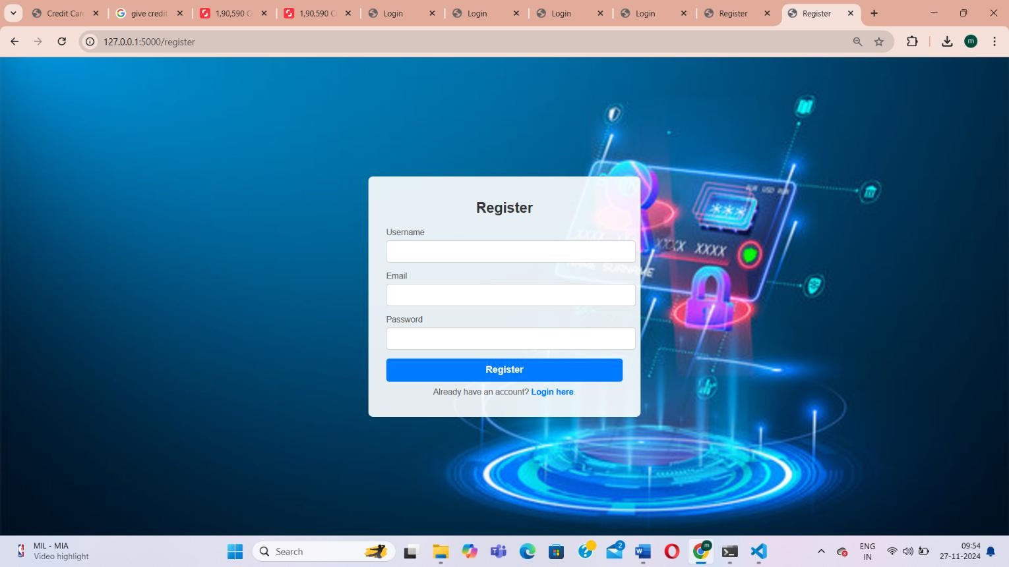 Login page: A login is the process of gaining authorized access to a system or application by providing credentials, typically a username and password.

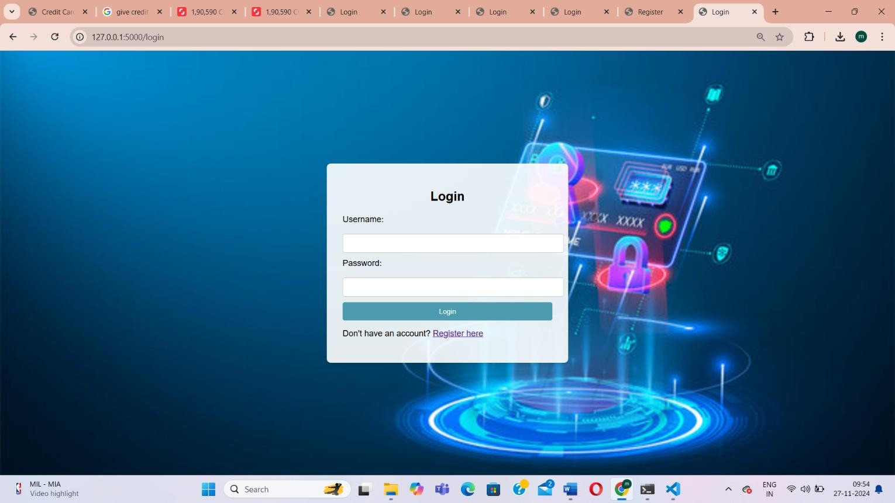

8.2 Output Screens

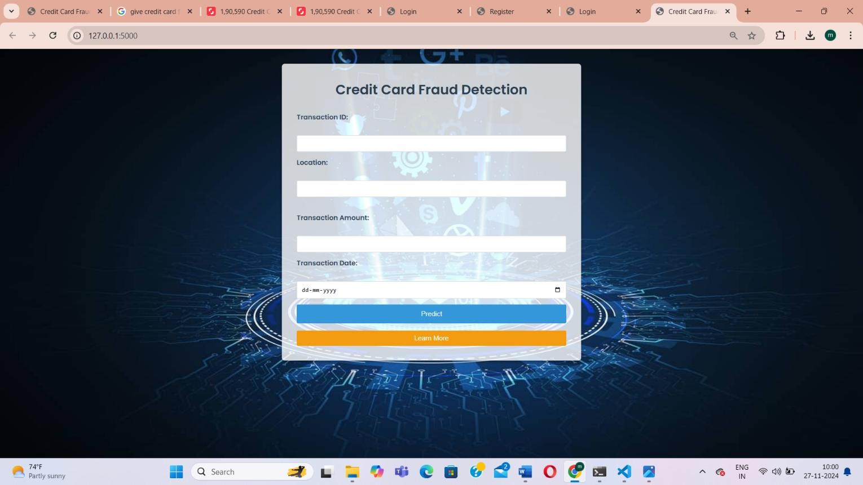

Fraud predict

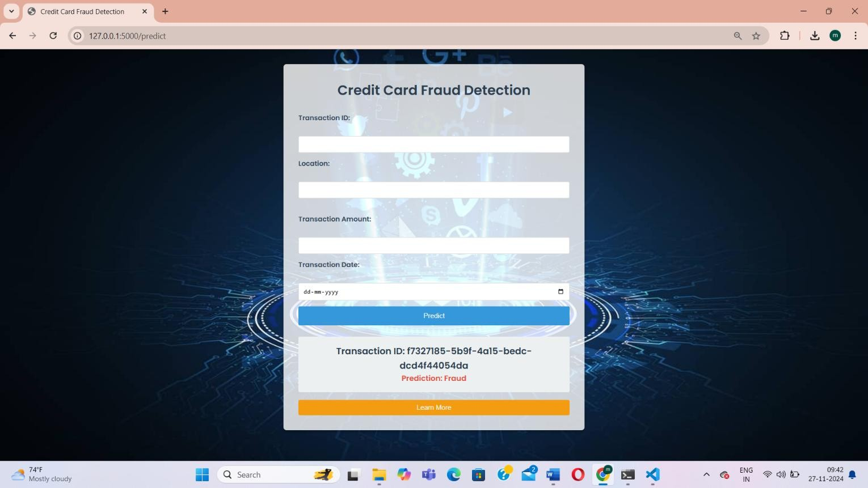

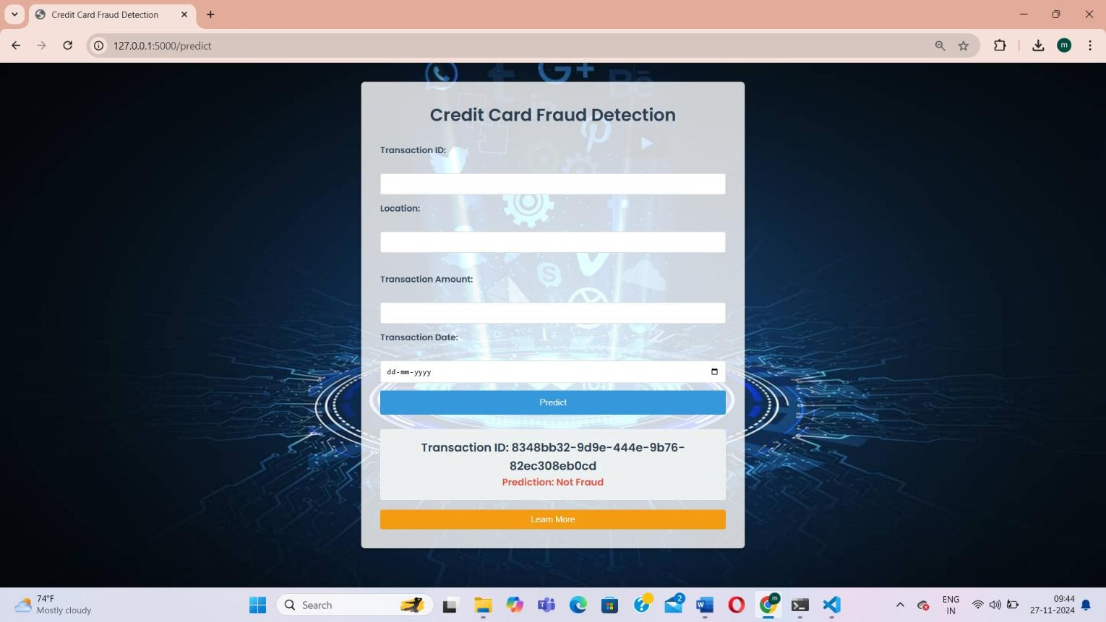

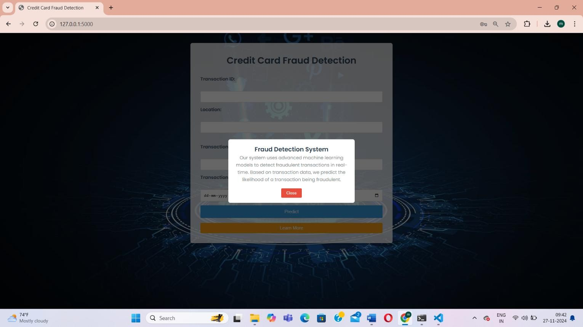

logout

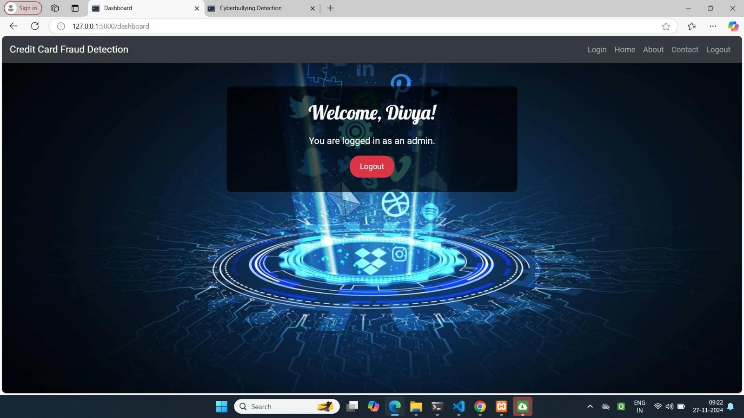

9.Conclusions and Future Scope

Conclusion:
Multi-factor authentication increases security. This Flask demo illustrates layered protection and modern design.

Future Scope:
- Add database for persistent storage
- OTP via SMS/Email integration
- Production-level deployment (nginx/gunicorn)
- Role-based user controls and analytics
- User profile, password reset, and admin tools

10.Reference

- Flask documentation
- Werkzeug documentation
- Research papers on MFA and session security
- The attached "Credit Card Fraud Detection" PDF as a model for documentation structure

11.Appendices

User Manual
Register, Login, pass OTP/Q/Symbol, see Dashboard

Installation
Quickstart install and run guide:
  - python -m venv venv && venv\Scripts\activate
  - pip install -r requirements.txt
  - python app.py
  - Access at http://127.0.0.1:5000

