**Page1: School Home Page**

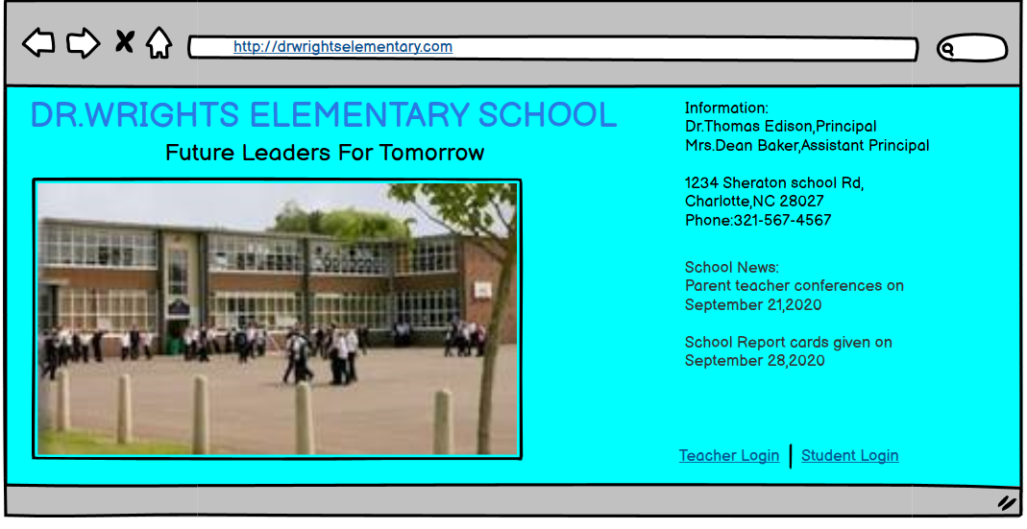

**Page 2: Student/Teacher Login Screen**

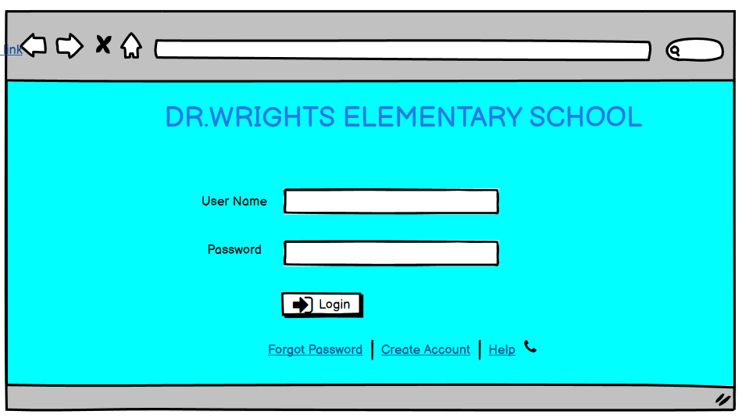

**Page 3: Account Creation Screen**

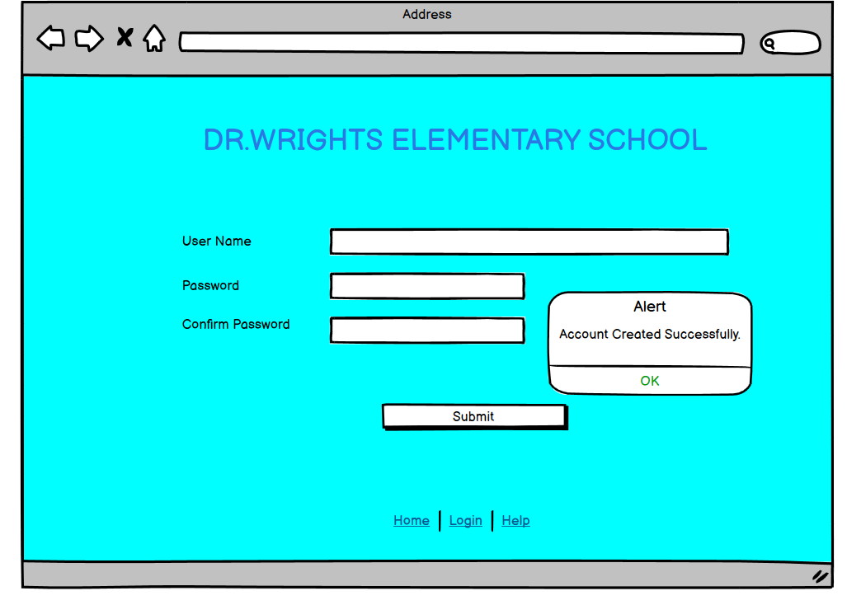

**Page 4: Teacher - Attendance Screen**

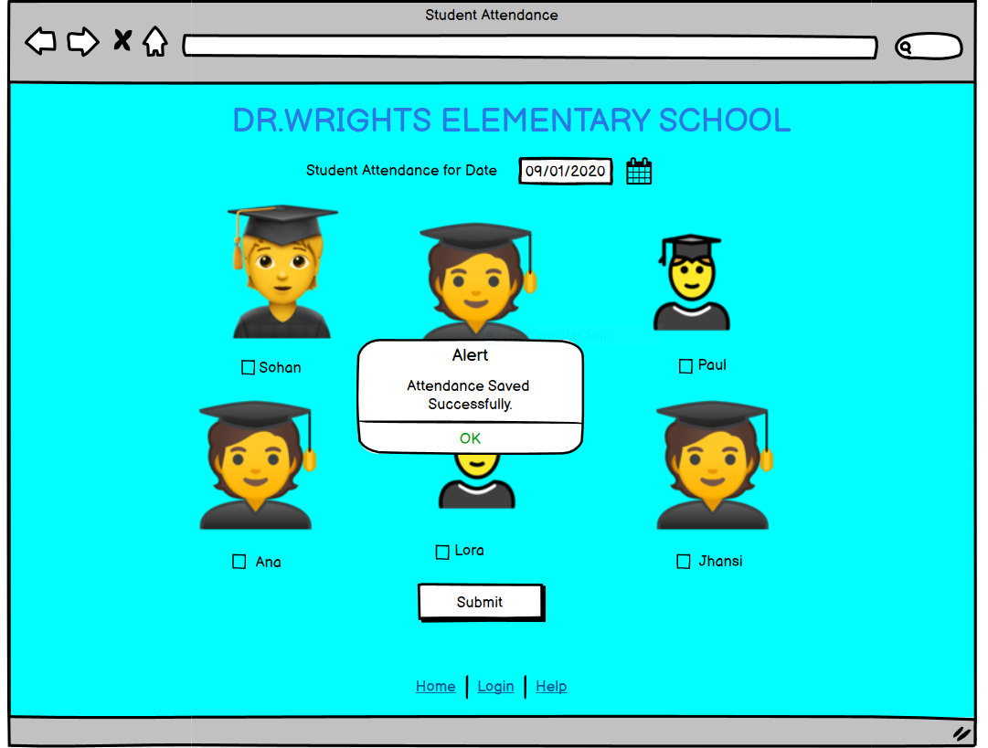

**Page 5: Student – Student to enter his/her details Screen**

