Project 2: Graph Algorithms and Related Data Structures
Team :
- Lakshmi Deepak Chidagam (801461579)
Language: Java

Introduction
This project implements three essential graph algorithms:
- Single Source Shortest Path – Dijkstra’s Algorithm
- Minimum Spanning Tree – Kruskal’s Algorithm
- Depth-First Search (DFS) – Topological Sorting & Cycle Detection

Each algorithm reads input from a structured text file defining vertices, edges, weights, and optionally the source node.
The program automatically detects whether to run Dijkstra, Kruskal, or DFS based on the graph type and presence of a source vertex.

Implementation Overview
The project is modular and implemented in the AlgoDS.Project2 package with the following classes:
Class Purpose
Main.java Entry point - reads i/p, determines graph type, and executes the correct algorithm
Graph.java Handles graph construction from file and stores adjacency lists
Edge.java Represents an edge (u, v, w)
Dijkstra.java Implements Dijkstra’s algorithm for directed graphs with a given source
Kruskal.java Implements Kruskal’s MST algorithm for undirected graphs
DFS.java Performs DFS traversal for topological sorting and cycle detection
The program automatically determines:
If source node exists → run Dijkstra
If graph is undirected → run Kruskal
If graph is directed and has no source → run DFS

Problem 1 – Dijkstra’s Algorithm
Description
Dijkstra’s algorithm finds the shortest paths from a given source vertex to all other vertices in a directed or undirected weighted graph without negative weights.
In this project, it builds a shortest path tree and prints each path with its cost.

Pseudo Code
Dijkstra(Graph, source):
for each vertex v in Graph:
dist[v] = ∞
prev[v] = NIL
dist[source] = 0
PQ = min-priority queue containing all vertices by dist[]

while PQ is not empty:
u = PQ.extract_min()
for each neighbor v of u:
if dist[v] > dist[u] + weight(u, v):
dist[v] = dist[u] + weight(u, v)
prev[v] = u
PQ.decrease_key(v, dist[v])
return dist[], prev[]
Data Structures Used
HashMap – stores distances and parent vertices
PriorityQueue – min-heap to get the next minimum distance vertex
Adjacency List – efficient storage for edges and weights
ArrayList – reconstructs shortest paths
Data Structure | Purpose | Reason for Choice
Adjacency List | Store distances and predecessors | Efficient O(V+E) space and easy traversal
Priority Queue (Min-Heap) | Select minimum-distance node | Provides O(log V) extract-min and decrease-key
ArrayList | Store distances and predecessors | Fast access for updates and path reconstruction

Algorithm Flow
Initialize all vertex distances to infinity except the source (0).
Insert the source into a priority queue.
Extract the vertex with the smallest distance.
Relax all its neighbors — update distances if a shorter path is found.
Repeat until the queue is empty.
Print all paths and their cumulative costs.
RunTime Analysis
Component Time Complexity
Extract-Min (heap) O(log V)
Relaxation (edges) O(E log V)
Total Runtime O(E log V)
Space Complexity O(V + E)
Implementation Details
Language: Java
Handles both directed and undirected graphs.
Ignores negative weights.
Reads input file format as specified:
<Vertices> <Edges> <Type>
<Node1> <Node2> <Weight>
...
<Source>
Inputs and its graphs
Dijkstra_input.txt
8 12 D
A B 4
A C 2
B C 5
B D 10
C E 3
E D 4
D F 11
E F 5
E G 2
G H 3
F H 4
C H 15
A

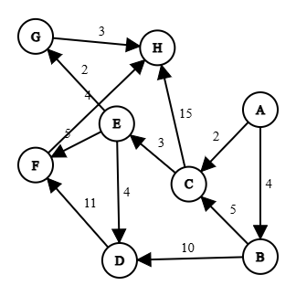
Outputs:
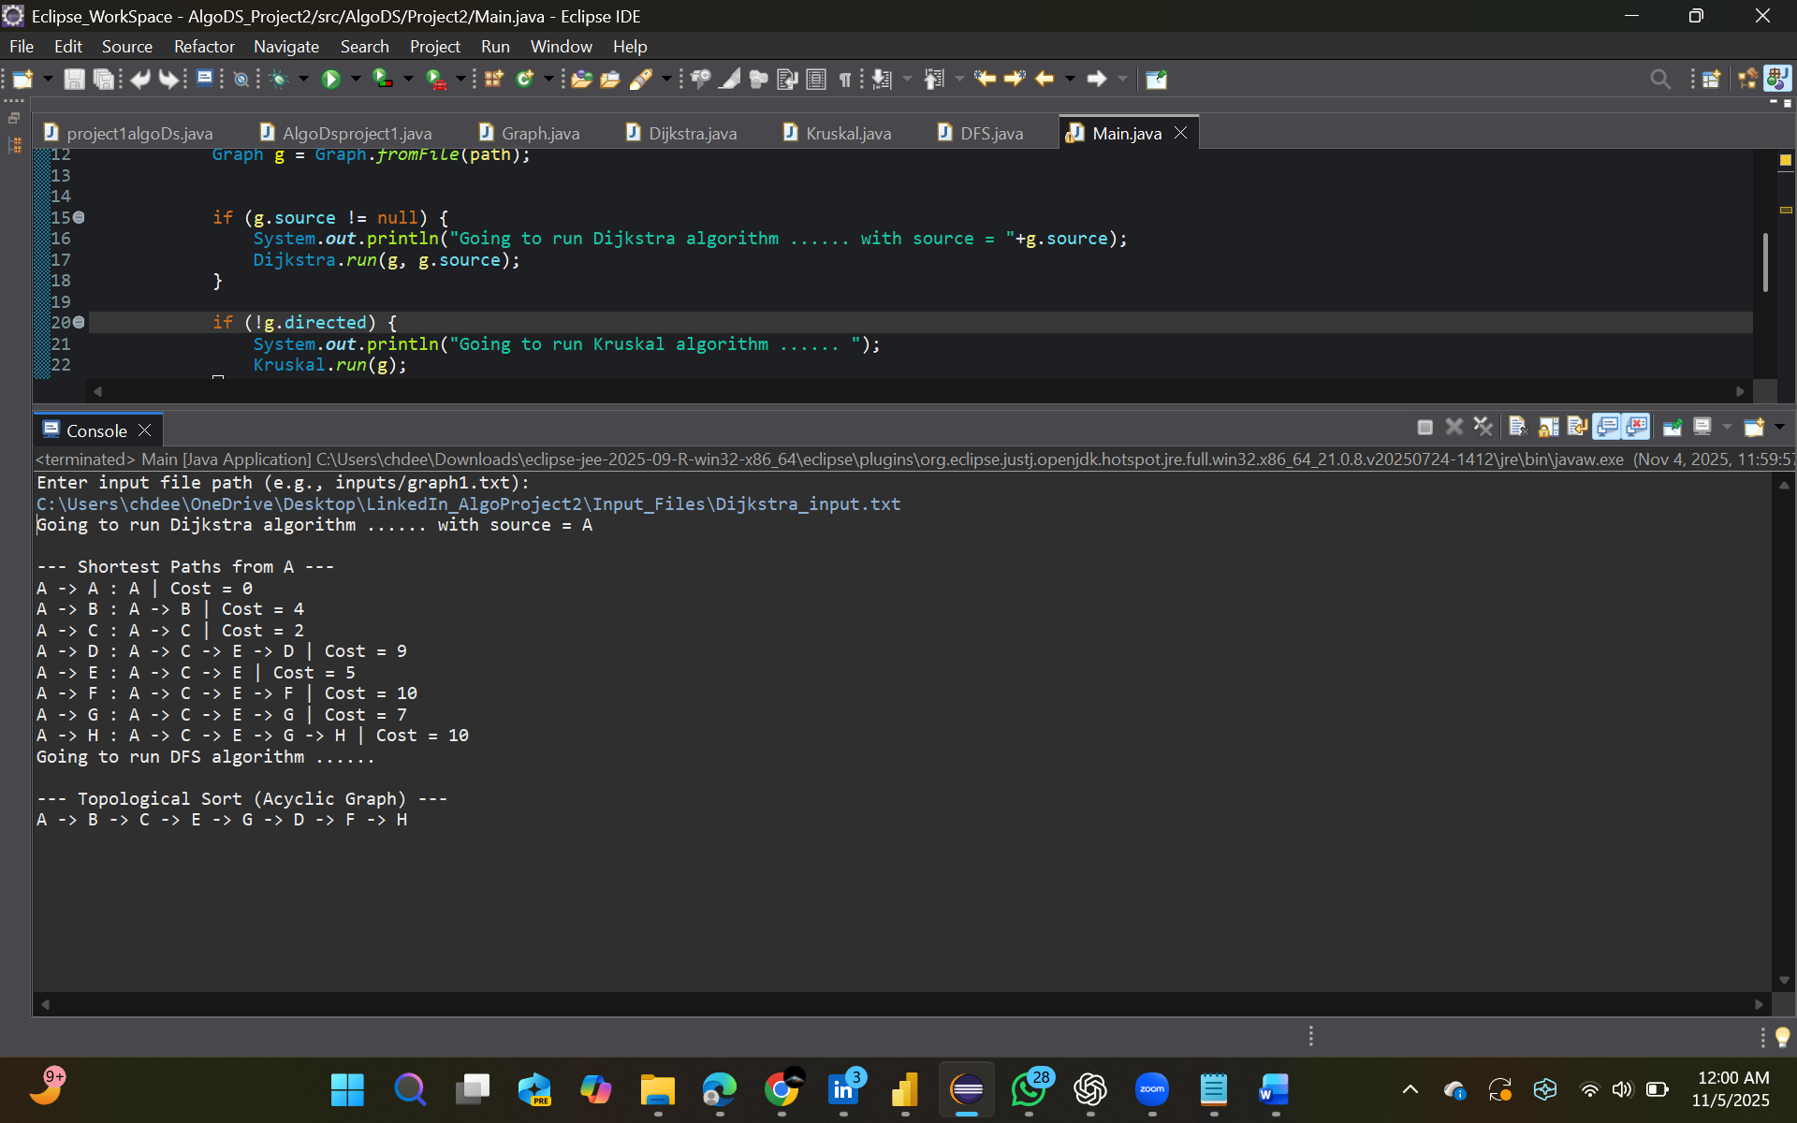

Problem 2 – Kruskal’s Algorithm
Description
Kruskal’s algorithm finds the minimum spanning tree (MST) for a connected, undirected, weighted graph.
It uses a greedy strategy — always picking the smallest edge that does not form a cycle.
Pseudo Code
Kruskal(Graph):
MST = ∅
for each vertex v in Graph:
MakeSet(v)
sort edges E by weight ascending
for each edge (u, v) in E:
if Find(u) ≠ Find(v):
MST.add((u, v))
Union(u, v)
return MST
Data Structures Used
Edge List (ArrayList) – all edges stored and sorted by weight – Reason: Required by kruskal
UnionFind (Disjoint Set) – detects cycles efficiently – Reason:O(v) per operation
HashMap & Set – track parent relationships between vertices – Reason : Simple Storage for results
Algorithm Flow
Read all edges and sort them by weight.
Initialize each vertex as its own set.
For each edge:
If the vertices belong to different sets → add the edge to MST and union the sets.
Otherwise → skip (to avoid cycle).
Continue until MST contains (V – 1) edges.
Print all selected edges and total MST cost.
RunTime Analysis
Component Time Complexity
Sorting edges O(E log E)
Union-Find operations O(E)
Total Runtime O(E log E)
Space Complexity O(V + E)
Inputs and graphs :
Kruskal_input.txt
9 14 U
A B 4
A H 8
B H 11
B C 8
C D 7
C F 4
C I 2
D E 9
D F 14
E F 10
F G 2
G H 1
G I 6
H I 7

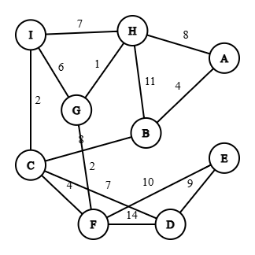

Outputs :
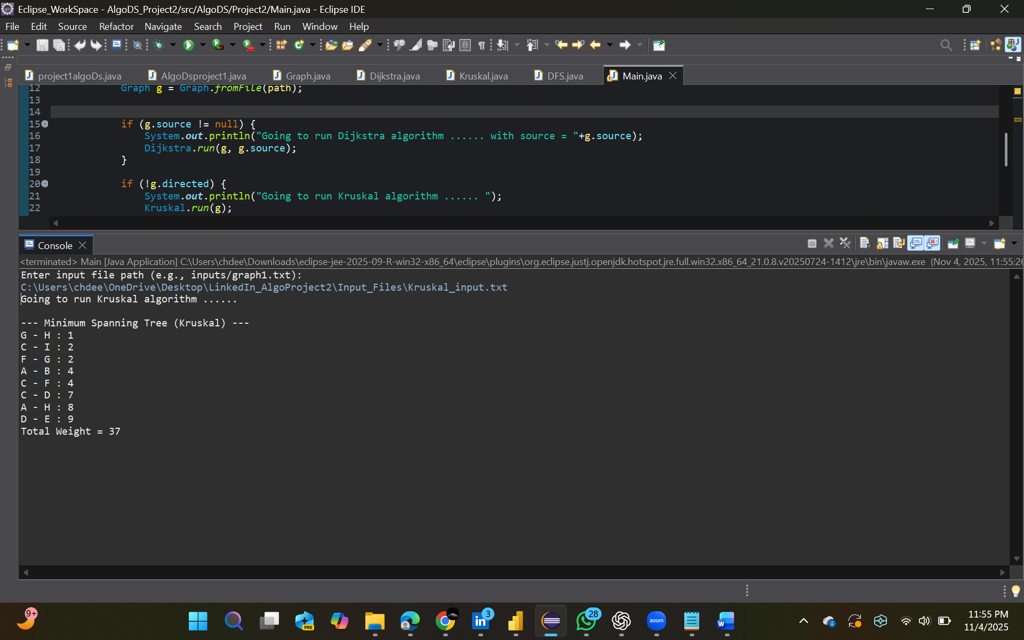

Problem 3 – DFS (Topological Sort and Cycle Detection)
Description
Depth-First Search (DFS) explores vertices recursively and is used here to:
Detect cycles in directed graphs
Generate topological sorting if the graph is acyclic
The algorithm colors vertices to track traversal state.
Pseudo Code
DFS(v):
visited[v] = true
stack[v] = true
for each neighbor u of v:
if not visited[u]:
parent[u] = v
DFS(u)
else if stack[u] == true:
record cycle (u → ... → v)
stack[v] = false
topo.push(v)
Data Structures Used
HashMap – stores vertex color (WHITE, GRAY, BLACK)
Stack – tracks recursion path for cycle reconstruction
ArrayList – stores topological order and cycle paths
Algorithm Flow
Initialize all vertices as WHITE (unvisited).
For each WHITE vertex, call DFS recursively.
Mark vertex as GRAY (active) → explore all neighbors.
If a GRAY neighbor is found → cycle detected.
After all neighbors are explored → mark BLACK (finished).
Reverse order of finished vertices → topological order.
RunTime Analysis
Component Time Complexity
DFS traversal O(V + E)
Cycle detection O(V + E)
Topological sorting O(V + E)
Total Runtime O(V + E)
Space Complexity O(V + E)
Inputs and Graphs :
Dfs_input.txt | Dfs_input2.txt
10 13 D  A B 1  B C 1  C D 1  D E 1  E B 1  C F 1  F G 1  G H 1  H F 1  D I 1  I J 1  J D 1  A J 1 | 10 9 D  A B 1  A C 1  B D 1  C D 1  C E 1  E F 1  D G 1  G H 1  H I 1

Helper/Tools: For input graphs, you can use any graph editing tool. You can use your own hand-drawn graphs as well. The following link - https://csacademy.com/app/graph_editor/ can be useful.
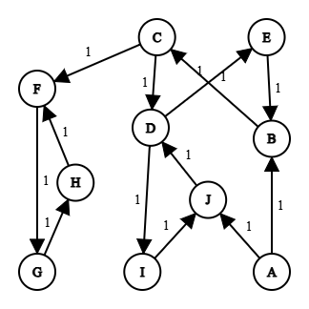
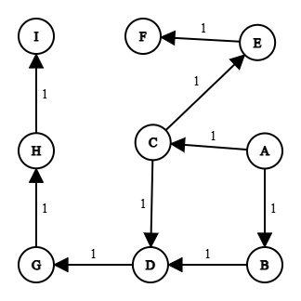

Outputs :
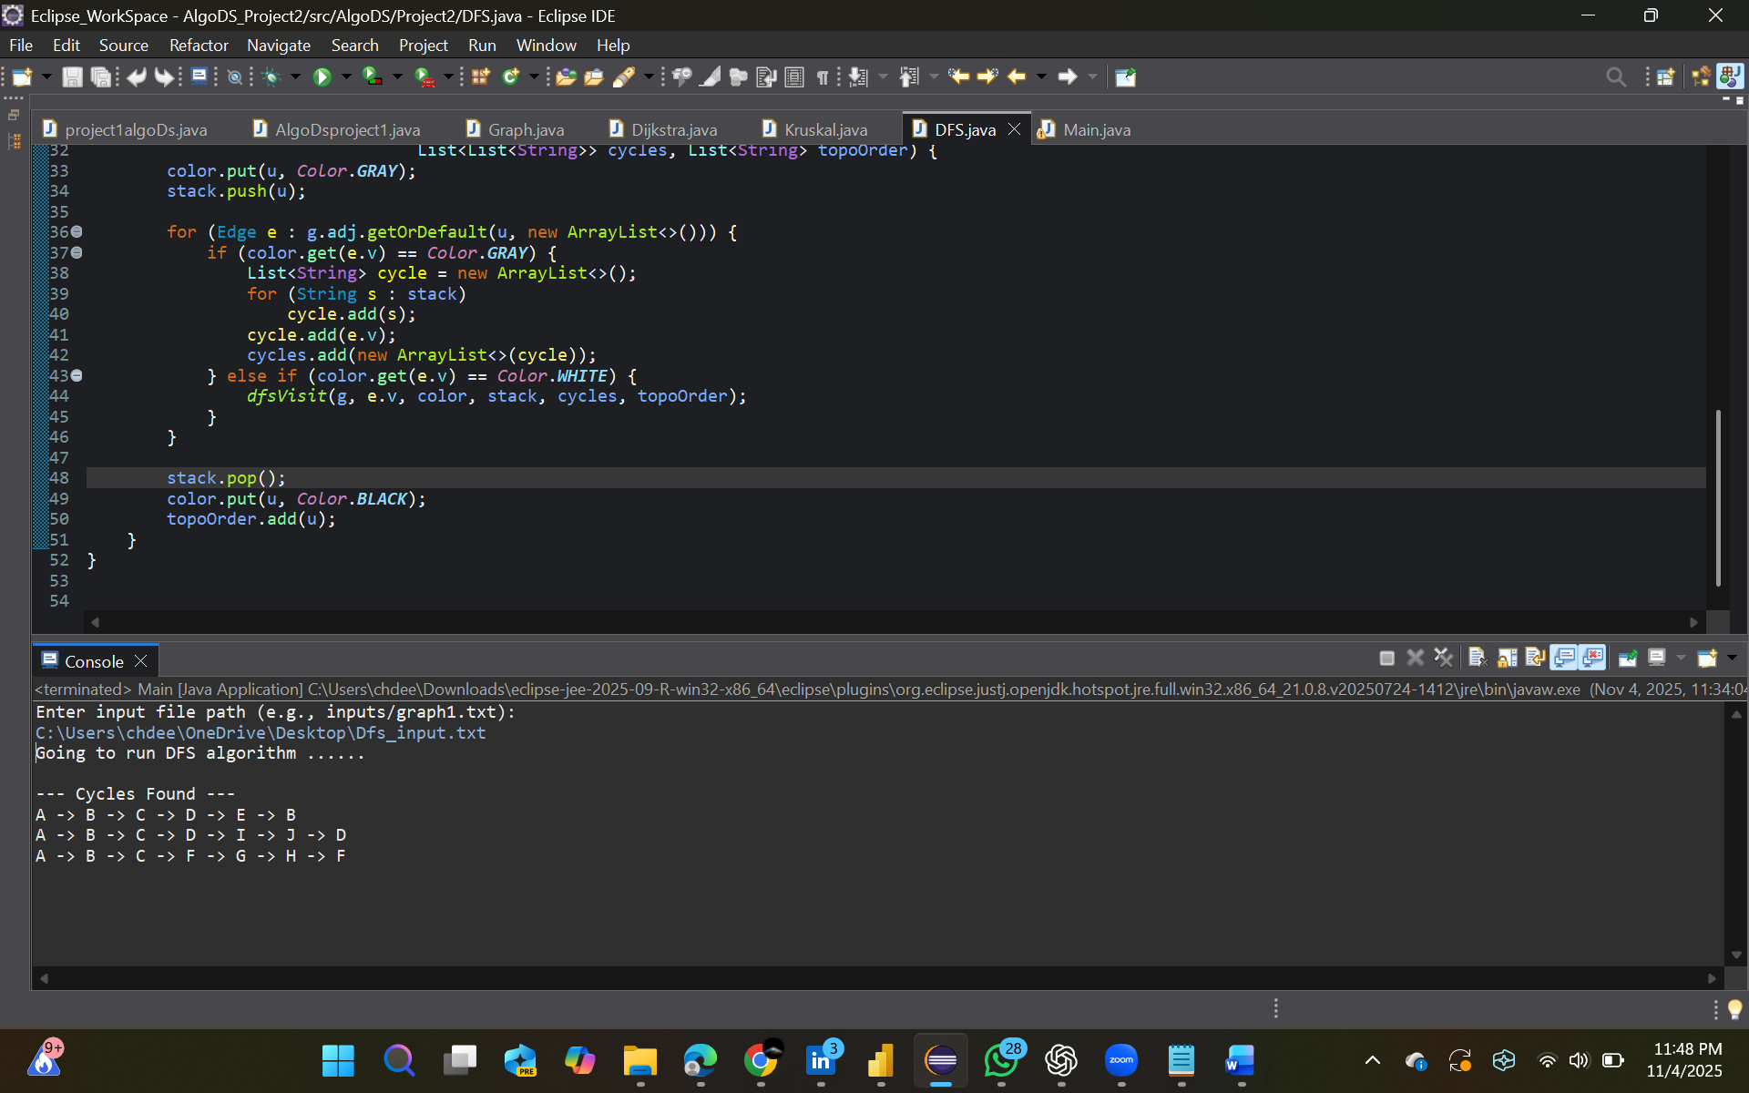

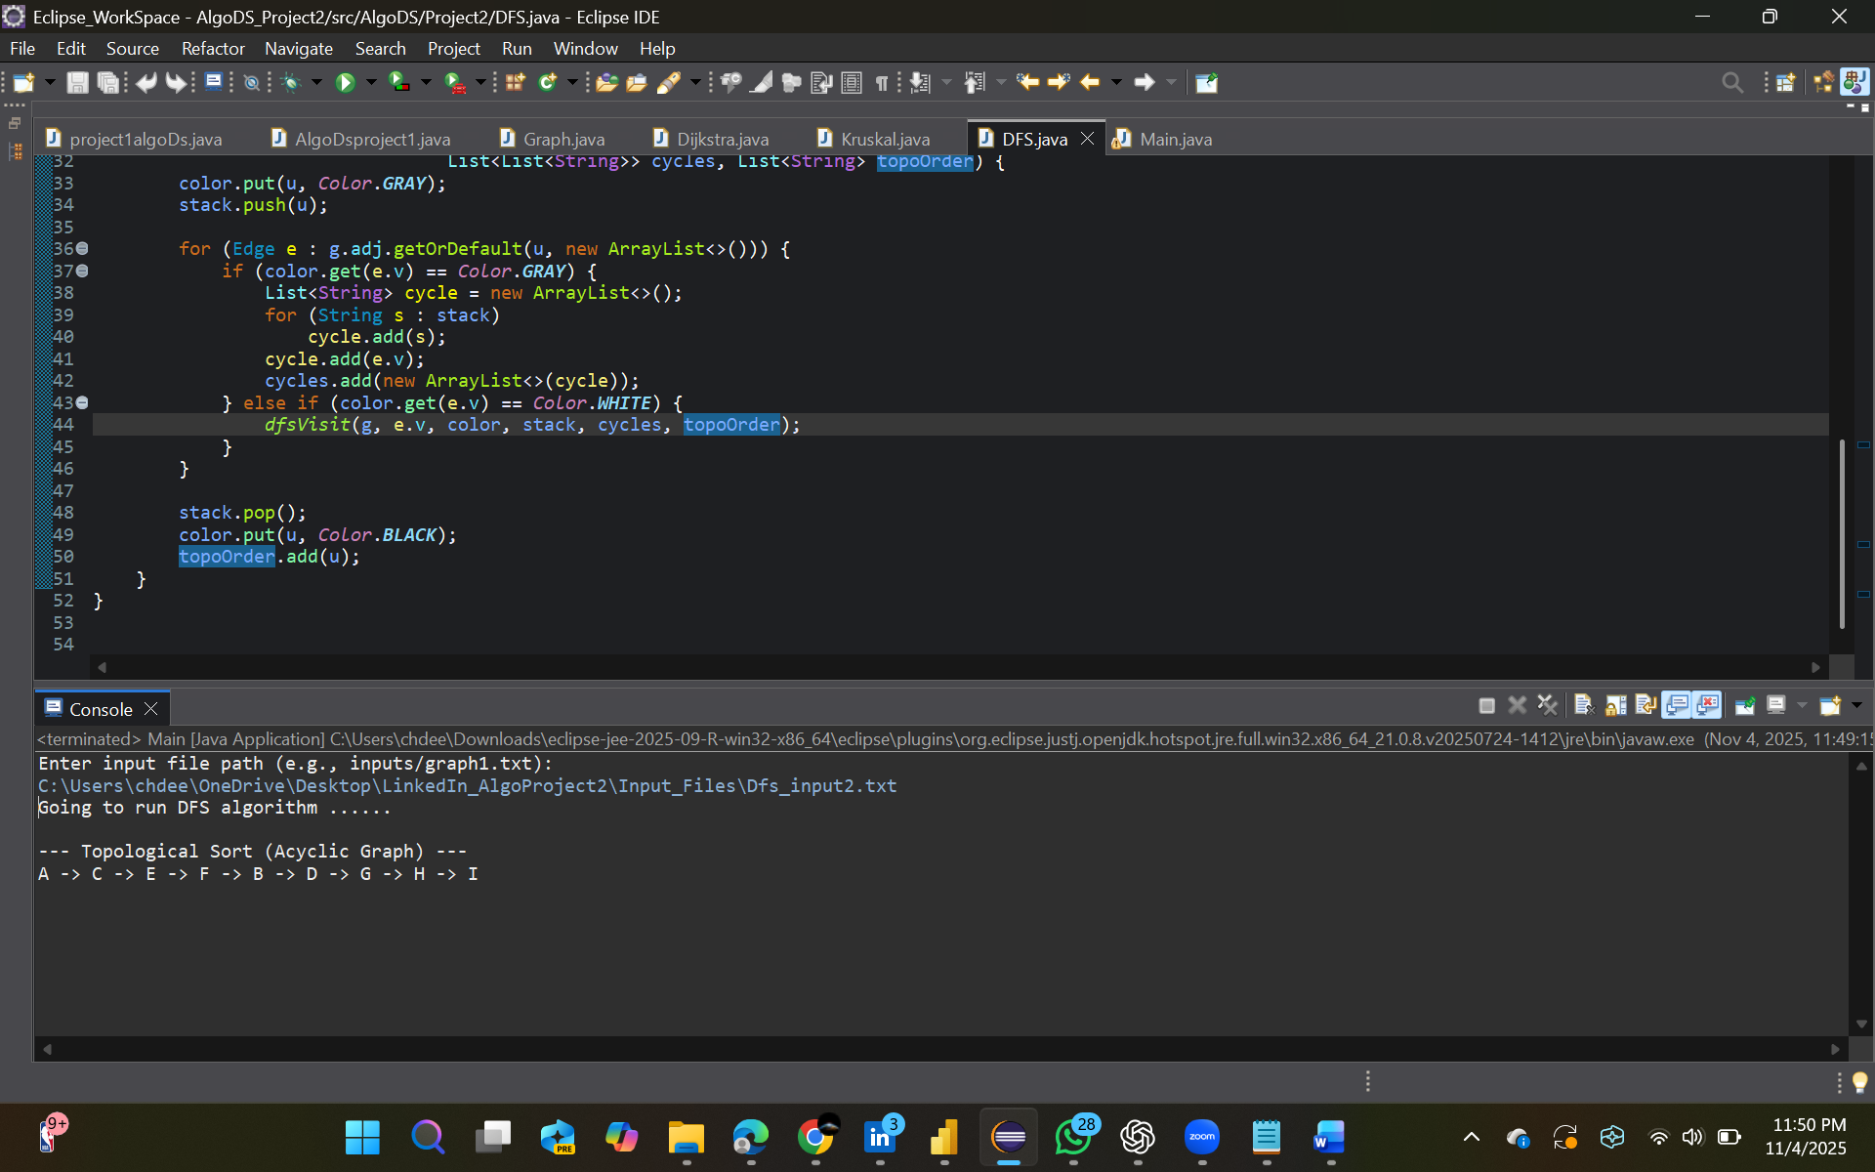

Input File Format

Example (graph1.txt):
6 10 U
A B 1
A C 2
B C 1
B D 3
B E 2
C D 1
C E 2
D E 4
D F 3
E F 3
A
6 → number of vertices
10 → number of edges
U → undirected (D for directed)
Each edge line → <u> <v> <weight>
Last line (optional) → source node (for Dijkstra)

Program Execution
Extract the Zip file provided by me in project submission
Copy the path of the directory where we have src folder in the provided zip folder
Open command prompt and change the directory to the path which you have copied
Now Compile all the java files from our package present inside the src folder
javac AlgoDS/Project2/*.java

After compiling the code, Run the main.java class which is starting point of our code flow
java -cp bin AlgoDS.Project2.Main.java

Now it will ask for the path of input txt file which needs to be run. Give the path accordingly and you will get output
Enter input file path (e.g., inputs/dfs1.txt)
Refer screenshot if needed while executing the code from terminal
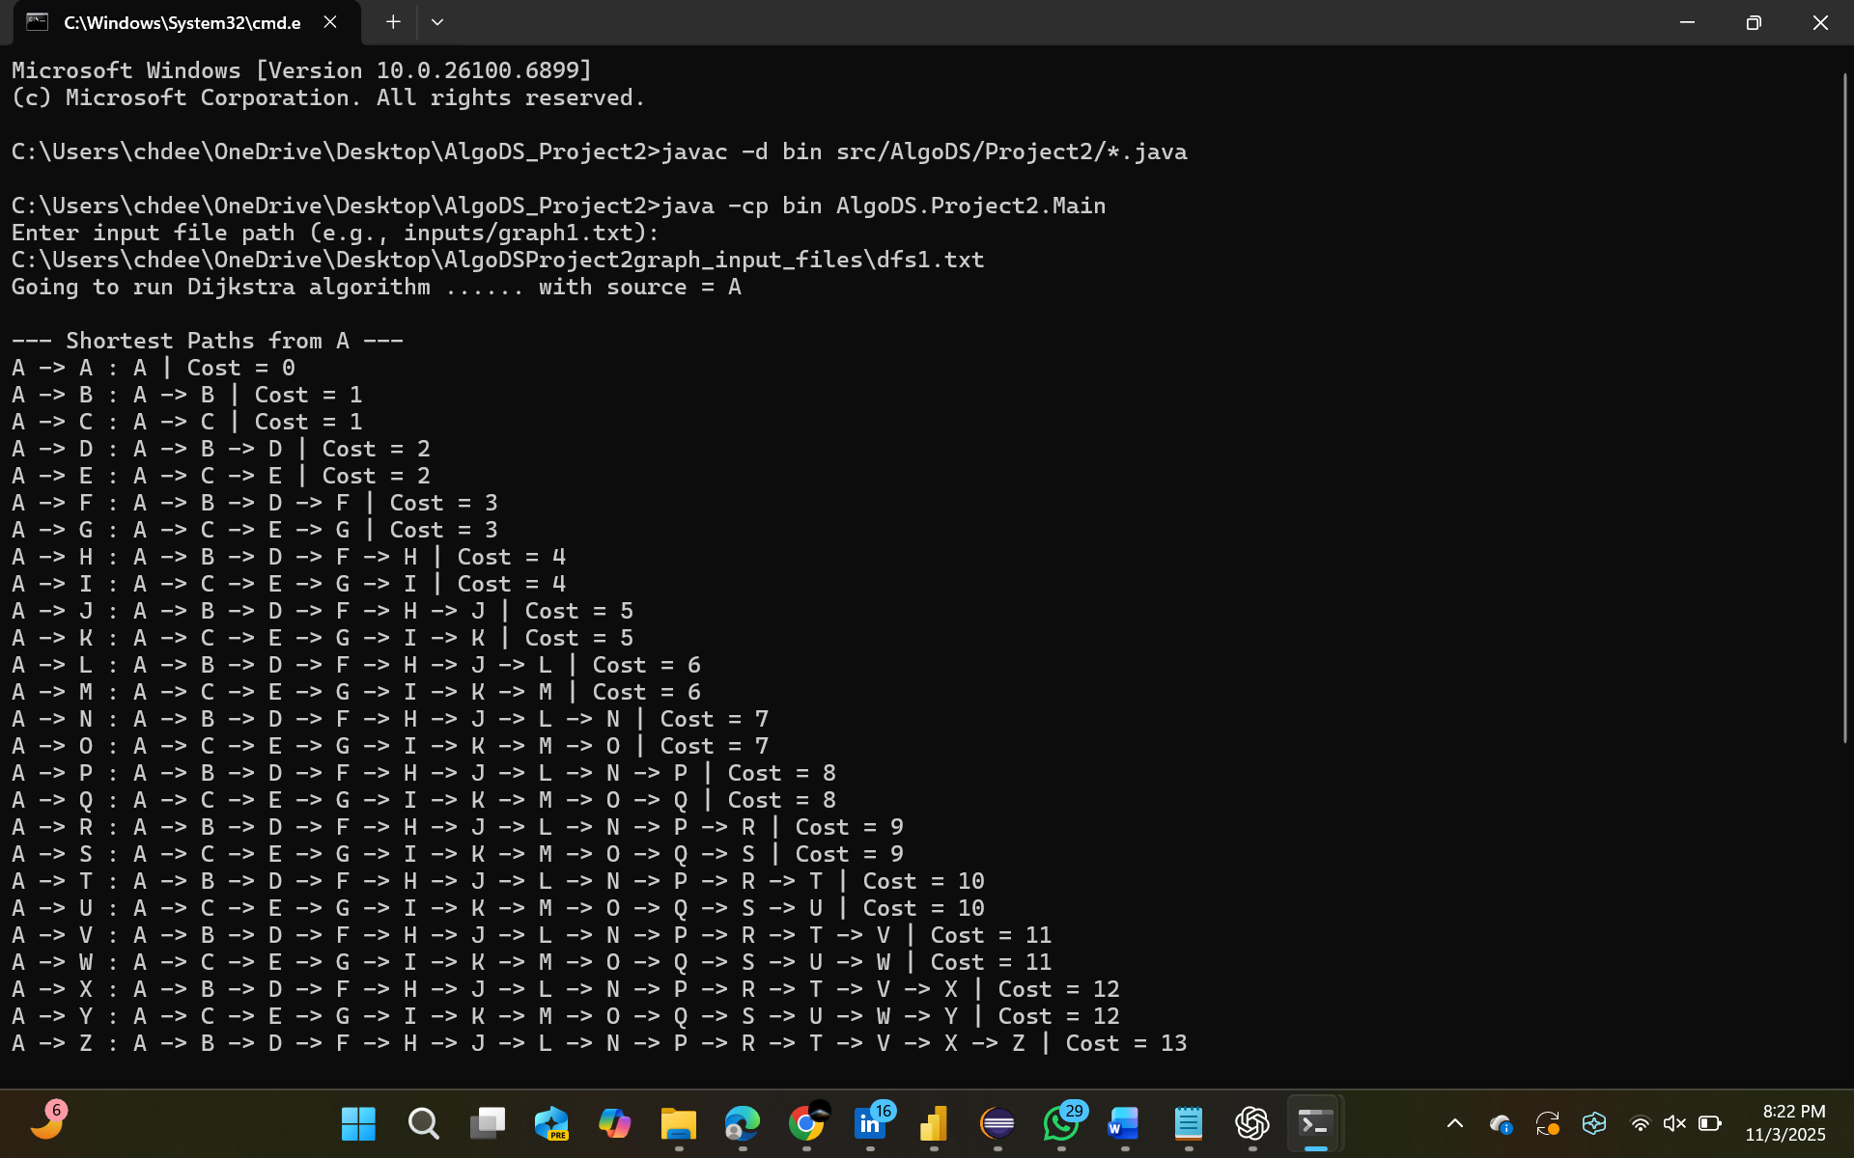
Output displayed on console:

For Dijkstra → shortest paths & costs

For Kruskal → MST edges & total cost

For DFS → topological order or cycles
Results and Observations
Dijkstra: Produced correct shortest paths and costs for all directed graphs with valid sources.
Kruskal: Correctly computed MST edges with minimal total weight for all undirected graphs.
DFS: Properly detected cycles and generated valid topological orders for acyclic graphs.
Runtime Comparison
Algorithm Graph Type Typical Runtime Verified on Input
Dijkstra Directed O(E log V) dijkstra1.txt, dijkstra2.txt
Kruskal Undirected O(E log E) mst1.txt … mst5.txt
DFS (Topo/Cycle) Directed O(V + E) dfs1.txt … dfs5.txt
Conclusion
This project successfully implements and compares three fundamental graph algorithms:
Dijkstra’s algorithm for shortest paths
Kruskal’s algorithm for minimum spanning tree
DFS for topological ordering and cycle detection
The modular design, efficient data structures (priority queues, adjacency lists, disjoint sets), and clean Java implementation ensure both performance and clarity.

