## ABSTRACT

## PROJECT ON :: ROAD FIGHTER

## 01)AIM.

## 02)OBJECTIVES.

## 03)INSTRUCTIONS(HOW TO PLAY).

## 04)EXPLANATION

## 1)AIM:

# To develop a Car Racing game using Java concepts.

## 2)OBJECTIVE:

# >>To create a nice background and make it move while the race is going on.

# >>Making the car move in directions based on the Keyboard Events.

# >>Creating obstracles on the track for increasing player difficulty.

# >> Brief Description of Code which makes player feel Good in this sample review.

# KNOWLEDGE ON: FRAMES,KEY EVENTS.

## 3)INSTRUCTIONS(HOW TO PLAY):

**Road Fighter** is a [pc game](http://en.wikipedia.org/wiki/Paper-and-pencil_game) for single player,here car can move in four directions(Up,Down,Left,Right).By using this directions player has to escape from the pot holes(Obstracles) and donot get touch edges of the road.

## Keys assignment for the movements of car:

## W, w, up arrow for UP

## A, a, left arrow for LEFT

## S, s, down arrow for DOWN

## D, d, right arrow for RIGHT

>>Winning chance:If the player cross the winning point without colloding any pot holes on the track and sides.

>>Loosing chance:If the player collides or touches any pot hole or edges of road then game ends.

## 4)EXPLANATION:

## Creating Background:

## Created a Frame with dimensions 1400,900.

a)Road:.The full background colour is setted as black and two cyan coloured rectangles first of length 500 from 0 to 500,second of length 500 from 900 to 1400 and created some rectangles in the middle of frame keeping X-coordinate constant to view as divider lines then clear view of road is formed.

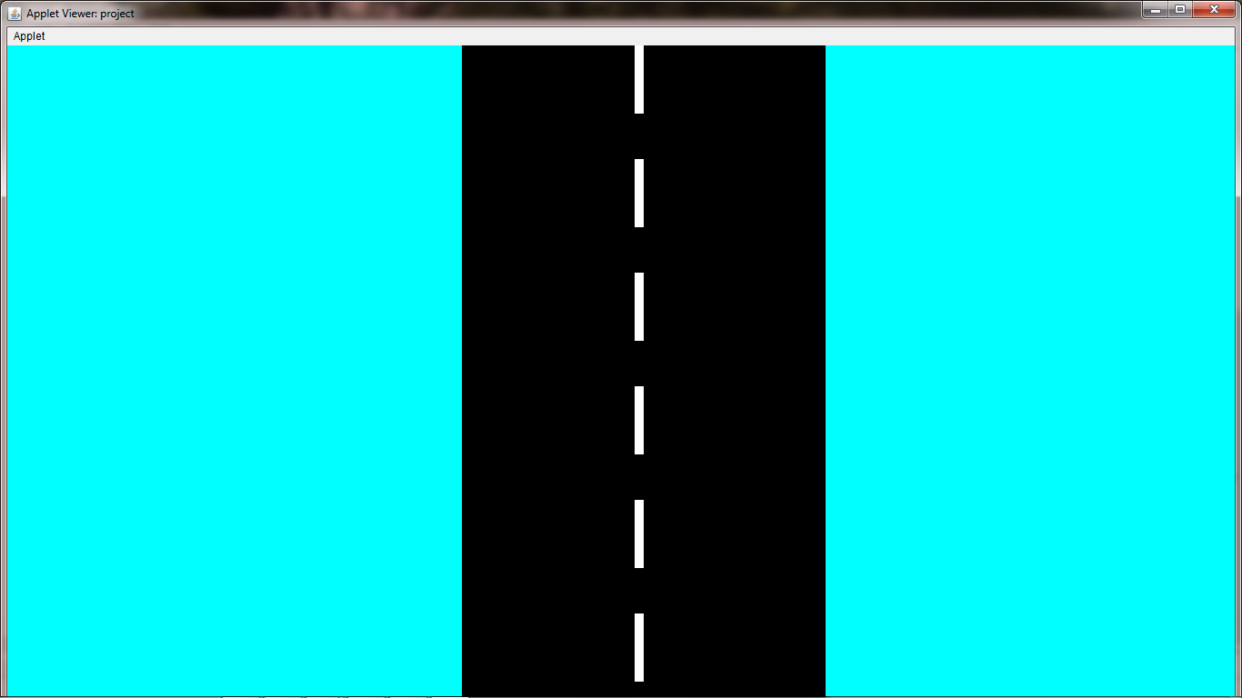

Source Code used for Road is:

|  |
| --- |
| g.setColor(Color.black);  g.fillRect(0,0,1400,900);  g.setColor(Color.cyan);  g.fillRect(0,0,500,900);  g.fillRect(900,0,500,900); |

b)Car:Two rectangles are used to create a car by placing one over the other with different colour and dimensions to view as Car.

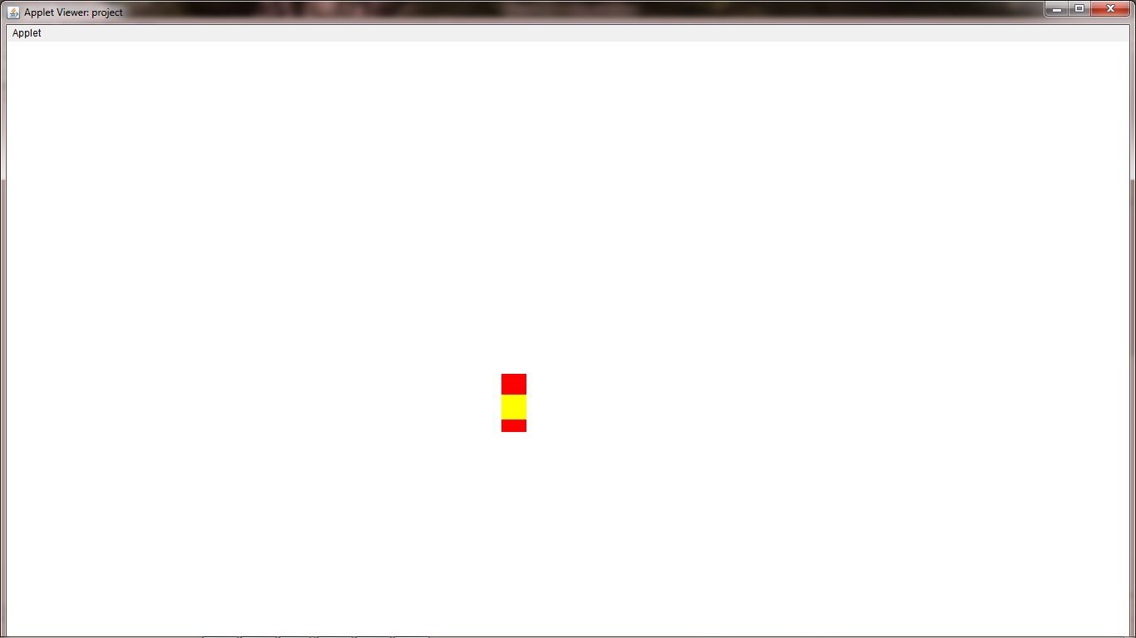

Source code used for Car is:

|  |
| --- |
| g.setColor(Color.red); //car red rect  g.fillRect(carx, cary, carLength, carWidth);  g.setColor(Color.yellow); //car yellow rect  g.fillRect(x1,yg,l,w); |

c)Movement of Road:We move divider lines to create a view as road moving.

Source code used for road movement:

|  |
| --- |
| y+=1; //divider lines movement  y1+=1;  y2+=1;  y3+=1;  y4+=1;  y5+=1;  y6+=1;  y7+=1;  if(y==900) //recycling divider lines  y=-100;  if(y1==900)  y1=-100;  if(y2==900)  y2=-100;  if(y3==900)  y3=-100;  if(y4==900)  y4=-100;  if(y5==900)  y5=-100;  if(y6==900)  y6=-100;  if(y7==900)  y7=-100; |

d)Movement of car:We used Key Events for four different keys for the movement of car the keys are A,W,S,D.

Source code used for car movement:

|  |
| --- |
| if (e.getKeyChar() == 'S' || e.getKeyChar() == 's')  {  cary += 2;  yg+=2;  }  if (e.getKeyChar() == 'W' || e.getKeyChar() == 'w')  {  cary-= 2;  yg-=2;  }  if (e.getKeyChar() == 'A' || e.getKeyChar() == 'a')  {  carx -= 2;  x1-=2;  }  if (e.getKeyChar() == 'D' || e.getKeyChar() == 'd')  {  carx += 2;  x1+=2;  } |

e)Creating Pot Holes:We created different ovals as obstracles on the track.

Source code used for Pot Holes:

|  |
| --- |
| g.setColor(Color.magenta);  g.fillOval(xp1,yp1,50,30);  g.setColor(Color.magenta);  g.fillOval(xp2,yp2,50,30);  g.setColor(Color.magenta);  g.fillOval(xp3,yp3,50,30); |

f)Creating Winning Strip:We created rectangle as winning point.

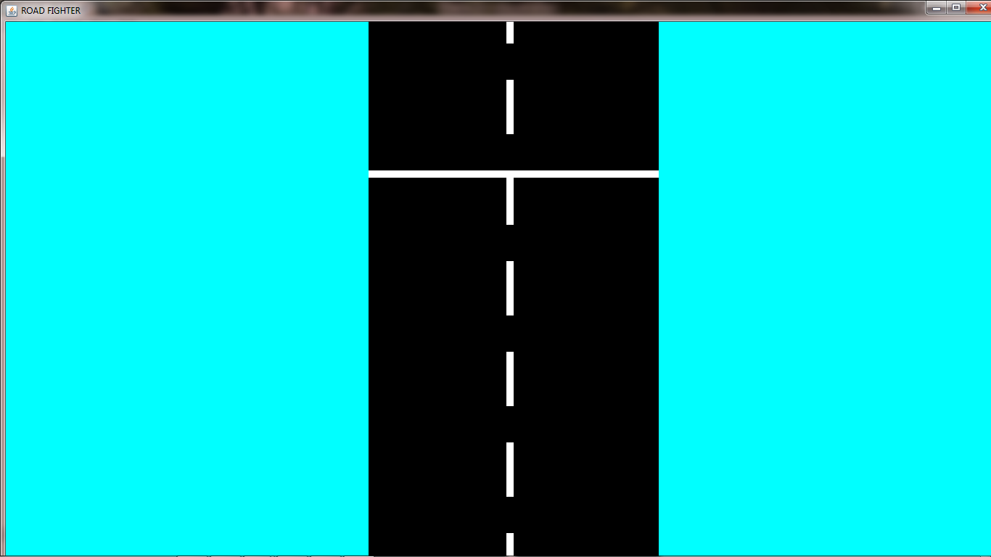

g)Conditions for Game Over:When the car collides the Pot Holes or it touches the edges of road the Game Over label will appears.

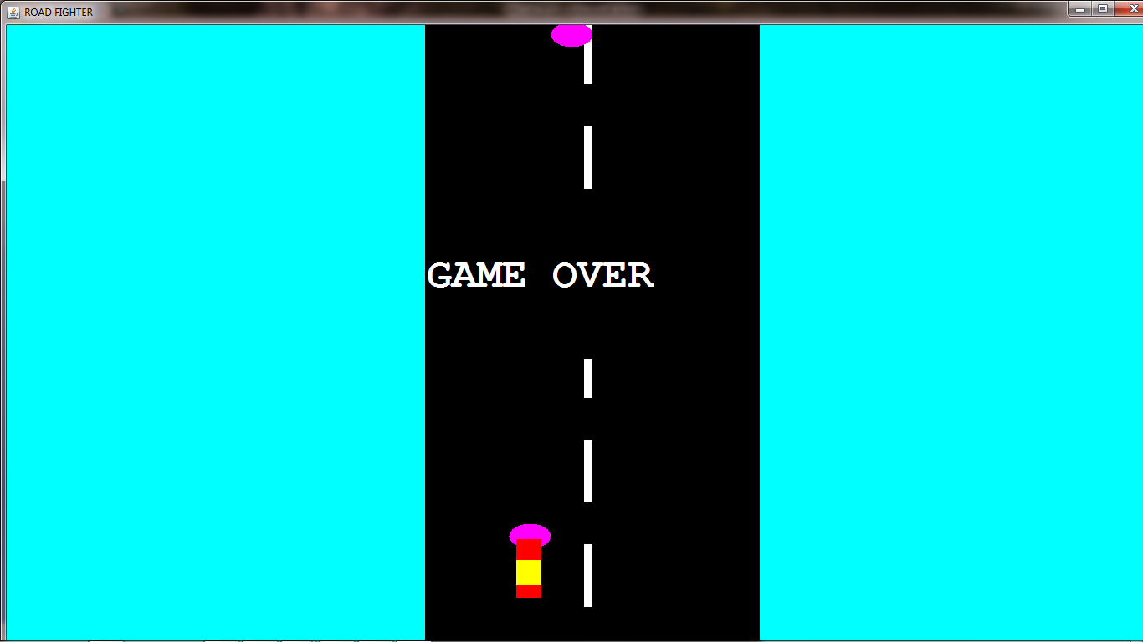

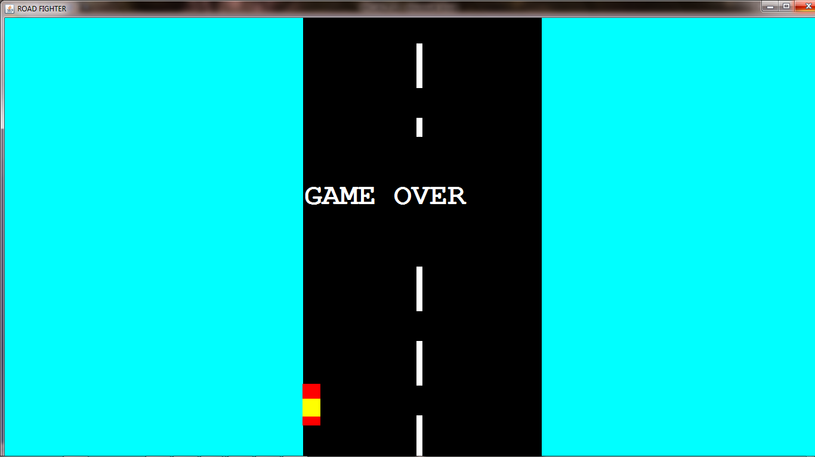

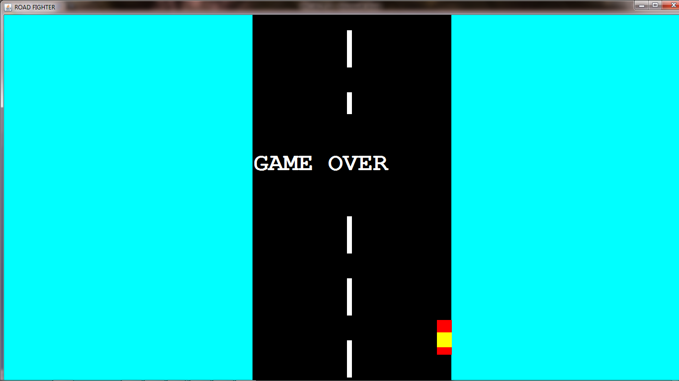

Source code for Game Over(When it touches Pot Hole):

|  |
| --- |
| if( (yp1>=cary && yp1<=(cary+70) && xp1<=(carx+30) && xp1>=carx) || (yp1>=cary && yp1<=(cary+70) && xp1+50<=(carx+30) && xp1+50>=carx) || (yp1+30>=cary && yp1+30<=(cary+70) && xp1+25<=(carx+30) && xp1+25>=carx) )  {  t.setBounds(500,200,400,200);  t.setForeground(Color.white);  t.setBackground(Color.black);  t.setFont(myFont);  add(t);  yend=-10000;  } |

Source code for Game Over(when it touches edges of road):

|  |
| --- |
| if(carx<=500) // touches left edge  {  t.setBounds(500,200,400,200);  t.setForeground(Color.white);  t.setBackground(Color.black);  t.setFont(myFont);  add(t);  yend=-10000;  }  if((carx+30)>=900) //touches right edge  {  t.setBounds(500,200,400,200);  t.setForeground(Color.white);  t.setBackground(Color.black);  t.setFont(myFont);  add(t);  yend=-10000;  } |

h)Game Win condition:Player will win the Game when he escapes from all Pot Holes and touches Winning Strip.

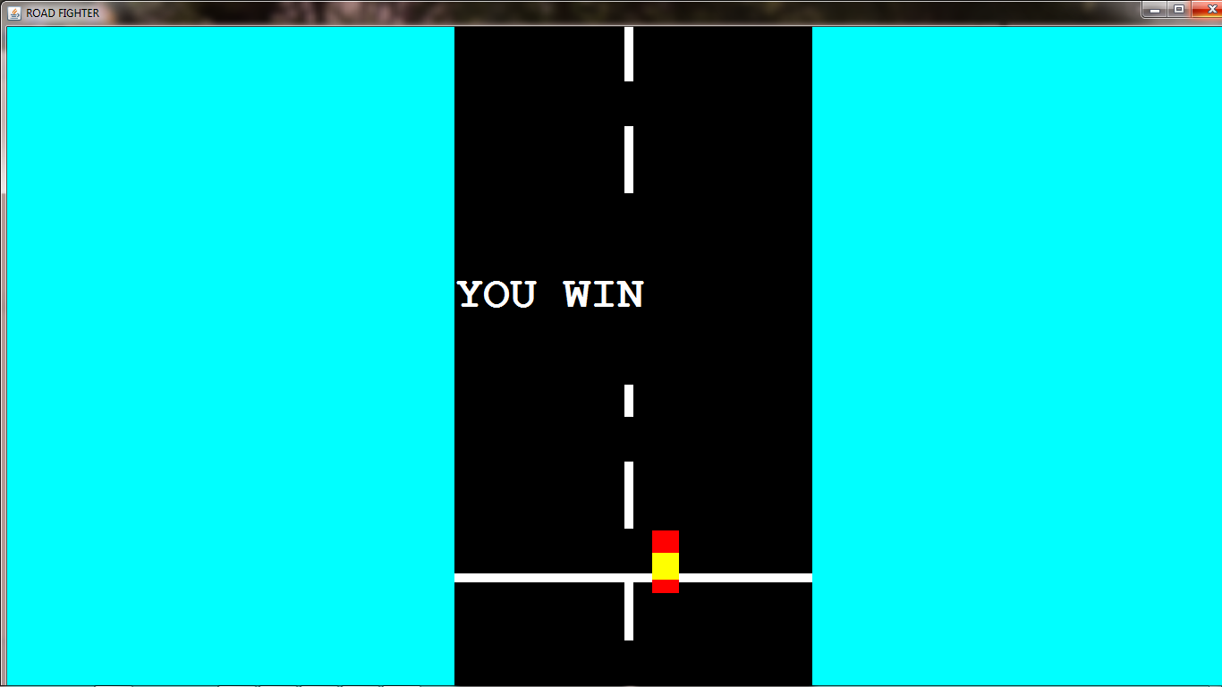

Total Source code for our Game:

import java.awt.*;

import javax.swing.*;

import java.awt.event.*;

public class Carproject extends JPanel implements KeyListener

{

int xend=500; //ending strip

int yend=-1500;

int xp1=600; //pot hole1

int yp1=-400;

int xp2=650; //pot hole2

int yp2=-1000;

int xp3=800; //pot hole3

int yp3=-700;

int carLength = 30; //car red rect

int carWidth = 70;

int l=30; //car yellow rect

int w=30;

Label t=new Label("GAME OVER"); //labels

Label t1=new Label("YOU WIN");

Font myFont = new Font("Courier", Font.BOLD,50); //setting font

int carx=595; //car red rect position

int cary=615;

int x1=595; //car yellow rect position

int yg=640;

int x=690; //starting point of divider lines

int y=0;

int y1=125,y2=250,y3=375,y4=500,y5=625,y6=750,y7=875;

private void movement() //movements

{

yend=yend+1; //movement of Winning strip

yp1=yp1+1; //movement of pot holes

yp2=yp2+1;

yp3=yp3+1;

if(cary==yend) //you won

{

t1.setBounds(500,200,400,200);

t1.setForeground(Color.white);

t1.setBackground(Color.black);

t1.setFont(myFont);

add(t1);

}

if( (yp1>=cary && yp1<=(cary+70) && xp1<=(carx+30) && xp1>=carx) || (yp1>=cary && yp1<=(cary+70) && xp1+50<=(carx+30) && xp1+50>=carx) || (yp1+30>=cary && yp1+30<=(cary+70) && xp1+25<=(carx+30) && xp1+25>=carx) ) //Game over

{

t.setBounds(500,200,400,200);

t.setForeground(Color.white);

t.setBackground(Color.black);

t.setFont(myFont);

add(t);

yend=-10000;

}

if( (yp2>=cary && yp2<=(cary+70) && xp2<=(carx+30) && xp2>=carx) || (yp2>=cary && yp2<=(cary+70) && xp2+50<=(carx+30) && xp2+50>=carx) || (yp2+30>=cary && yp2+30<=(cary+70) && xp2+25<=(carx+30) && xp2+25>=carx) ) //Game over

{

t.setBounds(500,200,400,200);

t.setForeground(Color.white);

t.setBackground(Color.black);

t.setFont(myFont);

add(t);

yend=-10000;

}

if( (yp3>=cary && yp3<=(cary+70) && xp3<=(carx+30) && xp3>=carx) || (yp3>=cary && yp3<=(cary+70) && xp3+50<=(carx+30) && xp3+50>=carx) || (yp3+30>=cary && yp3+30<=(cary+70) && xp3+25<=(carx+30) && xp3+25>=carx) ) //Game over

{

t.setBounds(500,200,400,200);

t.setForeground(Color.white);

t.setBackground(Color.black);

t.setFont(myFont);

add(t);

yend=-10000;

}

y+=1; //divider lines movement

y1+=1;

y2+=1;

y3+=1;

y4+=1;

y5+=1;

y6+=1;

y7+=1;

if(y==900) //recycling divider lines

y=-100;

if(y1==900)

y1=-100;

if(y2==900)

y2=-100;

if(y3==900)

y3=-100;

if(y4==900)

y4=-100;

if(y5==900)

y5=-100;

if(y6==900)

y6=-100;

if(y7==900)

y7=-100;

}

public void paint(Graphics g)

{

g.setColor(Color.black);

g.fillRect(0,0,1400,900);

g.setColor(Color.white);

g.fillRect(xend,yend,400,10); //designing Winning strip

g.fillRect(x, y, 10, 75); //designing divider lines

g.fillRect(x,y1,10,75);

g.fillRect(x,y2,10,75);

g.fillRect(x,y3,10,75);

g.fillRect(x,y4,10,75);

g.fillRect(x,y5,10,75);

g.fillRect(x,y6,10,75);

g.fillRect(x,y7,10,75);

g.setColor(Color.magenta); //pot hole1

g.fillOval(xp1,yp1,50,30);

g.setColor(Color.magenta); //pot hole2

g.fillOval(xp2,yp2,50,30);

g.setColor(Color.magenta); //pot hole3

g.fillOval(xp3,yp3,50,30);

g.setColor(Color.cyan); //baground except road

g.fillRect(0,0,500,900);

g.fillRect(900,0,500,900);

g.setColor(Color.red); //car red rect

g.fillRect(carx, cary, carLength, carWidth);

g.setColor(Color.yellow); //car yellow rect

g.fillRect(x1,yg,l,w);

}

public void keyPressed(KeyEvent e)

{

if (e.getKeyChar() == 'S' || e.getKeyChar() == 's') //movement down

{

cary += 2;

yg+=2;

}

if (e.getKeyChar() == 'W' || e.getKeyChar() == 'w') //movement front

{

cary-= 2;

yg-=2;

}

if (e.getKeyChar() == 'A' || e.getKeyChar() == 'a') //movement left

{

carx -= 2;

x1-=2;

if(carx<=500)

{

t.setBounds(500,200,400,200); //game over left side

t.setForeground(Color.white);

t.setBackground(Color.black);

t.setFont(myFont);

add(t);

yend=-10000;

}

}

if (e.getKeyChar() == 'D' || e.getKeyChar() == 'd') //movement right

{

carx += 2;

x1+=2;

if((carx+30)>=900)

{

t.setBounds(500,200,400,200); //game over right side

t.setForeground(Color.white);

t.setBackground(Color.black);

t.setFont(myFont);

add(t);

yend=-10000;

}

}

repaint();

}

public void keyReleased(KeyEvent e)

{

}

public void keyTyped(KeyEvent e)

{

}

public void addKeyListner()

{

}

public static void main(String args[]) throws InterruptedException

{

JFrame fm = new JFrame("ROAD FIGHTER"); //designing frame

Carproject g4=new Carproject();

fm.add(g4);

fm.setSize(1400, 900);

fm.setVisible(true);

fm.setDefaultCloseOperation(JFrame.EXIT_ON_CLOSE);

fm.addKeyListener(g4);

for( ; ; )

{

g4.movement();

g4.repaint();

Thread.sleep(10);

}

}

}