1.Create an array with the values (1, 2, 3, 4, 5, 6, 7) and shuffle it.  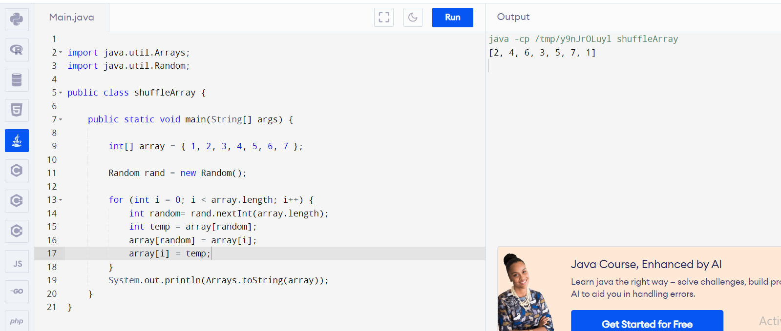

2. Enter a Roman Number as input and convert it to an integer. (ex IX = 9)  C. Check if the input is pangram or not. (Pangram is a sentence that contains all the alphabet from a-z)

