### Exercise 1: Create Azure resources

### 

### Exercise 2: Configure secrets and identities

### 

### Exercise 3: Build an Azure Functions app

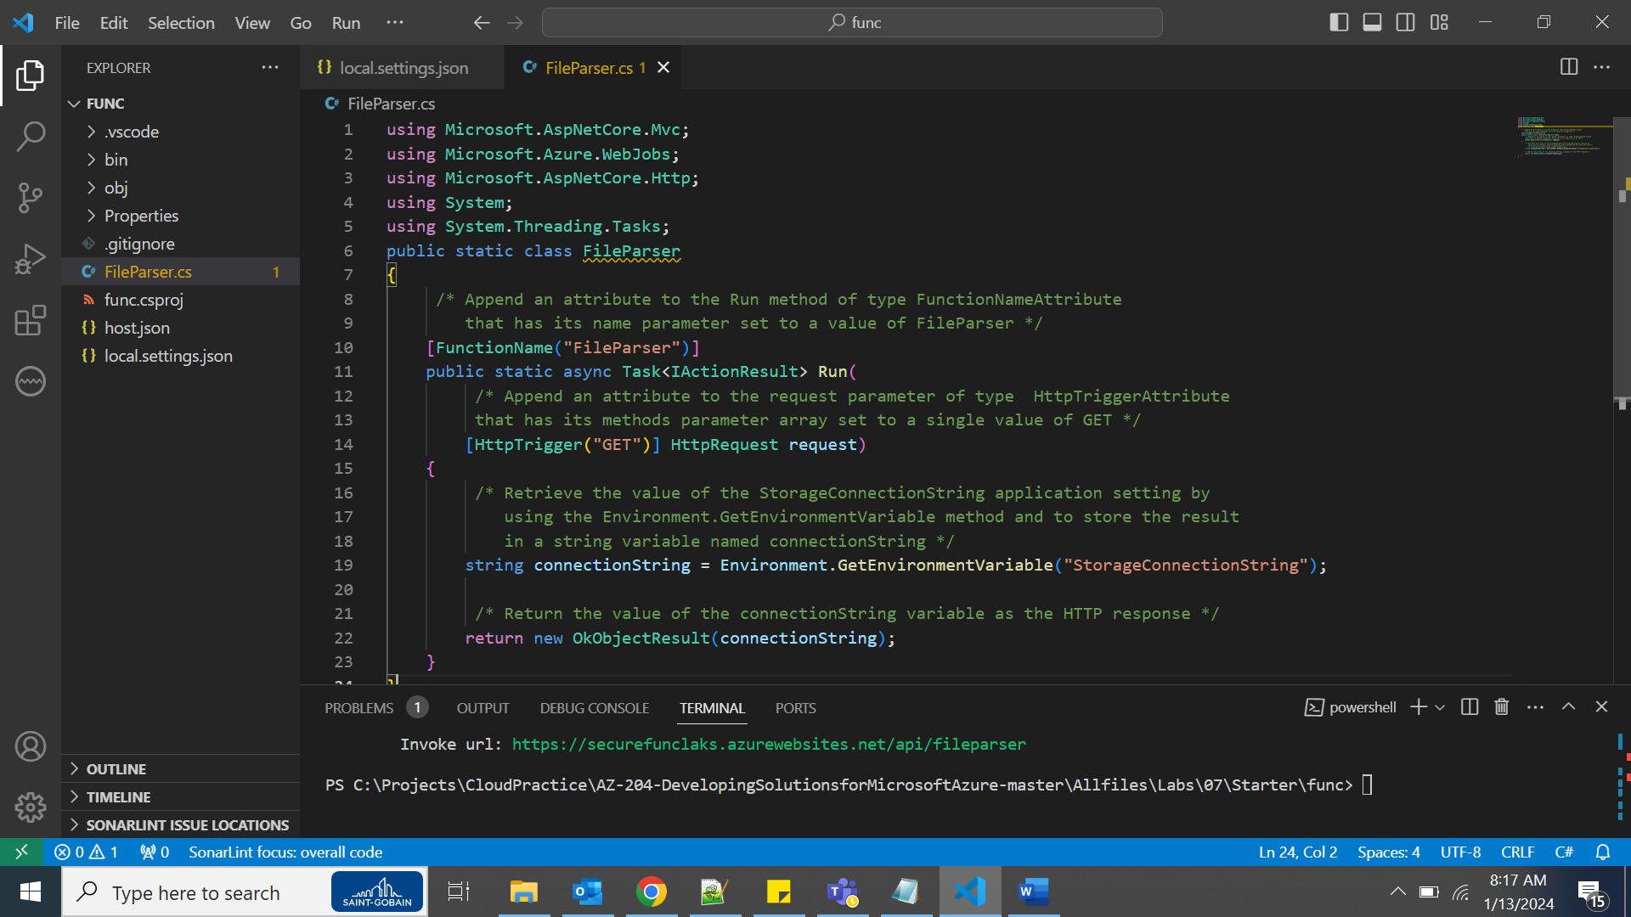

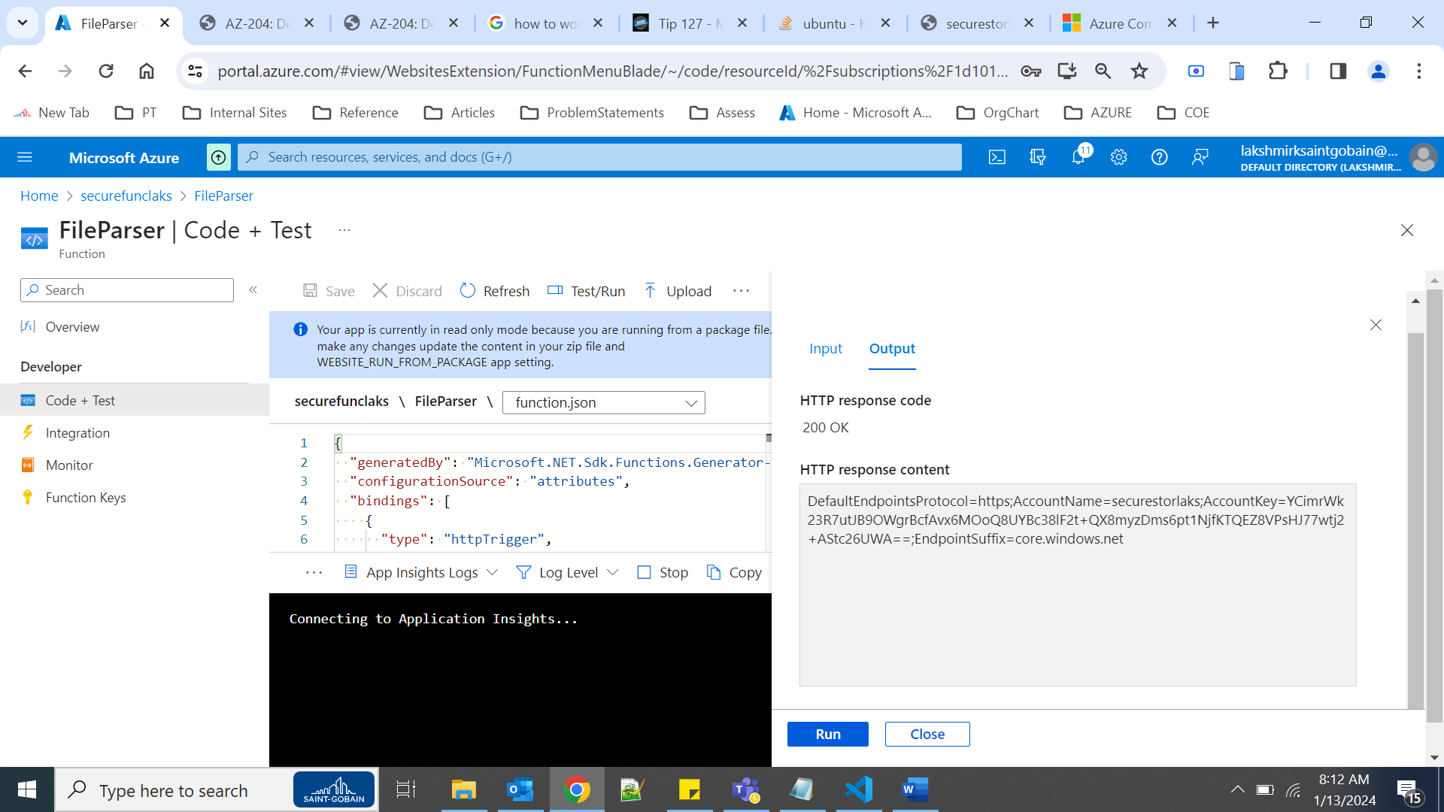

Exercise 4: Access Azure Blob Storage data

