

Manual Deletion of Backup Files from D Drive (windows)

All logos, trademarks and brand names used belong to their respective owners. This information is confidential and was prepared by Resolve Tech Solutions and is not to be relied on by any 3rd party without RTS’ consent.

Documentation Control

Preparation
Name | Title | Date
Anmol Tiwari | Manual Deletion of Backup Files from D Drive (windows) | 17/12/2025

Review
Name | Title | Date
Santhosh | Manual Deletion of Backup Files From D Drive (windows) | 17/12/2025

Proprietary Notice
Information contained in this Service Description is accurate to the best of RTS’s knowledge at the time of publication and it is required to be treated as Internal-Sensitive for specific customer use. This document should not be reproduced or made available in any form to people outside the group directly responsible for evaluating its contents.
Any provided performance data is based on relevant information made available to us at the present time and must (except were stated otherwise) be regarded as an estimate only, since the actual performance and functionality of any computer system will depend upon a variety of factors, not all of which are related to the products and services that may ultimately be supplied.
All brands and products referenced in this Service Description are acknowledged as trademarks or registered trademarks of their respective owners.


Contents
Documentation Control 2
Objective 4
Scope 4
Pre-requisites 4
Responsibilities 5
Do's and Don'ts 5
Tools & Commands 5
Procedure / Steps to Follow……………………………………………………………………………………………………5-8
Rollback Plan…………………………………………………………………………………………………………………………….9
Post-Validation………………………………………………………………………………………………………………………….9
References…………………………………………………………………………………………………………………………………9
Escalation…………………………………………………………………………………………………………………………………..9

Objective
To manually delete obsolete or excess backup files from the D drive on a Windows server in a controlled and secure manner in order to free up disk space, prevent warning alerts, and ensure system stability while adhering to organizational data retention and security policies.

Scope

Applies to Windows Servers where backups are stored locally on the D drive. • Specifically covers manual cleanup of backup files (e.g., .zip, .ezip, .bak, .vhd, or application-specific backup files). • Can be applied to other Windows servers experiencing disk space issues due to backup file accumulation. • Includes verification and alert clearance post-cleanup.

Pre-requisites
•Administrative or appropriate file system access to the Windows server.
• Approval to delete backup files as per data retention policy.
• Confirmation of backup retention requirement (e.g., keep last 2 days only).
• Remote Desktop (RDP) or console access to the server.
• Disk space alert or monitoring notification (if applicable).
• Change request or incident ticket approved (if applicable).

Responsibilities
Activity | Role

Implementation | Server Admin / Operations Team

Approval | Team Lead / Manager

Review & Audit | Security / IT Compliance Team

Documentation | Operations / Infrastructure Team

Do's and Don'ts

  - ✔ Do’s
  - Verify backup retention policy before deleting any files.
  - Take note of file names, sizes, and dates prior to deletion.
  - Delete only older or non-required backup files.
  - Ensure sufficient free space is available after cleanup.
  - Validate that services and backups are functioning post-cleanup.
  - Update the ticket with cleanup confirmation and alert status.

✘ Don’ts
  - Do not delete the most recent or active backup files.
  - Do not delete files without proper approval.
  - Do not delete system or application-critical files.
  - Do not perform cleanup during active backup jobs.
  - Do not permanently delete files without validation (use Recycle Bin or move temporarily if required).

Tools & Commands

- Windows File Explorer
- Remote Desktop (RDP)
- Disk Management / File Properties
- (Optional) Command Prompt or PowerShell<NewPasswor

Procedure / Steps to Follow

Step 1 – Login to Windows Server
• Connect to the server using RDP or console access.
• Login with an account having appropriate permissions.
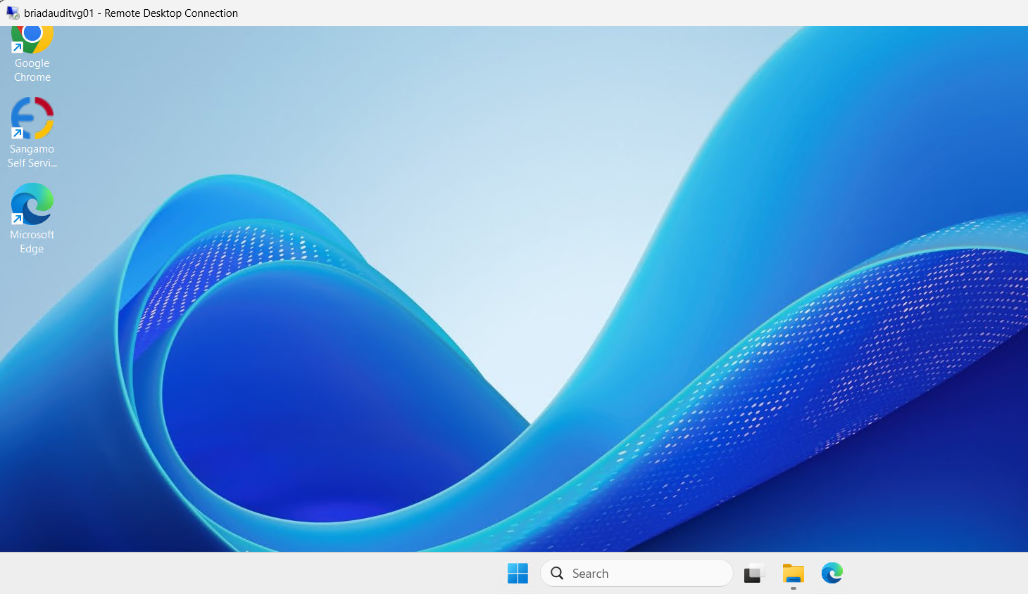
Step 2 – Navigate to Backup Location
• Open File Explorer.
• Navigate to *D:* drive.
• Locate the backup folder (e.g., D:\ManageEngine\ADAudit Plus\backup).
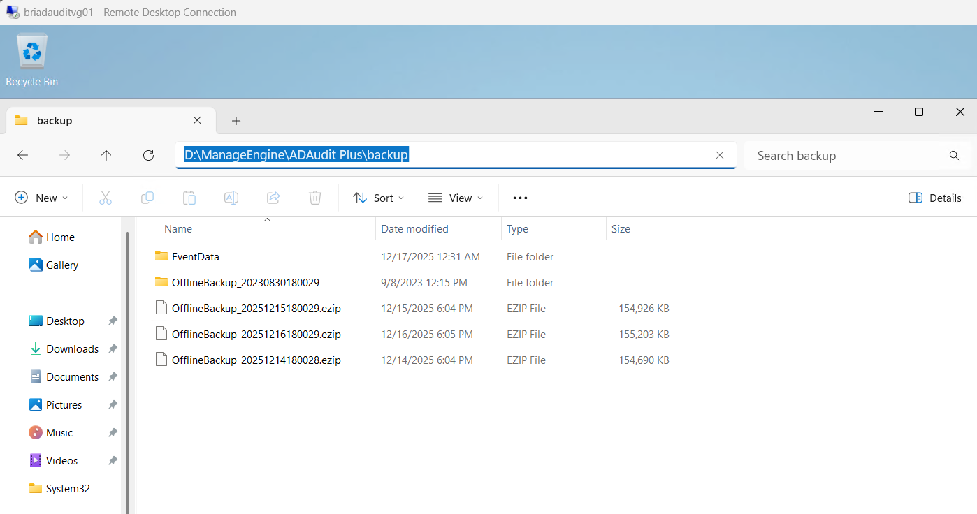
Step 3 – Identify Files for Deletion

• Sort files by Date Modified.
• Identify backup files older than the approved retention period (e.g., files older than last 2 days). • Verify file type and size to ensure they are backup-related files only.
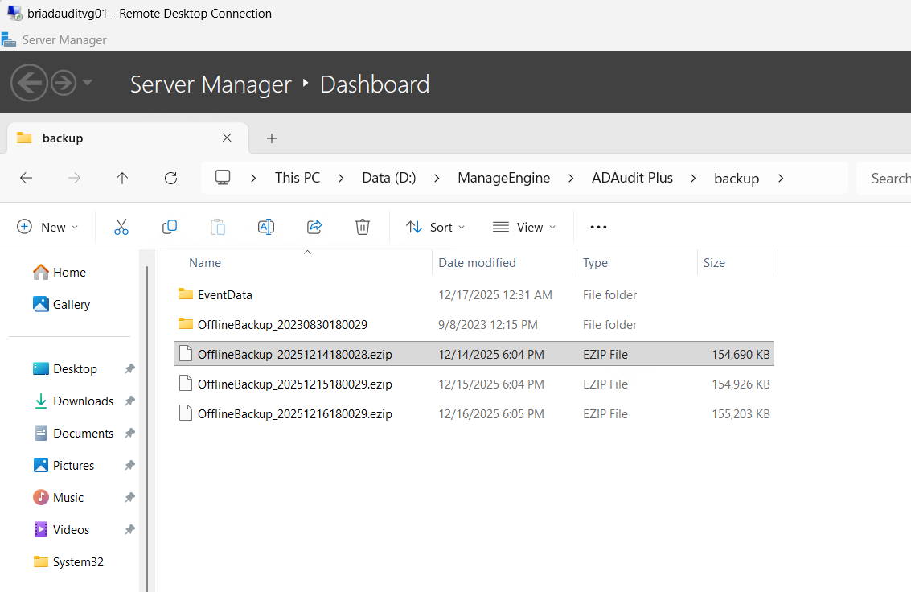
Step 4 – Delete Backup Files
• Select the identified old backup files.
• Right-click and select Delete.
• Confirm deletion.
• (Optional) Empty Recycle Bin if immediate disk space is required.
Backup files have now been deleted successfully.
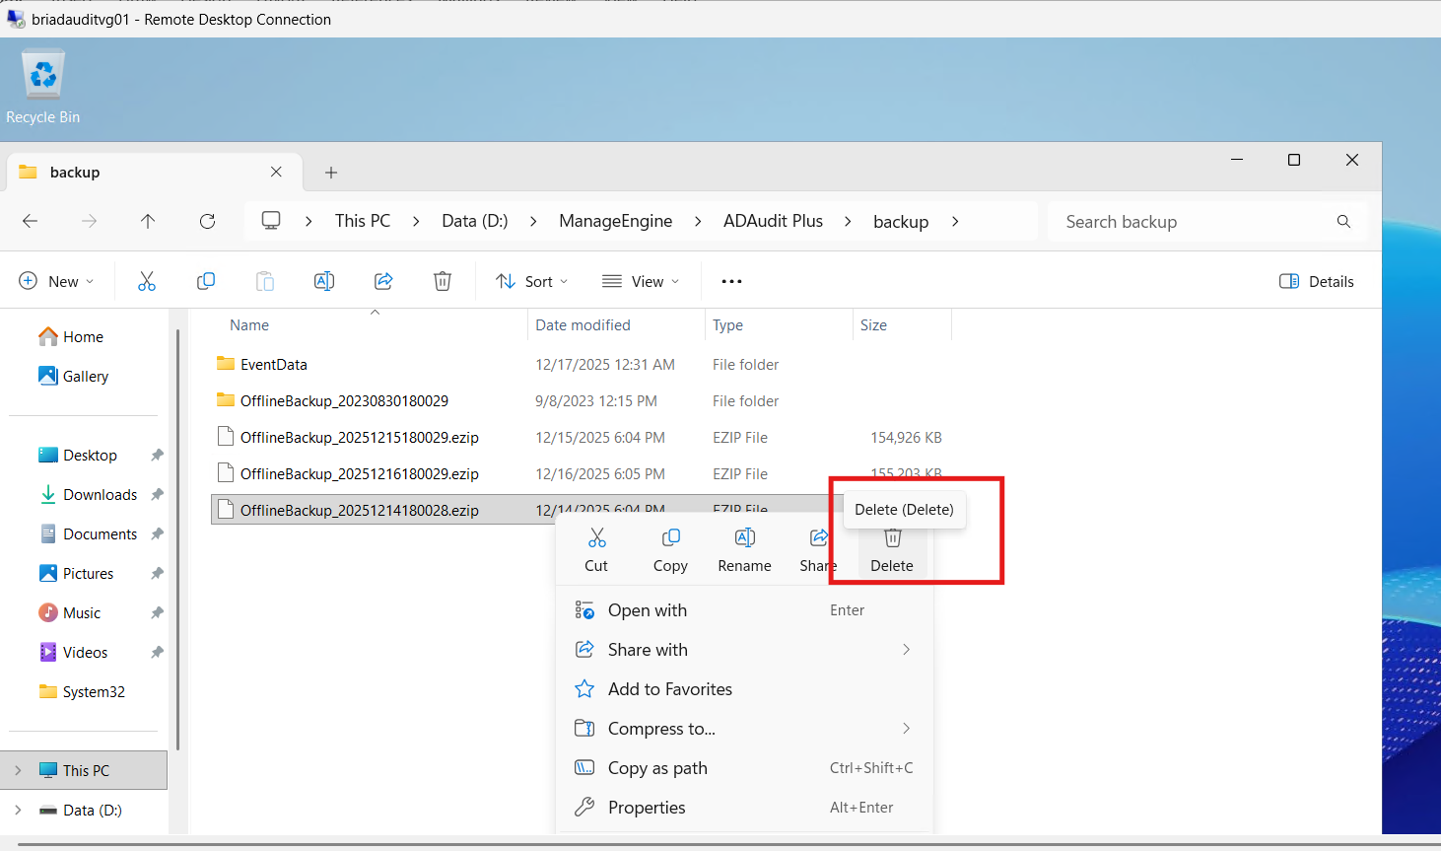
Step 5 – Verify Disk Space
• Right-click on D drive → Select Properties.
• Confirm available free space has increased.
• Ensure disk utilization is within acceptable threshold.
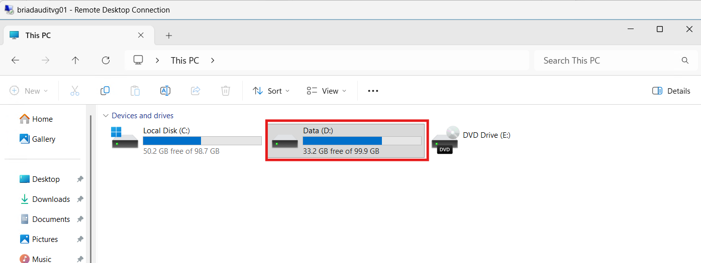
post-validation
• Confirm disk space warning alert is cleared.
• Verify no application or backup job failures.
• Check system and application logs for errors.
• Ensure monitoring tools reflect normal disk utilization.
• Update the incident/change ticket with successful cleanup details.
References
• Company Backup & Retention Policy
• Windows Server Administration Guide
• IT Operations Standard Operating Procedures

Rollback Plan
• If an incorrect file is deleted or an issue occurs:
- Restore the file from Recycle Bin (if not permanently deleted).
- Restore from centralized or secondary backup (if available).
- Inform the application or backup owner immediately.
- Escalate to the Infrastructure or Backup Team if recovery is required.

Escalation
Level | Role | Responsibility
L1 | Server Support | Initial investigation & cleanup
L2 | Infrastructure Lead | Approval & troubleshooting
L3 | Backup / Security Team | Retention & compliance validation
L4 | IT Architect / Vendor Support | Advanced recovery or design review

